Weekly Reporting

WBS 1.01.07 JLAB Management

Week of May 11-17, 2017

**Issues:**

**Accomplishments this week:**

Addressing recommendations from the Director’s Review.

Preparing a JLab Director’s Review of the Cryoplant General Contractor Installation Package Review.

**Upcoming Activities:**

International Particle Accelerator Conference 14-19 May

Collaboration Meeting 12 June 2017

DOE Status Review at SLAC 13-15 June 2017

SRF 2017 in China July 17-21, 2017

FAC at SLAC July 25-27, 2017 (Tentative)

Weekly Reporting

WBS 1.04.6 JLAB Cryomodules

Week of May 11-17, 2017

**Issues:** Impact on cryomodule assembly schedule due to design changes and parts availability associated with microphonics. Insufficient quantities of PICs may lead to delays in shipments from cavity vendors.

**Accomplishments this week:**

Prepared presentation for BCR to fabricate 18-20 cavities at RI from material that EZ had on hand.

LCLS-II staff (H. K. Park, T. Peshehonoff, E. Daly, J. Sekutowicz, N. Solyak) attended early coordination meeting at vendor that is producing HOM BLAs. Positive schedule adjustments agreed by vendor will be incorporated in BCR.

A planned CTF interruption for commissioning of the new CTF cold box beginning 22-May and ending by 4-June.

Revising estimate for using LERF for CM testing in advance of DOE review.

Cavity Status

No PCC meeting was held this week.

Continuing with vendor on-site support at Zanon. Focus was on process development associated with helium tank welding. Two cavities (260, 261) were inadvertently pressurized with existing tooling and exceeded the field flatness specification. These cavities will be reworked. Modifications to tooling are underway to avoid this in the future. Hold point 1 for CAV256 – CAV277 (NCR for 266), Hold point 2 for CAV256 – 265, Hold point 3 for CAV256 – 259.

RI is making good progress and is continuing to ship cavities. Hold Point 1 thru CAV0120 except 115 & 116, Hold Point 2 thru CAV0111 with several exceptions and Hold Point 3 thru CAV0094 + 98 & 104.

Upcoming RI Shipments

CAV0087, CAV0088, CAV0089, CAV0090 – at DESY for testing, destined for JLab

CAV0053, CAV0056, CAV0059, CAV0060 – qualified at DESY – shipped to JLab 10-May

CAV0058, CAV0091, CAV0093, CAV0098 – shipped to FNAL 15-May

CAV0092, CAV0094, CAV0097, CAV0104 – shipping to JLab approx. next week (S/N tentative)

CAV0099, CAV0100, CAV0101, CAV0102 – shipping to FNAL approx. the week after (S/N tentative)

pCM Status

All cavity maximum gradients have been obtained. Microphonics data was obtained for all cavities. Qexternal on FPC #8 was re-adjusted to meet requirements. Thermal cycle for flux expulsion was completed. Magnet tested on 05/14 – quenched at 17 A after 40 minutes. SSA#2 still not useable – re-routed power from SSA#1 in order to complete measurements. Qo measurements were conducted on Monday and Tuesday. There will be 1- 1 ½ shifts for LLRF work starting Wednesday. Testing continues until the end of the day on 18-May.

Production Status

Members of production staff participated in on-site ESH review on work planning, integration and safety by SLAC staff (I. Evans).

CM-02 (currently at WS5):

Nondestructive testing (RT) of JT & CD valve piping welds complete. End Cap installed. Clean beam pipe work on Bayonet box end complete. Confirmed that second gate valve was leak tight. Bayonet box assembly complete. Four warm couplers’ assembly complete.

CM-03 (currently at WS3):

Fluxgate installation complete. Mu metal shields installation complete. Tuner assembly is in progress.

CM-04 (currently at WS12:

Survey and Alignment fiducialized string and magnet. Two-phase welding in progress; vortex generator welded together. UCM welds fixed and inspected.

CM-05

String assembly delayed due to lack of eighth qualified cavity. Eighth cavity (080) was re-tested in 5mG field. Previous test showed high Qext FP due to bad cable. Cavity qualified - Q0(16) = 2.6e10, 22.5 MV/m quench limited. Passed all specifications. Currently string assembly is re-scheduled to begin 5/22/17. Rollout from cleanroom scheduled for Friday, 6/2/17.

CM-06

Four cavities qualified at DESY are planned for string 06. These shipped from DESY to RI on 10-May.

Two cavities (082, 083) were tested this week. Cavity 082 - initial test, 5mG field, Q0(16) = 2.8e10, 24 MV/m (admin), failed due to FE onset. This cavity will be re-rinsed and re-tested. Cavity 083 - initial test, 5mG field, Q0(16) = 1.9e10 (below 2.5e10 spec), 23.5 MV/m limited.

Vertical test planning – Cavity 063 planned for Wednesday 17 May, cavity

082 scheduled for retest 19 May.

**QUALITY**

Reviewed and discussed quality of work with Fermilab on the production VVs and UCMs from WXCX. Reviewed and provided feedback on the QC results to VV #16 and UCM #16.

Ian Evans (SLAC LCLSII ESH Program Manager) visited JLab on May 15 & 16 to look at Integrated Safety Management System as applied to the LCLSII cryomodule assembly and test. The visit went well. Ian spent quality time on the cryomodule production floor interviewing staff members. Ian also met with leadership folks from ESH&Q and Accelerator Divisions.

**Upcoming Travel:**

E. Zanon Vendor Oversight May 6-19 (A. Palczewski)

HOM BLA Vendor Kick-Off Mtg – May 14-18 (H. Park, E. Daly, T. Peshehonoff)

Magnetic Hygiene Visit to FNAL – May 25 (G. Cheng, L. Zhao)

E. Zanon Vendor Oversight May 16-26 (C. Reece)

E. Zanon Vendor Visit May 22 (K. Wilson, M. Laney)

E. Zanon Vendor Oversight May 30-Jun 10 (A. Palczewski)

SRF 2017 Lanzhou, China July 17-22 (A. Palczewski, C. Reece, N. Huque, L. Zhao, V. Bookwalter, K. Davis, G. Cheng)

WXCX Vendor Visit July 24-28 (Cheng, Fischer)

Weekly Reporting

WBS 1.04.08 JLAB Cryoplant System

Week of May 11-17, 2017

**Issues:**

**Accomplishments this week:**

Work continued to address the recommendations of the Director’s Review inclusive of recommendation #32 (JLab Director’s Review of the Cryoplant Installation Design Completion.) and recommendation #14 with SLAC (Expedite the BIO submittals).

Work continued to complete the drawings to be delivered to Smith Group for completion of the cryoplant installation GC installation.

One additional CP1 LP warm helium compressors is scheduled for delivery after Memorial Day with the final CP1 MP warm helium compressor scheduled for June 1.

4.5K Cold Box

* + CP1 Upper cold box head has been turned horizontally for continuation of its lower component assembly, piping spools/heat exchangers/vessels/

support structure materials are on hand to support the assembly. Vendor is behind schedule 1 week. Vendor is investigating schedule recovery options.

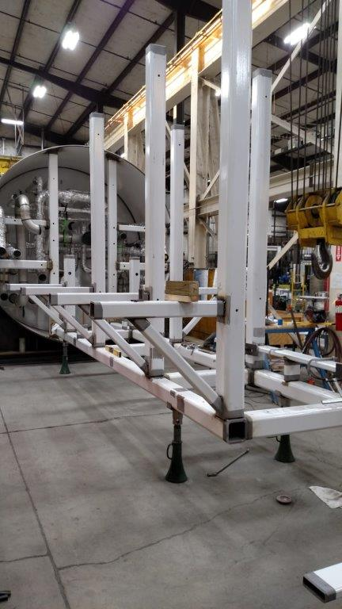

* + CP1 lower cold box shell painting is complete, Cold box nozzles have been prefabricated and will be welded to the shell next week after which the top of the cold box shell will be cut to further assembly of its internals. Piping spools fabrication continues. Vendor is 1 week behind schedule and is investigating schedule recovery options.

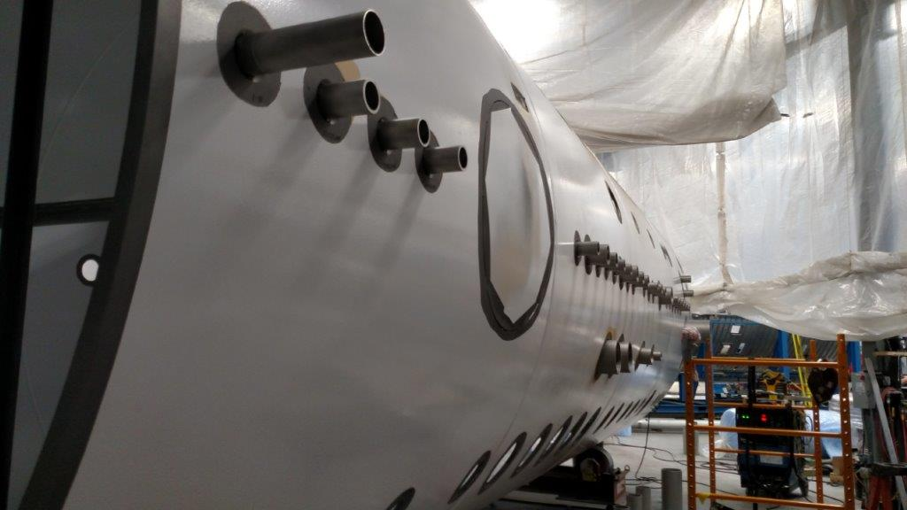

Work continued to complete the documentation submittals to SG and BIO for the cryoplant installation target date of June 15th.

2K Cold Box assembly FDR has been canceled due to PM request to modify the design for increased flow capacity.

Final stages of the two recovery compressor skids are nearing completion with electrical wiring underway. Scheduled delivery is for July 2017.

**QUALITY**

No Report.

**Upcoming Travel/Reviews:**

DOE Review, SLAC, June 13-15th 2017

JLab Director’s Review of Cryoplant Installation, June 1

FAC Review, SLAC, late July 2017 - tentative

Weekly Reporting

WBS 1.02.03.05.12 LLRF

Week of May 11-17, 2017

**Issues:** None

**Accomplishments this week at JLab:**

* LLRF Coordination/Documentation:
  + Heater: The FPGA board is in the process of being assembled. Front and back panels have been laid out and due back from the vendor in three weeks.
  + LLRF Production: On hold until we get more information from SLAC on the outside vendor costs.
  + BCS: We are discussing with SLAC about JLAB (Trent Allison) becoming the technical design lead for the cavity loss monitor system.
* Resonance/Stepper Motor Board/Chassis:
  + Stepper motor cables to the pCM were tested with the chassis.
  + PZT: Simple integrator was tested on the bench. A couple of bugs need fixing. Then it will be ready to track slow He drifts.
  + Test Bench: Procuring of parts (motors) for the test bench is ongoing. We are borrowing 4 motors because of the cost. Looking at encoders for stepper motor continues.
  + Design Freeze: We had meeting last week to review production modifications and freeze the design for the FDR.
* Interlock Board/Chassis:
  + Test bench: Investigating using existing ADCs or looking for a commercial solution continues …slowly
  + Making production modifications to the pc boards … 8 channels FEP
* Common Power Supply/Chassis/Boards:
  + Power Distribution Chassis: We held a design freeze meeting last week on the PS chassis. Meeting notes have been sent out the LLRF team.
  + Gun Power Distribution Board: It is waiting to be tested.
  + Gun/Buncher PS Chassis: The chassis is being assembled.
* CMTF
  + PRC/RFS: Garth and George are working on installing the PRC and RFS software on the JLAB server.
  + LLRF Tests: Some simple tests to verify the resonance and interlock chassis will be done this week.

**Upcoming Activities:**

* Prepare for DOE Review.
* pCM warm up at the end of the week.
* Interlock chassis design freeze meeting next week.
* LLRF FDR the week of June 19.