Weekly Reporting

WBS 1.01.07 JLAB Management

Week of May 25-31, 2017

**Issues:**

**Accomplishments this week:**

Preparing for DOE review

Preparing for Cryoplant Installation Design Review.

Adding the conceptual design of the BCS system to the LLRF effort.

SOTR and procurement trip to EZ, cavity vendor. Things looked good.

Collecting month end progress.

**Upcoming Activities:**

JLAB LCLS-II CP Installation Package, Director’s Progress Review 1 June 2017

Collaboration Meeting 12 June 2017

DOE Status Review at SLAC 13-15 June 2017

SRF 2017 in China July 17-21, 2017

FAC at SLAC July 25-27, 2017 (Tentative)

Weekly Reporting

WBS 1.04.6 JLAB Cryomodules

Week of May 25-31, 2017

**Issues:** Impact on cryomodule assembly schedule due to design changes and parts availability associated with microphonics.

**Accomplishments this week:**

Presented BCR to fabricate 18 cavities at RI from material that EZ had on hand at CCB. It was approved.

Presented BCR for HOM BLA including updated schedule and cost at CCB on Thursday. It was approved.

A planned CTF interruption for commissioning of the new CTF cold box began 22-May and is schedule to end by 4-June. Good progress is being made with the new cold box.

Reviewed revised estimate for using LERF for CM testing in advance of DOE review. Discussed proposal at Lab planning and coordination meeting. Lab management will provide input on cost estimates in about one week.

Cavity Status

Continuing with vendor on-site support at Zanon. Four bare rework cavities have arrived at JLab. These are category 4 & 5 cavities. First four dressed cavities will ship from Zanon on 01-June. Two more shipments of four are planned for June. Three shipments of four are planned for July.

RI is making good progress and is continuing to ship cavities. Hold Point 1 thru CAV0124 except 115, 116 & 123, Hold Point 2 thru CAV0117 with several exceptions and Hold Point 3 thru CAV0094 + 98 & 104.

Upcoming RI Shipments

2-Jun CAV0103, CAV0108, CAV0110, CAV0111 FNAL

7-Jun CAV0109, CAV0112 JLab

7-Jun CAV0087, CAV0088, CAV0089, CAV0090 JLab

20-Jun CAV0097, CAV0113, CAV0114, CAV0117 FNAL

23-Jun CAV0099, CAV0100, CAV0101, CAV0102 JLab

30-Jun CAV0105, CAV0118, CAV0119, CAV0120 FNAL

pCM Status

Planning to begin cooldown on 8-June in order to focus on Qo procedure development and 8-channel RF operations. Testing duration between two to four weeks.

Production Status

CM-02 (currently at WS5):

Complete and ready for installation into CMTF at completion of pCM testing.

CM-03 (currently at WS3):

Tuner Installation is complete. Magnet voltage taps installation is complete. MLI installation in progress. Conducting magnetic hygiene pass prior to shield installation.

CM-04 (currently at WS2:

Completed activities at WS2. Planned for move to WS3 on 01-Jun.

CM-05

Cavity string is assembled and undergoing leak-check. Rollout from cleanroom scheduled for Friday 02-June.

CM-06 Cavity Testing

Four cavities qualified at DESY are planned for string 06. These four are enroute from RI to JLab.

Cavity 082 was retested, previously field emitted at 16 MV/m, and field emitted at 5 MV/m. Disassembly and inspection to follow.

CM-07 Cavity Testing

Final test cycle (four cavities) was completed during May at DESY. All four cavities have low Q0 – PCCM is discussing further testing options.

Received vacuum vessel and cold mass assembly on 30-May.

**QUALITY**

Preparing to submit the monthly SNCR dashboard to SLAC.

Providing support with Task Hazard Analysis (THA) and Operational Safety Procedure (OSP) on the new demagnetization equipment.

**Upcoming Travel:**

E. Zanon Vendor Oversight May 30-Jun 10 (A. Palczewski)

SRF 2017 Lanzhou, China July 17-22 (A. Palczewski, C. Reece, N. Huque, L. Zhao, V. Bookwalter, G. Cheng)

WXCX Vendor Visit July 24-28 (Cheng, Fischer)

Weekly Reporting

WBS 1.04.08 JLAB Cryoplant System

Week of May 25-31, 2017

**Issues:**

**Accomplishments this week:**

Work continued to address the recommendations of the Director’s Review inclusive of recommendation #32 (JLab Director’s Review of the Cryoplant Installation Design Completion.) The recommendation called for a review of the resources and schedule to complete the JLab portion of the cryoplant. The review committee, committee charge, and agenda have been developed. The review will be held at JLab on June 1st.

Work continued to complete the drawings to be delivered to Smith Group for completion of the cryoplant installation GC installation. Status of the documentation was presented as part of the weekly CP/CDS weekly meeting.

One additional CP1 LP warm helium compressors is scheduled for delivery after Memorial Day with the final CP1 MP warm helium compressor scheduled for ~ 1 week later .

4.5K Cold Box

* + CP1 Upper cold box heat exchangers HX-1 and HX-2 have been mounted on the cold box internal structure. HX-3 is in the process of being mounted using CP2 HX-3. Bruce Lenzer will witness mounting at PHPK on June 7th.
  + The missing seismic analysis appendix was delivered to JLab. Work continues to close out the 4.5K Cold Box FDR action items.
  + 80% of the nozzle for the CP1 LCB has been completed.

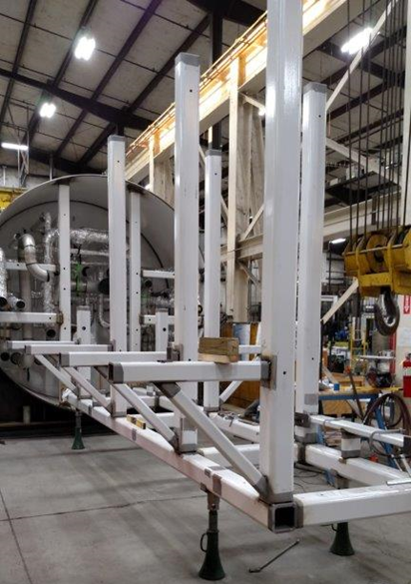

Heat Exchanger Mounting Frame

Work continued to complete the documentation submittals to SG and BIO for the cryoplant installation target date of June 15th. Status of the documentation was presented in the CP/CDS weekly status meeting.

Two recovery compressor skids remain on scheduled delivery for July 2017.

**QUALITY**

Preparing for the Director’s Progress Review on Cryoplant Installation on June 1 2017 at JLab.

Mike Skonicki is visiting JLab on May 31 ahead of the Director’s Progress Review to look at JLab’s review and approval process for the design drawings related to CryoPlant Installation.

Bruce Lenzer will visit PHPK on June 7th to witness mounting of the 4.5K CP1 UCB heat exchangers.

A trip to witness 2k cold compressor housing and 4.5K cold box turbine testing is being planned for week of July 7th.

**Upcoming Travel/Reviews:**

JLAB Director’s Review of LCLS-II CP Installation Package, Director’s Progress Review 1 June 2017

DOE Review, SLAC, June 13-15th 2017

CP Installation Package FDR July 17

FAC Review, SLAC, late July 2017 - tentative

Weekly Reporting

WBS 1.02.03.05.12 LLRF

Week of May 25-31, 2017

**Issues:** None

**Accomplishments this week at JLab:**

* LLRF preparing for pCM 2nd retest.
* Completed DOE Review LLRF presentation.
* Discussed JLAB participation in the LCLSII BCS design with Joe Delong.

**Upcoming Activities:**

* Prepare for DOE Review
* LLRF FDR the week of June 19