Weekly Reporting
WBS 1.01.07 JLAB Management
Week of June 8-14, 2017

Issues:

Accomplishments this week:
Prepared and reviewed presentations for the DOE review
Attended LCLS-II Collaboration Meeting at SLAC
Attended DOE review at SLAC
Began cooldown of pCM in the CMTF

Upcoming Activities:
SRF 2017 in China July 17-21, 2017
FAC at SLAC July 25-27, 2017 (Tentative)

Weekly Reporting
WBS 1.04.6 JLAB Cryomodules
Week of June 8-14, 2017

Issues: Impact on cryomodule assembly schedule due to design changes and parts availability associated with microphonics.
Accomplishments this week:
Participated in Collaboration meeting and DOE OPA review at SLAC.
Preparing EAC for close-out of 1.4.06.05 Engineering and Design control account.

Reviewed revised estimate for using LERF for CM testing in advance of DOE review. Discussed proposal at Lab planning and coordination meeting. Awaiting input from Lab management that is due imminently.

Cavity Status
Completed focused full-time vendor on-site support at Zanon. Next visit is K. Wilson in mid-July.

RI is making good progress and is continuing to ship cavities.

Cavity 067 was shipped to FNAL for additional testing along with four cavities (084, 092, 262 and 263) from JLab to FNAL in order to support their production schedule for June/July during their planned VT cryoplant down.

pCM Status
pCM was cooled down over the weekend and pumped down to 2K on Monday. Tuners were set to frequency. Initial Qo measurement evaluations have begun.

Production Status
CM-02 (currently at WS5):
Complete and ready for installation into CMTF at completion of pCM testing. Degaussed bayonet box gate valve to ensure good magnetic hygiene.

CM-03 (currently at WS4):
Moved to WS4 on 9-June. Installing MLI onto shield.

CM-04 (currently at WS3):
Helium lines welding in progress. Instrumentation in progress.

CM-05 (currently at WS2)
Two-phase piping in progress. SC magnet was installed. Noted alignment issue between magnet and spool that was resolved.

CM-06 Cavity Testing
Four cavities qualified at DESY are planned for string 06. These four are in receiving inspection at JLab. String assembly has been re-scheduled to start on 26-June due to lack of qualified cavities.

Cavities 094 did not qualify because the HOMs were not tuned prior to cooldown. This cavity will be re-tested next week. Dewar 5 (three cavities test stand) was cooled down successfully. Cavity 209 also missed the hom tuning step prior to cooldown. Cavity 225 had a cold leak and was not testable. Cavity 082, currently on dewar 5, will test 14-June. Plan to use D7 and D8 to test 094, 104, & 264. The D5 test stand should pull on Monday; we can decide then whether to repopulate D5 or test more in D7 & D8.

CM-07 Cavity Testing
No update. Final test cycle (four cavities) was completed during May at DESY. All four cavities have low Q₀ – PCCM is discussing further testing options.

QUALITY
Participate in Collaboration meeting and OPA reviews at SLAC week of June 12.

Preparing to visit cavity vendors to conduct QA audit.

Upcoming Travel:
QA audit of cavity vendor RI June 29 – June 30 (J. Leung)
QA audit of cavity vendor Zanon July 3 – July 4 (J. Leung)
E. Zanon Vendor Oversight July 17-21 (K. Wilson)
SRF 2017 Lanzhou, China July 17-22 (A. Palczewski, C. Reece, N. Huque, L. Zhao, V. Bookwalter, G. Cheng)
WXCX Vendor Visit July 24-28 (Cheng, Fischer)
E. Zanon Vendor Oversight August 2017 (H. Park)

Weekly Reporting
WBS 1.04.08 JLAB Cryoplant System
Week of June 8-14, 2017
Issues:
Accomplishments this week:
Participated in the LCLS-II DOE Project Review conducted at SLAC. Presentations included the cryoplant design and production status.

Work continued to complete the drawings to be delivered to Smith Group for completion of the cryoplant installation.

4.5K Cold Box
  - CP1 Upper cold box heat exchangers HX-1 and HX-2 have been mounted on the cold box internal structure. HX-3 is in the process of being mounted using CP2 HX-3. Bruce Lenzer along with Eric Fauve witnessed the mounting at PHPK on June 7th.
  - Pressure testing of some of the CP1 upper cold box pressure vessels were witnessed by JLab during the assembly process.
  - The missing seismic analysis appendix was delivered to JLab. A closeout of the remaining 4.5K cold box deliverables was held on June 8th with SLAC project management, JLab/SLAC engineers, and Alatus management.
  - 80% of the nozzle for the CP1 LCB has been completed.
  - AL/PHPK currently investigating manpower resources till end of delivery to avoid future projected schedule delays should the weekly assembly shop hours be decreased as proposed by PHPK.

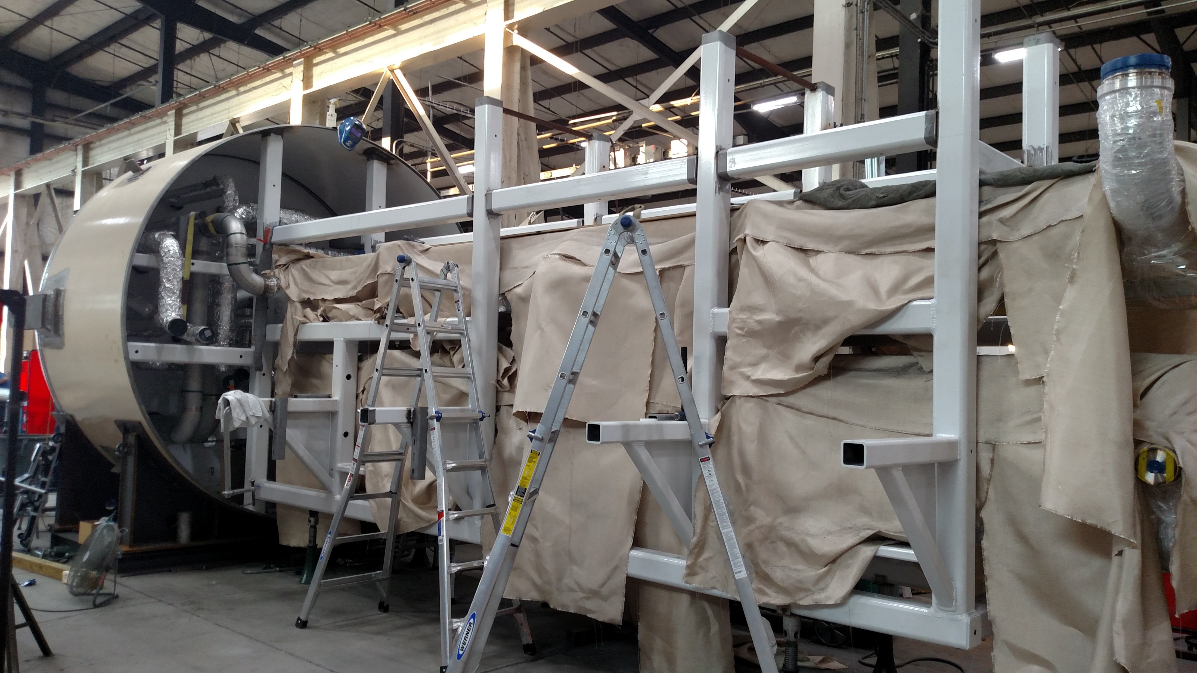
CP1 Upper Cold Box Heat Exchanger Mounting

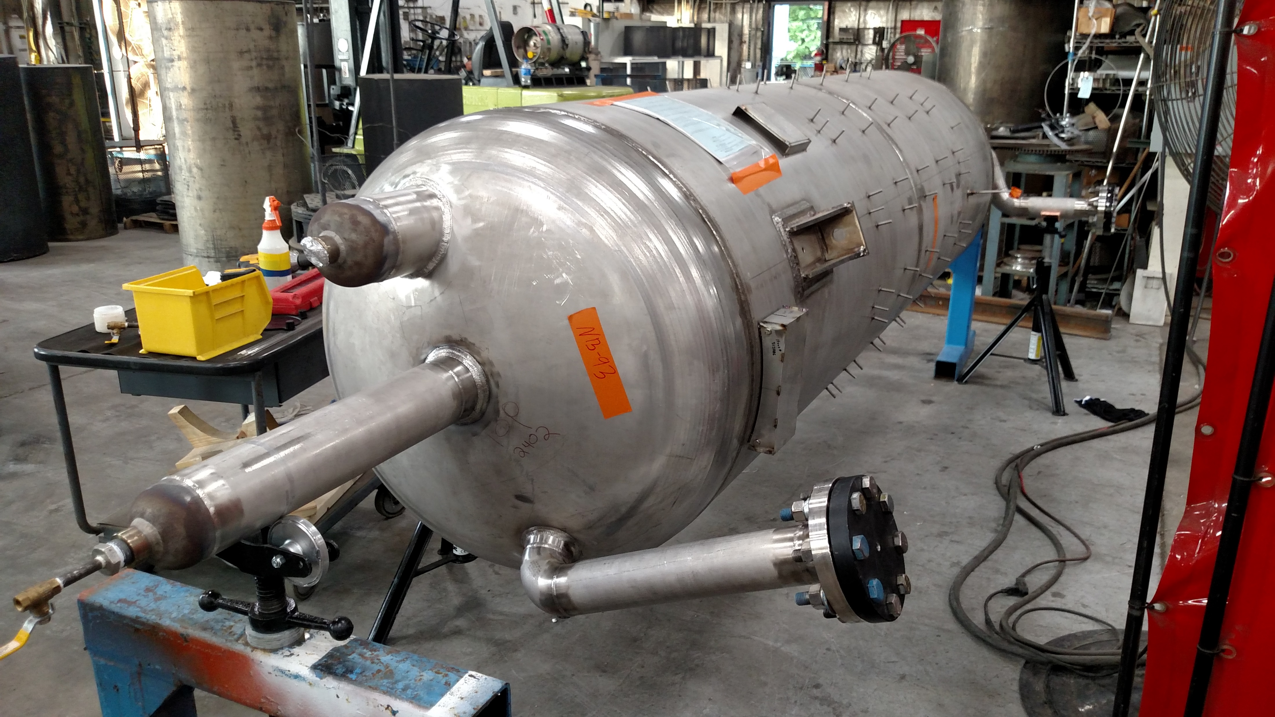
CP1 Upper Cold box Vessels Being Prepared for Pressure Testing.

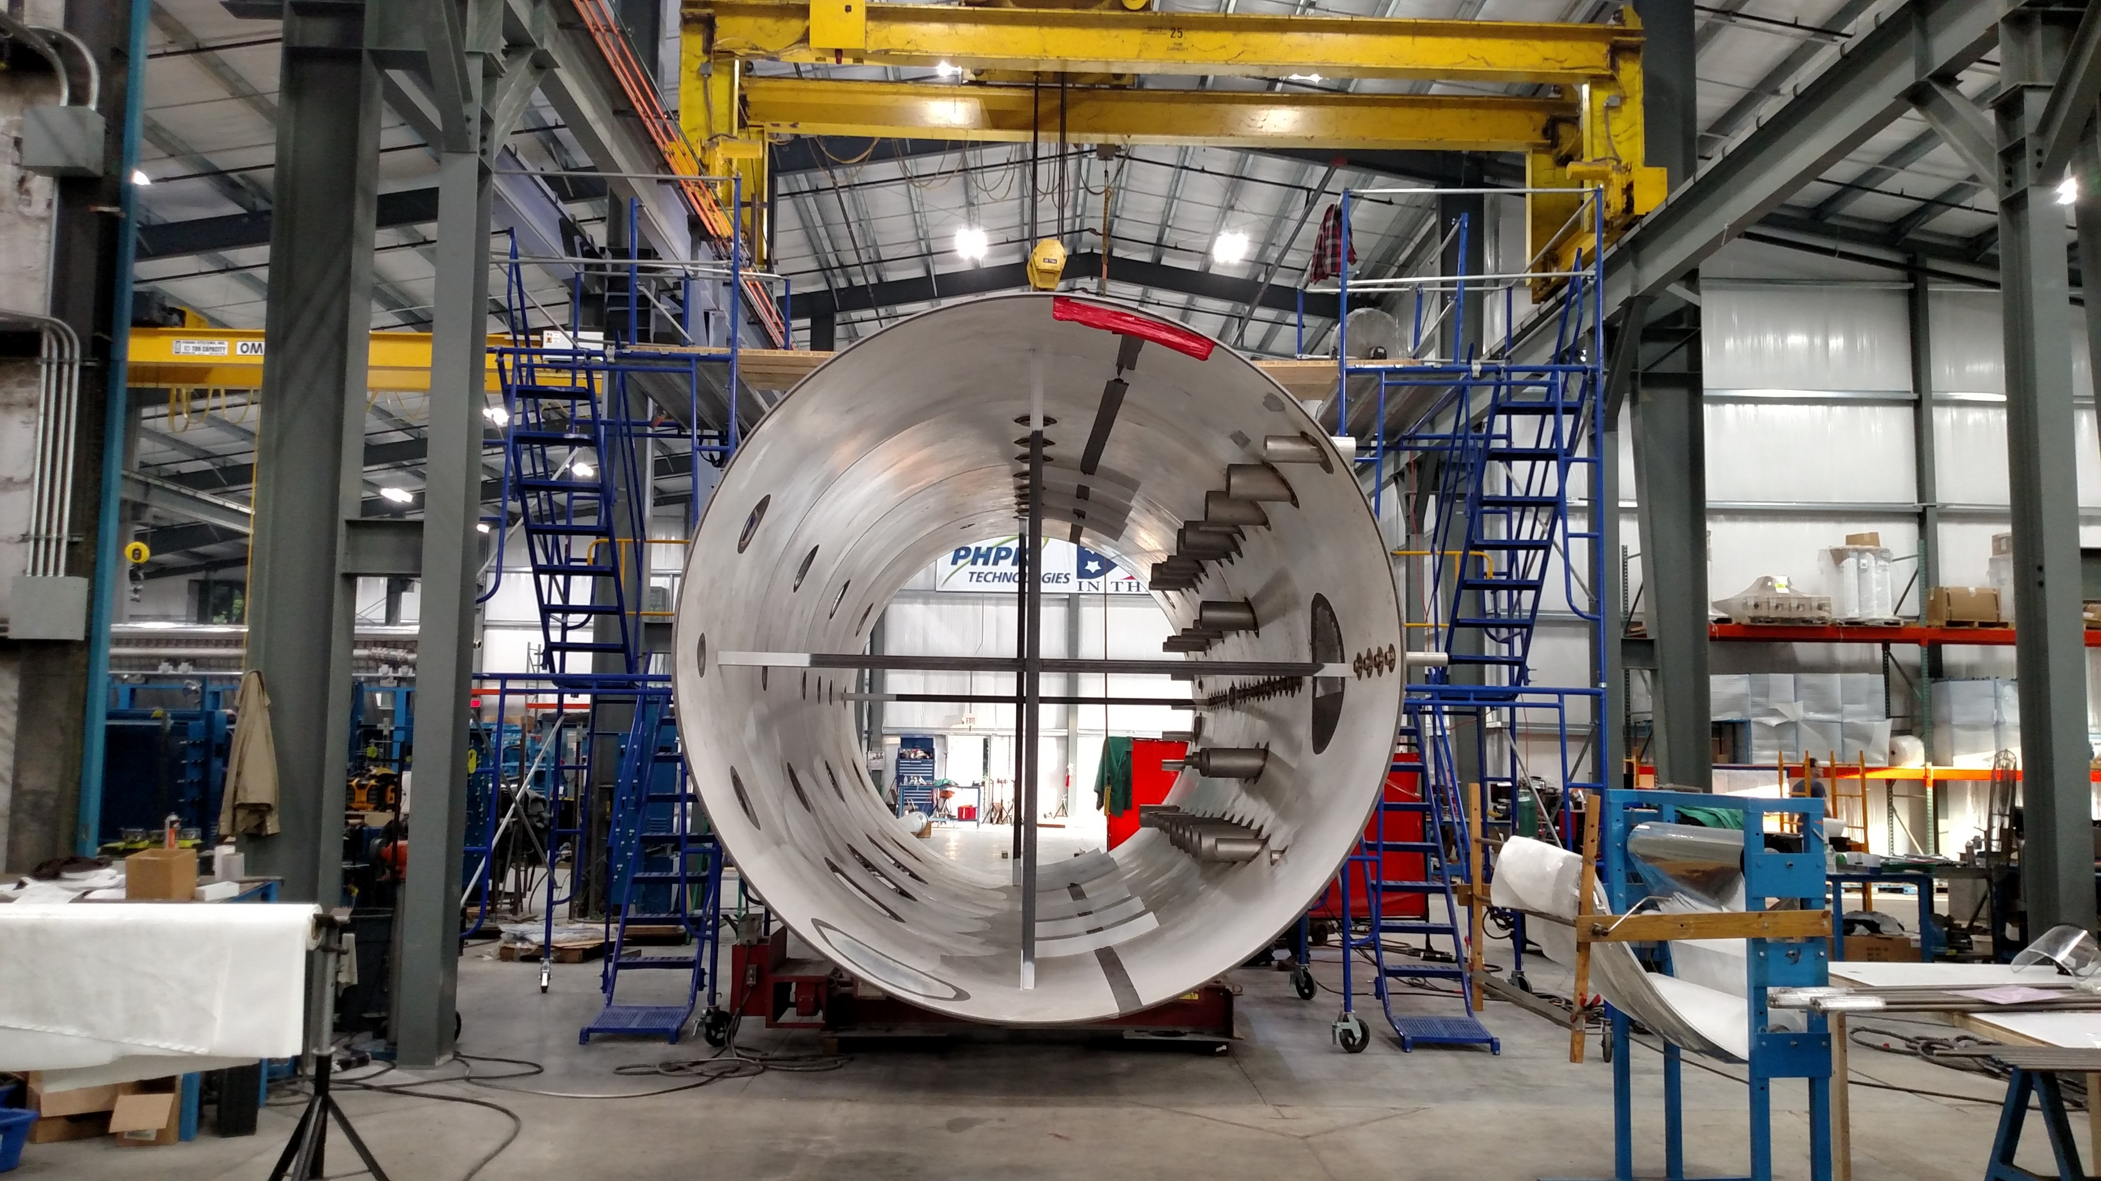
CP1 Lower Cold Box Staged for Internal Piping Assembly.

Warm Helium Gas Storage Vessels
- Coordination of storage vessel delivery in the later part of June and July has begun with SLAC. Documentation for seismic anchoring and vessel pressure design was received from the vendor for BIO review.

Two recovery compressor skids:
- Remaining on schedule for delivery in July 2017. Final electrical assembly is underway.

Ambient Air Vaporizers
- Shipment schedule to SLAC tentatively set for 2nd week of July.

QUALITY

Bruce Lenzer visited PHPK on June 8th to witness the mounting and assembly of the heat exchangers to the 4.5K Cold Box.

Participate in Collaboration meeting and OPA reviews at SLAC week of June 12.

Continue to provide support and discussion with CP Installation drawing approval process.

Bruce Lenzer visited PHPK on June 8th to witness the mounting and assembly of the heat exchangers to the 4.5K Cold Box.

Upcoming Travel/Reviews:
CP Installation Package FDR July 13-14 - Tentative
Vendor Visit to Air Liquide Sassenage, France July 17-21 (D. Arenius & T. Peshehonoff) to witness cold compressor housing pressure testing and 4.5K cold box turbine run tests.

Weekly Reporting
WBS 1.02.03.05.12 LLRF
Week of June 8-14, 2017
Issues: None
Accomplishments this week at JLab: No report this week; participating in DOE Status Review.

Upcoming Activities:
- LLRF FDR moved to the end of July.

