Weekly Reporting

WBS 1.01.07 JLAB Management

Week of June 15-21, 2017

**Issues:**

**Accomplishments this week:**

Attended DOE review at SLAC

Continued testing pCM in the CMTF

Delivered the last of six warm helium compressors for CP1 to SLAC

**Upcoming Activities:**

SRF 2017 in China July 17-21, 2017

FAC at SLAC July 25-27, 2017 (Tentative)

Weekly Reporting

WBS 1.04.6 JLAB Cryomodules

Week of June 15-21, 2017

**Issues:**

**Accomplishments this week:**

Participated in DOE OPA review at SLAC.

Preparing EAC for close-out of 1.4.06.05 Engineering and Design control account.

Preparing BCR form for additional PICs to support cavity deliveries.

Developing schedule and cost for four additional cryomodules.

LERF CM testing proposal – still awaiting input from Lab management that is due imminently.

Cavity Status

Zanon production status - hold point 1 for CAV256 – CAV297 except 285 (NCR, grinding), hold point 2 for CAV256 – 281 except 276 & 280 and hold point 3 for CAV256 – 269 except 266 & 268. Eight cavities are planned for shipment before the end of June.

RI is making good progress and is continuing to ship cavities. Production status - hold point 1 thru CAV0133, hold point 2 thru CAV0121 with several exceptions and hold point 3 thru CAV0117 with several exceptions. Remaining 28 cavities are planned to arrive before the end of July.

pCM Status

pCM testing focused on repeating Qo measurements with some procedural improvements to pressure-rise method. Completed measurements on all eight cavities. Conducted gradient calibration studies. Conducted initial Qo measurements using steady flow technique. Ramped all eight cavities and controlled in SEL mode while studying cryogenic system response.

Production Status

CM-02 (currently at WS5):

Complete and ready for installation into CMTF at completion of pCM testing.

CM-03 (currently at WS4):

Moved to WS4 on 9-June. Completed installing MLI onto shield, installed cold mass into VV and completed alignment.

CM-04 (currently at WS3):

Invar rods and stops installed. Needle bearings in place. Gate valve support installed.

Cavity string transferred to cold mass and lollipops returned to clean room.

CM-05 (currently at WS2)

Fiducialization complete. RF acceptance tests complete. Magnet installed and aligned. Berry bolts and 2 phase pipes in progress.

CM-06 Cavity Testing

A sixth cavity was qualified. String assembly has been re-scheduled to start on 26-June due to lack of qualified cavities. Roll-out scheduled for 7-July.

It was a notable week as a total of six cavity tests were conducted including three in dewar 5. Five more tests are planned by COB Friday 23-June.

Cavity 094 (TD) qualified after its initial test. Results Q(16)=3.5e10 with quench at 20 MV/m with no FE.

Cavity 104 (NX-A) did not qualify due to low Qo. Results Q(16)=2.2e10 with quench at 23.8 MV/m with no FE.

Three cavities tested in dewar 5. Cavity 225 (TD) did not qualify, previously field emitted. Results Q(16)=1.8e10 with quench at 19.5 MV/m and FE onset at 15.5 MV/m. Cavity will be re-rinsed. Two other tests were aborted due to cable problems (082) and mis-tuned HOMs (209).

Cavity 264 (restart) did not qualify on its initial test due to FE onset at 12 MV/m. Results Q(16)=3.3e10 with Emax at ~23 MV/m. Cavity will be re-rinsed and re-tested.

CM-07 Cavity Testing

No update. Final test cycle (four cavities) was completed during May at DESY. All four cavities have low Q0 – PCCM is discussing further testing options.

**QUALITY**

Participated in Collaboration meeting and OPA reviews at SLAC week of June 12.

Preparing to visit cavity vendors to conduct QA audit.

Participated in the discussions with Fermilab on copper plated components.

**Upcoming Travel:**

QA audit of cavity vendor RI June 29 – June 30 (J. Leung)

QA audit of cavity vendor Zanon July 3 – July 4 (J. Leung)

E. Zanon Vendor Oversight July 17-21 (K. Wilson)

SRF 2017 Lanzhou, China July 17-22 (A. Palczewski, C. Reece, N. Huque, L. Zhao, V. Bookwalter, G. Cheng)

WXCX Vendor Visit July 24-28 (Cheng, Fischer)

E. Zanon Vendor Oversight August 2017 (H. Park)

Weekly Reporting

WBS 1.04.08 JLAB Cryoplant System

Week of June 15-21, 2017

**Issues:**

**Accomplishments this week:**

Participated in the LCLS-II DOE Project Review conducted at SLAC. Presentations included the cryoplant design and production status.

Work continued to complete the drawings to be delivered to Smith Group for completion of the cryoplant mechanical piping installation.

Submitted the electrical and controls deliverables to the Smith Group for incorporation into the GC Installation Package.

The sixth and final warm helium compressor for CP1 was delivered to SLAC.

Warm Helium Gas Storage Vessels

* Received updated drawings and calculations from the vendor.

**QUALITY**

Participated in Collaboration meeting and OPA reviews at SLAC week of June 12.

Conducting progress checks on QA/QC documentation & Inspection Test Plans for 4.5K Cold Box subcontract.

**Upcoming Travel/Reviews:**

CP Installation Package FDR July 13-14

Vendor Visit to Air Liquide Sassenage, France July 17-21 (D. Arenius & T. Peshehonoff) to witness cold compressor housing pressure testing and 4.5K cold box turbine run tests.

Weekly Reporting

WBS 1.02.03.05.12 LLRF

Week of June 15-21, 2017

**Issues:** None

**Accomplishments this week at JLab:**

* LLRF Coordination/Documentation:
  + Heater: The FPGA board is assembled and waiting for testing.
  + LLRF Production Estimate: Received SLAC vendor estimate. We are now assembling the costs (space, labor, etc.) for producing the LLRF system at JLAB. We plan to present the different options and costs to JLAB leadership at the end of July.
  + BCS: Trent sent SLAC an estimate for the conceptual design. A teleconference was held last week to review the effort.
* Resonance/Stepper Motor Board/Chassis:
  + CMTF Resonance Tests: Installed EPICS interface for the piezo controls. The plan is to test a single channel this week.
  + Install the remaining piezo cables for cavity tests by early next week to support eight cavity GDR run.
* Interlock Board/Chassis:
  + No activity.
* Common Power Supply/Chassis/Boards:
  + Modified an existing PS chassis for the new distribution board. We then tested it using 6 electronic loads See picture (below in Figure 1). The design looks good.
  + Gun/Buncher PS Chassis: Should be able to start on this power supply later this week. Both of the small PS distribution boards have been delivered to LBNL and SLAC.
  + 1.3 GHz Power Supply Chassis: We are building 6 more chassis. This will include the recent production mods. SLAC has completed the wiring diagram, the chassis hole pattern and front/back panel modifications. SLAC has ordered 12 front and back panels for the new PS Chassis
* CMTF
  + PRC/RFS: Ordered a new rack to house the LCLSII LLRF chassis. In addition we have ordered two computers and monitors for the EPICS interface. No word yet on a delivery/install date.
  + Preparing for extended pCM tests.

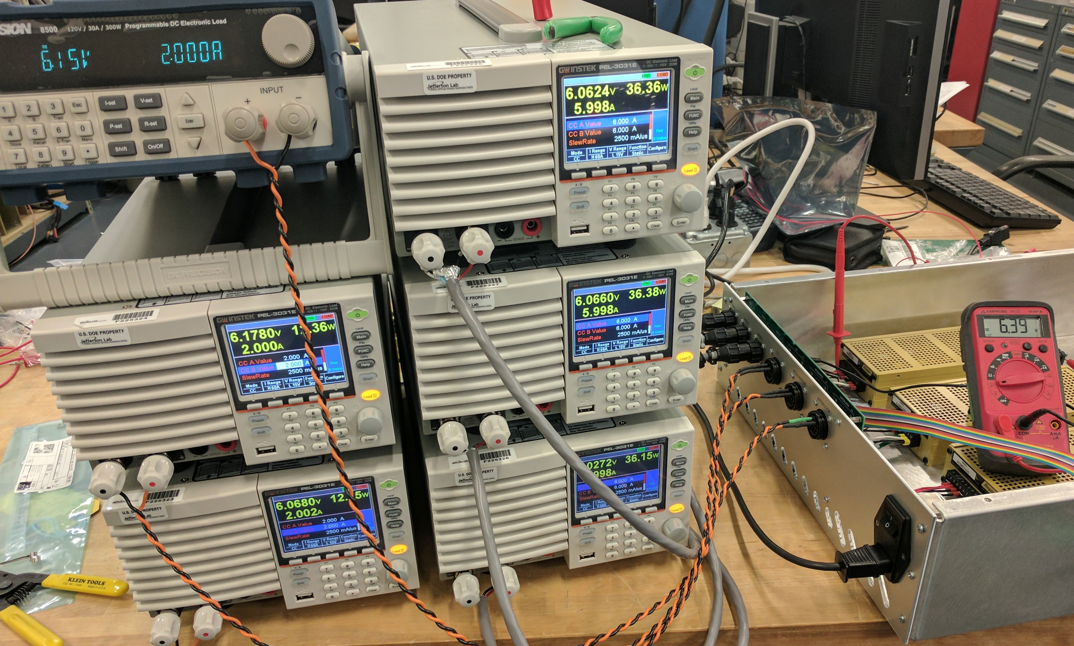

Figure 1: LCLSII Power Supply Chassis being tested under load.

**Upcoming Travel/Reviews:**

* LLRF FDR moved to the end of July.