Weekly Reporting

WBS 1.01.07 JLAB Management

Week of July 20-26, 2017

**Issues:**

**Accomplishments this week:**

Conducted 1.04 Performance Review.

CP CAM visited Air Liquide to witness cold compressor housing pressure testing and 4.5K cold box turbine run tests.

Continued planning efforts regarding CM testing in LERF.

Preparing 4.5K CB Mods BCR and 2+2 CMs BCR.

**Upcoming Activities:**

CP Controls Review August 30, 2017

FAC at SLAC September 2017

Weekly Reporting

WBS 1.04.06 JLAB Cryomodules

Week of July 20-26, 2017

**Issues**: Expect delays in cavity shipments due to lack of availability of PICs.

**Accomplishments this week:**

Continuing to develop BCR schedule and cost for four additional (2+2) cryomodules and schedule adjustment.

LERF CM testing proposal – Presented proposal to Lab Director for internal review that was accepted with some schedule adjustments. Planning for technical review of proposal with LCLS-II staff.

Planning to ship JLab pCM to FNAL for fast cooldown testing on 11-Aug.

Investigating ways to increase cooldown rate in CMTF (plumbing, plant ops). Met with Cryo Group at JLab to review proposed options. Have identified a method to bypass some of the piping to increase overall flow rate. Planning to build u-tubes and test method on CM03.

Cavity Status

RI - Hold Point 1 thru CAV0133 except 115; Hold Point 2 thru CAV0133 with several exceptions; Hold Point 3 thru CAV0131 with several exceptions.

Zanon - Hold point 1 for CAV256 – CAV302; Hold point 2 for CAV256 – 297; Hold point 3 for CAV256 – 283. K Wilson visited Zanon on 18-20 July to review cavity progress, discuss NCRs, and review shipping plans. Working on a list for rework cavities that specifies recovery steps.

Shipping from RI

Four cavities to FNAL on 21-July; Three cavities to JLab on 28-July; Three cavities to FNAL on 4-August; Four cavities to JLab on 9-August.

Shipping from Zanon

Four cavities to JLab on 21-July; Four cavities to FNAL on 3-August; Four to JLab on 8-August; Four to FNAL on 25-August.

First tests of NX-B with 950 deg C heat treatment planned for early next week (099, 101, 102). Bead pulls planned for cavity with worst pass band changes since HP#3 at RI.

pCM Status

Module is being prepared for shipment to FNAL. Checking GV alignment. End cap removal in progress. Seismic tie down holes being added to support brackets on VV.

Production Status

CM-02 (currently at CMTF):

CM is pumped down to 2K. Tuners have been tested. Cavities are on frequency. FPC Qexternals are being adjusted. Planning to run high power on 26-July in the evening.

CM-03 (currently at WS5):

Leak check two more warm couplers vacuum spaces for a total of 6 completed. Radiography on 2K piping completed. Instrumentation checks are in progress.

CM-04 (currently at WS3):

Tuners installation complete. Mag shields installation complete. Tubing restraints installed.

CM-05 (currently at WS3)

Two-phase pipe welding complete. Lollipop supports have been removed.

CM-06 (currently at WS2)

Two-phase pipe welding in progress. SC magnet installed.

CM-07

Cavity qualification testing in progress with four cavities qualified for string and one marginal cavity. Target date for string assembly is 7-August.

Six cavity tests conducted this past week.

Cavity 082, previously FE limited, rerinsed, Q(16)= 2.5e10; Admin limited to 24 MV/m, FE free. Cavity qualified for string 07.

Cavity 211, previously FE limited, rerinsed, Q(16)= 1.8e10; Quench 19.1 MV/m, FE free.

Noted Q0 rolloff. Cavity did not qualify and will be set aside.

Cavity 260 (TD) first test, Quench 15.2 MV/m, Q0(15)=2.9e10, FE free.

Cavity 261, first test, Q(16)= 2.3 e10; Admin limited 18 MV/m, FE free. Plan to recool and retest.

Cavity 268, first test, Q(16)= 2.3e10; Admin limited 18 MV/m, FE free. Plan to recool and retest.

Cavity 244, (bare Zanon rework 9-cell, retuned at Jlab to >95% field flatness, TD mat’l), Q(16)= 3.4e10; Quench 20.3 MV/m, FE free.

Vertical test planning

Cavities 260, 261 and 268 will be re-cooled down in D5. Re-testing will begin on 26 July.

**QUALITY**

Reviewing the updated information from SLAC on the new process for Equipment Transfer Verification.

On-going evaluation and data collection on SNCRs.

**Upcoming Travel:**

WXCX Vendor Visit July 24-28 (Cheng, Fischer)

E. Zanon Vendor Oversight August (D. Gonella), September 2017 (H. Park)

Weekly Reporting

WBS 1.04.08 JLAB Cryoplant System

Week of July 20-26, 2017

**Issues:**

**Accomplishments this week:**

Cryogenic plant #1 lower horizontal cold box shell has been split in readiness for internal piping and vessel assembly.

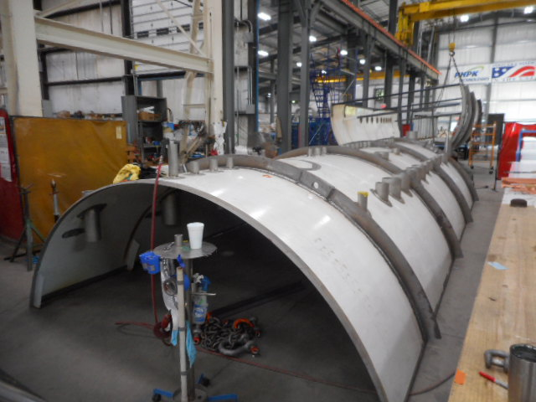

A 4.5K cold box Cryogenic Plant #1 turbine T1 run test was held on July 18 at the Air Liquide facility in Sassenage, France. The testing was performed with demonstration of cold/warm starting, variable speed brake, and operation with large variations of inlet/outlet pressures and temperatures at design conditions. The turbine passed all test requirements.

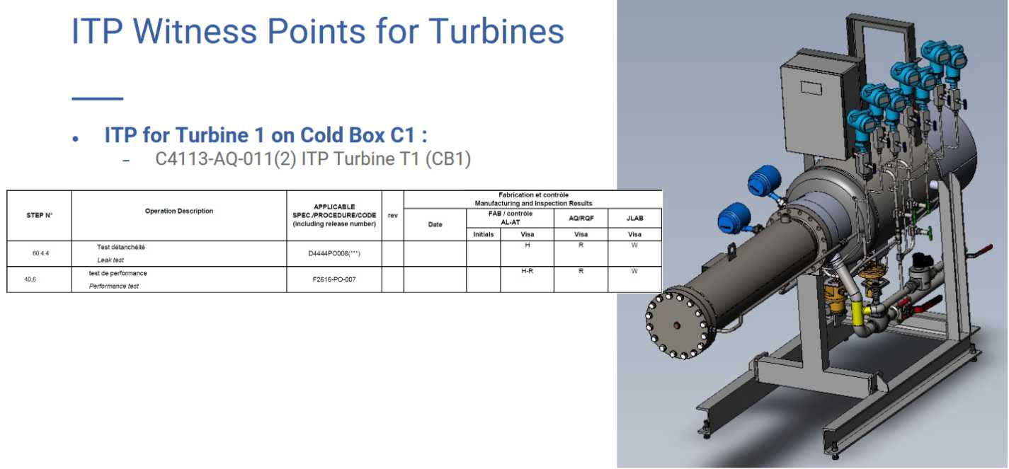

Leak and pressure testing of the Cryoplant #1 4.5K cold box turbine pods and cold compressor housings are underway and witnessed by JLab on July 19th for T1. Piping and instrument connection routing on the turbine pod was also conducted in accordance with the Process and Instrumentation diagram. All testing met all requirements.

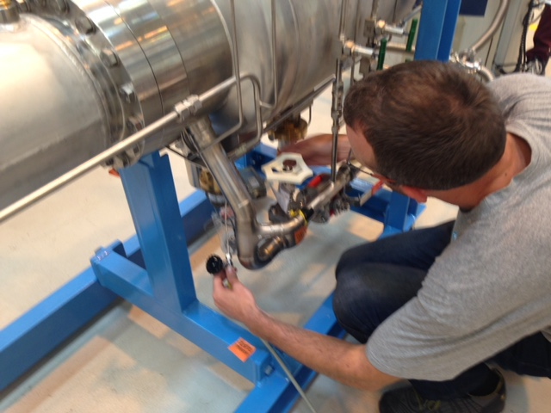

The 4.5K cold box turbine pods will be ready for shipment to SLAC in August 2017. Turbine cartridges will be stored at the vendor location until the 4.5K cold box reassembly begins.

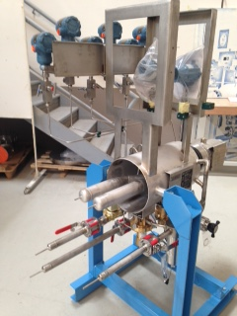

Turbine 4 Pod.

Assembly work continued to complete Cryoplant #1 Upper 4.5K cold box with additional interconnecting piping installation

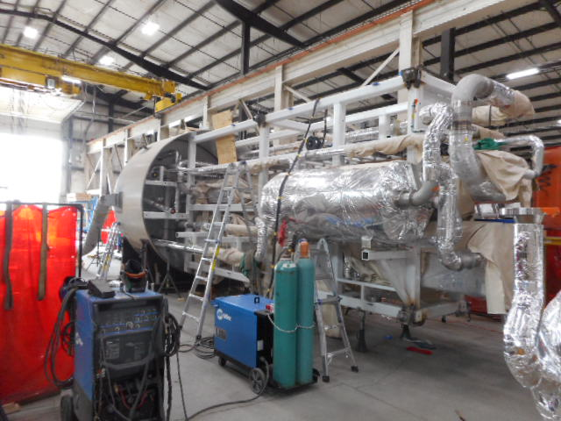

Upper 4.5K Cold Box Installation Piping

**QUALITY**

Met with Bruce Lenzer and Jarrod to discuss 4.5K Cold Box vendor documents and Inspection and Test Plans (ITPs).

**Upcoming Travel/Reviews:**

CP Controls Specification Review August 30, 2017

Weekly Reporting

WBS 1.02.03.05.12 LLRF

Week of July 20-26, 2017

**Issues:** None

**Accomplishments this week at JLab:**

* At SLAC to participate in the LLRF FDR.