Weekly Reporting
WBS 1.01.07 JLAB Management
Week of August 24-30, 2017

Issues:
Accomplishments this week:
Conducted 1.04.06 and 1.04.08 Progress Updates.
Began cool down of CM03 in the CMTF.
Arranging a meeting between ALATUS, JLab and SLAC.
Draft report of the inventory inspection activities at PHPK is under review.
Upcoming Activities:
CP Controls Review September 13, 2017
FAC at SLAC September 26-28, 2017

Weekly Reporting
WBS 1.04.06 JLAB Cryomodules
Week of August 24-30, 2017, 2017

Issues: Need to define additional cavities (133) procurement strategy.
Accomplishments this week:
LERF - planning internal meetings for 8-September and kick-off for 14-September with LCLS collaboration.
2+2 CM procurement BCR is in preparation.
Preparing BCR for fabrication of 133 replacement cavities.
Presented rework strategy at PCCM. 25 tanked cavities require rework and 30 bare cavities require rework. Awaiting response from Zanon on rework costs.
Planning to purchase additional split rings (50 each) to support additional cavity deliveries.
pCM (J1.3-1) at FNAL where it is being prepared for testing after F1.3-4.
CM02 – HOM tuning complete. Plan to move to temporary storage location.
CM03 at CMTF: Preparations for cooldown starting 30-Aug. All HOMs are tuned within specifications.
CM04 at WS-4: HOM’s re-tuned. Mu metal HOM covers going back on. Installing shields.
CM05 at WS-3: Magnet lead soldering complete. Alignment in progress.
CM06 at WS-3: Moved to WS3. String mated to UCM.
CM07 at WS-2: Magnet installed. Two-phase pipe assembly in progress.
CM08: Six cavities qualified; Cavity 099 marginal, quenched at 18.8 MV/m. Fifteen cavities in-house are candidates for vertical testing or rework/retesting. String build start date 11-Sep, gated by qualified cavities and return of string tooling.
Cavity 270 (TD) – first test in D8; Admin limited at 24 MV/m; Q0(16)=3.4e10; FE free. Qualified for string 8.
Cavity 261 (TD) – second test in D7, re-test (failed Q0 in D5); Admin limited at 24 MV/m; Q0(16)=3.1e10; X-ray onset 21.2MV/m; Qualified for string 8.
Cavity 102 (NX-B950) – second test in D8, re-test after HPR (fast vented after first test); Quenched at 21 MV/m; Q0(16)=4.0e10; FE free; Qualified for string 8.
Future cavity test plans - 272 (TD) re-test in D7 (failed FE@16MV/m), 130,131,133 (all NX-C) first test in D5, 289 (NX-A) first test in D8, 238 (R&D bare 9-cell) first test in D7. Conducting D5 low Q0 investigation.
CMTF warm, new Cold Box #3 back online.
CMTF cool down may change cavity test plan.
QUALITY:
Officially turned over QA duties to Stephen Smith. SLAC and FNAL have been informed. Goal is to have a full time replacement person by December.

Continue to monitor SNCR development for the Dashboard reporting to SLAC.

Participated in the LCLSII cryomodule HOM evaluation discussions.

Upcoming Travel:
E. Zanon Vendor Oversight August (D. Gonella), September 2017 (C. Reece)
FNAL for preparations for pCM testing (R. Legg)
LERF Kick-Off 14 or 15 September TBC at JLab (K. Jordan, C. Hovater)
FAC at SLAC 26-28 September - TBD

Weekly Reporting
WBS 1.04.08 JLAB Cryoplant System
Week of August 24-30, 2017
Issues:
Accomplishments this week:
Members of the JLab/SLAC engineering team visited the 4.5K cold box subcontractor to assess the shop progress status on August 23rd. Cryoplant #1 Upper Cold box piping assembly is complete. Instrument and heater power wiring is underway followed by piping leak checking. Process line routing and instrumentation location checking indicates correct assembly. The lower CP1 Upper Cold Box Vacuum Shell is in painting.

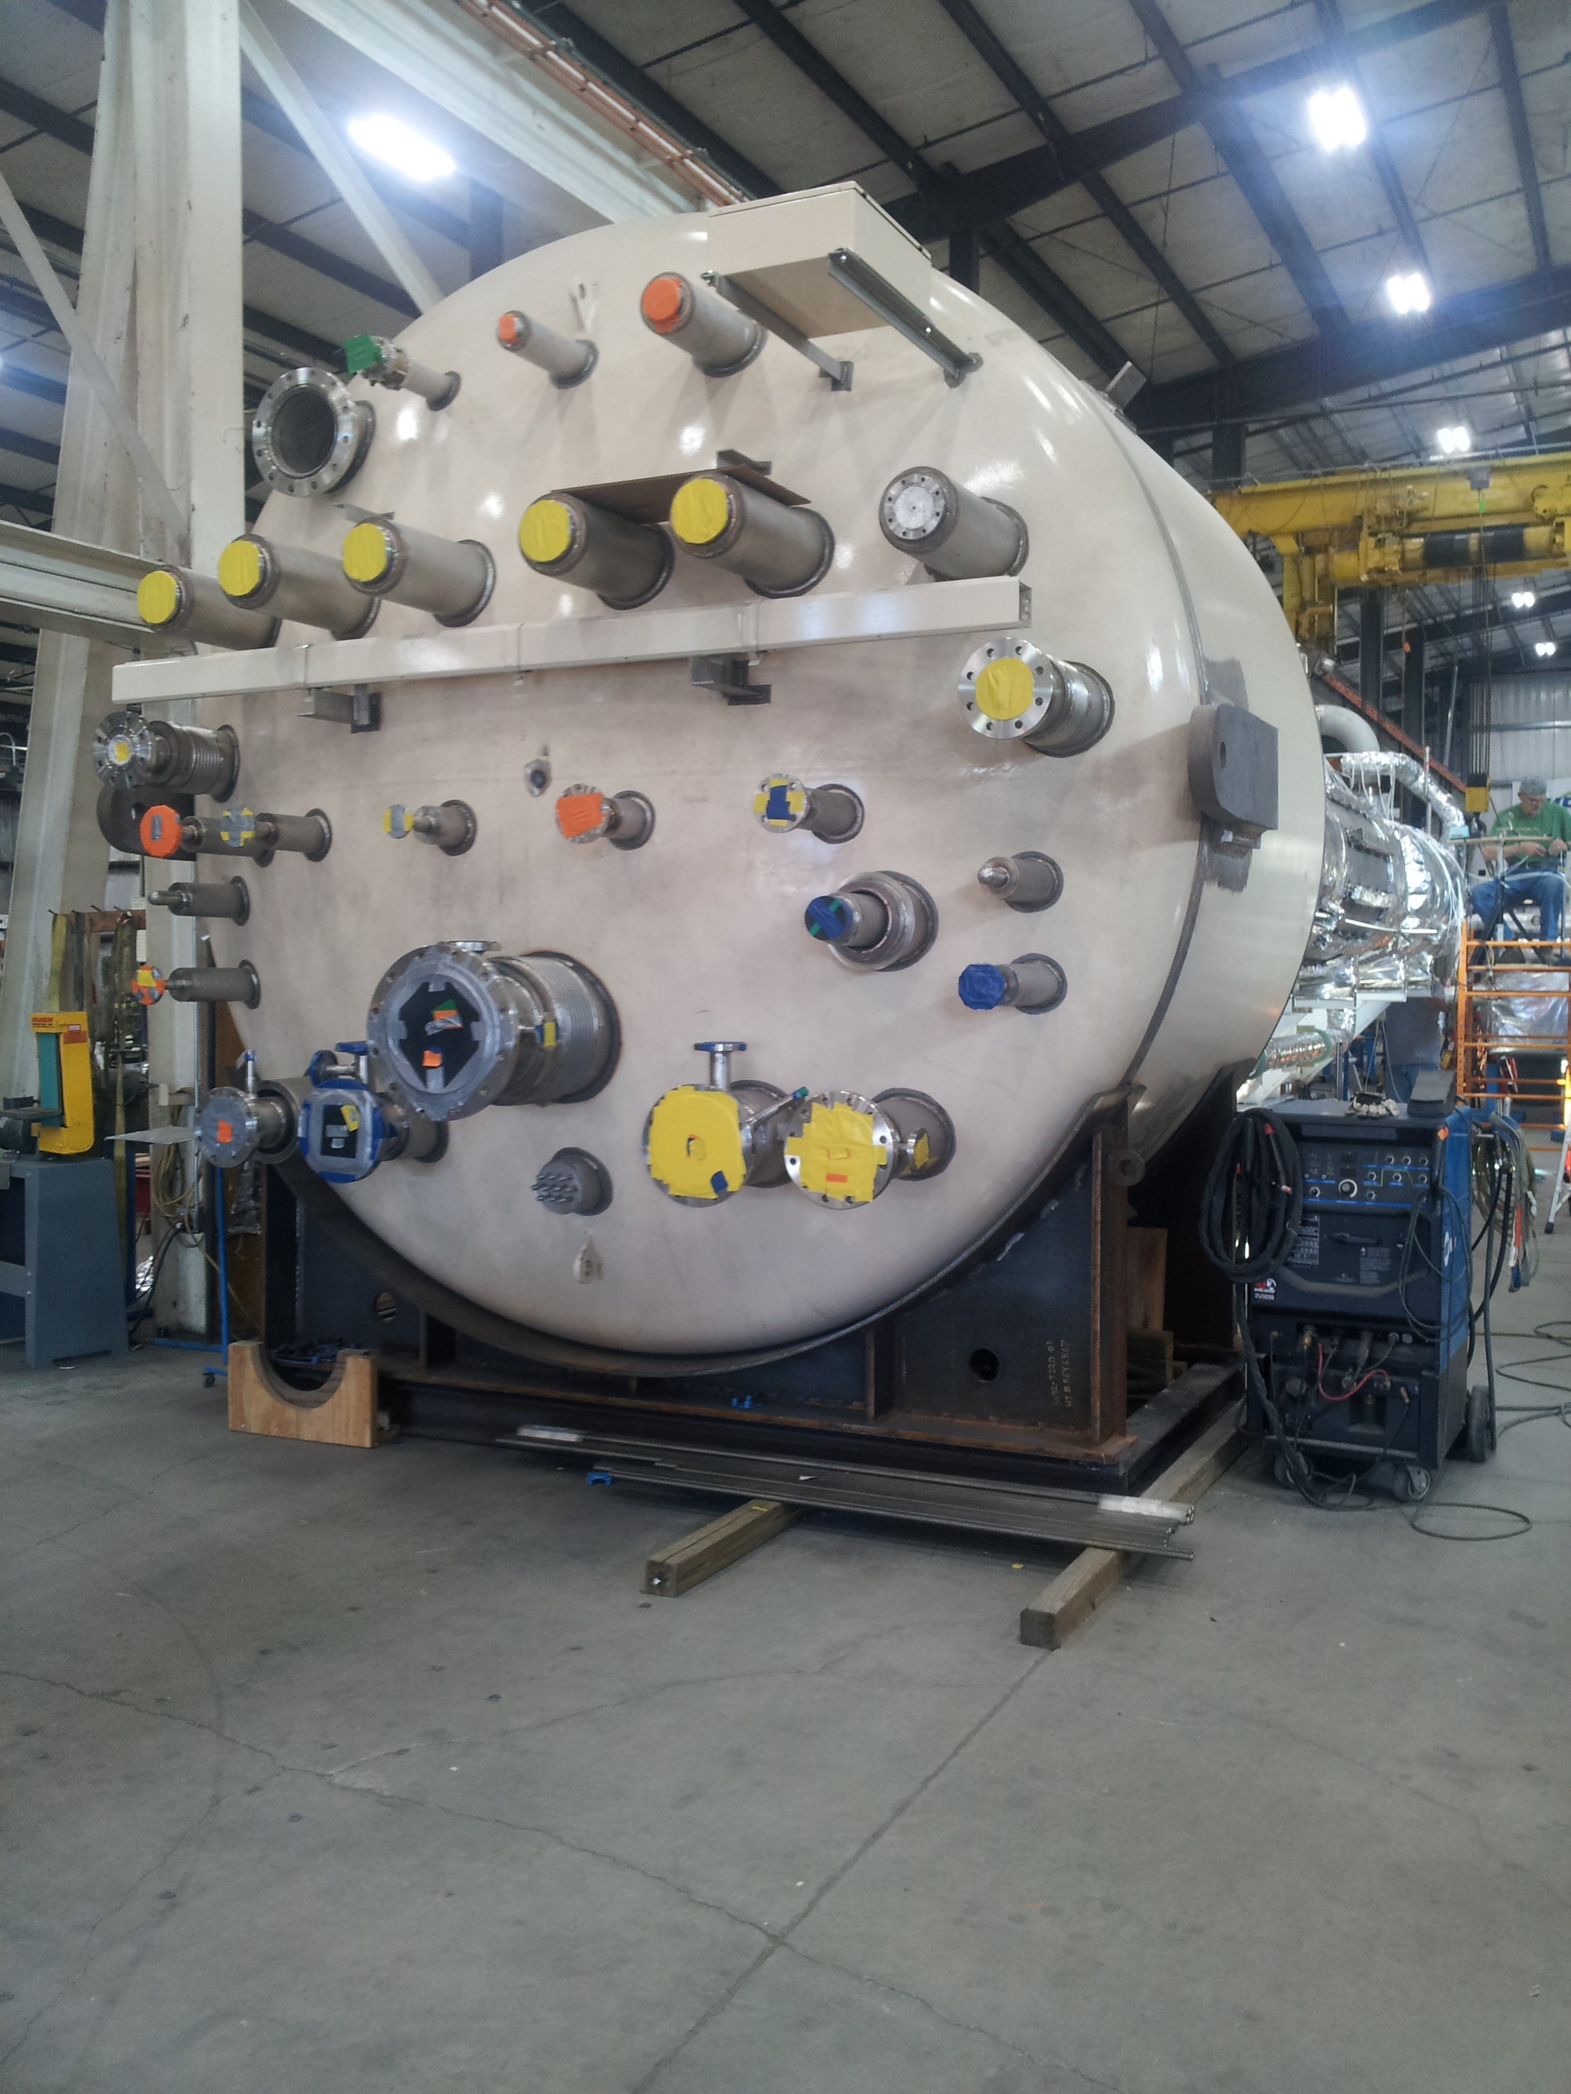
CP1 Upper Cold Box Top Head

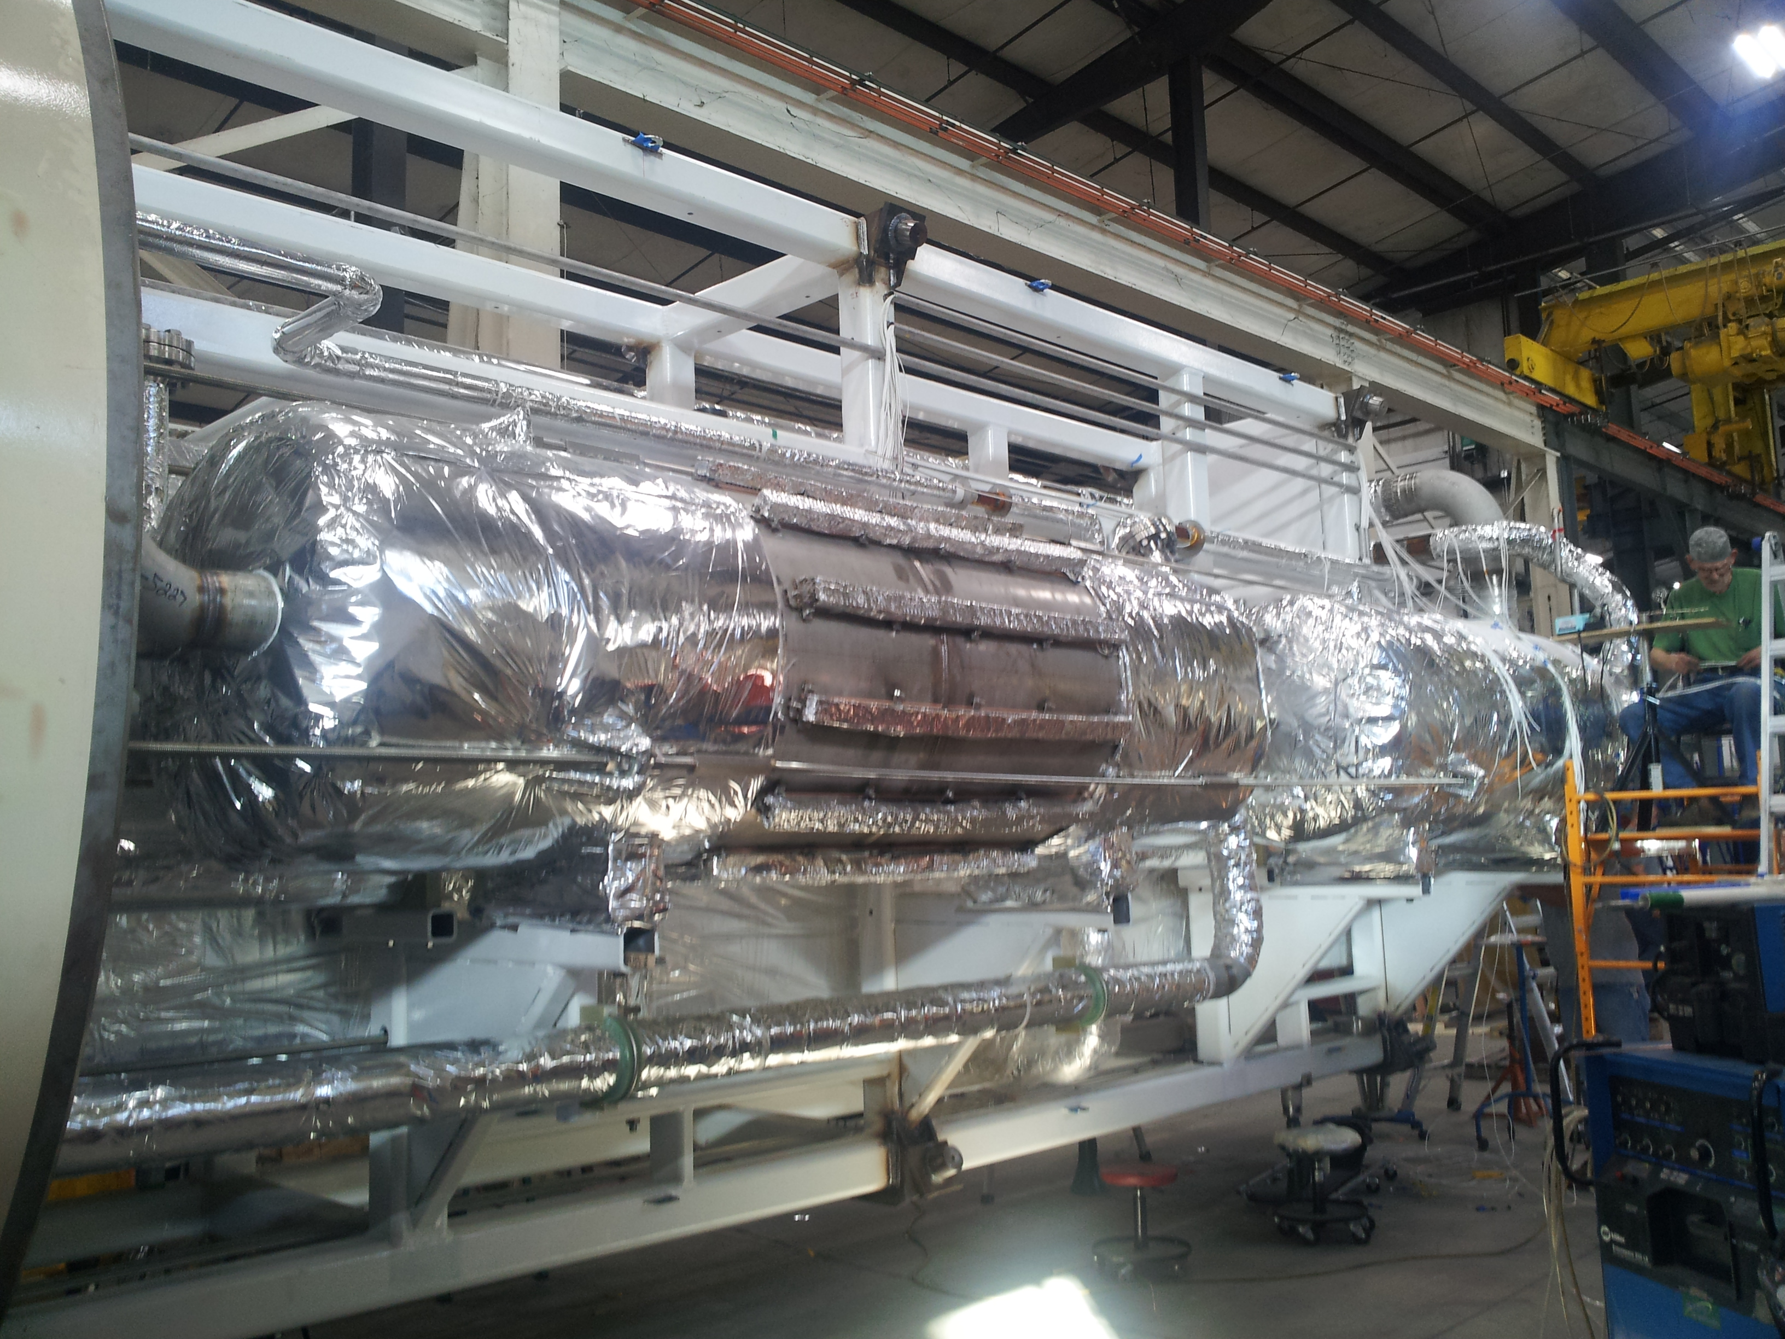
CP1 Upper Cold Box Internal Piping.

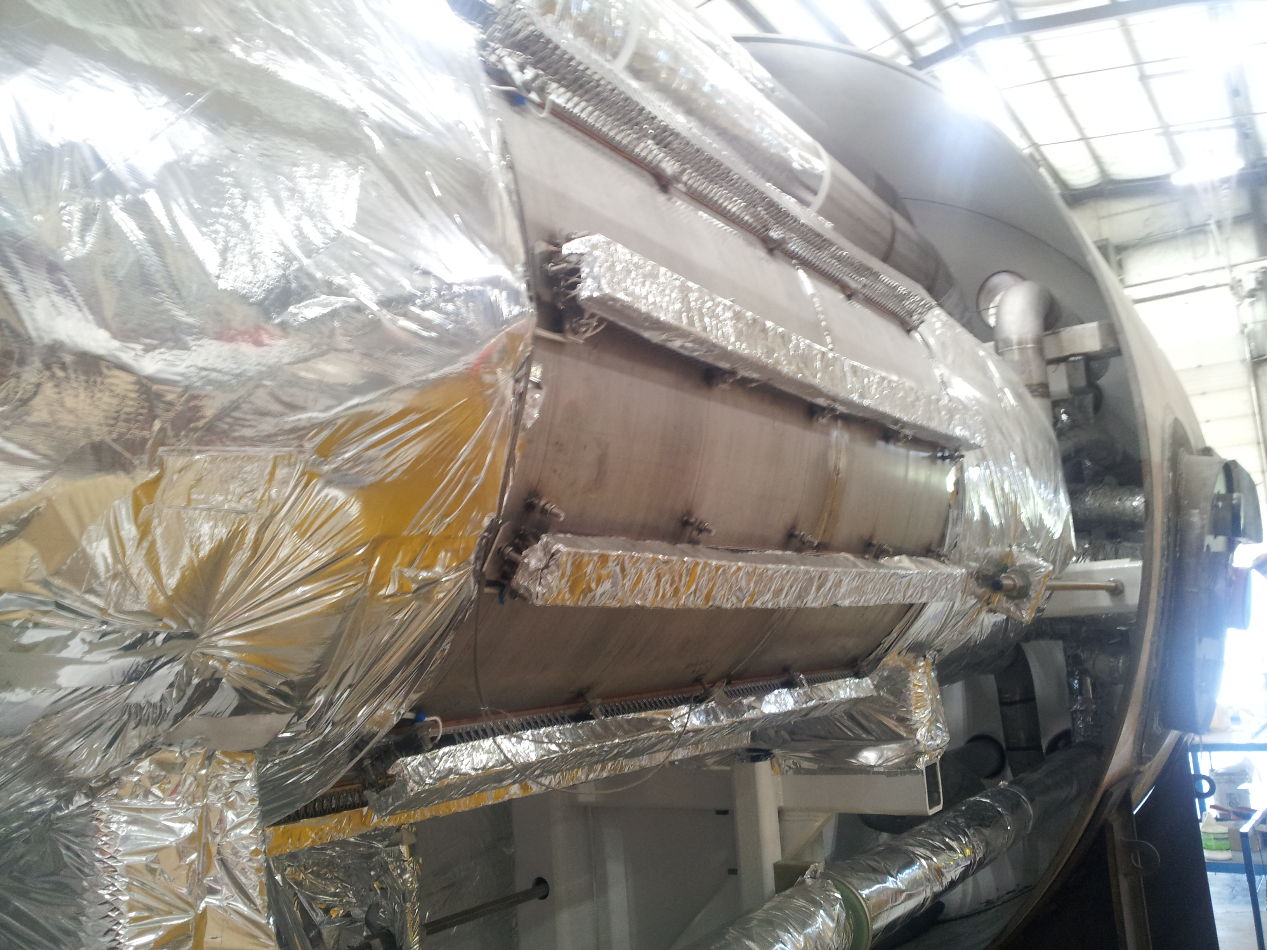
CP1 Upper Cold Box Internal Piping, 80K Absorber Vessel Heater Shown.

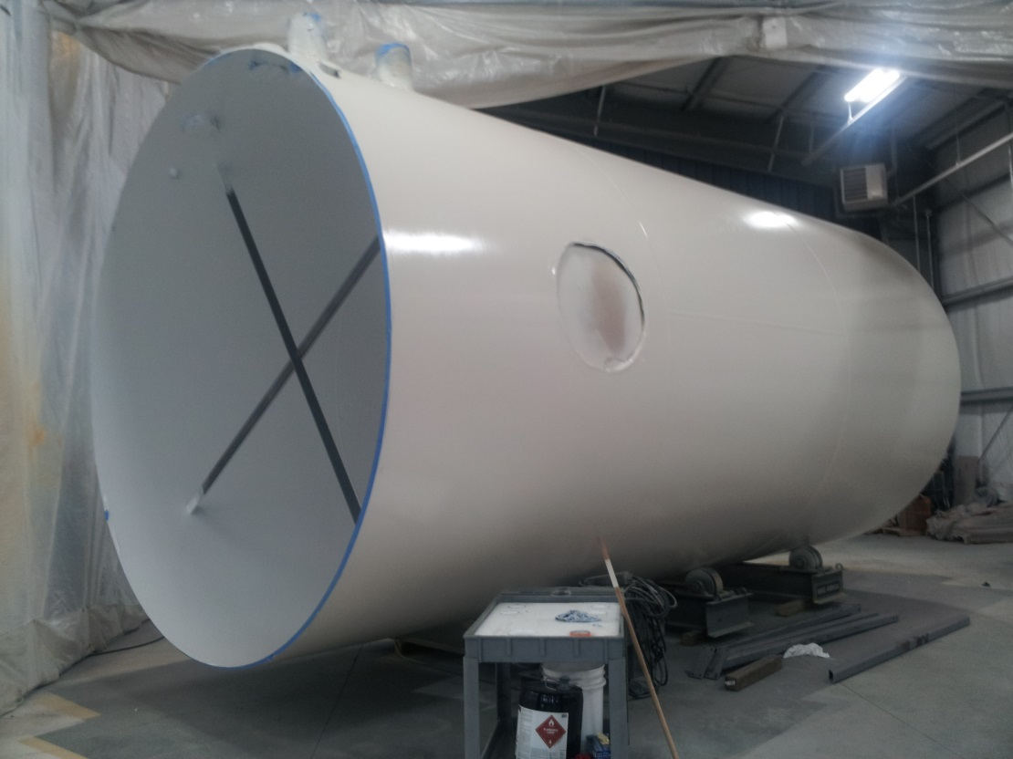
Cryoplant #1 Upper Cold Box Lower Vacuum Shell in Painting.

Cryoplant #1 Upper 4.5K Cold Box mounting base plate has been delivered to Mid Ohio for base ring hole drilling to match actual as-built cryoplant building concrete pad bolt measurement.

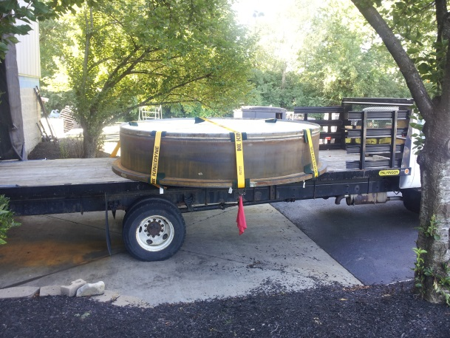
Cryoplant #1 Upper Cold Box Mounting Skirt for base hole drilling.

Cryoplant #1 4.5K Cold Box Turbine Pods are scheduled to be shipped to SLAC~ September 16. Shipping coordinated with SLAC.

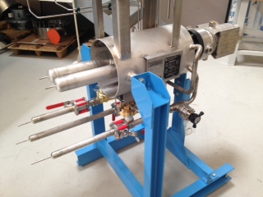
Cryoplant #1 Typical 1 of 4 Turbine Pods Shipping.

Cryoplant #1 Lower Cold Box assembly work continued. Valve bodies area being installed in top cold box vacuum shell and heat exchangers/vessels onto the internal support structure. Piping spools are ready for lower cold box assembly.

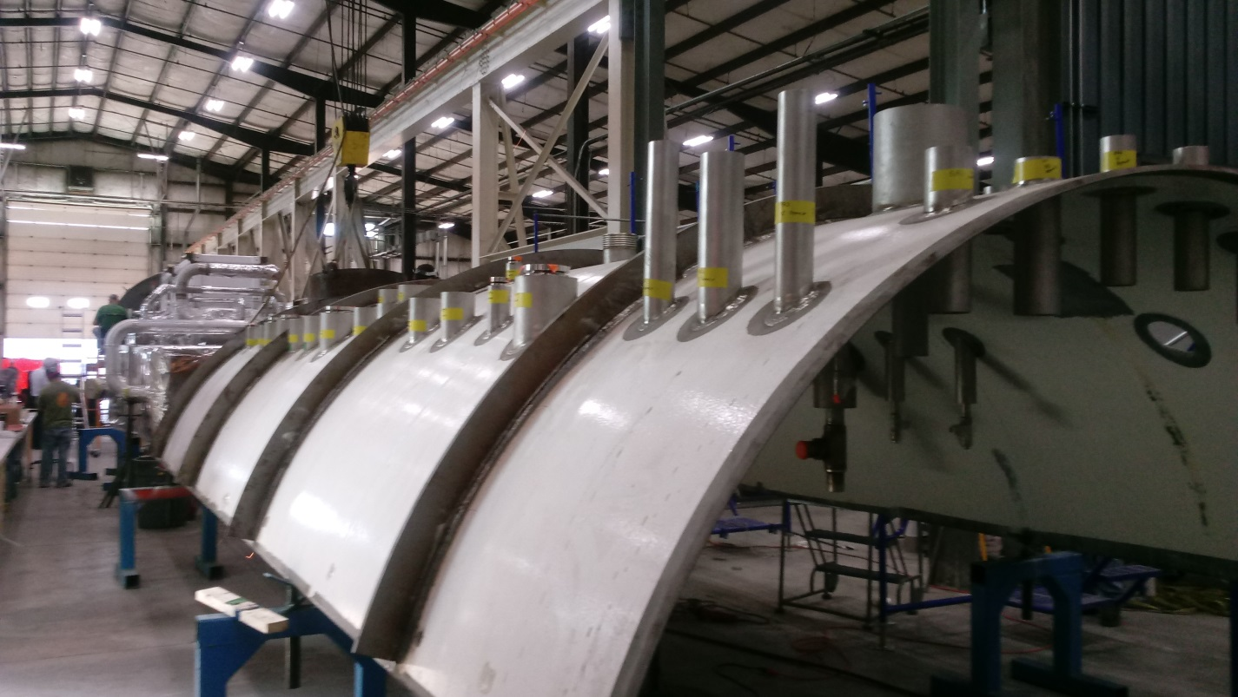
Cryoplant #1 Top Cold Box Vacuum Shell.
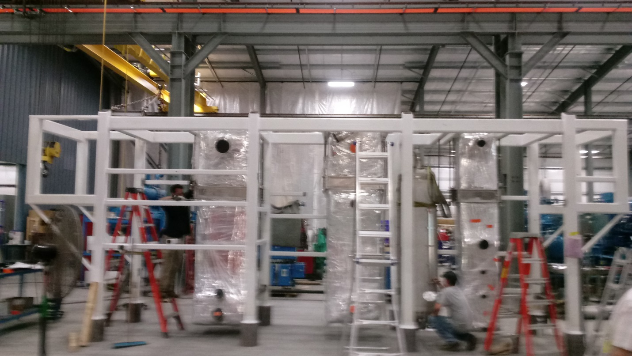
Cryoplant #1 Lower Cold Box Support Structure Assembly.

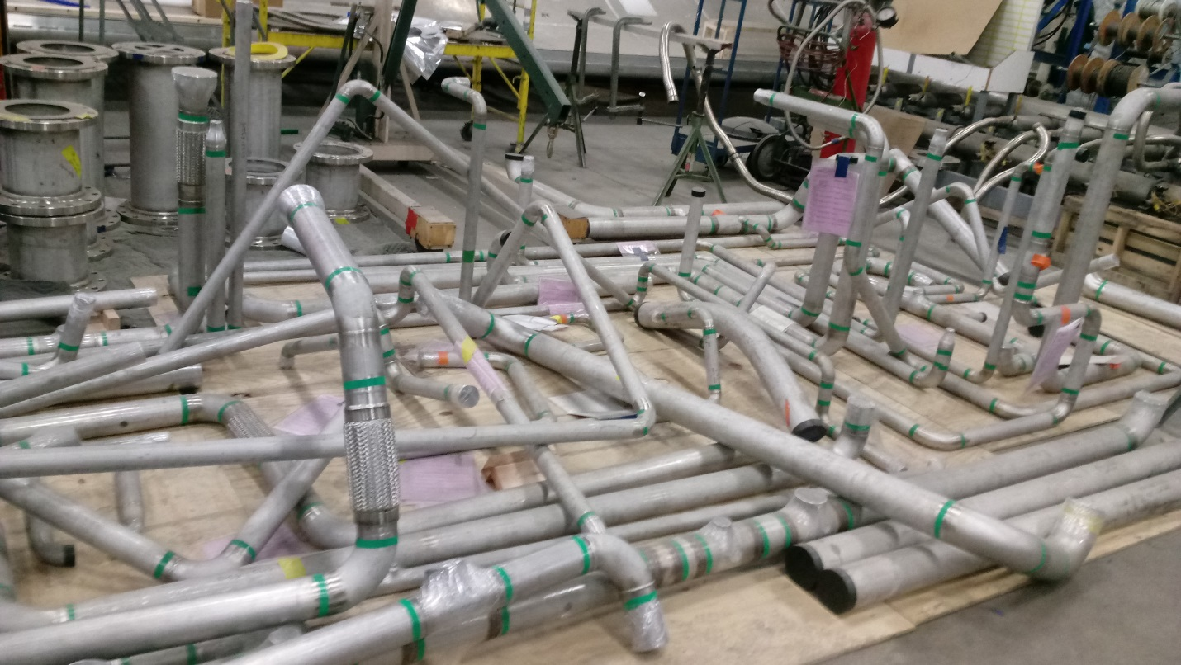
Piping Spools ready for Cryplant #1 Lower Cold Box Assembly.

The internal support frame for mounting of heat exchangers and vessels is complete for CP#1 4.5K lower cold box. Mounting of heat exchangers and vessels are pending. 75% complete.

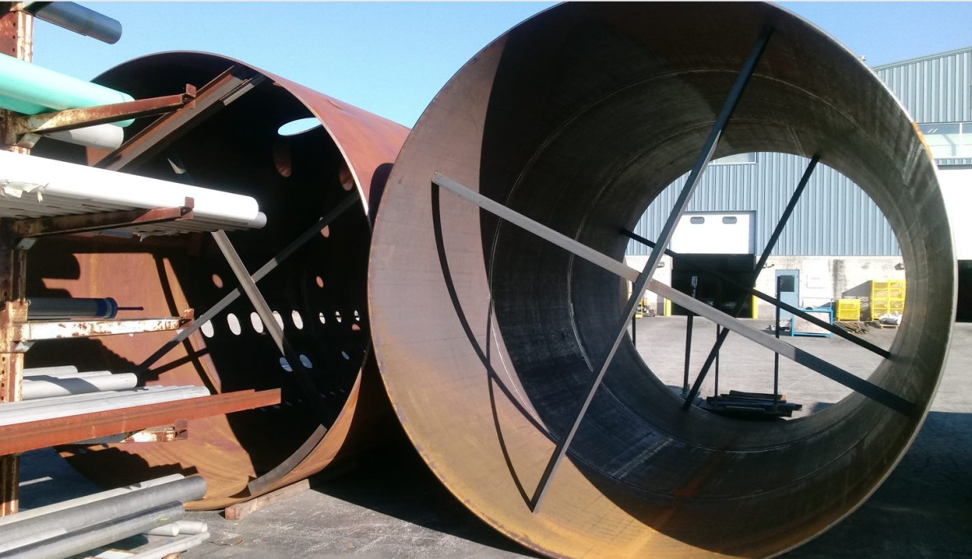
Cryoplant #2 Lower and Upper Cold Box Vacuum Shells in Storage.

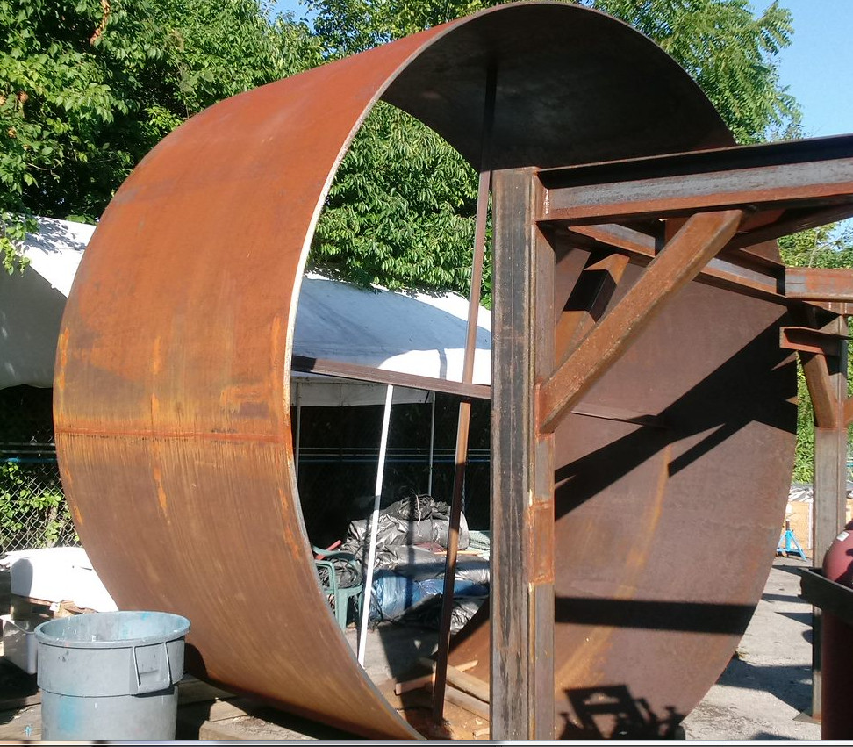
Cryoplant #2 Upper Cold Box Vacuum Shell Skirt.

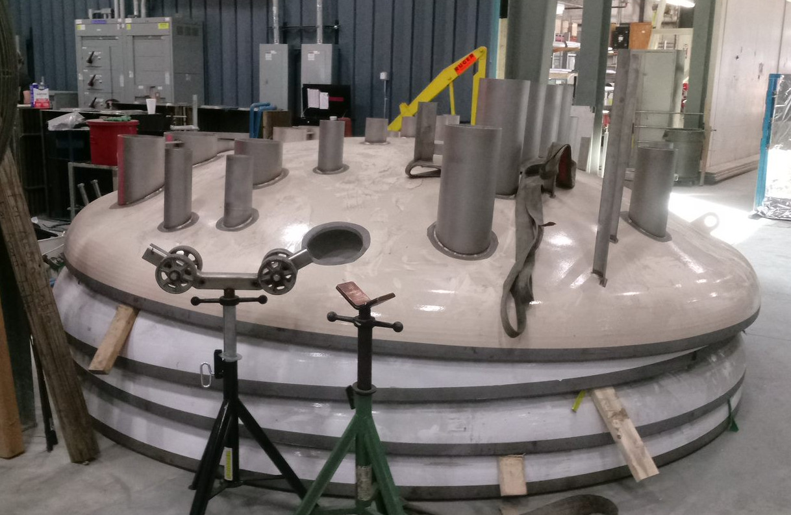
Cryoplant #2 Cold Box Dished Heads for Vacuum Shell, Ready for Assembly.

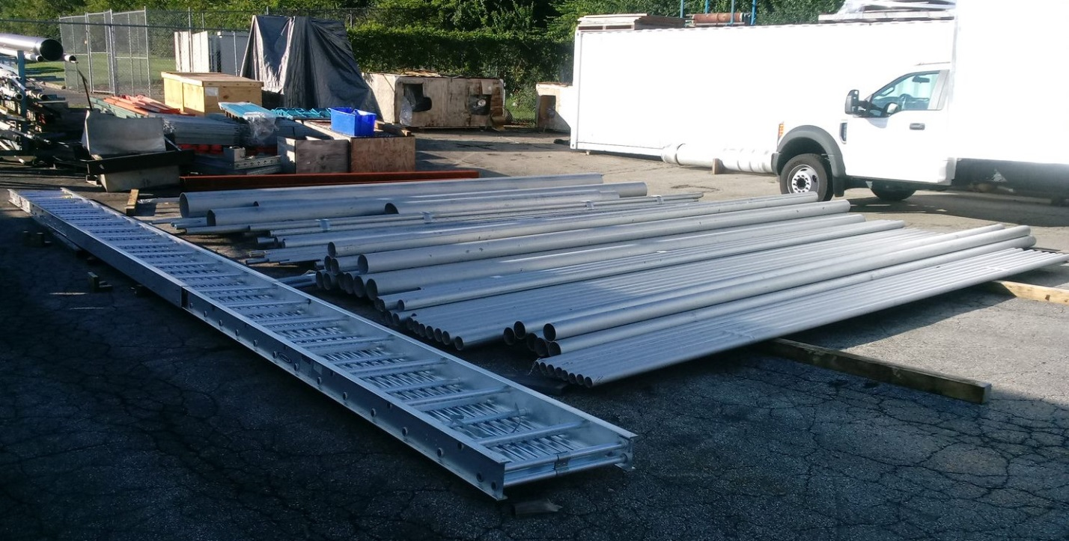
SS Piping Ready for Cryoplant #2 Piping Spool Fabrication.

The first warm helium compressor skids for Plant #2 is scheduled to be shipped late August. Delivery is being coordinated with SLAC. A compressor skid will be shipped every 3 weeks. The last compressor skid weld is underway at Mid West Ohio.

QUALITY:
He leak check testing scheduled for warm helium gas storage Sept 6th He leak check testing scheduled for CP1 Upper Cold Box piping, Early Sept Quality Check of 4.5K Cold Box Valve Assembly Documentation indicated correct tracking and control.

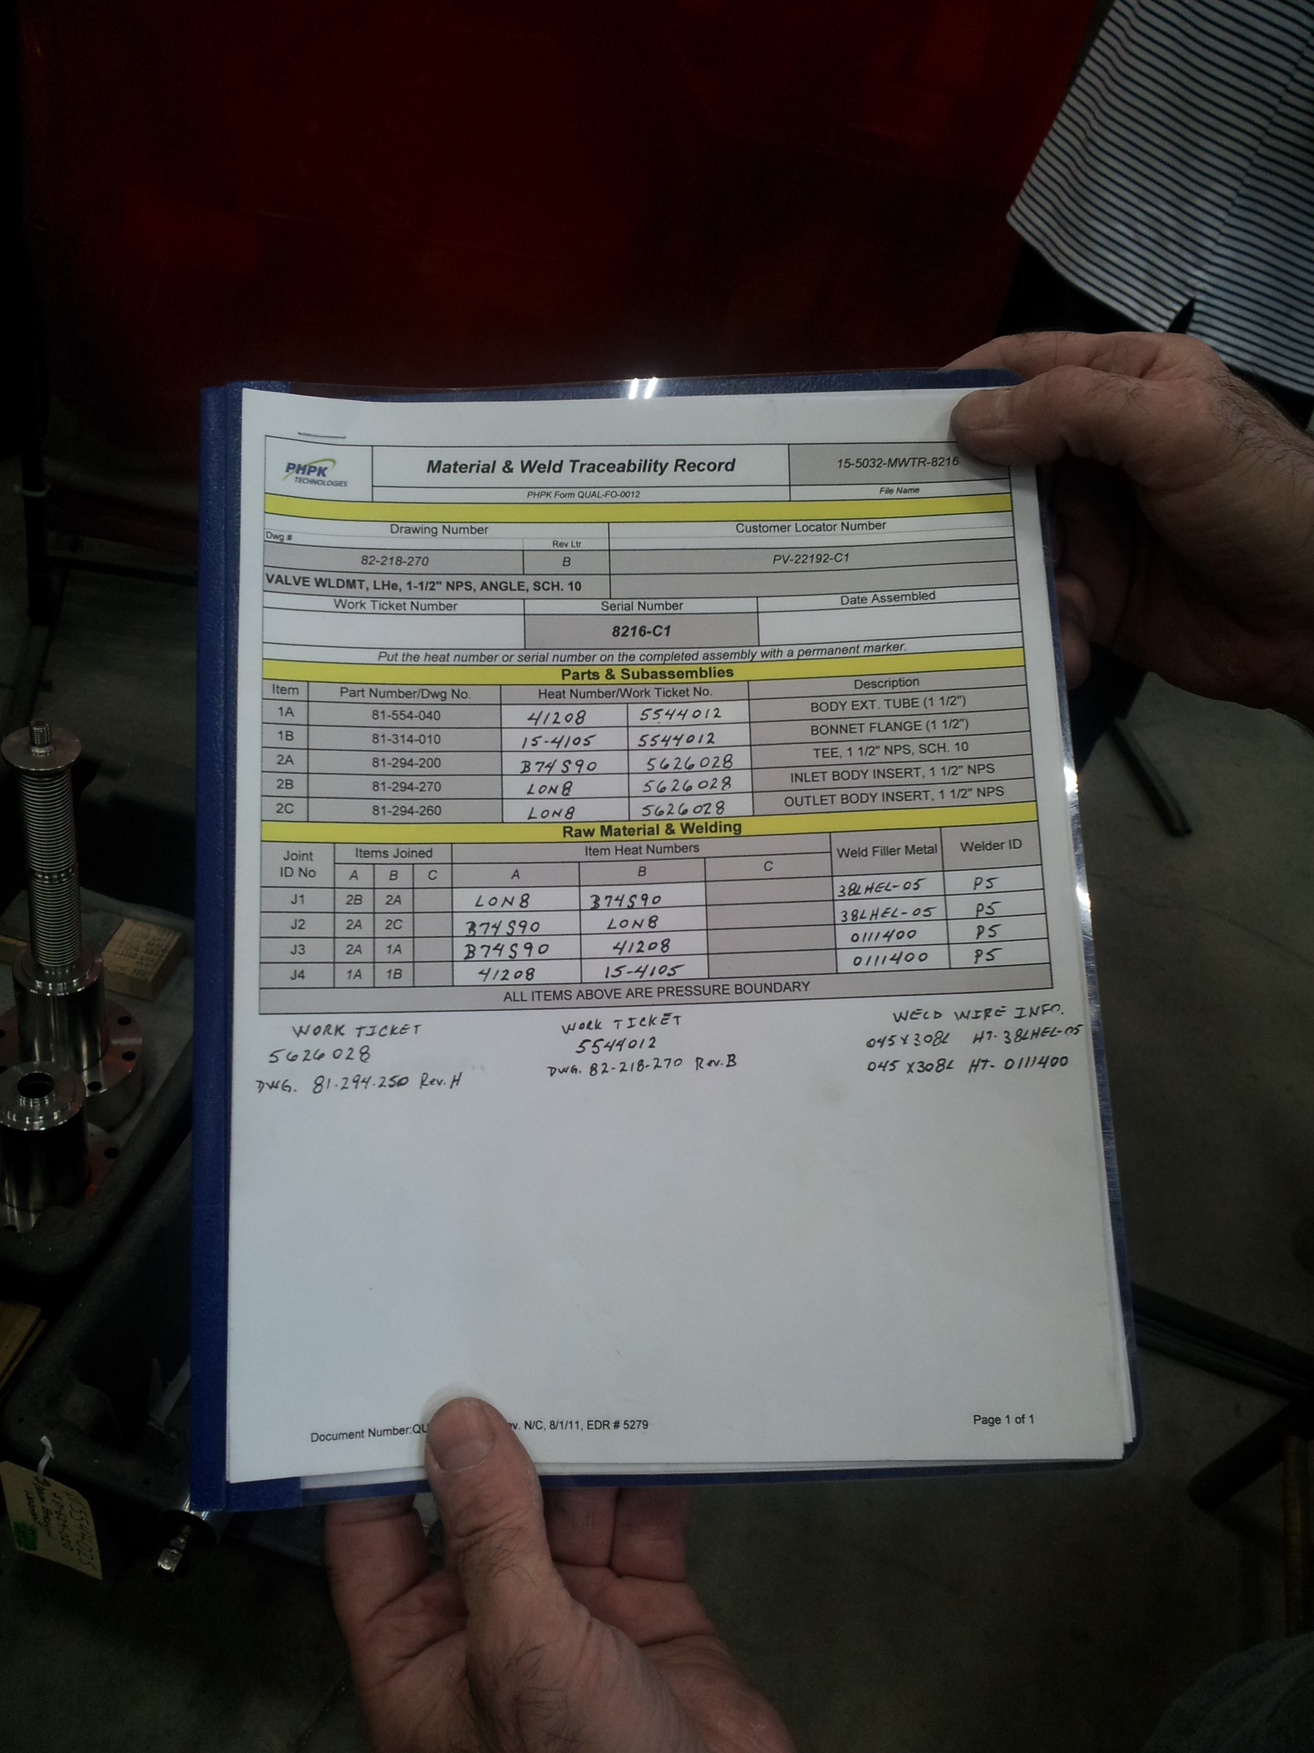

Upcoming Travel/Reviews:

4.5K Cold Box Vendor Site Visit to SLAC, Sept 13
CP Controls Specification Review Sept 13
FAC Review Sep 26-28, 2017

Weekly Reporting
WBS 1.02.03.05.12 LLRF
Week of August 24-30, 2017
Issues: None
Accomplishments this week at JLab:
- LLRF Coordination/Documentation:
  - LLRF Production: JLAB leadership decided that the production schedule was too tight to also support CEBAF operations and asked for 6 months of float be added to the schedule. This was passed along to Matt Boyes the CAM of the account.
  - LERF project: Discussed SSA delivery with Dian Yeremian and Karen Fant. Plan now is to have all the SSAs here by December 1.

- Resonance/Stepper Motor Board/Chassis:
  - Rama continues working on chassis test procedure and test bench with RF technician.
  - Dave has been working on the design freeze package to send to Andre.

- Interlock Board/Chassis:
  - Onish Kumar is revising the FEP board from 12 channels down to 8 channels. The analog part is finished and he working on the ADC part.

- Common Power Supply/Chassis/Boards:
  - Dave ordered a 6 volt 40 A power supply for evaluation.
  - CAD is working on modifying the power supply distribution boards, adding current monitoring capabilities.

- CMTF
  - PRC/RFS: Couplers and switches which are due in by mid-September.
  - CM03 will be cold next week. Rama and Clyde will shake down the 8 channel interface for steppers and piezo tuners.
Upcoming Activities:
- LERF presentation for SLAC week of September 13
- FAC at the end of September

