Weekly Reporting

WBS 1.01.07 JLAB Management

Week of August 31 to September 6, 2017

**Issues:**

**Accomplishments this week:**

Management meeting held with ALATUS, JLab and SLAC with a follow-on meeting to occur next week.

Participated in CAM surveillance training.

Conducted CP 1.04.08 and CM 1.04.08 progress meetings.

Awarded the Motor Control Center procurement.

Began CM03 testing at 2K in the CMTF.

**Upcoming Activities:**

4.5K Cold Box Vendor Site Visit to PHPK September 12

CP Controls Review September 13, 2017

Management 4.5K Cold Box Meeting with ALATUS at SLAC September 14

FAC at SLAC September 26-28, 2017

Weekly Reporting

WBS 1.04.06 JLAB Cryomodules

Week of August 31 to September 6, 2017

**Issues**: Need to define additional cavities (133) procurement strategy.

**Accomplishments this week:**

LERF - planning internal meetings for 8-September and kick-off for 14-September with LCLS collaboration. Shielding block removal plans in progress. Conceptual design of cryogenic hardware on-going.

2+2 CM procurement BCR preparation is complete.

Preparing BCR for fabrication of up to 133 replacement cavities.

Preparing BCR for rework strategy. Received response from Zanon on rework costs. Planning on-site visit for the end of next week.

pCM (J1.3-1) at FNAL where it is being prepared for testing after F1.3-4.

CM02 – Potential tuning of HOMs awaiting data from CM03 test.

CM03 at CMTF: Cooldown started Wednesday 30-Aug and completed Sunday 3-Sep. Pumped down 5-Sep. Testing program has begun.

CM04 at WS-4: VV installation is complete. Final alignment checks in progress.

CM05 at WS-3: Tuner installation on-going. Preparing for RT due to rework of UCM.

CM06 at WS-3: Piping welding and leak checking in progress. Preparing for RT due to rework of UCM. String tooling returned for CM08.

CM07 at WS-2: Complete. Plan to move to WS-3 after CM05 clears.

CM08: Preparation for string assembly have started. The following cavities will be used for string assembly – 099, 102, 116, 122, 261, 270, 278, 289. String build start date 11-Sep.

Cavity 272 (TD) in D7, re-test after re-rinse (failed previous test due to FE@16MV/m), Final FE onset 5.5MV/m, test aborted.

Cavity 289 (NX-A) in D8, first test, Quenched at 22.9 MV/m, Q0(16)=2.8e10, FE free, Qualified for string 8.

Cavity 238 (R&D bare 9-cell) in D7, first test, Q0(16)=2.8e10, FE onset at 11.1MV/m, FE limited at 21.7MV/m (reached 1 R/hr).

Three cavities - 130,131,133 (all NX-C) first test in D5, all had low Qo at 16 MV/m. Thermal gradients during cooldown were acceptable.

Future cavity test plans - 286 (NX-A) first test in D7, 268 (TD) re-test in D8 (due to low Q0 in D5), L2-118 (NX-A) re-test in D7 (due to FE in D7), D5 low Qo investigation with 130, 131 and 133.

**QUALITY**:

Submitted August update of SNCR Dashboard to SLAC.

Was informed that Lori Plummer is retiring and will leave the Project by September 15; her replacement is Ginger DeContreras.

**Upcoming Travel/Meetings:**

E. Zanon Vendor Visit Sep 14-15, 2017 (J. Fitzpatrick, E. Daly)

E. Zanon Vendor Oversight September 17-21, 2017 (C. Reece)

FNAL for preparations for pCM testing Sep 6-8, 2017 (G. Cheng)

LERF Kick-Off 14 September at JLab (K. Jordan, C. Hovater)

Production CM QA/QC Meeting at FNAL via VC (TBD)

FAC at SLAC 26-28 September – (Daly, Wilson)

Weekly Reporting

WBS 1.04.08 JLAB Cryoplant System

Week of August 31 to September 6, 2017, 2017

**Issues:**

**Accomplishments this week:**

Preparation for the Cryoplant #1 4.5K Upper Cold Box intermediate helium piping leak check began. External interface piping and tubing will be sealed for the test. Kurt Macha (JLab Leak Technician) and Bruce Lenzer (JLab ESH&Q)) will witness the testing for the milestone #15 vendor witness point. The test is scheduled for the week of Sept 11th.

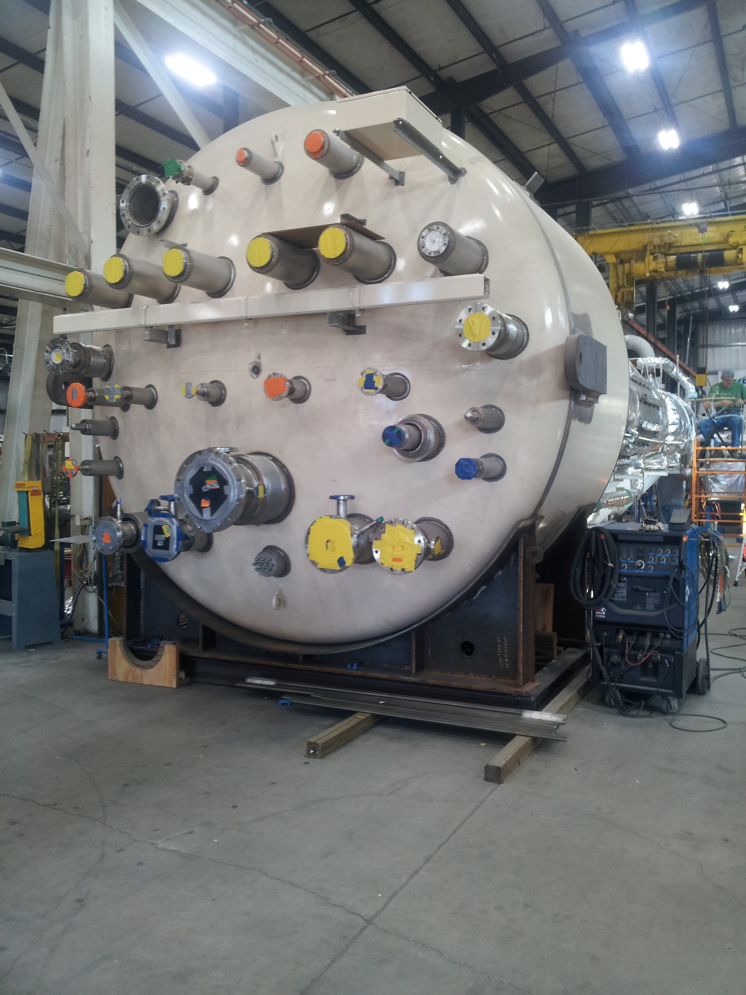

CP1 Upper Cold Box Top Head

The warm helium compressor 4160V motor control centers for both Cryoplant #1 and #2 were ordered. The delivery date of the first motor control center for Cryplant #1 is January 2017.

A 4.5K Cold Box Schedule meeting consisting of JLab/Alatus/SLAC personnel was held at Jefferson Lab on Thursday, August 31st. Discussion centered on the schedule for the delivery of the Cryoplant #1 and #2 4.5K Cold Boxes, the reasons for the schedule slip of the Cryoplant #1 4.5K Cold Box, and the mitigation to prevent further schedule slip. A continuing meeting is planned for September 12 at the PHPK facility in Columbus, OH.

4.5K Cold Box vendor deliveries included 36 inch diameter cryoduct vacuum jacket piping to the PHPK fabrication facility.

The shipment for the first Cryoplant #2 warm helium compressor skid to SLAC remains on schedule for September 14th.

The shipment to SLAC of expansion turbine pods remain on schedule for the end of September.

Preparation for the Cryoplant Control Hardware Final Design Review continued during the week. The review will be held at Jefferson Lab on September 12th. Reviewers include Joe Delong and Matt Cyterski from the SLAC Controls Dept.

Preparation is underway for attending the 2K cold compressor run testing schedule for November 6-7th.

Work continued to provide small amount of follow up activity in support of the cryoplant installation design documentation.

The first warm helium compressor skids for Plant #2 is scheduled to be shipped late August. Delivery is being coordinated with SLAC. A compressor skid will be shipped every 3 weeks. The last compressor skid weld is underway at Mid West Ohio.

**QUALITY**:

He leak check testing scheduled for warm helium gas storage ~Sept 614h He leak check testing scheduled for CP1 Upper Cold Box piping, Early Sept Quality Check of 4.5K Cold Box Valve Assembly Documentation indicated correct tracking and control.

**Upcoming Travel/Reviews:**

4.5K Cold Box Schedule Review, PHPK, Sept 12th

CP Controls Specification Review Sept 13

4.5K Cold Box Vendor Site Visit to SLAC, Sept 14

CP Controls Specification Review Sept 13

FAC Review Sep 26-28, 2017

2K Cold Compressor Run Witness Test, MECOS, France, Nov 6-10

Weekly Reporting

WBS 1.02.03.05.12 LLRF

Week of August 31 to September 6, 2017

**Issues:** None

**Accomplishments this week at JLab:**

* LLRF Coordination/Documentation:
  + LLRF Production: SLAC has decided not to pursue JLAB as a production partner for the LLRF system.
  + LERF project: Trying to catch up with Joe Delong.
  + BCS: Trent and John are finishing up on their BCS report and recommendations this week. It should go out by the end of the week.
* Resonance/Stepper Motor Board/Chassis:
  + The LLRF team held a review/design freeze meeting last week. A number of action items were generated and are being worked on (nothing major).
  + Dave sent most of the design freeze package to Andre.
* Interlock Board/Chassis:
  + Onish Kumar is revising the FEP board from 12 channels down to 8 channels. The analog part is finished and he working on the ADC part.
  + *We are debating the utility of the interlock chassis. There is a discussion going on now whether to keep the electron probes. If not, the slow temperature and vacuum signals could be added to the resonance chassis. This could save the project $500k. Rama is to investigating this and will report Wednesday at the LLRF team meeting.*
* Common Power Supply/Chassis/Boards:
  + Manny is installing the 6 volt 40 A power supply into the power supply for evaluation.
  + CAD finished modifying the power supply distribution boards. Rama is reviewing them now. We hope to send them out for manufacture at the end of the week.
* CMTF
  + PRC/RFS: Couplers and switches which are due in by mid-September.
  + CM03 is cooling down now. Rama and Clyde will test the 8 channel EPICS interface for steppers and piezo tuners.

**Upcoming Activities:**

* LERF presentation for SLAC week of September 13
* FAC at the end of September