Weekly Reporting

WBS 1.01.07 JLAB Management

Week of September 7-13, 2017

**Issues:**

**Accomplishments this week:**

Management meeting held with ALATUS, PHPK, JLab and SLAC

Prepared presentations and conducted dry runs for the Controls FDR

Conducted Controls FDR

Preparing multiple BCRs and an ETC to be presented in September business

2+2 CM BCR presented and accepted

**Upcoming Activities:**

4.5K Cold Box Management Meeting at PHPK September 12

CP Controls Review September 13

4.5K Cold Box Installation Meeting with ALATUS at SLAC September 14

FAC at SLAC September 26-28

Weekly Reporting

WBS 1.04.06 JLAB Cryomodules

Week of September 7-13, 2017

**Issues**: Need to define additional cavities (133) procurement strategy.

**Accomplishments this week:**

LERF - Held internal meeting on 8-September. Removed shield blocks at LERF vault. Planning kick-off meeting for 14-September with LCLS collaboration. Conceptual design of cryogenic hardware on-going.

2+2 CM procurement BCR in final approval stage.

Preparing BCR for fabrication of up to 133 replacement cavities.

Preparing BCR for rework strategy. On-site visit at Zanon is planned for Thursday and Friday this week to discuss proposed path.

pCM (J1.3-1) at FNAL where it is being prepared for testing after F1.3-4.

CM02 – Planning re-tuning of HOMs awaiting data from CM03 test.

CM03 at CMTF: Testing program is on-going. Six cavities have max gradients measured. Cavity 5 exhibits field emission. Qo’s highest measured at JLab averaging 2.5e10. HOM Qext values are low compared with specification. FPC Qext values are within specified range.

CM04 at WS-5: Alignment completed at WS4. Moved to WS5.

CM05 at WS-3: Tuner installation on-going. RT of cooldown line due to rework of UCM scheduled for 13-September.

CM06 at WS-3: Due to mishandling of flange, string was accidentally vented. Draft report was developed. SNCR was transmitted. Plans for rework and full disassembly are being developed.

CM07 at WS-2: Two-phase pipe assembly in progress. Tacking Ti sheets to helium vessels. Plan to move to WS-3 after CM05 clears.

CM08: Preparation for string assembly have started. The following cavities will be used for string assembly – 099, 102, 116, 122, 261, 270, 278, 289. String build start date 11-Sep.

CM09: Four cavities qualified for string.

Cavity 286 (NX-A) in D7, first test, Admin limited at 24 MV/m, Q0(16)=2.8e10, FE free, Qualified for string.

Cavity 130 (NX-C) in D5, Quench limited at 20.5 MV/m, Q0(16)=3.1e10, FE free, Qualified for string.

Cavity 131 (NX-C) in D5, Quench limited at 21.6 MV/m, Q0(16)=2.9e10, FE free, Qualified for string.

Cavity 133 (NX-C) in D5, Quench limited at 21.2 MV/m, Q0(16)=3.9e10, FE free, Qualified for string.

Cavity 118 (NX-A) in D8, Admin limited at 24 MV/m, Q0(16)=2.6e10, FE free, Qualified for string.

Future cavity test plans - 288 (NX-A) first test in D7, 268 (TD) re-test in D8 (due to low Q0 in D5), 113 (NX-A) first test in D7.

**QUALITY**:

No report.

**Upcoming Travel/Meetings:**

E. Zanon Vendor Visit Sep 14-15, 2017 (J. Fitzpatrick, E. Daly)

E. Zanon Vendor Oversight September 17-21, 2017 (C. Reece)

FNAL for pCM testing Sep 13-14, 2017 (G. Cheng)

LERF Kick-Off 14 September at JLab (K. Jordan, C. Hovater)

Production CM QA/QC Meeting at FNAL via VC (TBD)

FAC at SLAC 26-28 September – (Daly, Wilson)

Weekly Reporting

WBS 1.04.08 JLAB Cryoplant System

Week of September 7-13, 2017, 2017

**Issues:**

**Accomplishments this week:**

Preparation for the Cryoplant #1 4.5K Upper Cold Box intermediate helium piping leak check continues. External interface piping and tubing are being sealed for the test. Kurt Macha (JLab Leak Technician) and Bruce Lenzer (JLab ESH&Q)) will witness the testing for the milestone #15 vendor witness point. The test is scheduled for the week of Sept 11th has been postponed pending completion of the temperature sensors in the cold box. Exact test date will be confirmed.

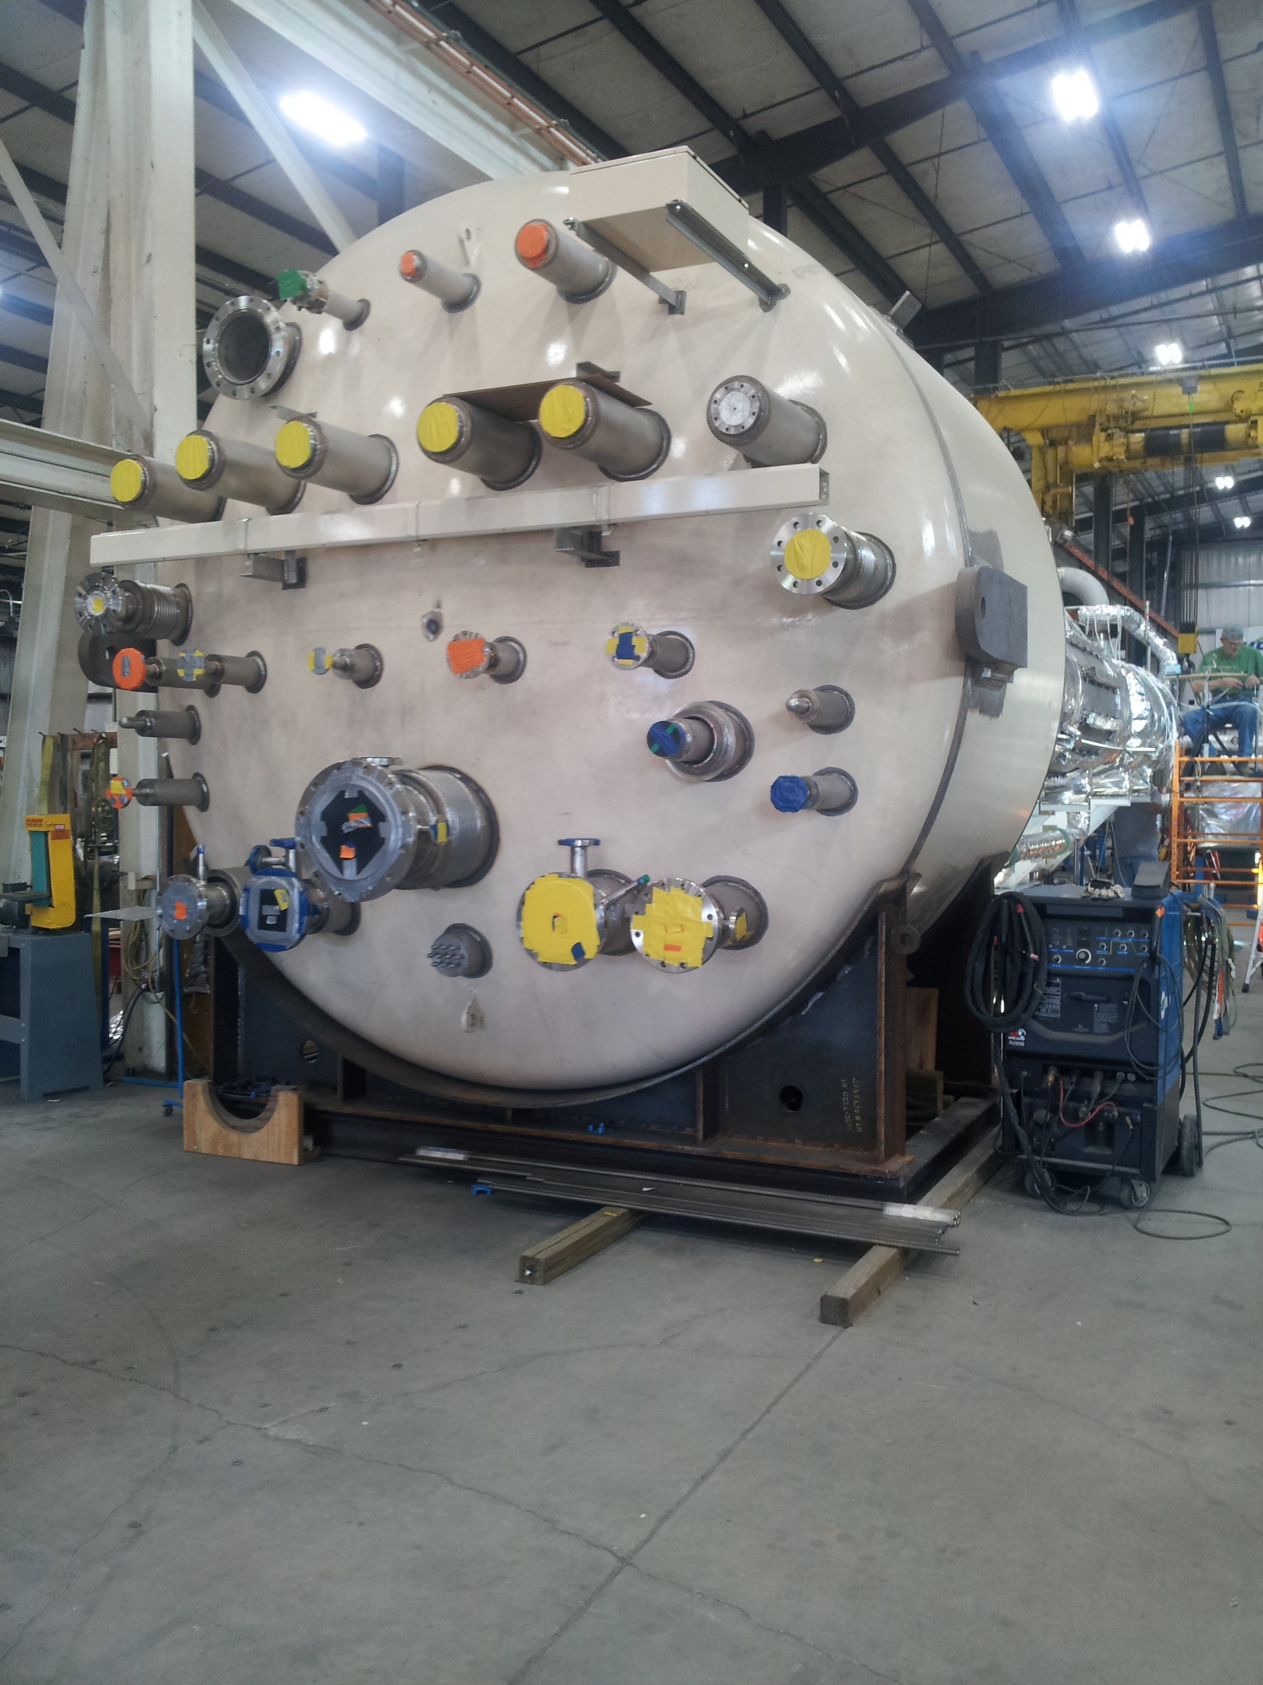

CP1 Upper Cold Box Top Head

The 4.5K cold box vendor has received 36” diameter vacuum shell and bellows material for fabrication of the cryoduct connecting the upper and lower cold boxes of CP#1.

The CP2 lower 4.5K cold box 2K sub-cooler is in the process of being mounted on the internal support structure.

The warm helium compressor 4160V motor control centers for both Cryoplant #1 and #2 are on order. The delivery date of the first motor control center for Cryoplant #1 is January 2017. The vendor kick-off meeting is scheduled for Thursday, Sept 14th.

A 4.5K Cold Box Schedule meeting consisting of JLab/Alatus/PHPK/SLAC personnel was held at PHPK on Tuesday, Sept 12th. Discussion centered on the schedule for the delivery of the Cryoplant #1 and #2 4.5K Cold Boxes, the reasons for the schedule slip of the Cryoplant #1 4.5K Cold Box, and the mitigation to prevent further schedule slip.

The second Cryoplant #2 warm helium compressor skid to SLAC is in the process of being shipped on schedule by September 14th.

The shipment to SLAC of expansion turbine pods remain on schedule for the end of September.

A controls hardware review was held at Jefferson Lab on September 13th. Reviewers include Joe Delong and Matt Cyterski from the SLAC Controls Dept.

Preparation is underway for attending the 2K cold compressor run testing schedule for November 6-7th.

Work continued to provide a small amount of follow up activity in support of the cryoplant installation design documentation.

**QUALITY**:

He leak check testing of the warm helium storage tanks were completed. He leak check testing scheduled for CP1 Upper Cold piping is on hold until completion of the installation of temperature sensors.

**Upcoming Travel/Reviews:**

4.5K Cold Box Schedule Review, PHPK, Sept 12

CP Controls Specification Review Sept 13

4.5K Cold Box Vendor Site Visit to SLAC, Sept 14

FAC Review Sep 26-28

2K Cold Compressor Run Witness Test, MECOS, France, Nov 6-10

Weekly Reporting

WBS 1.02.03.05.12 LLRF

Week of September 7-13, 2017

**Issues:** None

**Accomplishments this week at JLab:**

* LLRF Coordination/Documentation:
  + LERF project: We have a SLAC LERF kick off meeting scheduled for this Thursday. Last week we held an internal JLAB kick off meeting with JLAB stake holders in the project.
  + LERF Controls: We met with the controls people that will be assisting in the LERF project.
  + BCS: Report has been delayed a week. Matt, Trent and John are to meet at JLAB Friday morning and discuss the JLAB work.
* Resonance/Stepper Motor Board/Chassis:
  + Work continues on the resonance chassis test stand.
  + Sent FNAL a modified Resonance chassis.
* Interlock Board/Chassis:
  + Onish Kumar is working on the ADC portion of the board.
  + Matt Boyes is inquiring with project management on how to best to proceed with illuminating the interlock chassis*.*
* Common Power Supply/Chassis/Boards:
  + Manny is testing the 6V/40A power supply.
  + The power supply board for the PRC/RFS/LO is ready to go out for manufacture*.* Other boards are on hold until the interlock chassis decision is made.
* CMTF
  + PRC/RFS: Couplers and switches which are due in by mid-September.
  + CM03 is being tested now. Rama and Clyde will test the resonance system later this week.

**Upcoming Activities:**

* LERF presentation for SLAC September 14
* FAC at the end of September