Weekly Reporting

WBS 1.01.07 JLAB Management

Week of September 14-20, 2017

**Issues:**

**Accomplishments this week:**

Management meeting held with ALATUS, PHPK, JLab and SLAC

Meeting held with ALATUS, JLab, and SLAC at SLAC to start coordination of ALATUS work on the SLAC site.

Conducted Controls FDR

Preparing multiple BCRs and an ETC to be presented in September business

Oil processor FDR

**Upcoming Activities:**

FAC at SLAC September 26-28

Weekly Reporting

WBS 1.04.06 JLAB Cryomodules

Week of September 14-20, 2017

**Issues**:

**Accomplishments this week:**

LERF - Conceptual design of cryogenic hardware on-going. 'Back leg' quad girders removed providing access to move CMs in/out of LERF vault. Dark light solenoid, power supply, cables, & tray removed from LERF. Conceptual gallery layout for SSAs complete. Conceptual waveguide design layout in gallery complete. Kickoff meetings were held for both JLab & SLAC staff. Daily coordination and weekly project meetings are established and on-going.

Reviewed schedule progress for August with system manager.

2+2 CM procurement BCR was approved. PRs for tuner components have been submitted.

Preparing BCR for fabrication of up to 133 replacement cavities. Procurement strategy has been defined as a competitive bid. The APP projects award no earlier that Mar-2018.

Held on-site visit at Zanon last Thursday and Friday to discuss proposed path which included incentives for quality and delivery. Compensation for grinding recovery was not accepted by JLab. Zanon accepted proposal and is proceeding with restart and rework plans. Updated delivery schedule was provided for 75 cavities.

pCM (J1.3-1) at FNAL where it is installed in CMTS. Currently FNAL is leak checking the cryo connections prior to cooldown tentatively scheduled for 25-Sep.

CM02 – Planning re-tuning of HOMs in coordination with visit from FNAL expert (Timergali).

CM03 at CMTF: Initial testing was complete with HOM tuning limiting cavity performance. The CM is warm and will be removed from CMTF for HOM retuning. CM will return to CMTF once retuning with support from FNAL expert is completed.

CM04 at WS-5: Installing cryo connections and warm-cold beam pipes. Planning for retuning of HOMs as part of FNAL expert visit.

CM05 at WS-3: RT of cooldown line due to rework of UCM has been completed. Installation of instrumentation is on-going.

CM06 at WS-3: Plans for rework and full disassembly were developed. All cavities were removed from UCM and disassembled in preparation for re-processing.

CM07 at WS-2: Two-phase pipe assembly in progress. Tacking Ti sheets to helium vessels. Plan to move to WS-3 after CM05 clears.

CM08: Preparation for string assembly was delayed due to concerns with FE observed in CM03. String build start date 25-Sep.

CM09: Five cavities qualified for string.

Cavity 113 (NX-A) in D7, first test, Quench limited at 22.3 MV/m, Q0(16)=2.8e10, FE free, Qualified for string.

Cavity 288 (NX-A) in D7, first test, Admin limited at 24 MV/m, Q0(16)=2.8e10, FE onset at >20 MV/m, Due to concerns with minor FE cavity will be disassembled and inspected for particulate in HOM cans.

Future cavity test plans - 116 was horizontally assembled for vertical test in D5.

JLab has launched a development effort to understand the impact of cu-plated bellows on particulate generation. Cavity 116 has a bellows installed onto the cavity assembly for vertical testing. The installation uses horizontal assembly techniques similar to those used for string assembly. Results from VTA will guide understanding of bellows as a source of field emission.

**QUALITY**:

No report.

**Upcoming Travel/Meetings:**

Production CM QA/QC Meeting at FNAL via VC (TBD)

FAC at SLAC 26-28 September – (Daly, Wilson)

Zanon Vendor Visit Oct 9-14 (Park)

Weekly Reporting

WBS 1.04.08 JLAB Cryoplant System

Week of September 14-20, 2017

**Issues:**

**Accomplishments this week:**

During the past week PHPK reported a difficulty in mounting RTD temperature sensors within the CP#1 Upper Cold Box. Along with ALATUS and PHPK, a design solution accepted by all was developed and is in the process of being implemented. Mounting of the sensors is key to continuing the completion of leak and pressure testing of the cold box as the next step. While the sensor implementation is conducted work continues on the upper box to blank off piping for the leak and pressure test as well as completing the fabrication of the lower vacuum shell for the future overall combined leak test.

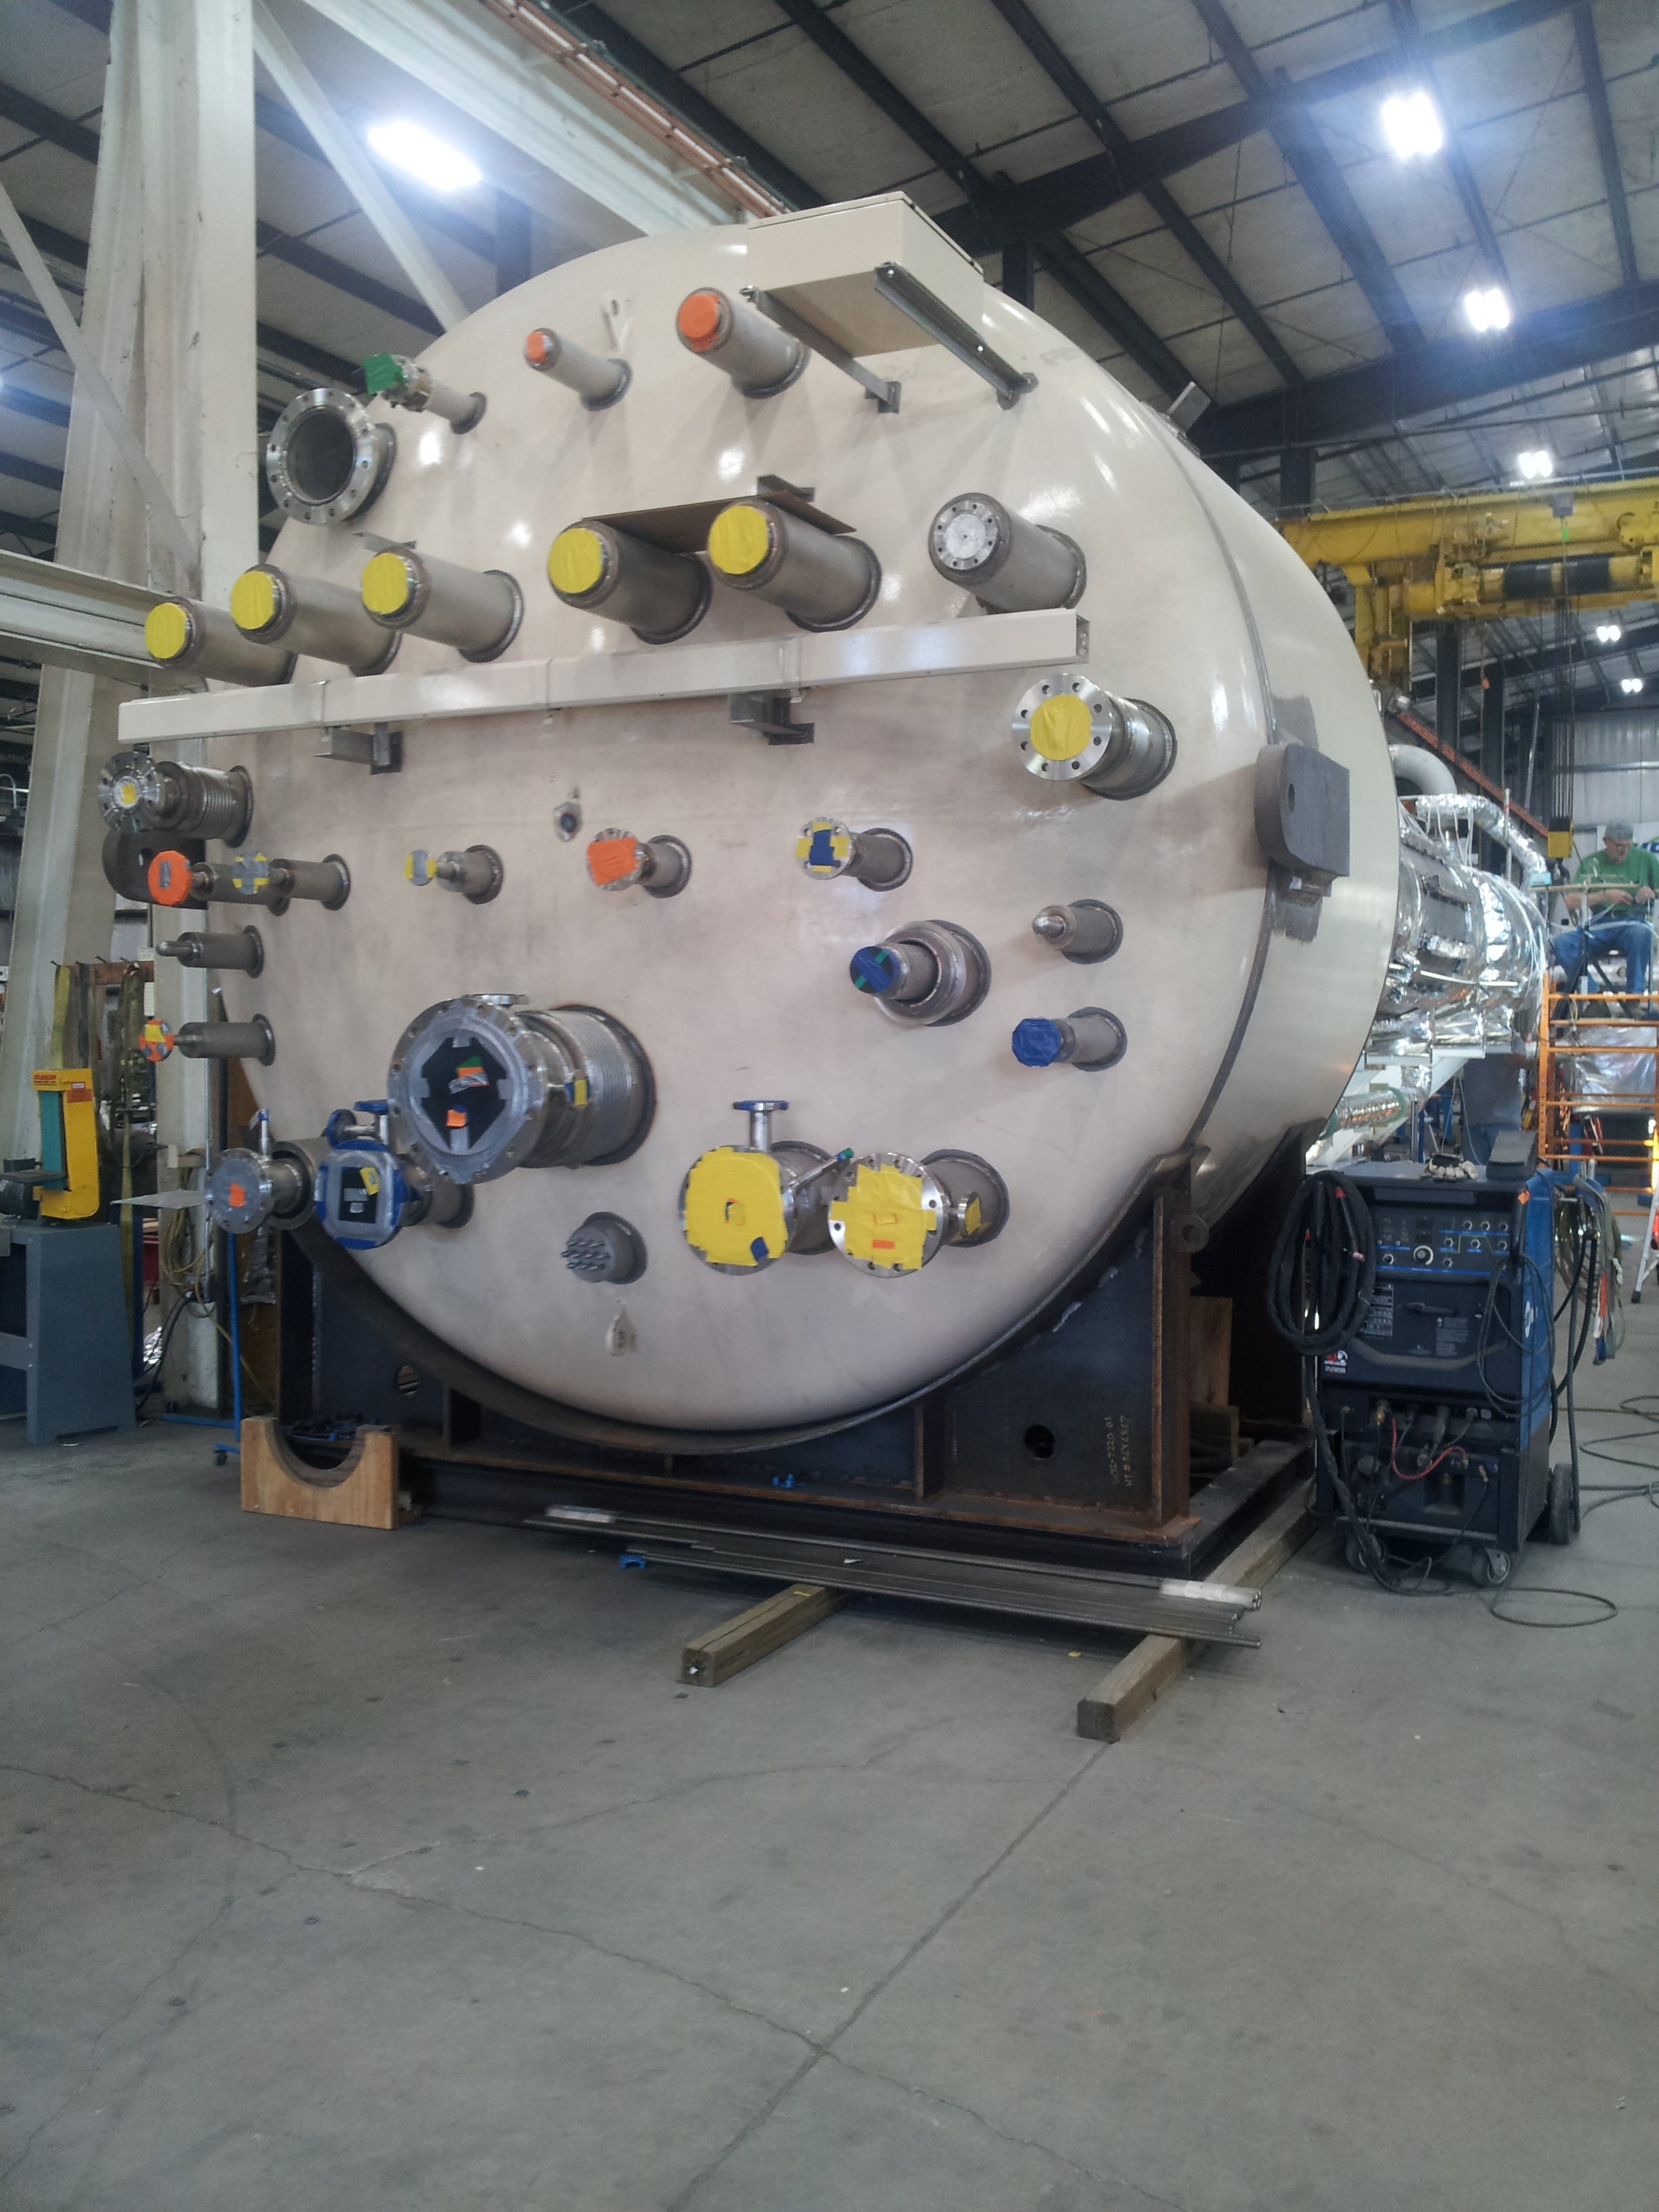

CP1 Upper Cold Box Top Head

The second CP#2 low pressure warm helium compressor skid was delivered to SLAC on Sept 19th and placed into storage. All equipment appeared arrive in good condition. The current compressors now at SLAC include all six CP#1 plant compressors and two of six CP#2 plant compressors.

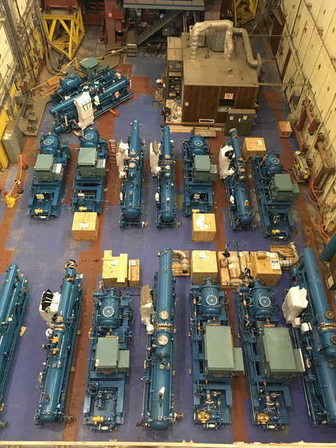

Cryoplant #1 & #2 Warm Helium Compressors in Storage at SLAC

All four cryogenic turbine pods (to be reassembled on site to the 4.5K cold box) are being air shipped to SLAC for Cryoplant #1 on Sept 20th. Coordination with SLAC for the shipment is in place. Turbine cartridges will be held at Air Liquide until cold box reassembly.

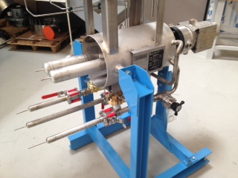

One of Four CP#1 Turbine Pods

The Guard Vacuum Skid and two Helium Recovery Compressor skids fabrication are nearly complete at JLab. SLAC electrical safety group will be visiting JLab to inspect the skids prior to shipping in October.

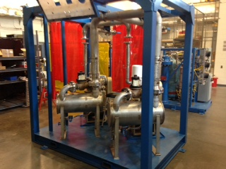

LCLSII Guard Vacuum Skid

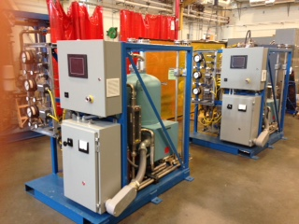

LCLSII Helium Recovery Compressors

Work continued to develop three presentations for the LCLSII FAC Review at SLAC for Sept 16-28th. The talks include the Cryoplant Status Overview, Engineering, and Commissioning Plan.

**QUALITY**:

Preparing for the witness point #15 leak test of the CP#1 Upper Cold Box.

**Upcoming Travel/Reviews:**

FAC Review Sep 26-28

2K Cold Compressor Run Witness Test, MECOS, France, Nov 6-10

Weekly Reporting

WBS 1.02.03.05.12 LLRF

Week of September 14-20, 2017

**Issues:** None

**Accomplishments this week at JLab:**

* LLRF Coordination/Documentation:
  + LERF project: The LERF kick off meeting went well. Additional meetings are planned at SLAC, next week (Curt H.), week of October 2 (Kevin and Wes).
  + LERF Controls: Wes will have a conference calls later in the week with Jingchen Zhou and Patrick Pascual to discuss the controls environment.
  + BCS: We met last Friday with Joe and Matt to discuss the work and the next steps. John and Trent are finishing up the conceptual design report.
  + Resonance/Interlock chassis: We have been given the go ahead to combine what is left of the cavity interlocks into the resonance chassis. We plan to keep the interlock and resonance chassis design stable for the 3.9 GHz system, but for the 1.3 GHz system it will be a new design.
* Resonance/Interlock Chassis:
  + Jeff Lyons is working on the modified FMC board. The plan is to finish the schematic this week and begin layout next week.
  + Lori is modifying the power supply distribution board and should be ready for review tomorrow.
  + Savy is modifying the coupler, vacuum and UPS (new) board and should be done Friday.
  + Rama and Savy will get back to the test bench when the modified boards are complete.

* Interlock Board/Chassis:
  + Onish Kumar is working on the ADC portion of the FEP board. He has been delayed by CEBAF projects which have just ended.
* Common Power Supply/Chassis/Boards:
  + Manny is still testing the 6V/40A power supply.

* CMTF
  + PRC/RFS: Couplers and switches which are due in by mid-September.
  + CM03 is has been warmed up to make some HOM adjustments. It will be cooled down in two weeks and we will pick up where we left off with resonance testing.

**Upcoming Activities:**

* FAC at the end of September 26/27/28.