Weekly Reporting

WBS 1.01.07 JLAB Management

Week of September 21-27, 2017

**Issues:**

**Accomplishments this week:**

Conducted 1.04 Performance Review Meeting.

STL, CAMs and others attending FAC review at SLAC September 26-28.

Preparing multiple BCRs and a ETC to be presented in September business.

**Upcoming Activities:**

Weekly Reporting

WBS 1.04.06 JLAB Cryomodules

Week of September 21-27, 2017

**Issues**:

**Accomplishments this week:**

LERF:

* Preliminary safety assessment complete & submitted to EHS&Q.
* Met with Fire Safety - additional 8 “tees & heads” will be cut into existing piping in the vault.
* Waveguide layout >95% complete, will place requisition ~ 1 week.
* Preparing for visit to SLAC Oct 4-6.
* Had preliminary cryogenic transfer line review.

Participated in FAC meetings at SLAC.

Prepared VARs for August.

Preparing BCR for fabrication of up to 133 replacement cavities.

Zanon is proceeding with restart and rework plans. Updated delivery schedule was provided for 75 cavities. Contract is being modified to reflect incentives for performance and delivery.

pCM (J1.3-1) at FNAL, has been cooled down and is undergoing cold testing.

CM02 – In storage.

CM03 at WS-5: The CM has been removed from CMTF for HOM retuning. FNAL expert is on-site and guiding HOM retuning effort.

CM04 at WS-5: End cap in place. Ports opened for HOM retuning. Instrumentation flanges in progress. Warm couplers in progress.

CM05 at WS-3: Cavity 1 retuned. Tuner installation is in progress. RF cable installation is in progress. Vacuum vessel degaussed.

CM06: Full disassembly is completed. Cavities and couplers set aside for reprocessing. Lollipops returned for string assembly.

CM07 at WS-2: Idle.

CM08: Preparation for string assembly was delayed due to concerns with FE observed in CM03. String build start date is TBD based on results from FE and particulate studies on bellows.

CM09: Eight cavities qualified for string.

Cavity 128 (NX-C, 975 deg C) in D8, first test, Quench limited at 17.8 MV/m, Q0(16)=23.3e10, FE free, Not qualified for string.

Cavity 116 in D5, additional test after qualification for string, Admin limited at 24 MV/m, Q0(16) is low, FE free, Suspect that bellows attached to cavity is magnetic. Qo(16) from previous test was 2.7e10.

Cavity 125 in D5, first test, Admin limited at 24.1 MV/m, Q0(16)=2.5e10, FE free, Qualified for string.

Cavity 106 in D5, first test, Quench limited at 20.2 MV/m, Q0(16)=4.1e10, FE free, Qualified for string.

JLab has launched a development effort to understand the impact of cu-plated bellows on particulate generation. Cavity 116 was tested. Bellows will be actuated without breaking vacuum then cavity will be vertically tested next week.

**QUALITY**:

No report.

**Upcoming Travel/Meetings:**

FAC at SLAC 26-28 September – (Daly, Wilson)

LERF Mtg at SLAC Oct 4-6 (Jordan, Moore)

Zanon Vendor Visit Oct 9-14 (Park)

WUXI Vendor Visit to China Dec 4-8 (Cheng, Legg)

Kubara Lamina Vendor Visit Nov 7 (Park, Stirbet, Daly)

Weekly Reporting

WBS 1.04.08 JLAB Cryoplant System

Week of September 21-27, 2017

**Issues:**

**Accomplishments this week:**

During the past week PHPK reported a difficulty in mounting RTD temperature sensors within the CP#1 Upper Cold Box. Along with ALATUS and PHPK, a design solution accepted by all was developed and was in the process of being implemented. The devices for the solution were sent to the vendor and manufacturing can now be continued. Mounting of the sensors is key to continuing the completion of leak and pressure testing of the cold box as the next step. While the sensor implementation is conducted work continues on the upper box to blank off piping for the leak and pressure test as well as completing the fabrication of the lower vacuum shell for the future overall combined leak test.

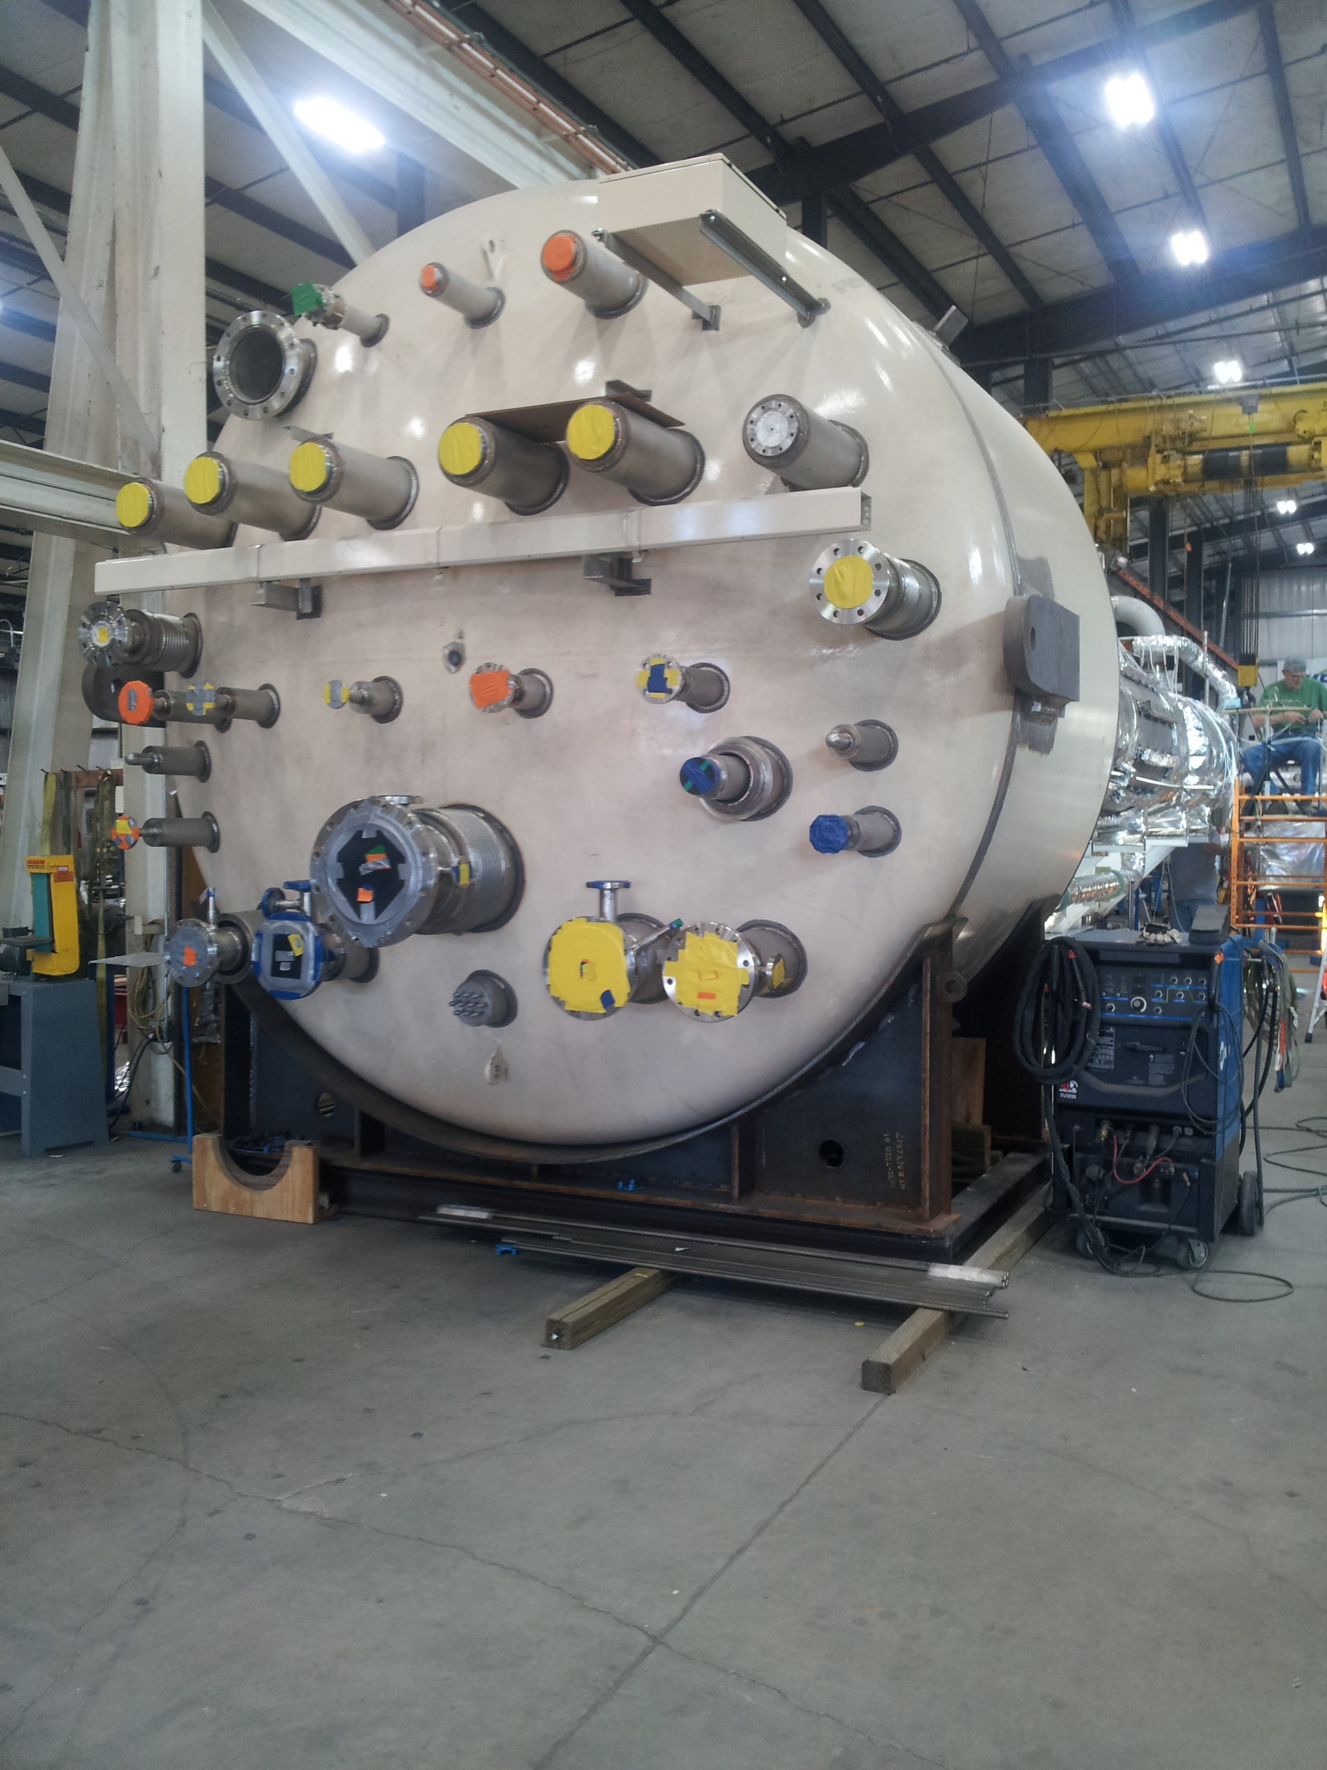

CP1 Upper Cold Box Top Head

The third CP#2 low pressure warm helium compressor skid delivery was requested by SLAC to be delayed until cryoplant BOD ~Oct 16th.

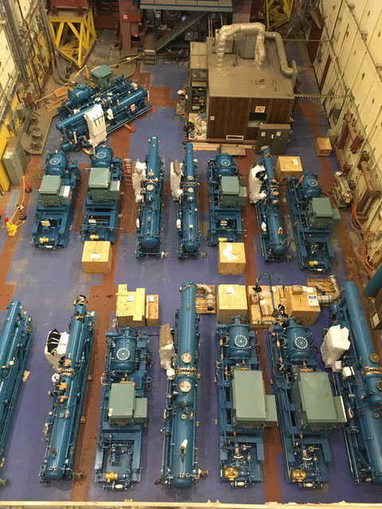

Cryoplant #1 & #2 Warm Helium Compressors in Storage at SLAC

All four cryogenic turbine pods (to be reassembled on site to the 4.5K cold box) are being air shipped to SLAC for Cryoplant #1 on Sept 20th. Coordination with SLAC for the shipment is in place. Turbine cartridges will be held at Air Liquide until cold box reassembly. SLAC is waiting on the delivery.

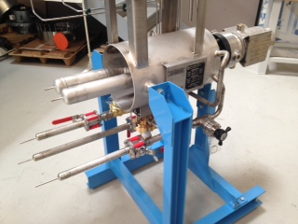

Work continued to present three presentations for the LCLSII FAC Review at SLAC for Sept 16-28th. The talks included the Cryoplant Status Overview, Engineering, and Commissioning Plan.

**QUALITY**:

Preparing for the witness point #15 leak test of the CP#1 Upper Cold Box.

**Upcoming Travel/Reviews:**

2K Cold Compressor Run Witness Test, MECOS, France, Nov 6-10

Weekly Reporting

WBS 1.02.03.05.12 LLRF

Week of September 21-27, 2017

**Issues:** None

**Accomplishments this week at JLab:** Participating in the FAC this week.