Weekly Reporting

WBS 1.01.07 JLAB Management

Week of September 28-October 4, 2017

**Issues:**

**Accomplishments this week:**

Participated in surveillance dry runs.

Conducted progress meetings for 1.04.06 CM and 1.04.08 CP WBSs.

STL, CAMs and others attended FAC review at SLAC September 26-28.

4.5K CB Schedule Alignment BCR was approved.

Preparing multiple BCRs and a ETC to be presented in October business.

**Upcoming Activities:**

Weekly Reporting

WBS 1.04.06 JLAB Cryomodules

Week of September 28-October 4, 2017

**Issues**:

**Accomplishments this week:**

Participated in FAC meetings at SLAC.

Prepared monthly status for September.

Preparing BCR for fabrication of up to 133 replacement cavities. PR has been submitted. Need to confirm quantity of replacement cavities.

Preparing BCR for reprocessing of String 06 couplers at vendor.

Zanon is proceeding with restart and rework plans. Considering awarding optional cavities to Zanon to improve cavity delivery schedule during Spring 2018.

pCM (J1.3-1) at FNAL, has been cooled down and is undergoing cold testing. Main point of testing was to verify Qo improvement due to fast cooldown. Initial results confirm that Qo has improved with ~32 g/s cooldown rate.

CM02 – In storage.

CM03 at WS-5: Re-tuning out of spec HOM’s. Investigation of cavity 4 coupler heating in progress. Retuned cavity 1 in-situ. Plan to install in Test Cave by the end of this week. Cooldown planned to start on 11-Oct.

CM04 at WS-5: End cap in place. Ports opened for HOM retuning. Instrumentation flanges in progress. Warm couplers in progress. Beampipe assembly complete.

CM05 at WS-4: Tuner installation is complete. String alignment verified. Moved to WS04.

CM06: Full disassembly is completed. Lessons learned; new installation tooling and technique. Working with SRF Engineering to develop additional, engineered protection.

CM07 at WS-2: Pressure test of weld repair on upper cold mass from J1.3-06 complete. Upper cold mass from J1.3-06 moved so it can be mated to cavity string 7; clears west assembly rail for cavity string 8.

CM08: Preparation for string assembly was delayed due to concerns with FE observed in CM03. String build start date is tentatively 9-Oct. Bellows will be high-pressure rinsed, mechanically cycled and verified as clean via particle counters prior to installation in the string. Roll-out scheduled for 20-Oct.

CM09: Eight cavities qualified for string.

Cavity 288 (NX-A) in D7, first test, Admin limited at 24 MV/m, Q0(16)=3.1e10, FE on 19.4MV/m. Although qualified, due to concerns with FE this cavity will be rinsed and re-tested.

Cavity 268 (TD) in D8; retest due to low Q0 in D5, Quench limited at 17.3 MV/m, Q0(16)=2.7e10, FE processed away, Major NCR.

Cavity 113 (NX-A) in D7, Quench limited at 22.3 MV/m, Q0(16)=2.8e10, FE free, Qualified.

Cavity 097 (NX-A) in D8, Quench limited at 20.2 MV/m, Q0(16)=3.0e10, FE free, Qualified.

Cavity 284 (NX-A) in D8, Quench limited at 15 MV/m, Q0(15)=2.5e10, FE free, Major NCR.

Vertical test planning for the next 7 days: Cavities 278/286/116 in D5 (bellows cleanliness testing), Cavity 279 in D7 (retest due to previous low Q0 in D5), Cavity 281 in D8 (retest due to previous low Q0 in D5).

JLab has launched a development effort to understand the impact of cu-plated bellows on particulate generation. Cavity 116 was tested. Bellows was actuated and cavity will be re-tested in D5. The other two cavities in D5 have HPR’d bellows installed atop the cavity for vertical testing. The cavities were not horizontally assembled.

Majority of parts for fast cooldown flex u-tubes are in-hand at JLab. Assembly will start once balance of parts arrive.

**QUALITY**:

No report.

**Upcoming Travel/Meetings:**

LERF Mtg at SLAC Oct 17-19 (Jordan, Moore)

Visit FNAL to witness pCM testing Oct 2-5 (Solopova)

Zanon Vendor Visit Oct 5-13 (Park)

WUXI Vendor Visit to China Dec 4-8 (Cheng, Legg)

Kubara Lamina Vendor Visit Nov 7 (Park, Daly)

Weekly Reporting

WBS 1.01.07 JLAB Management

Week of September 28-October 4, 2017

**Issues:**

**Accomplishments this week:**

**LERF:**

Preliminary Safety Assessment for testing CMs in the LERF completed and submitted.

Waveguide layout closing in on completion, hope is to have a review and submit requisition in the next week.

Location of the SSAs in the gallery has passed egress review.

Entire LERF transferline is being warmed up to accommodate the CM shuffle.

Created a WIKI site for documentation: wiki.jlab.org/lerf

**Upcoming Activities:**

Move portable clean hood to LERF vault (from CEBAF) and secure the CM beamline vacuum of the existing three CMs.

Weekly Reporting

WBS 1.04.08 JLAB Cryoplant System

Week of September 28-October 4, 2017

**Issues:**

**Accomplishments this week:**

Plans continue to attend the witness test for leak and pressure testing of the CP#1 Upper Cold Box the week of Oct 9th at PHPK. Plans also include an additional process line trace in accordance with the cold box Process and Instrumentation Diagram (P&ID) to insure fabrication compliance.

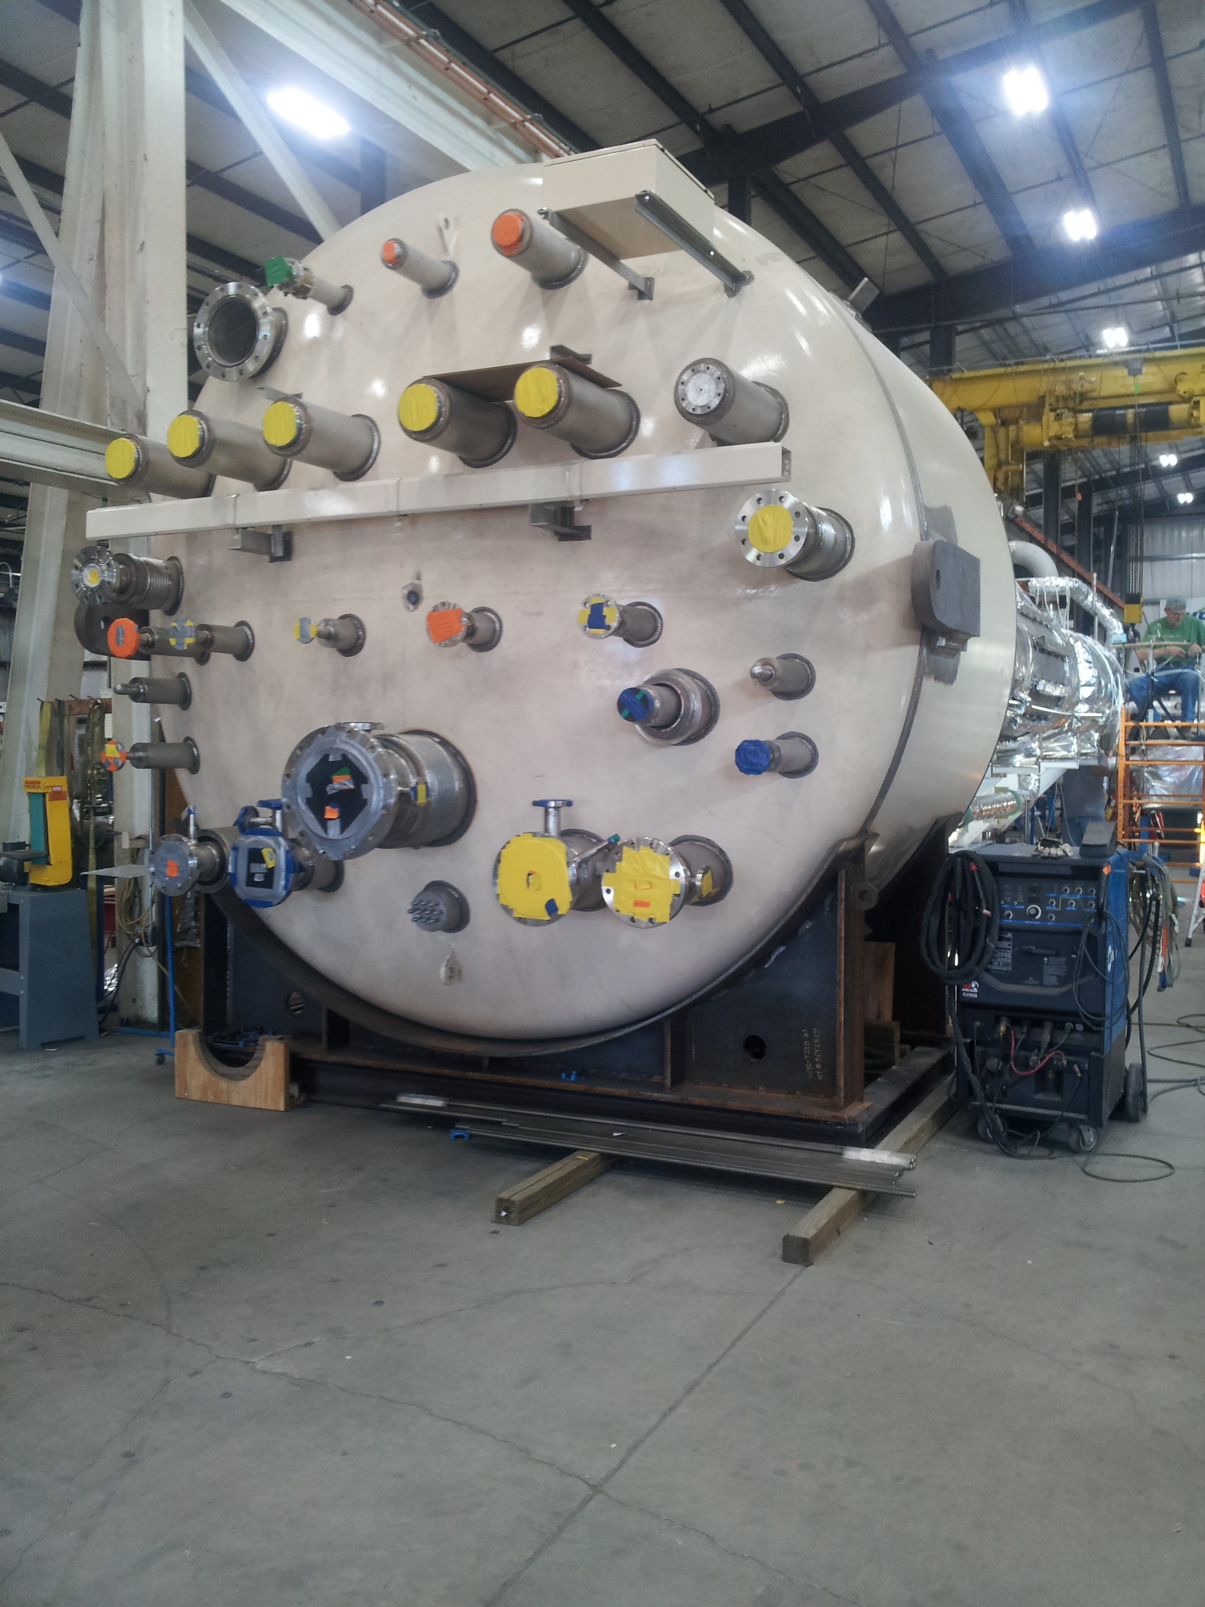

CP1 Upper Cold Box Top Head

Vacuum shells for the CP#2 Upper Cold Box has been moved from PHPK storage to Mid-Ohio for painting in preparation of starting the assembly of the CP#2 Cold Box.

A third and fourth CP#2 low pressure warm helium compressor skid delivery was requested by SLAC to be delayed until cryoplant BOD ~Oct 16th.

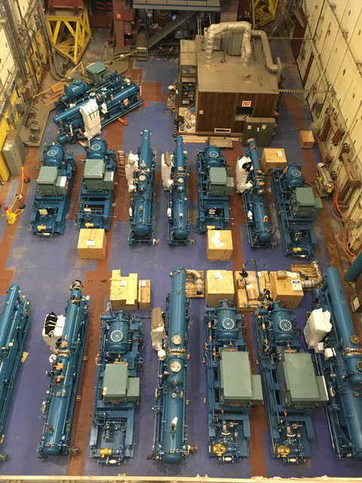

Cryoplant #1 & #2 Warm Helium Compressors in Storage at SLAC

Four cryogenic turbine pods (to be reassembled on site to the 4.5K cold box) were received and stored at SLAC for Cryoplant #1. Slight wooden damage was noted on one create but visual inspection of the contents did not indicate the contents were damaged in any way.

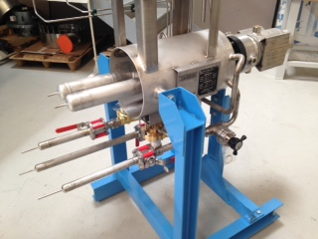

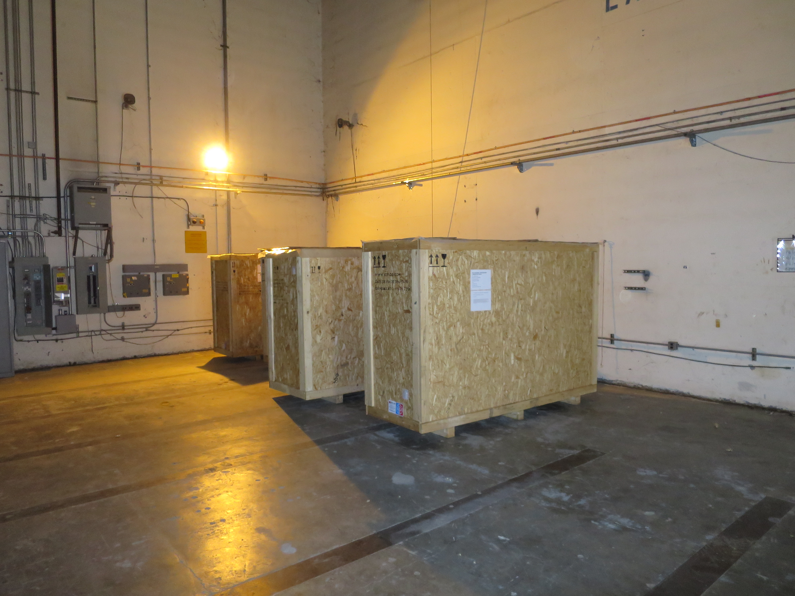

Crated Turbine Pods in Storage at SLAC

Three presentations for the LCLSII FAC Review at SLAC were presented on Sept 16-28th. The talks included the Cryoplant Status Overview, Engineering, and Commissioning Plan.

**QUALITY**:

Conducted final review of the oil removal vessels for CP#1 in preparation of shipment to SLAC ~Oct 16th.

**Upcoming Travel/Reviews:**

Vendor Visit to Eden, Ohio, Oct 11, Oil Removal Vessels

2K Cold Compressor Run Witness Test, MECOS, Switzerland, Nov 10-11

Weekly Reporting

WBS 1.02.03.05.12 LLRF

Week of September 28-October 4, 2017

**Issues:** None

**Accomplishments this week at JLab:**

* LLRF Coordination/Documentation:
  + LERF project: Met with SLAC LERF hardware and software contacts last week. Alex Ratti presented and ICD defining the roles and responsibilities of both labs. This document is in review.
  + BCS: Christine had a conference call with SLAC people and JLAB (Trent, John and myself). Trent is finishing up the conceptual design report and we are discussing how to proceed with Trent leaving. We need $20k to complete the project.
* Resonance/Interlock Chassis:
  + Jeff Lyons finished the schematic and layout of the FMC board. He is working on the routing and it should be ready for review by early next week.
  + Power supply distribution board is ready to go out to manufacture.
  + Coupler, vacuum and UPS (new) board is ready for manufacture.
  + Savvy is working on the test bench.
* Interlock Board/Chassis:
  + Onish Kumar continues to be saddled with higher priority projects and we are moving the FEP board to Savvy.
* Common Power Supply/Chassis/Boards:
  + The 6V/40A power supply tested fine.
  + We are waiting on the 7V/40A power supply which was ordered last week.
* CMTF
  + Held meeting with Larry King to discuss what needs to be completed so that the RFS/PRC can be made operational. After CM03 is removed from the test cave we will begin installing the cables, couplers and switches (early November).
  + CM03 is being cooled down at the end of next week and should be cold through 10/31. We have asked for test time to ring out the piezo tuners.

**Upcoming Activities:**

* CM03 Resonance tests (end of October)