Weekly Reporting
WBS 1.01.07 JLAB Management
Week of October 5-11, 2017

Issues:
Accomplishments this week:
This is the last week of work for one of our procurement staff members and we are transferring all activities to other staff members.
Completed dry runs for surveillance review.
Presented to SLAC project management our SRF cavity procurement strategy to get cavities of sufficient quantity as fast as possible.
Continue to work on procurements for the 2+2 cryomodule parts. The majority are in process already.
C03 started cooldown in the CMTF.
Released the RFP for the HEP machine.
Upcoming Activities:

Weekly Reporting
WBS 1.04.06 JLAB Cryomodules
Week of October 5-11, 2017

Issues: Transfer of HOM tuning procedure from FNAL to JLab is impacting CM assembly progress.
Accomplishments this week:
Conducted BCR facilitation meeting covering path forward for reworking cavities including schedule recovery options. Focused on BCR for fabrication of up to 133 replacement cavities. Working with JLab procurement to prepare RFP package.
Preparing BCR for reprocessing of String 06 couplers at vendor.
Zanon is proceeding with restart and rework plans. Shipment schedule was reviewed at PCCM. H. Park is currently on-site monitoring vendor processes and procedures.
Continuing to pursue option for 16 cavities from Zanon using a subset of the 133 material when available.
RI is making progress with cavities 134 and above. Shipment schedule was reviewed at PCCM.
pCM (J1.3-1) at FNAL, where cold testing is complete. pCM is being prepared for return shipment in early November after load testing of JLab shipping frame at FNAL.
A. Solopova visited FNAL to witness pCM testing and discuss FNAL’s HOM tuning procedures.
Discussed minor issue of axial position of several cavities in CM02, CM03 and CM04. Approximately two cavities per CM exceed the axial position tolerance by 0.5 mm. NCRs have been written. Project direction is to use as is rather than disassembly and re-alignment.
CM02 – In storage.
CM03 at CMTF: Investigated cavity 4 coupler heating. Completed this round of HOM measurements. Cryomodule moved into CMTF, aligned and being prepped for cooldown to start 11-Oct.
CM04 at WS-5: Ports opened for HOM retuning. Pressure tests complete. Warm couplers final installation in progress. Beam pipe assembly complete.
CM05 at WS-4: Instrumentation In progress. On hold for HOM tuning.
CM06: Full disassembly is completed. Plan for re-assembly after CM13.
CM07 at WS-3: String has been rolled out under to WS3. UCM from CM06 has been moved and re-aligned to East rail fixture. De-magnetized all bearings and hangers. Discussing with FNAL procedure to transfer gate valve load to tuner arms. Two-phase piping in progress. Install needle bearing supports between UCM and cavities.
CM08: String build started 9-Oct. Bellows will be high-pressure rinsed, mechanically cycled and verified as clean via particle counters prior to installation in the string. Roll-out scheduled for 20-Oct.
CM09: Eight cavities qualified for string. Preparation for string assembly will begin 23-Oct. String build planned for 30-Oct with roll-out tentatively 10-Nov.
CM10: Two cavities qualified for string.
Cavity 279 (TD) in D7 (re-test due to previous low Q0 in D5), Admin limited at 24 MV/m, Q0(16)=2.6e10, FE free, Qualified.
Cavity 281 (TD) in D8 (re-test due to previous low Q0 in D5), Admin limited at 24 MV/m, Q0(16)=2.7e10, FE free, Qualified.
Vertical test planning for the next 7 days: 276 (TD-950) in D8 (first test), L2-288 (NX-A) in D7 (re-test due to FE at 19MV/m, full disassembly), L2-295 (NX-B) in D8 (first test).
JLab has launched a development effort to understand the impact of cu-plated bellows on particulate generation. Cavity 116 was re-tested after bellows was actuated in D5. The other two cavities retested in D5 have HPR’d bellows installed atop the cavity for vertical testing. The cavities were not horizontally assembled. Results below.
Cavity 116 (NX-A) in D5 (exercised bellows attached to cavity under vacuum), Admin limited at 24 MV/m, Q0(16)=1.8e10 likely due to bellows/fasteners, FE free.
Cavity 286 (NX-A) in D5 (HPR and VTRF with bellows on top), FE onset at 8.6MV/m, A single quench at 6.5MV/m, then self recovered.
Cavity 278 (TD) in D5 (HPR and VTRF with bellows on top), Possible cable issue, FE onset early.
Majority of parts for fast cooldown flex u-tubes are in-hand at JLab. Assembly will start once balance of parts arrive.
QUALITY:
Submitted September version of Significant NCR report to Mike Skonicki at SLAC. Only change was the addition of NCR 1085 (leaking valve seal, reworking string).

Replacement hire for LCLS-II QA Engineer was posted for a two-year term. Names have been gathered for an interview team and the process will start in the next two weeks.

Upcoming Travel/Meetings:
LERF Mtg at SLAC Oct 17-19 (Jordan, Moore)
Zanon Vendor Visit Oct 5-13 (Park)
WUXI Vendor Visit to China Dec 4-8 (Cheng, Legg)
Kubara Lamina Vendor Visit Nov 7 (Park, Daly)

Weekly Reporting
WBS 1.01.07 JLAB Management
Week of October 5-11, 2017

Issues:
LERF accomplishments this week:
Preliminary Hazard Analysis for testing CMs in the LERF signed off & posted
Safety Assessment document is in progress
Waveguide layout finished and was reviewed
Clean hood was moved to tunnel so CEBAF style modules vacuum can be secured
480/208/120 AC power was removed from RF Zones 3 & 4, these no longer need to be locked out
Continued work on WIKI site for documentation: wiki.jlab.org/lerf
Upcoming Activities:
Move portable clean hood to girders and secure the CM beamline vacuum of the existing three CMs.
Begin to remove klystrons from racks in zone 3 & 4.
Complete Safety Assessment document.
SLAC visit October 17-19.

Weekly Reporting
WBS 1.04.08 JLAB Cryoplant System
Week of October 5-11, 2017
Issues:
Accomplishments this week:
The CP#1 Upper Cold Box completed its process line pressure test. JLab and SLAC traveled to PHPK in Columbus to witness the CP#1 Upper Cold Box piping leak testing. Plans also included an additional process line trace in accordance with the cold box Process and Instrumentation Diagram (P&ID) to insure fabrication compliance. The lower shell of the cold box has been positioned next to the Upper Cold Box as the next assembly activity.

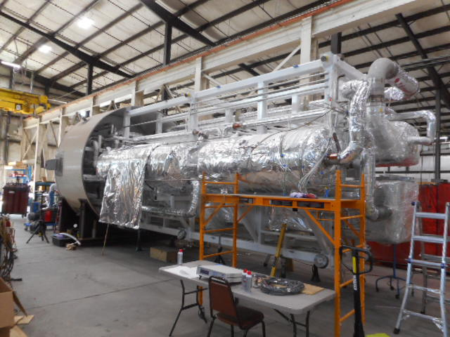
CP1 Upper Cold Box.

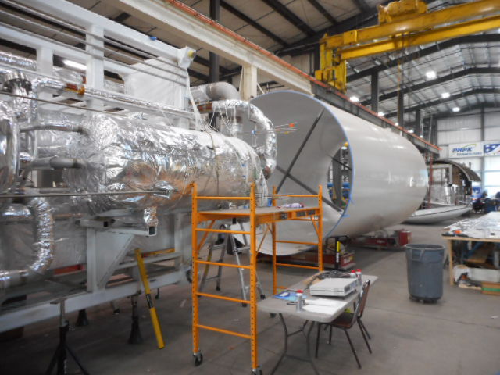
Vacuum Shell Ready for Next Assembly Step.

Vacuum shells for the CP#2 Upper Cold Box has been moved from PHPK storage to Mid-Ohio for painting in preparation of starting the assembly of the CP#2 Cold Box.

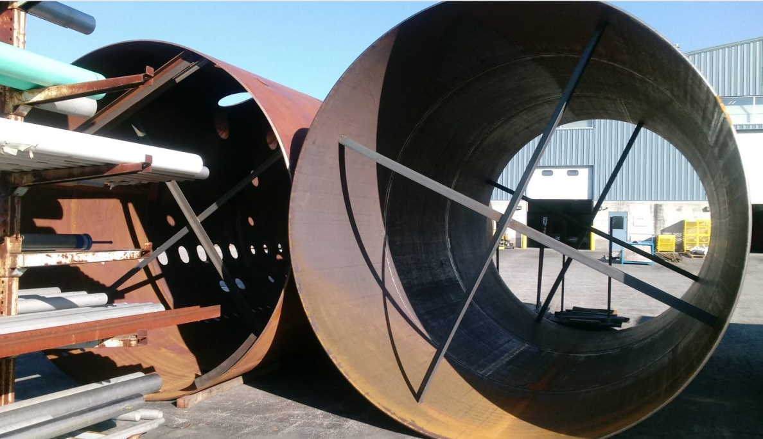

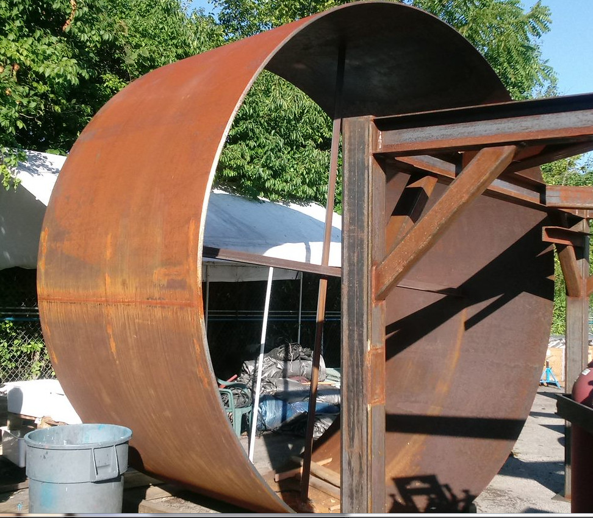
Vacuum Shells to be Painted.

A third and fourth CP#2 low pressure warm helium compressor skid delivery was requested by SLAC to be delayed until cryoplant BOD ~Oct 16th. A CP#2 medium pressure compressor is scheduled to be shipped to SLAC on Oct 23rd followed by a CP#2 low pressure compressor on Oct 24th. This will bring the full total of compressor to 9 out of the 12 which has been delivered to SLAC with only 3 CP#2 compressors to be delivered

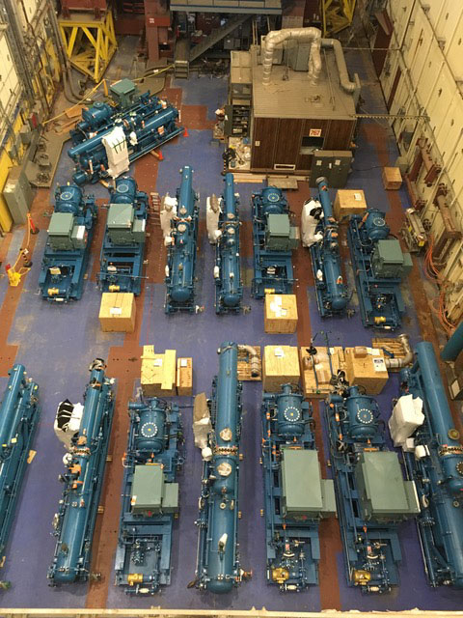
Cryoplant #1 & #2 Warm Helium Compressors in Storage at SLAC.

The CP#1 Lower Cold Box Upper Shell has been mounted to the top of the internal supporting frame structure which supports the internal heat exchangers and piping.
Work has begun on the installation of the internal piping by first tack welding the preassembled piping spools into place prior to the final welding and insulating.

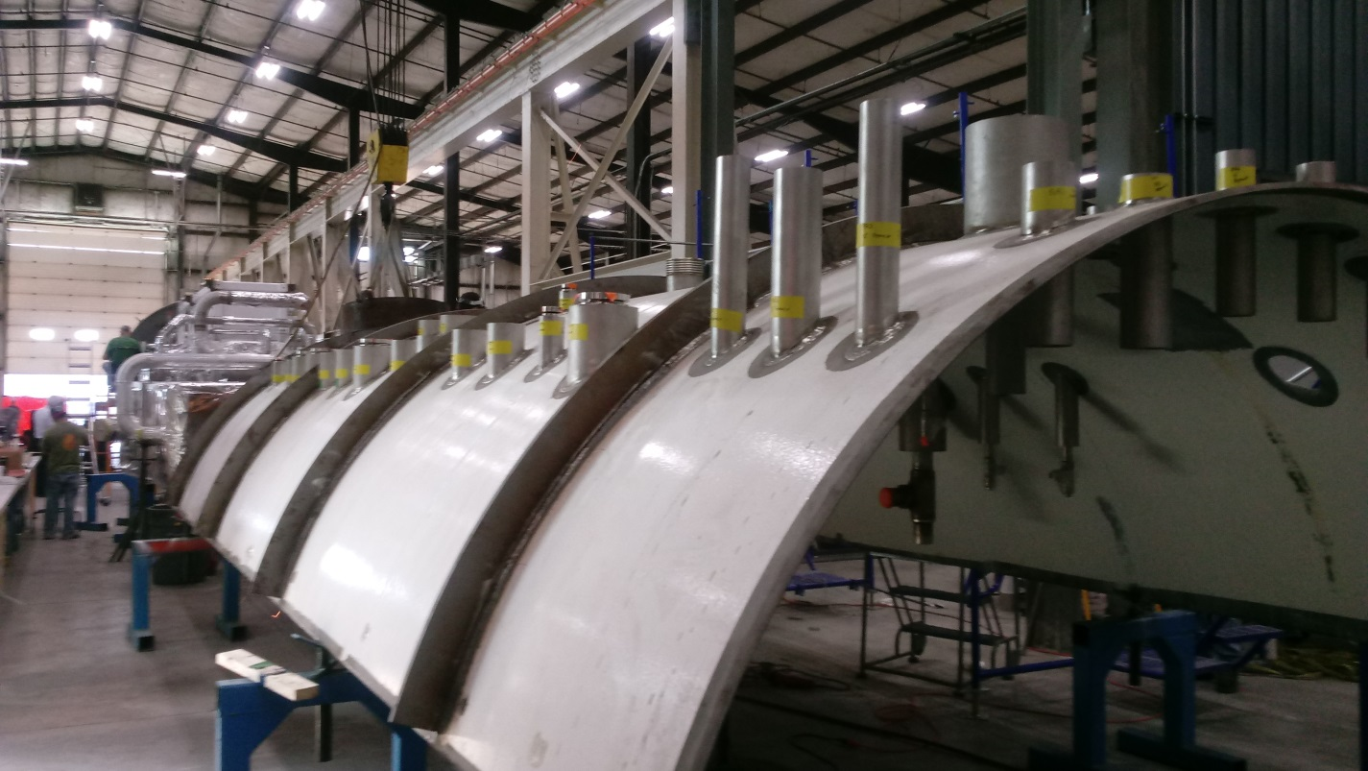

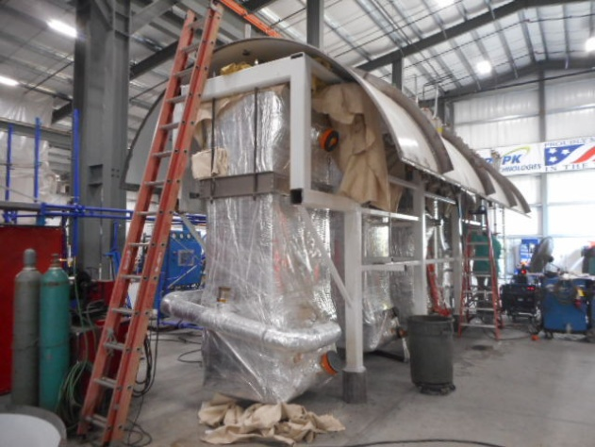
CP#1 Lower Cold Box Upper Shell Mounting to internal Support Structure.

JLab engineering and procurement visited Eden located in Columbus OH to inspect the progress of the oil removal vessels fabrication readiness for shipment in the upcoming weeks.

Two BCRs were in the process of development, 2K Cold Box Redesign scheduled for presentation on Oct 12 and the Cryoplant Engineering EAC for Oct 19th.

Control hardware documentation was released to JLab procurement to begin the procurement process.

QUALITY:
Mike Martin, the site CWI, will be traveling to the UK to review a liquid helium dewar prior to its shipment.

Conducted final review of the oil removal vessels for CP#1 in preparation of shipment to SLAC ~Oct 16th.

Upcoming Travel/Reviews:
Vendor Visit to Eden, Ohio, Oct 11, Oil Removal Vessels
2K Cold Compressor Run Witness Test, MECOS, Switzerland, Nov 10-11

Weekly Reporting
WBS 1.02.03.05.12 LLRF
Week of October 5-11, 2017

Issues: None
Accomplishments this week at JLab:
- LLRF Coordination/Documentation:
  - LERF project: JLAB reviewed the LERF ICD and sent to Alex Ratti for review. The plan is to merge the edits (SLAC and JLAB) next week while Alex and I are at the LLRF workshop.
  - BCS: We met with FNAL (Brian Chase and Ed Cullerton) and discussed the BCS receiver. They are willing to take on the work and we believe this is a path forward. Another meeting is planned Thursday with SLAC to discuss the next steps.

- Resonance/Interlock Chassis:
  - Jeff Lyons finished the routing and Rama is reviewing. It will go out at the end of the week.
  - Power supply distribution board went out yesterday.
  - Coupler, vacuum and UPS (new) board will go out by the end of the week.

- Interlock Board/Chassis:
  - Onish Kumar will finish the FEP board by Friday, which includes routing.

- Common Power Supply/Chassis/Boards:
  - Installing and testing the 7V/40A power supply.

- CMTF/LERF
  - Installing the cables, couplers and switches will begin in early November.
  - CM03 is being cooled down now. We have asked for test time to ring out the piezo tuners.
  - Dave is getting the LLRF Captar together for the LERF. He has been obtaining the cable lengths needed in the LERF vault.
Upcoming Activities:
- CM03 Resonance tests (end of October)

