Weekly Reporting

WBS 1.01.07 JLAB Management

Week of October 12-18, 2017

**Issues:**

**Accomplishments this week:**

Transitioning the procurement responsibilities on multiple contracts due to attrition in the procurement department.

Presented the 2K CB Redesign BCR.

Preparing several other BCRs for October business including an EAC for the 1.4.8.5 WBS

Made good progress on the design of several CP components. Releasing the LN2 Transfer Line specification this week.

Have been receiving regular cavity deliveries from EZ.

**Upcoming Activities:**

Weekly Reporting

WBS 1.04.06 JLAB Cryomodules

Week of October 12-18, 2017

**Issues**: Transfer of HOM tuning procedure from FNAL to JLab is impacting CM assembly progress.

**Accomplishments this week:**

Conducted pre briefing and BCR facilitation meeting covering path forward for reworking cavities including schedule recovery options. Focused on BCR for fabrication of up to 133 replacement cavities. Working with JLab procurement to prepare RFP package.

Continuing to pursue option for 16 cavities from Zanon using a subset of the 133 material when available.

RI shipped the 1st of the option cavities.

CM02 – In storage.

CM03 at CMTF: Cooled down and high power rf testing has started.

CM04 at WS-5: Ports opened for HOM retuning. Warm couplers complete, Beam pipe assembly complete, Final leak check in progress

CM05 at WS-4: Instrumentation In progress. On hold for HOM tuning.

CM07 at WS-3: Assembled new long tuner arms and gate valve support fixture to accommodate bellows between cavity 1 and gate valve on evacuated beamline, 2 Phase piping in progress, Leak check of Vac Vessel 20 in progress

Cavity Tests;

* L2-276 Eacc admin limit (24MV/m), Q0(16)=3.8e10, FE onset 23 MV/m
* L2-288 retest Eacc admin limit (24MV/m), Q)(16)=2.9e10
* L2-295 Eacc admin limit (24MV/m), Q0(16)=3.1e10

CM08: String build start date Mon.,9 Oct. aborted due to moisture in two cavities after drying. String build re-started Monday, 16 October. String rollout scheduled for Friday, 27 October.

CM09: Eight cavities qualified for string. String build planned for 6-Nov. with roll-out tentatively 17-Nov.

**QUALITY**:

**Upcoming Travel/Meetings:**

LERF Mtg at SLAC Oct 17-19 (Jordan, Moore)

RI & Zanon Vendor Visit Oct 31-Nov 9 (Palczweski)

RI & Zanon Vendor Visit Nov 1-7 (Wilson, Laney)

Kubara Lamina Vendor Visit Nov 7 (Park, Daly)

Zanon Vendor Visit Nov 8-11 (Park)

WUXI Vendor Visit to China Dec 4-8 (Cheng, Legg)

Weekly Reporting

WBS 1.01.07 JLAB Management

Week of October 12-18, 2017

**Issues:**

**LERF accomplishments this week:**

Results from the waveguide design review have been posted to:  
<https://wiki.jlab.org/lerf/index.php/Oct_11_2017_WG>

Safety Assessment document is in progress.

Waveguide purchase requisition submitted and signed off, procurement will use many of the documents from the LCLS-II waveguide procurement to expedite the award of this contract.

CEBAF style modules vacuum is being secured, clean room tent (w/gowning room) is in place for this activity. Once the modules have been isolated from the adjacent quad girders two of the modules will be removed for use in CEBAF and the remaining one will be relocated to the first position and reconnected for Q0 studies.

The 480 VAC panel work has started for the SSA power.

Visit to SLAC to discuss many topics, including the network & computing architecture is in progress. Last week a note was sent out with briefing questions so all are ready make this a productive trip.

**Upcoming Activities:**

Cryomodule shuffle.

Begin to remove klystrons from racks in zone 3 & 4.

Complete Safety Assessment document.

Write up & document computer hardware & network architecture.

Weekly Reporting

WBS 1.04.08 JLAB Cryoplant System

Week of October 12-18, 2017

**Issues:**

**Accomplishments this week:**

JLab and SLAC traveled to PHPK in Columbus to witness the CP#1 Upper Cold Box piping leak testing. One leak was discovered and plans are to identify location and repair. Remaining work includes proceeding with the installation of the outer vacuum shell for final leak test. Plans also included an additional process line trace in accordance with the cold box Process and Instrumentation Diagram (P&ID) to insure fabrication compliance. The lower shell of the cold box has been positioned next to the Upper Cold Box as the next assembly activity.

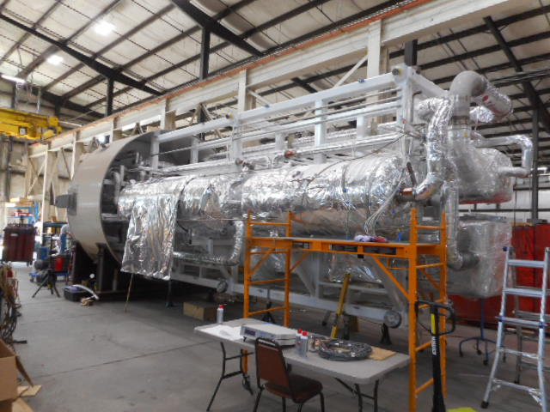

CP1 Upper Cold Box.

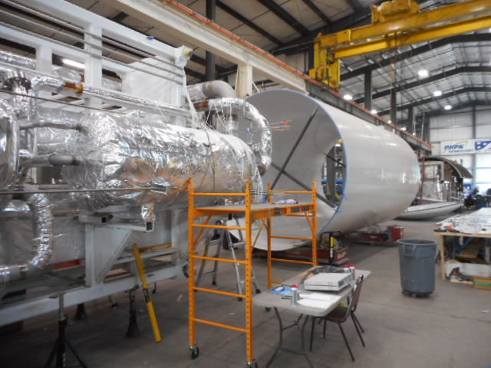

Vacuum Shell Ready for Next Assembly Step.

Vacuum shells for the CP#2 Upper Cold Box has been moved from PHPK storage to Mid-Ohio for painting in preparation of starting the assembly of the CP#2 Cold Box.

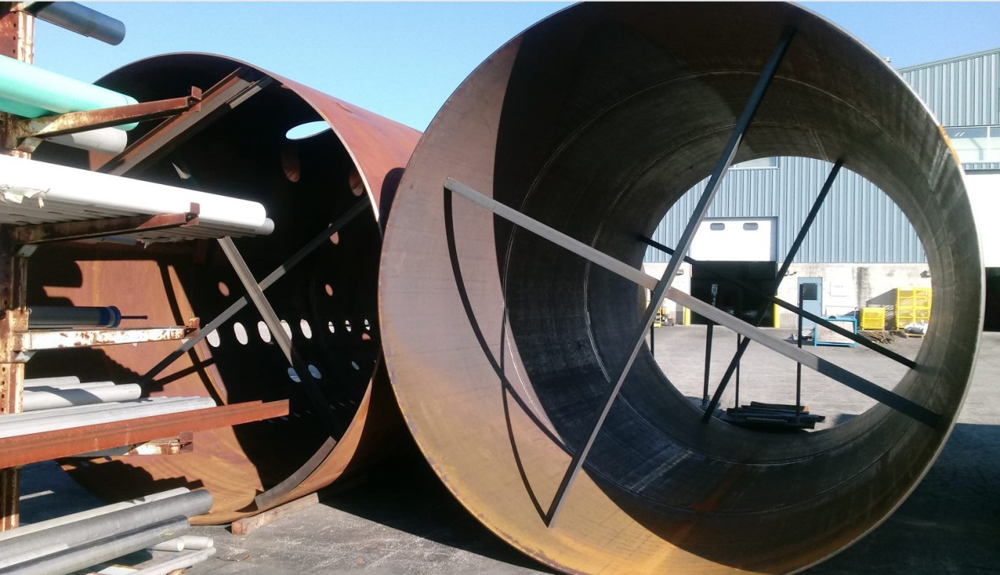

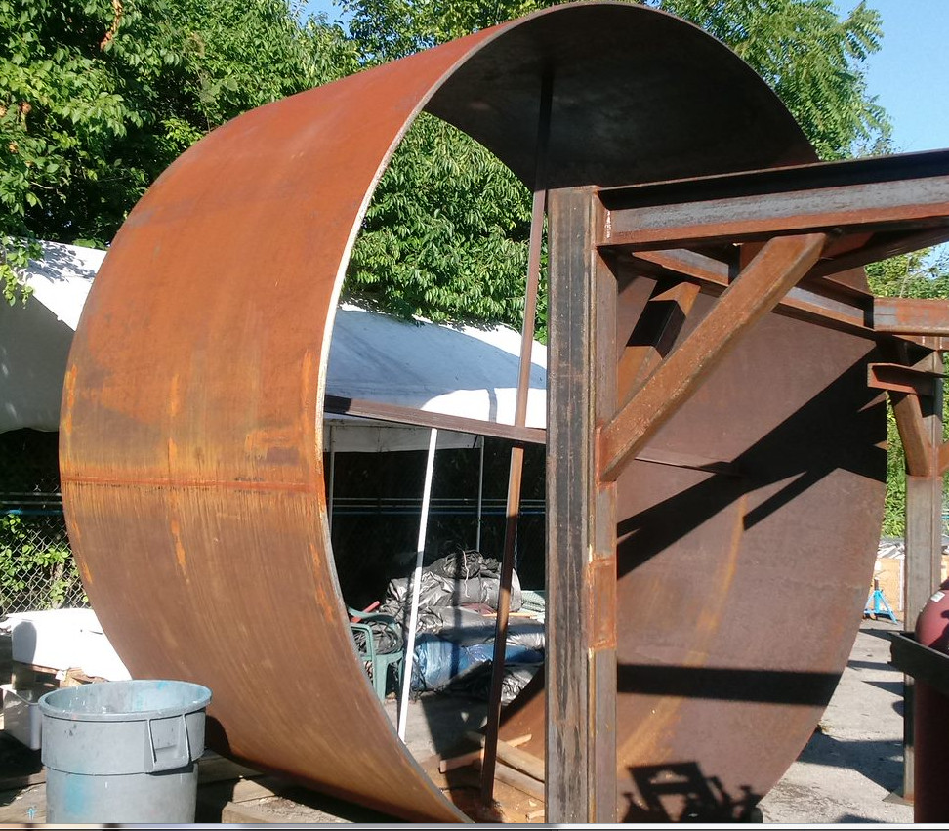

Vacuum Shells to be painted.

A third and fourth CP#2 low pressure warm helium compressor skid delivery was requested by SLAC to be delayed until cryoplant BOD ~Oct 16th. A CP#2 medium pressure compressor is scheduled to be shipped to SLAC on Oct 23rd followed by a CP#2 low pressure compressor on Oct 24th. This will bring the full total of compressor to 9 out of the 12 which has been delivered to SLAC with only 3 CP#2 compressors to be delivered.

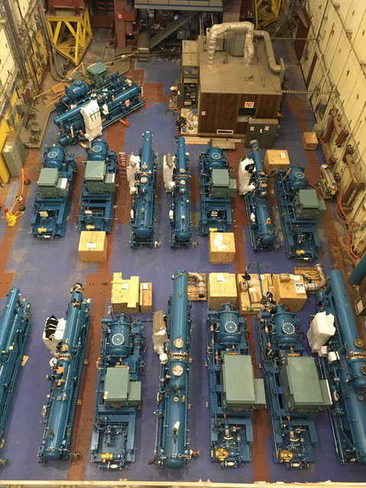

Cryoplant #1 & #2 Warm Helium Compressors in Storage at SLAC.

The CP#1 Lower Cold Box Upper Shell has been mounted to the top of the internal supporting frame structure which supports the internal heat exchangers and piping.

Work has begun on the installation of the internal piping by first tack welding the preassembled piping spools into place prior to the final welding and insulating. During the past week, 20% of the internal piping has been installed.

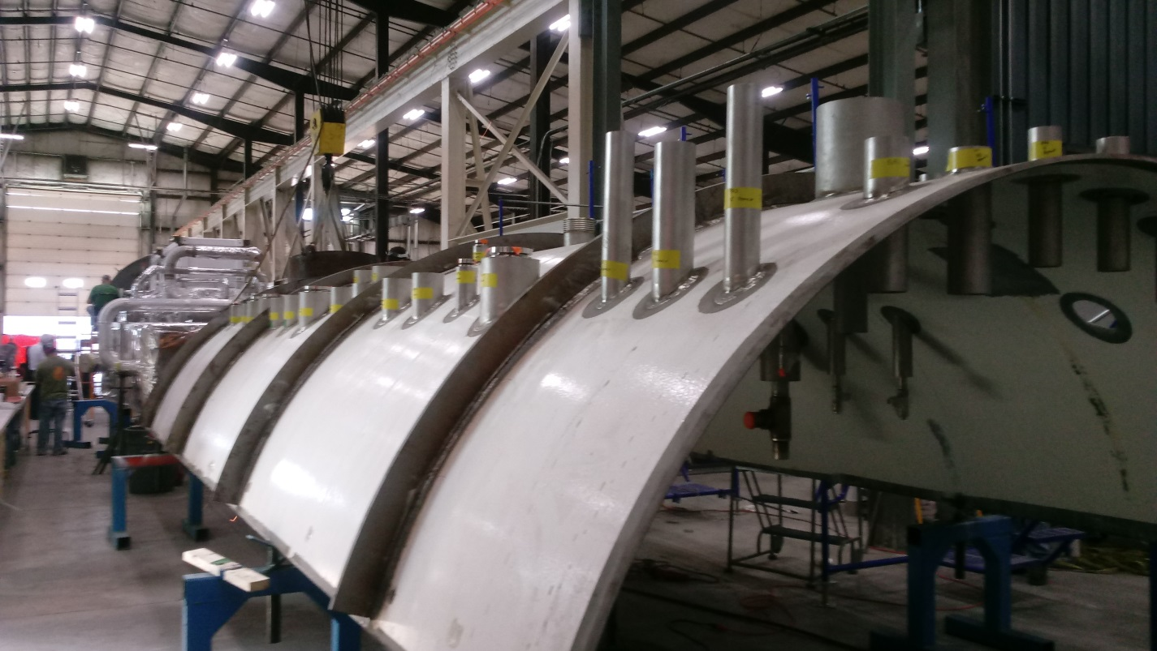

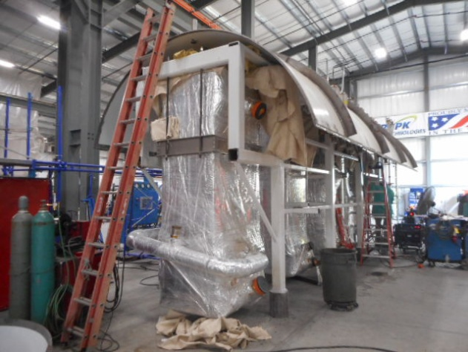

CP#1 Lower Cold Box Upper Shell Mounting to internal Support Structure.

JLab engineering and procurement visited Eden located in Columbus OH to inspect the progress of the oil removal vessels fabrication readiness for shipment in the upcoming weeks.

Two BCRs were in the process of development, 2K Cold Box Redesign scheduled for presentation on Oct 12 and the Cryoplant Engineering EAC for Oct 19th.

Control hardware documentation was released to JLab procurement to begin the procurement process.

**QUALITY**:

Mike Martin, the site CWI, will be traveling to the UK to review a liquid helium dewar prior to its shipment.

Conducted final review of the oil removal vessels for CP#1 in preparation of shipment to SLAC ~Oct 16th.

Working with Ginger DeContreras of SLAC to determine Equipment Handoff requirements and documentation needed and by when. They have not established a final spec yet.

**Upcoming Travel/Reviews:**

2K Cold Compressor Run Witness Test, MECOS, Switzerland, Nov 10-11

Weekly Reporting

WBS 1.02.03.05.12 LLRF

Week of October 12-18, 2017

**Issues:** None

**Accomplishments this week at JLab:** On Travel; no report.