Weekly Reporting
WBS 1.01.07 JLAB Management
Week of October 19-25, 2017

Issues:
Accomplishments this week:
Presented the CP EAC and it was approved.
Presented BCR for the JLab methodology change at JLab. Our understanding is that SLAC has what they need for this BCR.
Presented BCR for the cavity path forward. Still working this one. We need this one done as vendors are waiting on us.
Upcoming Activities:

Weekly Reporting
WBS 1.04.06 JLAB Cryomodules
Week of October 19-25, 2017

Issues: Transfer of HOM tuning procedure from FNAL to JLab is impacting CM assembly progress.
Accomplishments this week:
Presented BCR covering path forward for reworking cavities including schedule recovery options. Investigating. Revised based on feedback from CCB.
Continuing preparation for RFP of up to 133 replacement cavities with JLab procurement.
Vendors continue to ship cavities to both PLs.
FNAL requested a long spool due to plating concerns with current units in hand in their inventory. JLab, FNAL and SLAC developing plan to rework a subset of the possible rejected components.
Fast-cooldown flex u-tube components are in-house. Pre-assembly for welding has started. Expect units completed within two to three weeks, and available for use on CM04.
Planning to review HOM tuning procedures during visit by A. Burrill tomorrow and Friday.
CM02 – In storage.
CM03 at CMTF: Completed first round of high power rf testing, performed thermal cycle and plan to continue high power rf testing has started. Average Qo prior to thermal cycle is 2.0e10; expect higher Qo’s after thermal cycle. SLAC colleagues (Gonnella, Nelson) participated significantly in CM testing activities.
CM04 at WS-5: Ports opened for HOM retuning. Plan to insert into CMTF after CM03 completes testing.
CM05 at WS-4: Instrumentation In progress. On hold for HOM tuning.
CM07 at WS-3: Vacuum vessel leak check is complete. Gate valve connected to cavity 1 tuner arms. Two phase helium circuit leak check is in progress. Magnet lead soldering in progress.
Cavity Tests:
297 (NX-B) in D7, first test, Admin limited at 24 MV/m, Q0(16)=3.6e10, FE free, qualified.
CM08: String rollout scheduled and on track for Friday, 27 October.
CM09: Eight cavities qualified for string. String build planned for 6-Nov. with roll-out tentatively 17-Nov.
CM10: Four cavities qualified for string.
QUALITY:
No report.

Upcoming Travel/Meetings:
RI & Zanon Vendor Visit Oct 31-Nov 9 (Palczweski)
RI & Zanon Vendor Visit Nov 1-7 (Wilson, Laney)
Kubara Lamina Vendor Visit Nov 7 (Park, Daly)
Zanon Vendor Visit Nov 8-11 (Park)
WUXI Vendor Visit to China Dec 4-8 (Cheng, Legg)

Weekly Reporting
WBS 1.01.07 JLAB Management
Week of October 19-25, 2017

Issues:
LERF accomplishments this week:
Status update presented to Friday collaboration meeting, slides are at: https://wiki.jlab.org/lerf/index.php/File:Lerf_status_oct20_2017.pdf
Safety Assessment document is in progress.
The 480 VAC panel work for the SSA power is in progress.
Visit to SLAC to discuss many topics, including the network & computing architecture is in progress. Last week a note was sent out with briefing questions so all are ready make this a productive trip.
Waveguide removed from CM in zone 4.
Prepping for Heliax order.
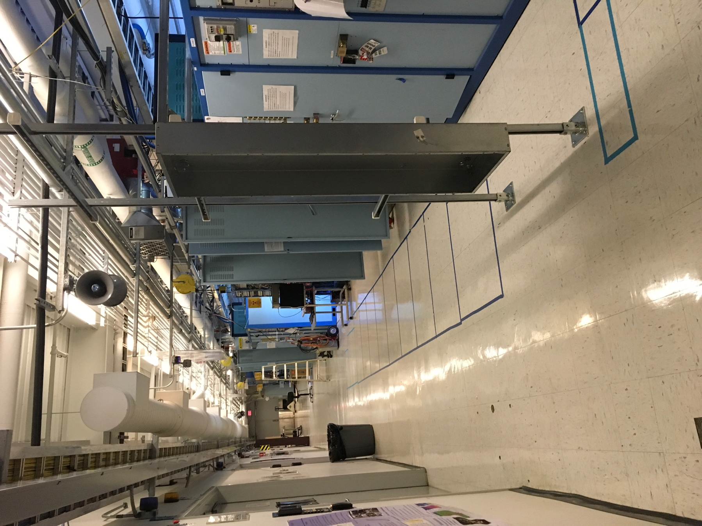
Electrical panels for SSA power
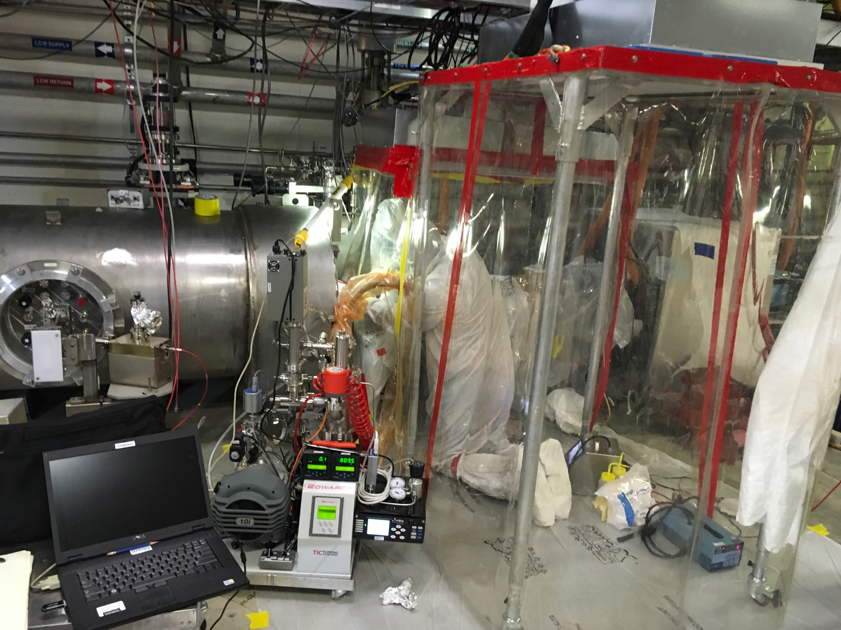
Clean hood in place for CM vacuum work

Upcoming Activities:
Cryomodule shuffle.
Begin to remove klystrons from racks in zone 3 & 4.
Complete Safety Assessment document.
Write up & document computer hardware & network architecture.

Weekly Reporting
WBS 1.04.08 JLAB Cryoplant System
Week of October 19-25, 2017
Issues:
Accomplishments this week:
JLab and SLAC traveled to PHPK in Columbus to witness the CP#1 Upper Cold Box piping leak testing. One leak was discovered and plans and plans were to identify location and repair. During the past week the leak was found as a gasket leak on one of two 80K absorber vessel fill port flanges. Remaining work includes the installation of the outer vacuum shell for final leak test. Plans also included the additional process line trace in accordance with the cold box Process and Instrumentation Diagram (P&ID) to indicated full fabrication compliance. The lower shell of the cold box has been positioned next to the Upper Cold Box as the next assembly activity scheduled for this coming week.

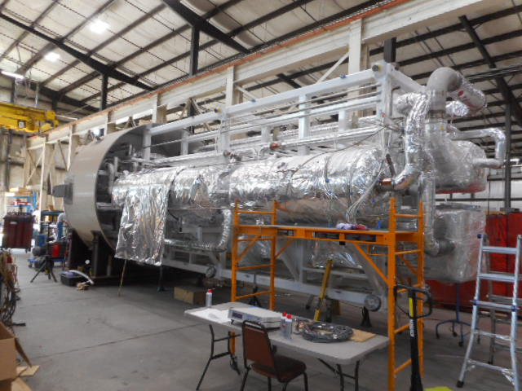  CP1 Upper Cold Box. | 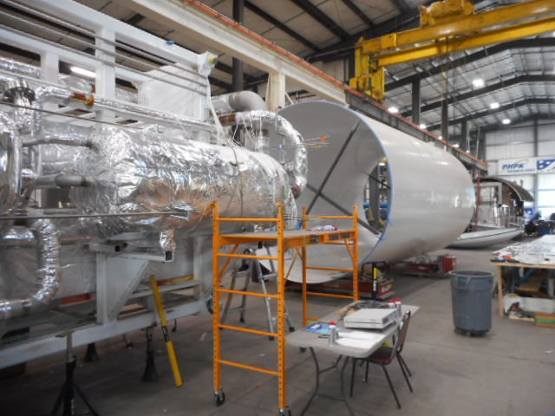  Vacuum Shell Ready for Next Assembly Step.

CP#1 Lower Cold Box assembly is progressing with 40% of internal piping installed. Sufficient prefabricated piping spools are ready to continue the assembly work. The welding work force has been increased to a total of 14 welders on the project.

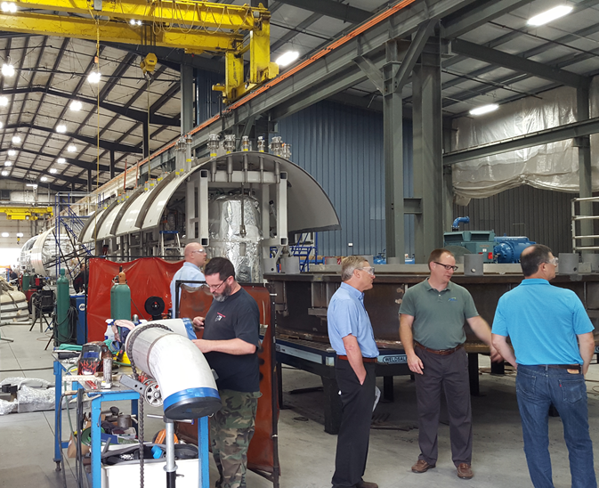  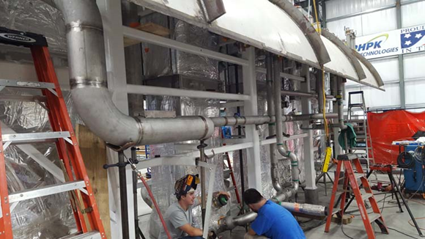 | 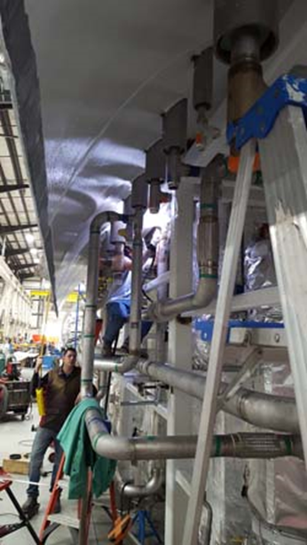
CP1 Lower Cold Box Internal Piping Assembly

CP#1 Upper Cold Box platform fabrication of both the platform supporting posts and platform landings has progressed at Mid-Ohio (sister company to PHPK). Other work included fabrication of the CP#1 Upper Cold Box Vacuum Skid weldment and CP#2 Upper Cold Box cradle fabrication.

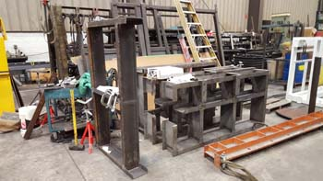

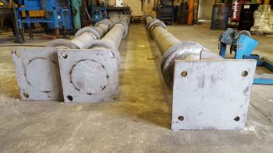
Mid-Ohio Fabrication of CP1 Upper Cold Box Platform and Stands

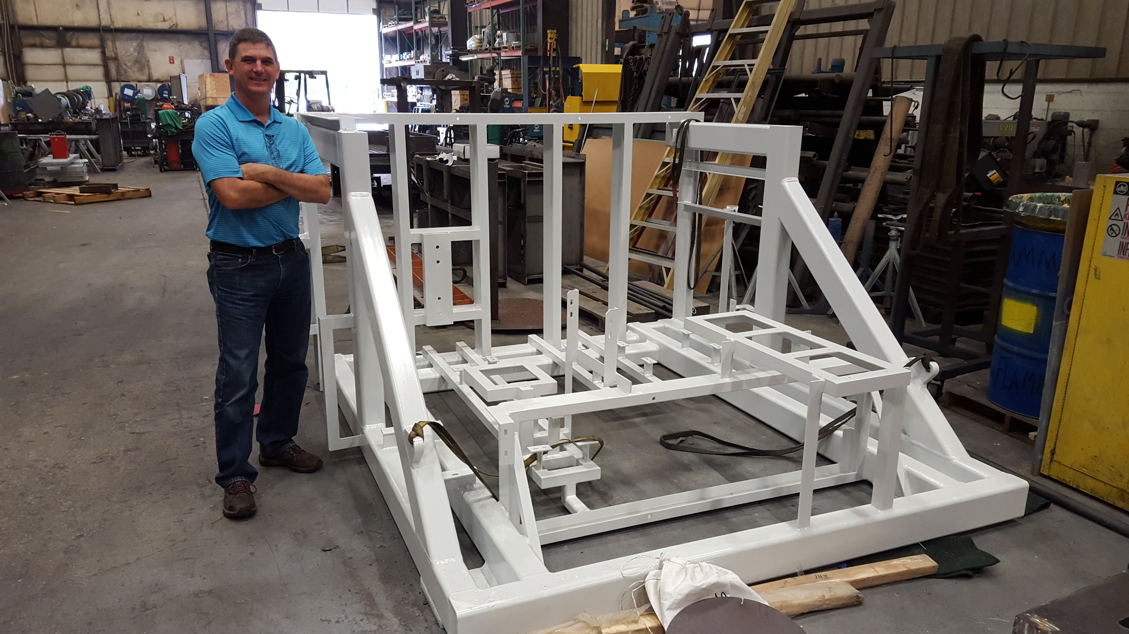
CP#1 Upper Cold Box Vacuum Skid Weldment

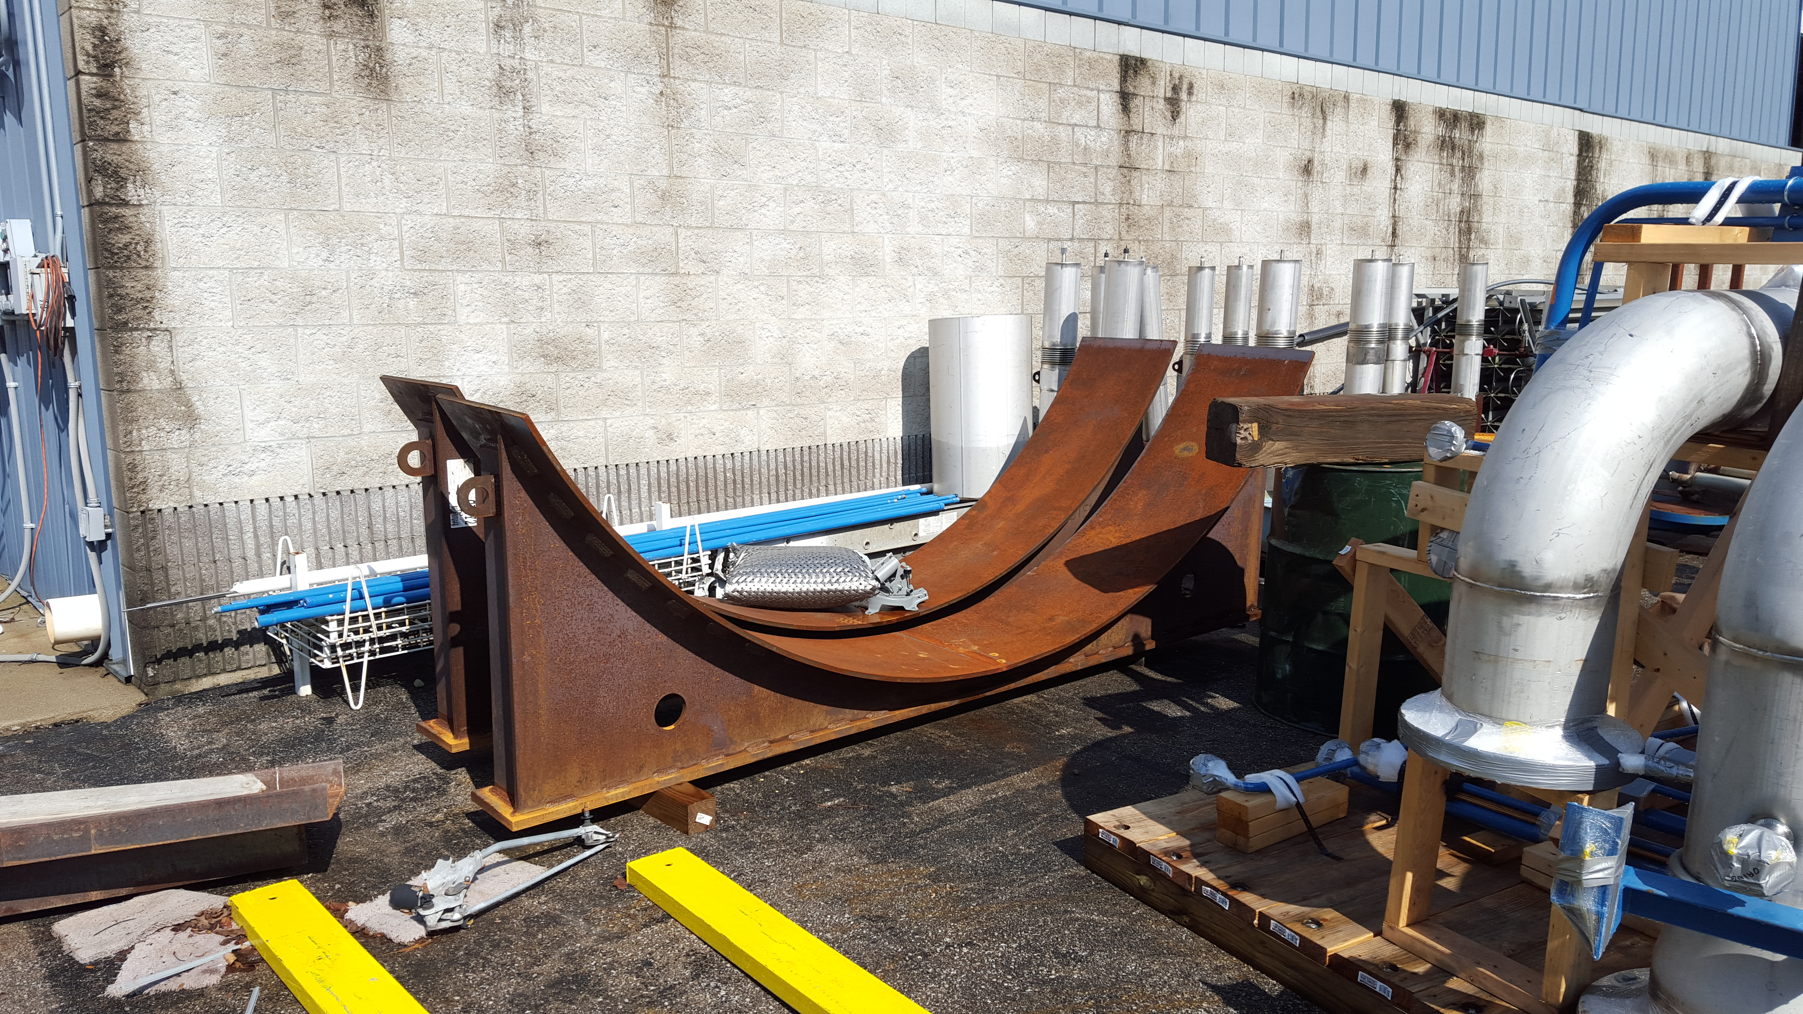
CP#2 Upper Cold Box Cradles

A third and fourth CP#2 low and medium pressure warm helium compressor skid delivery was delivered to SLAC and placed within building B905. There was some minor damage to the frames and a NCR is being generated.

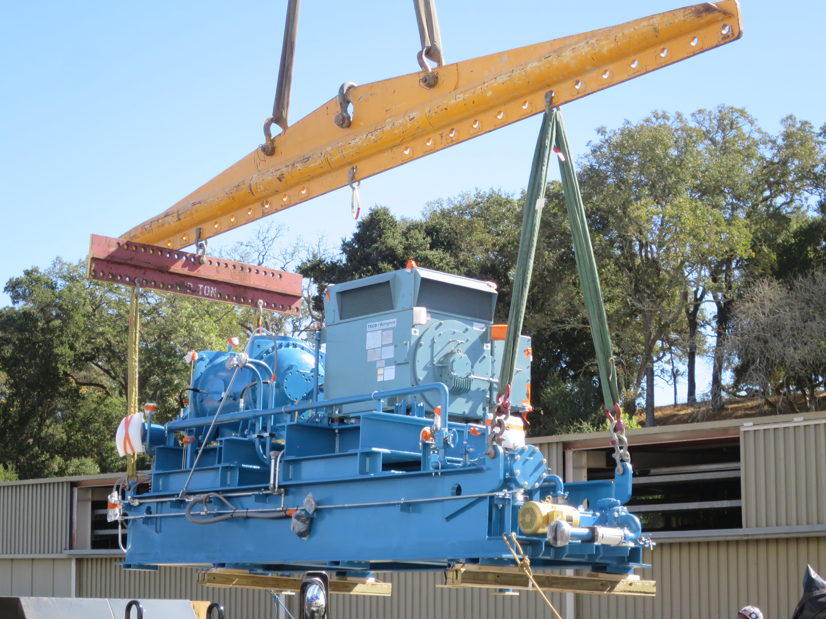 | 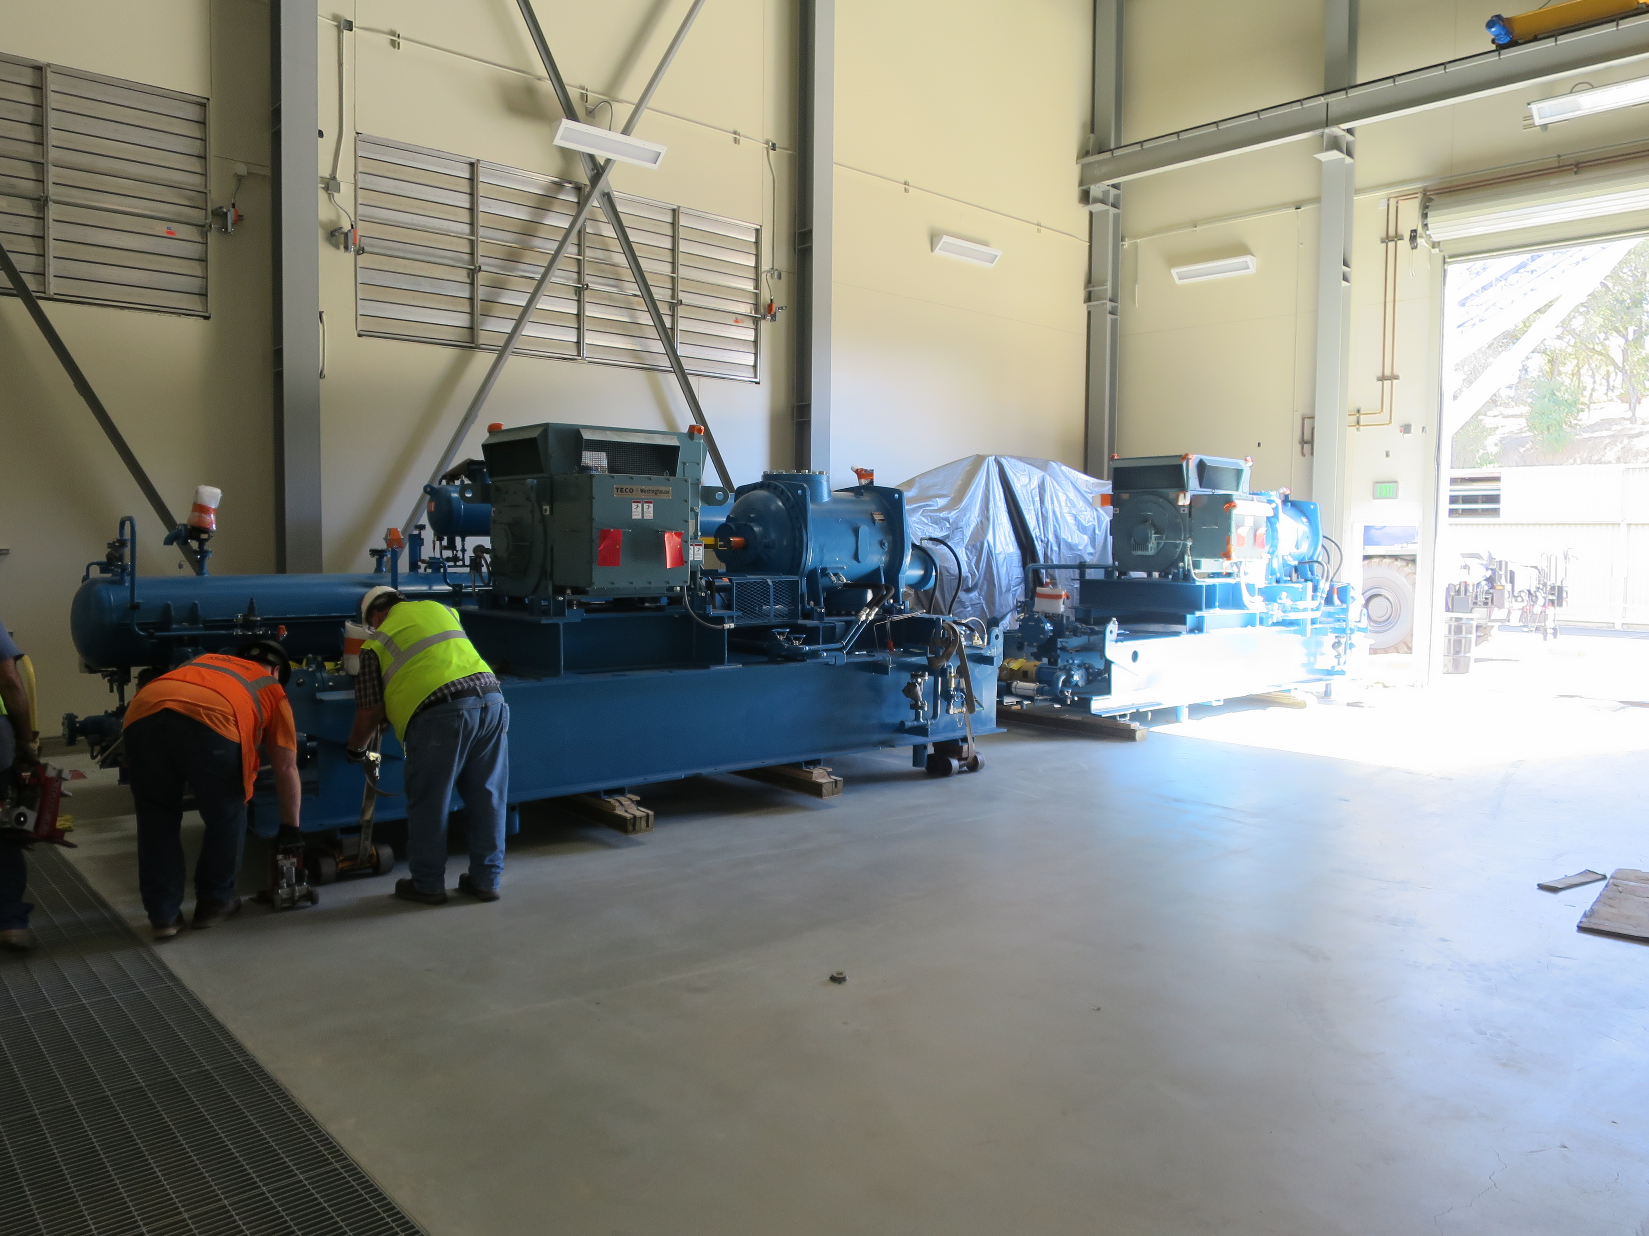

JLab engineering and procurement visited Eden located in Columbus OH to inspect the progress of the oil removal vessels fabrication readiness for shipment in the upcoming weeks.
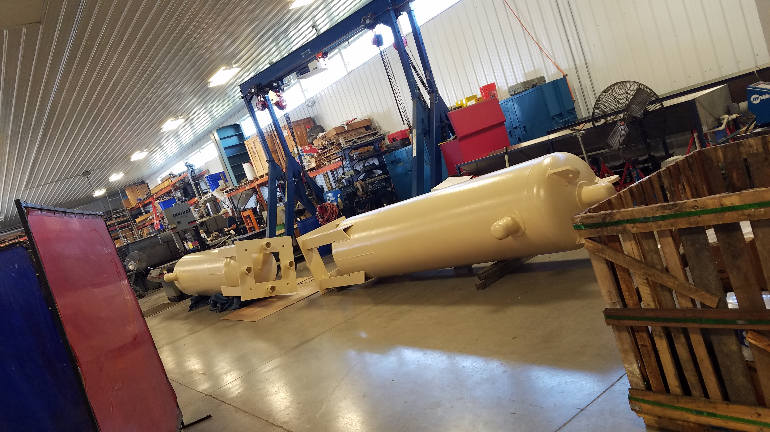

A BCR presentation for the Cryoplant Engineering EAC (1.04.08.05) was presented on Oct 24th and approved.

Control hardware documentation was released to JLab procurement to begin the procurement process.

QUALITY:
Mike Martin, the site CWI, will be traveling to the UK to review a liquid helium dewar prior to its shipment.

Conducted final review of the oil removal vessels for CP#1 in preparation of shipment to SLAC in November
Working with Ginger DeContreras of SLAC to determine Equipment Handoff requirements and documentation needed and by when. They have not established a final spec yet.

Upcoming Travel/Reviews:
2K Cold Compressor Run Witness Test, MECOS, Switzerland, Nov 10-11

Weekly Reporting
WBS 1.02.03.05.12 LLRF
Week of October 19-25, 2017

Issues: None
Accomplishments this week at JLab: Folks on travel. Working on the LERF RF cable purchase and the LERF CM Test Facility ICD.

