Weekly Reporting

WBS 1.01.07 JLAB Management

Week of October 26-Nov 1, 2017

**Issues:**

**Accomplishments this week:**

Received approval for two BCRs including the cavity path forward and end lever tuners.

Two of JLab CAMs were interviewed as part of the LCLS-II Earned Value Surveillance Review.

Conducted cryoplant and cryomodule monthly EV progress meetings.

Began shipment of Oil Removal Vessels for CP1 to SLAC.

Cold testing of CM03 has completed.

**Upcoming Activities:**

Weekly Reporting

WBS 1.04.06 JLAB Cryomodules

Week of October 26-Nov 1, 2017

**Issues**:

**Accomplishments this week:**

Re-presented BCR covering path forward for reworking cavities including schedule recovery options. BCR was approved. Implementation of incentives in P6 will be done with guidance from SLAC PMO.

Continuing preparation for RFP of up to 133 replacement cavities with JLab procurement. Expected on the street during second week of November.

Completed monthly progress for October.

Vendors continue to ship cavities to both PLs. RI has completed up to cavity 165 at HP#1, up to cavity 150 at HP#2 and up to cavity 138 at HP#3.

JLab, FNAL and SLAC are developing plan to rework a subset of the possible rejected plated components.

Fast-cooldown flex u-tube components are in-house. Pre-assembly for welding is continuing. Expect units completed by 27-NOV, and available for use on CM04.

Reviewed HOM tuning procedures during visit by A. Burrill last week.

CM02 – In storage.

CM03 at CMTF: Completed CM testing, LLRF resonance control testing and low power microphonics testing. HOM tuning was generally satisfactory with only one HOM (3A) below 1e11 but this did not limit cavity performance. CM warm up planned to start 2-NOV.

CM04 at WS-5: Plan to insert into CMTF on 8-NOV with cooldown planned for 9-NOV. Testing commences on 13-NOV with completion planned for 30-NOV.

CM05 at WS-4: Final check of HOM tuning complete. Installation of thermal shields has started.

CM07 at WS-3: Two phase helium circuit leak check is complete. Magnet lead soldering is complete. Alignment is in progress.

CM08: String rollout was delayed due to problems with helium background, but is now at WS2.

CM09: Eight cavities qualified for string. String build planned for 6-Nov. with roll-out tentatively 17-Nov.

Cavity Tests:

299 (NX-B) in D7, first test, FE onset at 5 MV/m. Did not qualify. Plan to re-rinse and re-test.

Plan to test 304 in D8 on 2-NOV, and three cavities in D5 on 3-NOV.

CM10: Four cavities qualified for string.

**QUALITY**:

No report.

**Upcoming Travel/Meetings:**

RI & Zanon Vendor Visit Oct 31-Nov 9 (Palczweski)

RI & Zanon Vendor Visit Nov 1-7 (Wilson, Laney)

Kubara Lamina Vendor Visit Nov 7 (Park, Daly)

Zanon Vendor Visit Nov 8-11 (Park)

FNAL Production & Engineering Discussion 17-NOV (Daly)

WUXI Vendor Visit to China Dec 4-8 (Cheng, Legg)

Weekly Reporting

WBS 1.01.07 JLAB Management

Week of October 26-Nov 1, 2017

**Issues:** None yet

**LERF accomplishments this week:**

Safety Assessment document is in progress.

The 480 VAC panel work for the SSA power is in progress.

Network switches are on order.

All CEBAF modules and girder vacuums have been secured in preparation for removing girders and two modules as well as shuffling the third from zone 4 to zone 2.

The two racks for network, servers, and vacuum controls have been moved into place in the gallery. Bases are on order then power can be connected. An ATLis was submitted for connecting 120VAC power to SSAs and to the racks.

LCLS-II CM #1 & #2 locations (including waveguide) have been taped out on the vault floor in preparation for cable order – both cryogenic control and RF/LLRF cables.

**Upcoming Activities:**

Cryomodule shuffle and two cryomodules removal from vault

Completion of the Process & Instrumentation diagram for the cryogenic end can and transferline

Complete Safety Assessment document

Cable procurement

Server procurement

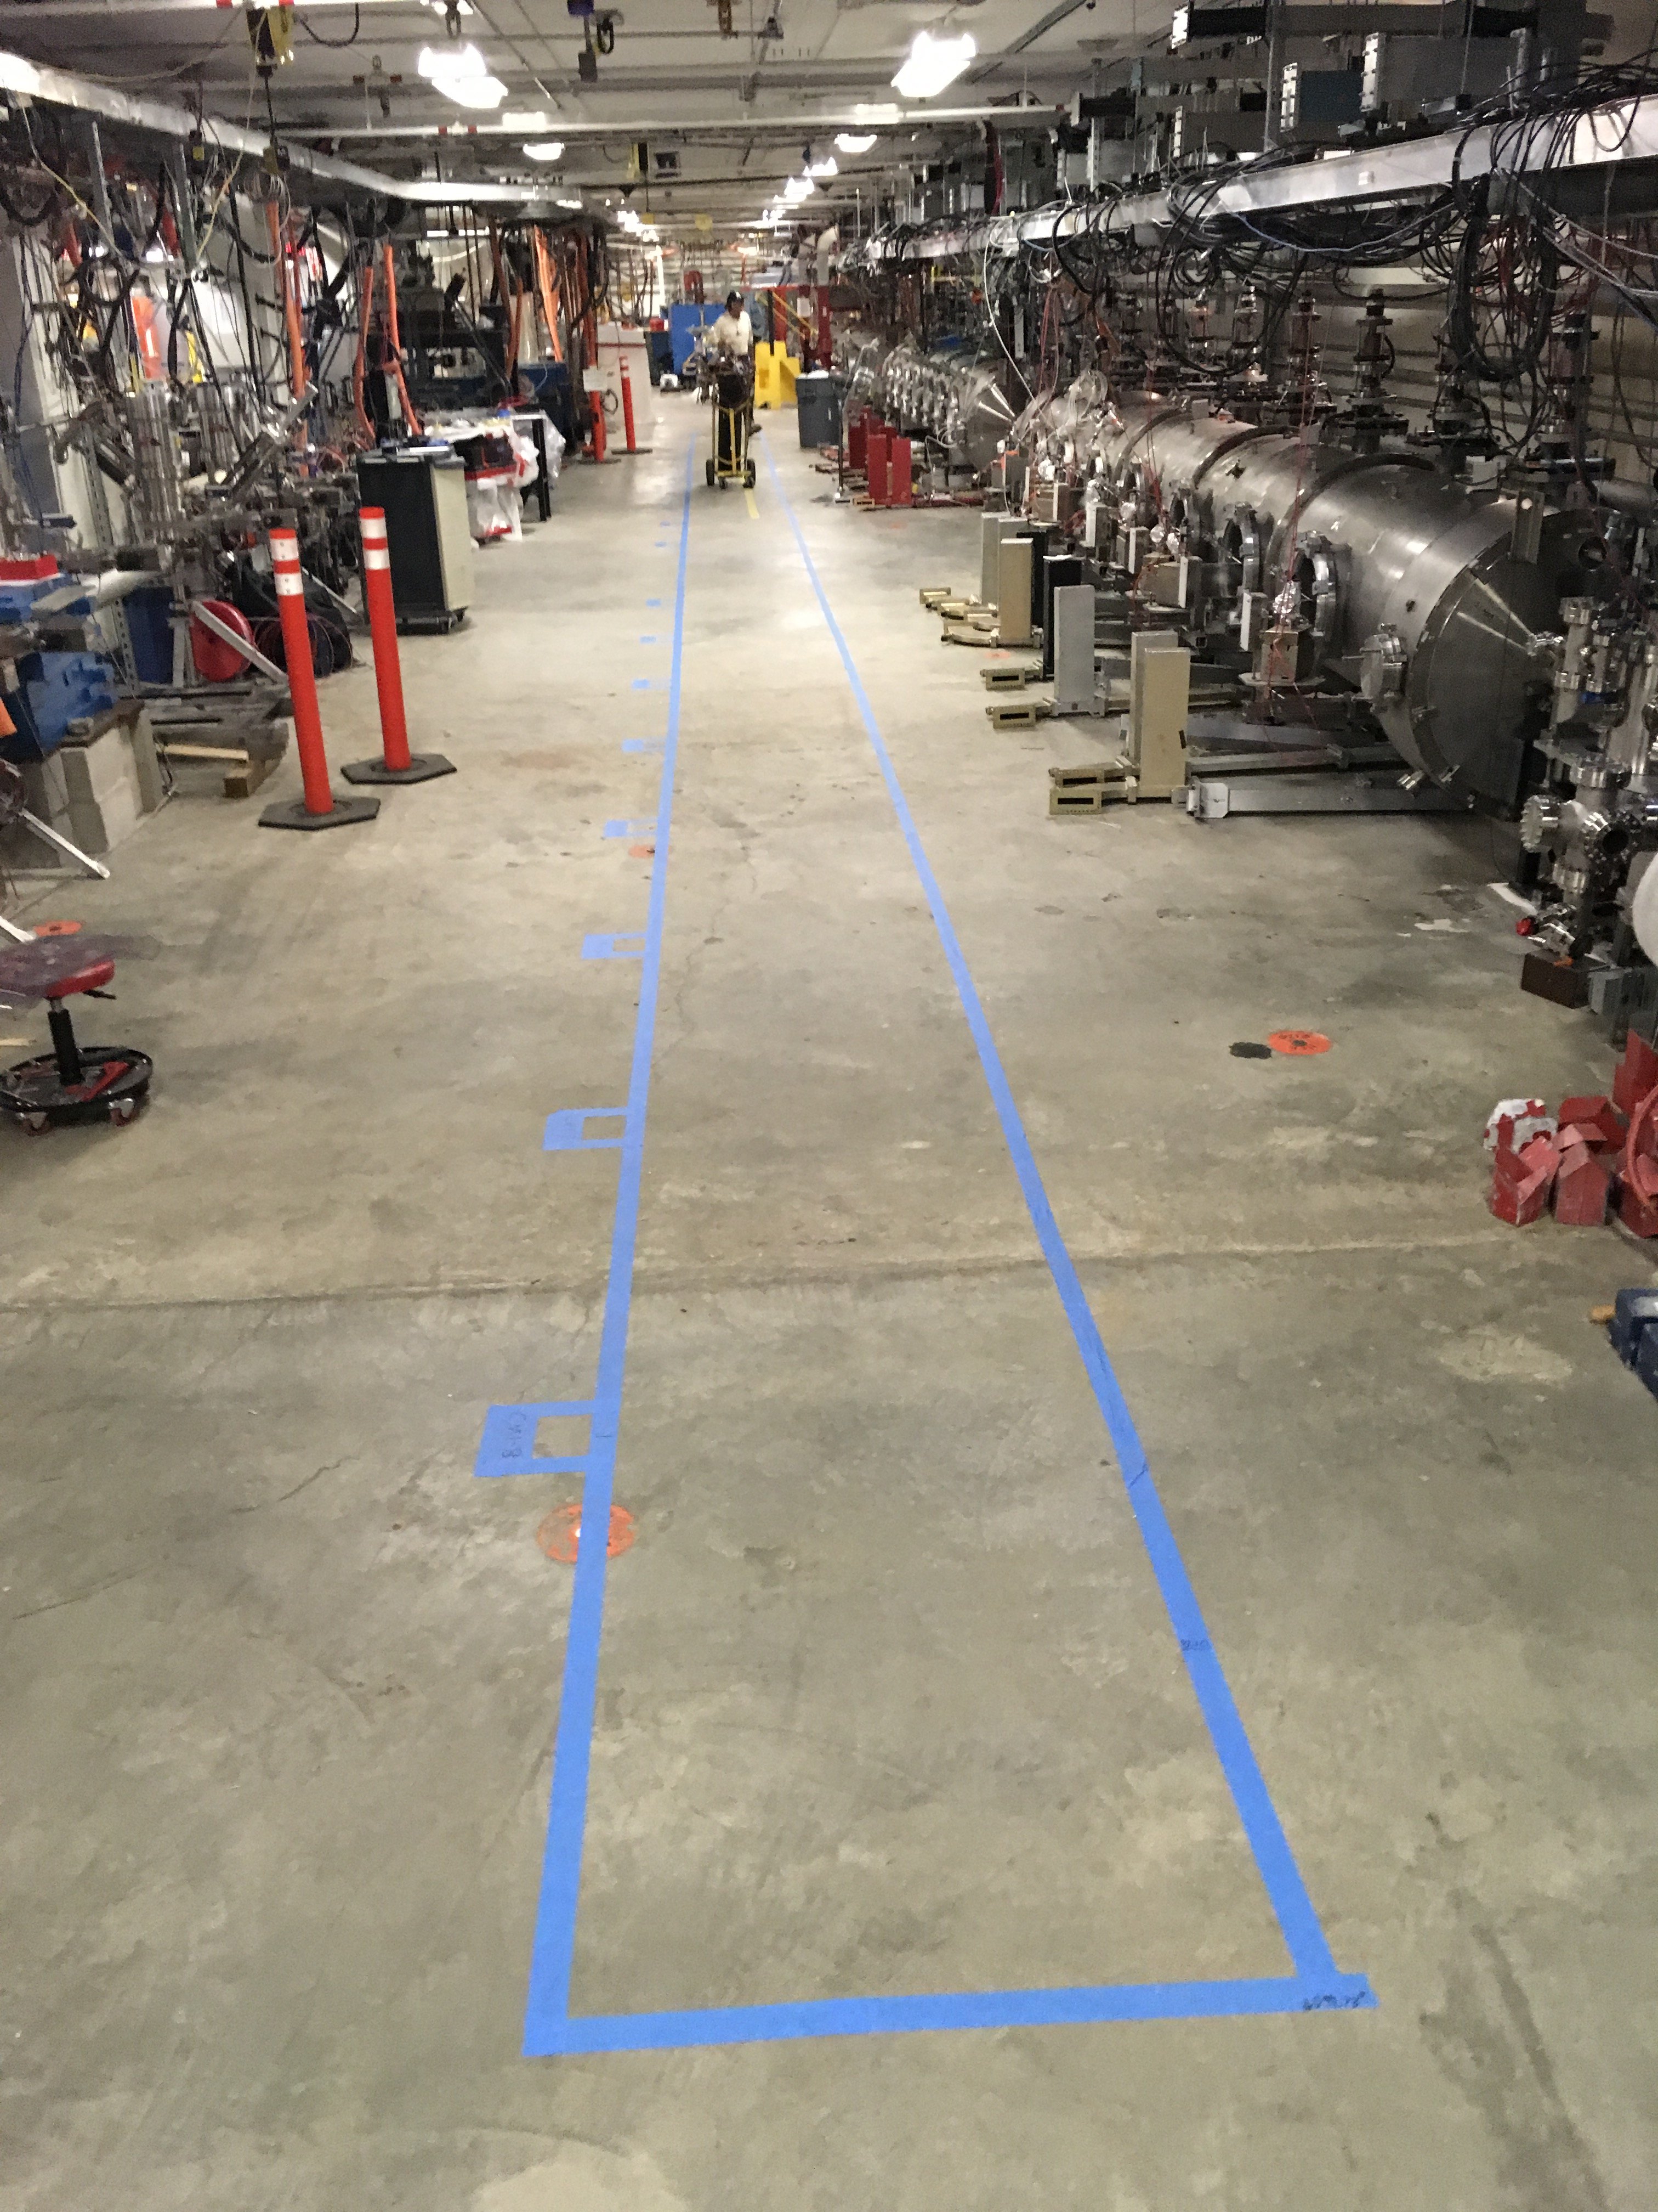  
Layout of cryomodules in accelerator vault.

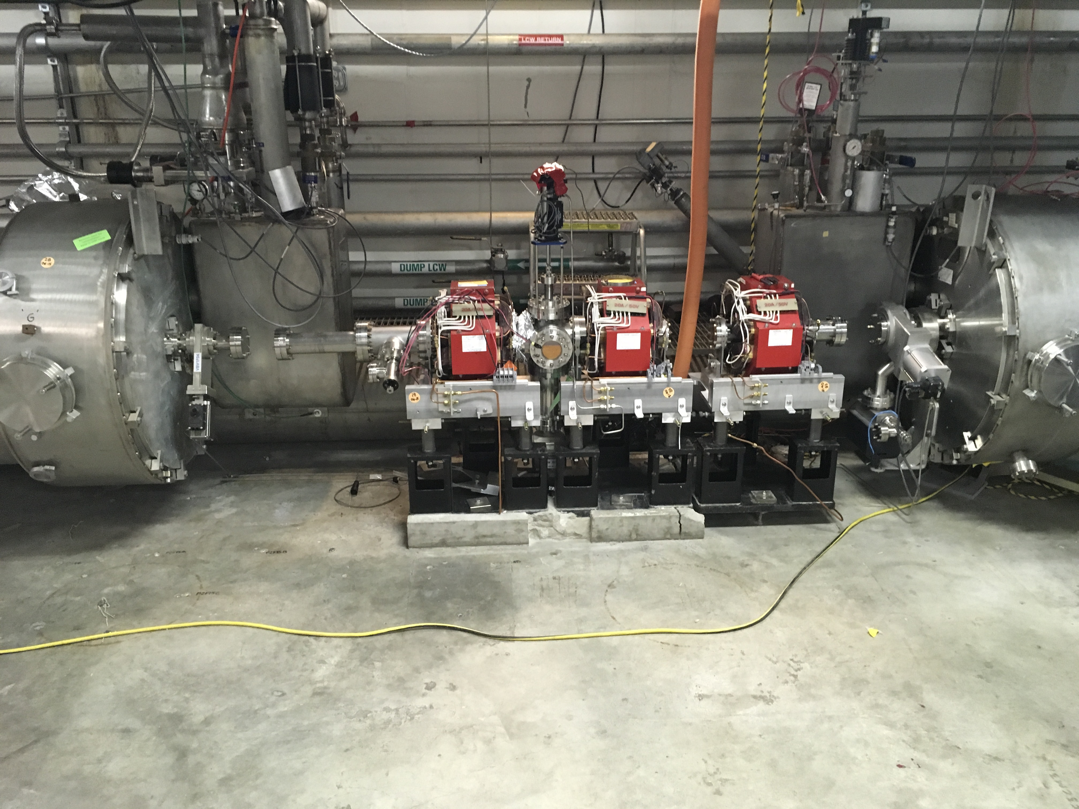

Vacuum spaces secured for cryomodule shuffle

Weekly Reporting

WBS 1.04.08 JLAB Cryoplant System

Week of October 26-Nov 1, 2017

**Issues:**

**Accomplishments this week:**

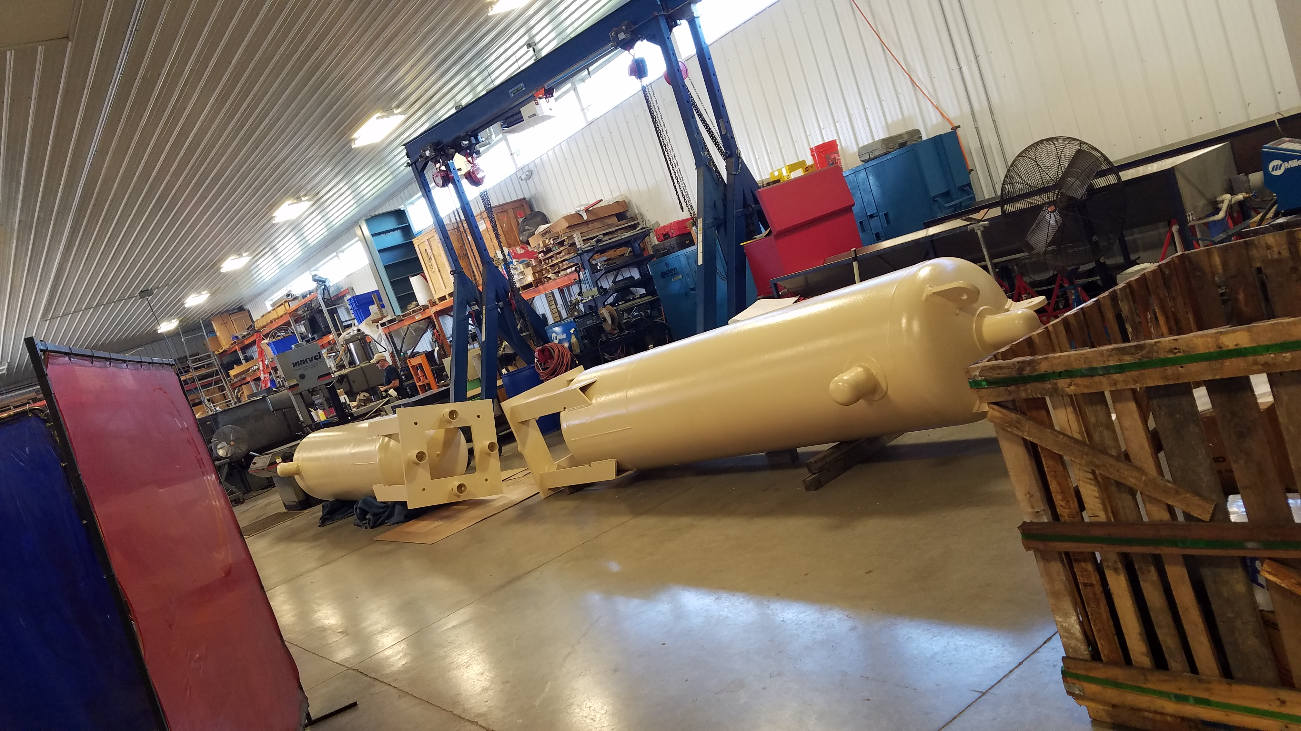

* Completed JLab CAM surveillance review 10/27/2017.
* ALATUS is requesting Wednesday, 11 or 12:30 EST meeting on shipping.
* CP#1 compressors skid oil removal vessels have been shipped to SLAC.
* CP#1 cold box assembly continues with recheck of HP circuit after repair of gasket leak on 80K absorber charcoal fill gasket.
* November 9-10th CP#1 CC drive testing scheduled at MECOs next week

Control cabinet shipping should follow shortly after successful test.

* Remaining two warm helium compressors (HP) to be shipped to SLAC for Nov 20 and 21.
* 2K Cold Box valve, flowmeter, and relief valve specifications have been developed and reviewed.
* December 1 target date for control panel procurement PRR.
* Need final disposition on holding gaseous helium storage tanks until March.
* CP1 4.5K Cold Box remains on schedule for January 25, 2017 delivery.

**QUALITY**:

Mike Martin, Conner Kaufmann, and Melissa Torres will be traveling to the UK to inspect weldments of the liquid helium dewars prior to shipment.

Working with Ginger DeContreras of SLAC to determine Equipment Handoff requirements and documentation needed and by when. They have not established a final spec yet.

**Upcoming Travel/Reviews:**

Vendor Visit to UK Nov 1-4

Visit to SLAC to Receive Oil Removal Vessels, Nov 1-4

2K Cold Compressor Run Witness Test, MECOS, Switzerland, Nov 10-11

Weekly Reporting

WBS 1.02.03.05.12 LLRF

Week of October 26-Nov 1, 2017

**Issues:** None

**Accomplishments this week at JLab:**

* LLRF Coordination/Documentation:
  + LERF project: LERF ICD is being edited by Alex Ratti and myself.
  + BCS: Funding for the small remaining amount of work has been restored.
* Resonance/Interlock Chassis:
  + FMC board: Receiving quotes for assembly now.
  + Temperature sensor board: Still out for manufacture. It will be assembled in house.
  + Power supply distribution board and Vac/Digital I/O boards are being kitted for in house assembly.
  + Stepper motor board has been reviewed by Rama and will go out for manufacture tomorrow.
  + Test Bench progress should speed up now that the boards are basically done.
* Interlock Board/Chassis:
  + Onish Kumar finished the FEP board. We will hold this until after the 3.9 GHz cryomodule has been tested.
* Common Power Supply/Chassis/Boards:
  + No action.
* CMTF/LERF
  + Installing the cables, couplers and switches will begin in early November.
  + Resonance Chassis tests: Manually through EPICS moved all eight steppers and piezos in the two resonance chassis. This was the first time all cables had been tested on a CM. unfortunately could not complete tests do to faulty circuit breaker on the SSAs. This will have to wait until CM04.
  + Dave and Larry have been working on getting the RF cable lengths in the LERF vault.
  + From the LERF waveguide lengths, bends and flexes calculated the power loss through the waveguide. From the calculations, all cavities will be able to make 21 MV/m assuming 4 kW at the SSA and a QL of 4e7.

**Upcoming Activities:**

* CMFT cable/coupler/switch installation