Weekly Reporting
WBS 1.01.07 JLAB Management
Week of November 2-8, 2017

Issues:
Accomplishments this week:
Presented CM Testing Results at the LCLS-II Collaboration Meeting.
Conducted internal progress updates for the CM and CP 1.4.6 and 1.4.8 WBSs.
Conducted status meetings for 1.4.6 and 1.4.8.
CM03 was removed from the CMTF and CM04 was installed.
Preparing several BCRs for November presentations
Working on Equipment Transfer documentation.
Upcoming Activities:
28 Nov – 2 Dec 2018 – ESS Cryomodule Review (Drury, Preble)
7 May 2018 - Collaboration Meeting @ SLAC
8–10 May 2018 – OPA Review @ SLAC

Weekly Reporting
WBS 1.04.06 JLAB Cryomodules
Week of November 2-8, 2017

Issues:
Accomplishments this week:
Technical and procurement staff on several vendor visits last week including vendors for the BLAs, and SRD cavity vendors.
J1.3-03 – Warm, Re-test complete, removed from CMTF
J1.3-04 - HOM tuning complete, Insulating vacuum leak check complete, moved into CMTF.
J1.3-05 - Weld on 50k shield, MLI installation complete, Alignment in VV complete, Move to WS5 today
J1.3-07 - String alignment complete, Tuners in progress, VV moved to WS4 for demag.
J1.3-08 - Berry bolts in progress, 2 phase pipe welding in progress, UCM alignment complete
J1.3-09 – Cavity string assembly started
HOM and FP FTs ordered.
CM03 was warmed up and removed from the CMTF and CM04 was installed and demagnetized in place.
QUALITY:
Working on Equipment Transfer documentation.
Upcoming Travel/Meetings:
RI & Zanon Vendor Visit Oct 31-Nov 9 (Palczweski)
Zanon Vendor Visit Nov 8-11 (Park)
FNAL to see CMTF Nov 7-9 (Jordan)
FNAL to return pCM Nov 7-10 (Huque)
TTC @ FNAL Nov 14-17 (Wilson, Palczweski)
FNAL Production & Engineering Discussion Nov 17(Daly)
ESS Cryomodule Review Nov 28-Dec 2 (Drury, Preble)
WUXI Vendor Visit to China Dec 4-8 (Cheng, Legg)

Weekly Reporting
WBS 1.04.06 Cryomodules - LERF Conversion
Week of November 2-8, 2017

Issues: None, installation crews working in CEBAF tunnel this week. This is last week machine will be open so activity will pick up next week with the cryomodule shuffle.
LERF accomplishments this week:
LERF ICD is has been released for official review. Curt met with the SLAC team Friday and finalized delivery dates for RF hardware and racks.
Dave and Larry now have the needed lengths for ordering the Heliax cable; this will be completed later this week.
Semi-annual Personnel Safety System re-certification complete

Daily activities can be seen at; https://wiki.jlab.org/lerf/index.php/Daily_Activities
P & ID diagram draft is posted https://wiki.jlab.org/lerf/images/9/94/P_ID_rev-draft.pdf
Safety Assessment document is in progress
The 480 VAC panel work for the SSA power is in progress
Tunnel is all cleaned-up and ready for the shuffle, once the CEBAF style modules were moved out the waveguide will be prepared for the new installation.
A 36” deep rack was acquired from ‘free stock’ to hold the 29.5” deep servers
Upcoming Activities:
Cryomodule shuffle and two cryomodule removal from vault
Complete Safety Assessment document
Cable procurement – layout for RF, LLRF, Cryo, & Vac
Server procurement (2) Dell R630’s
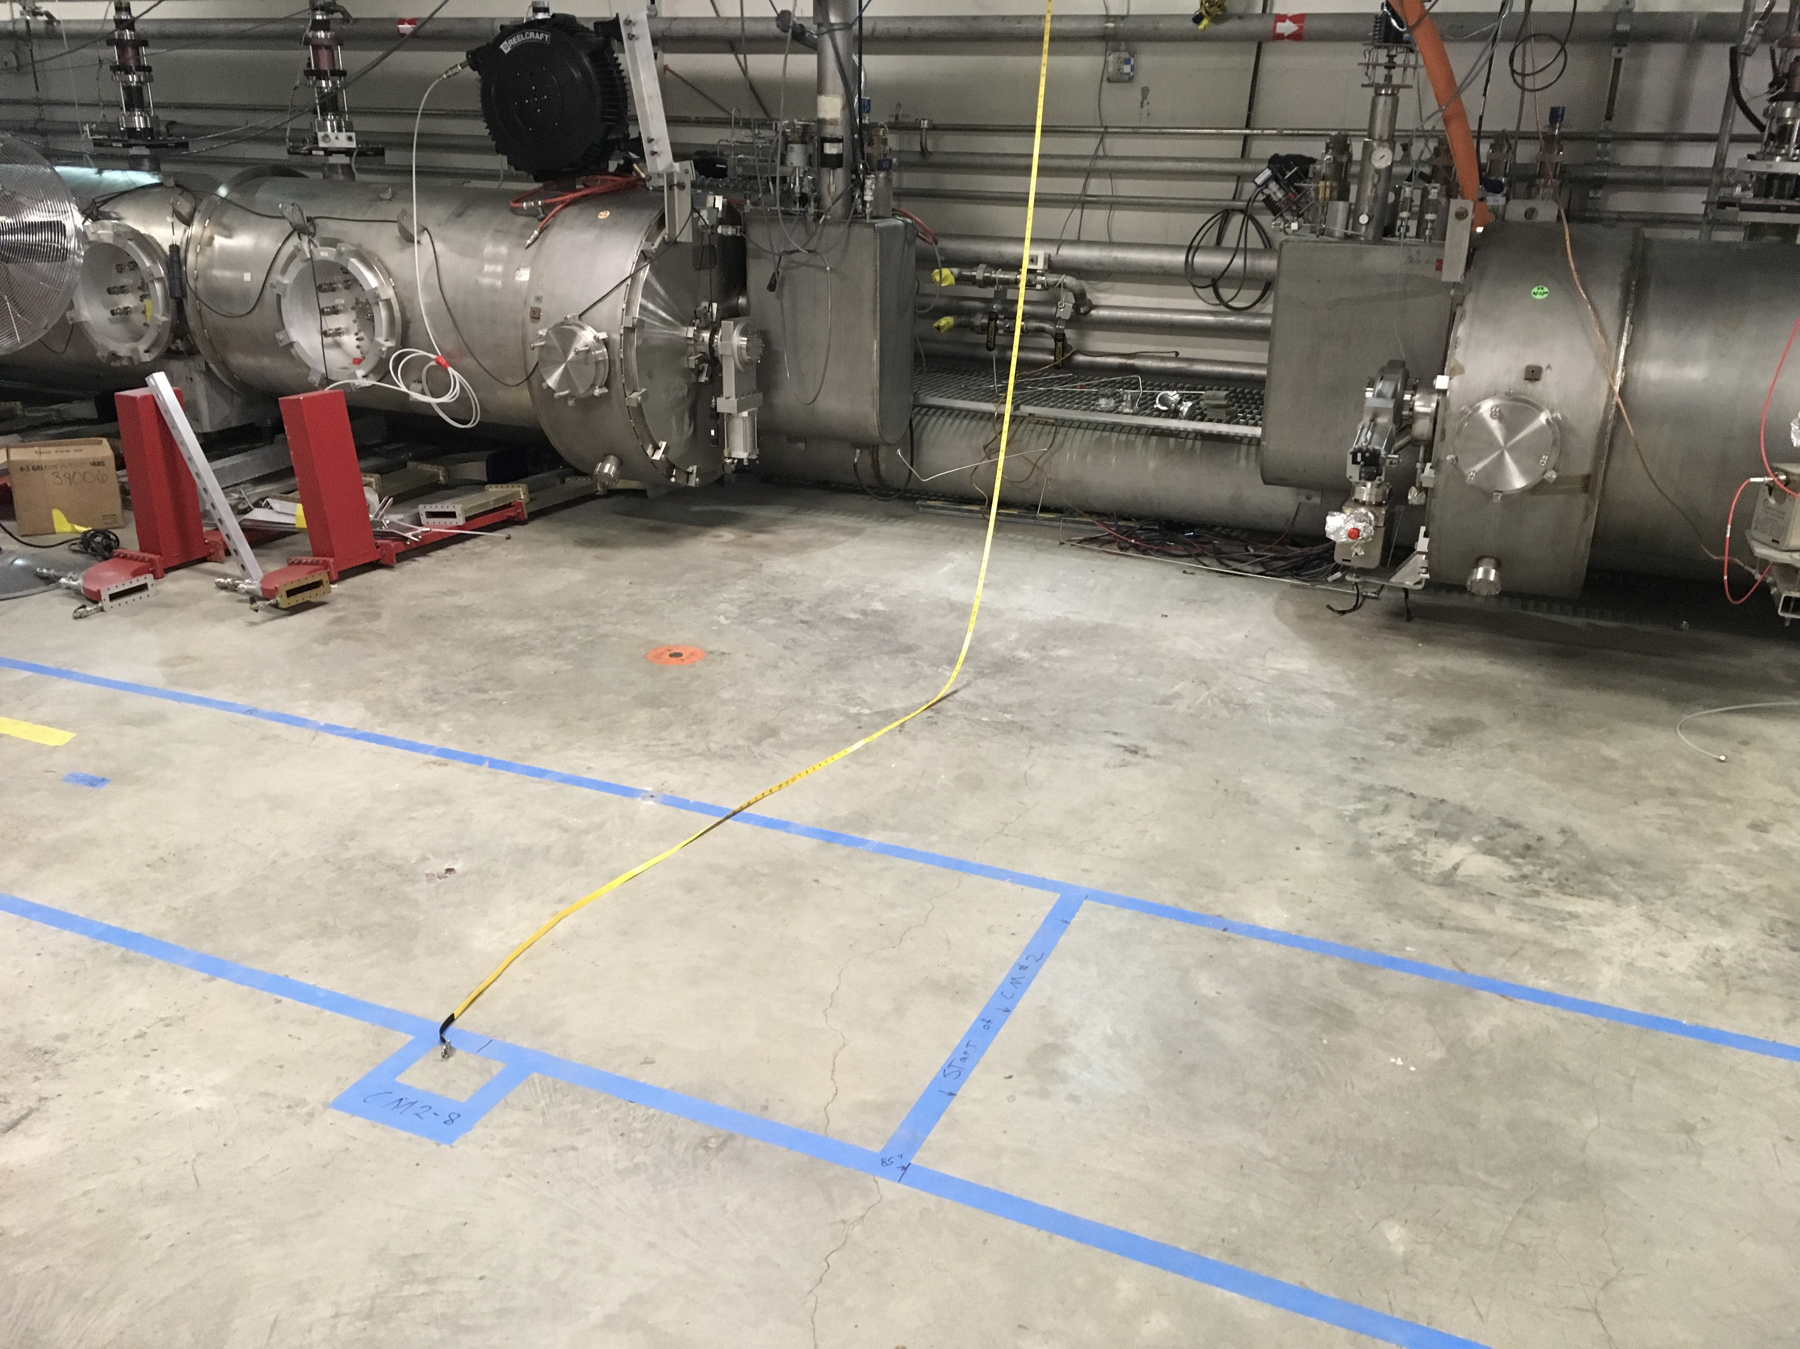
Layout of cryomodules in accelerator vault, girders removed, cable lengths check (tape measure)

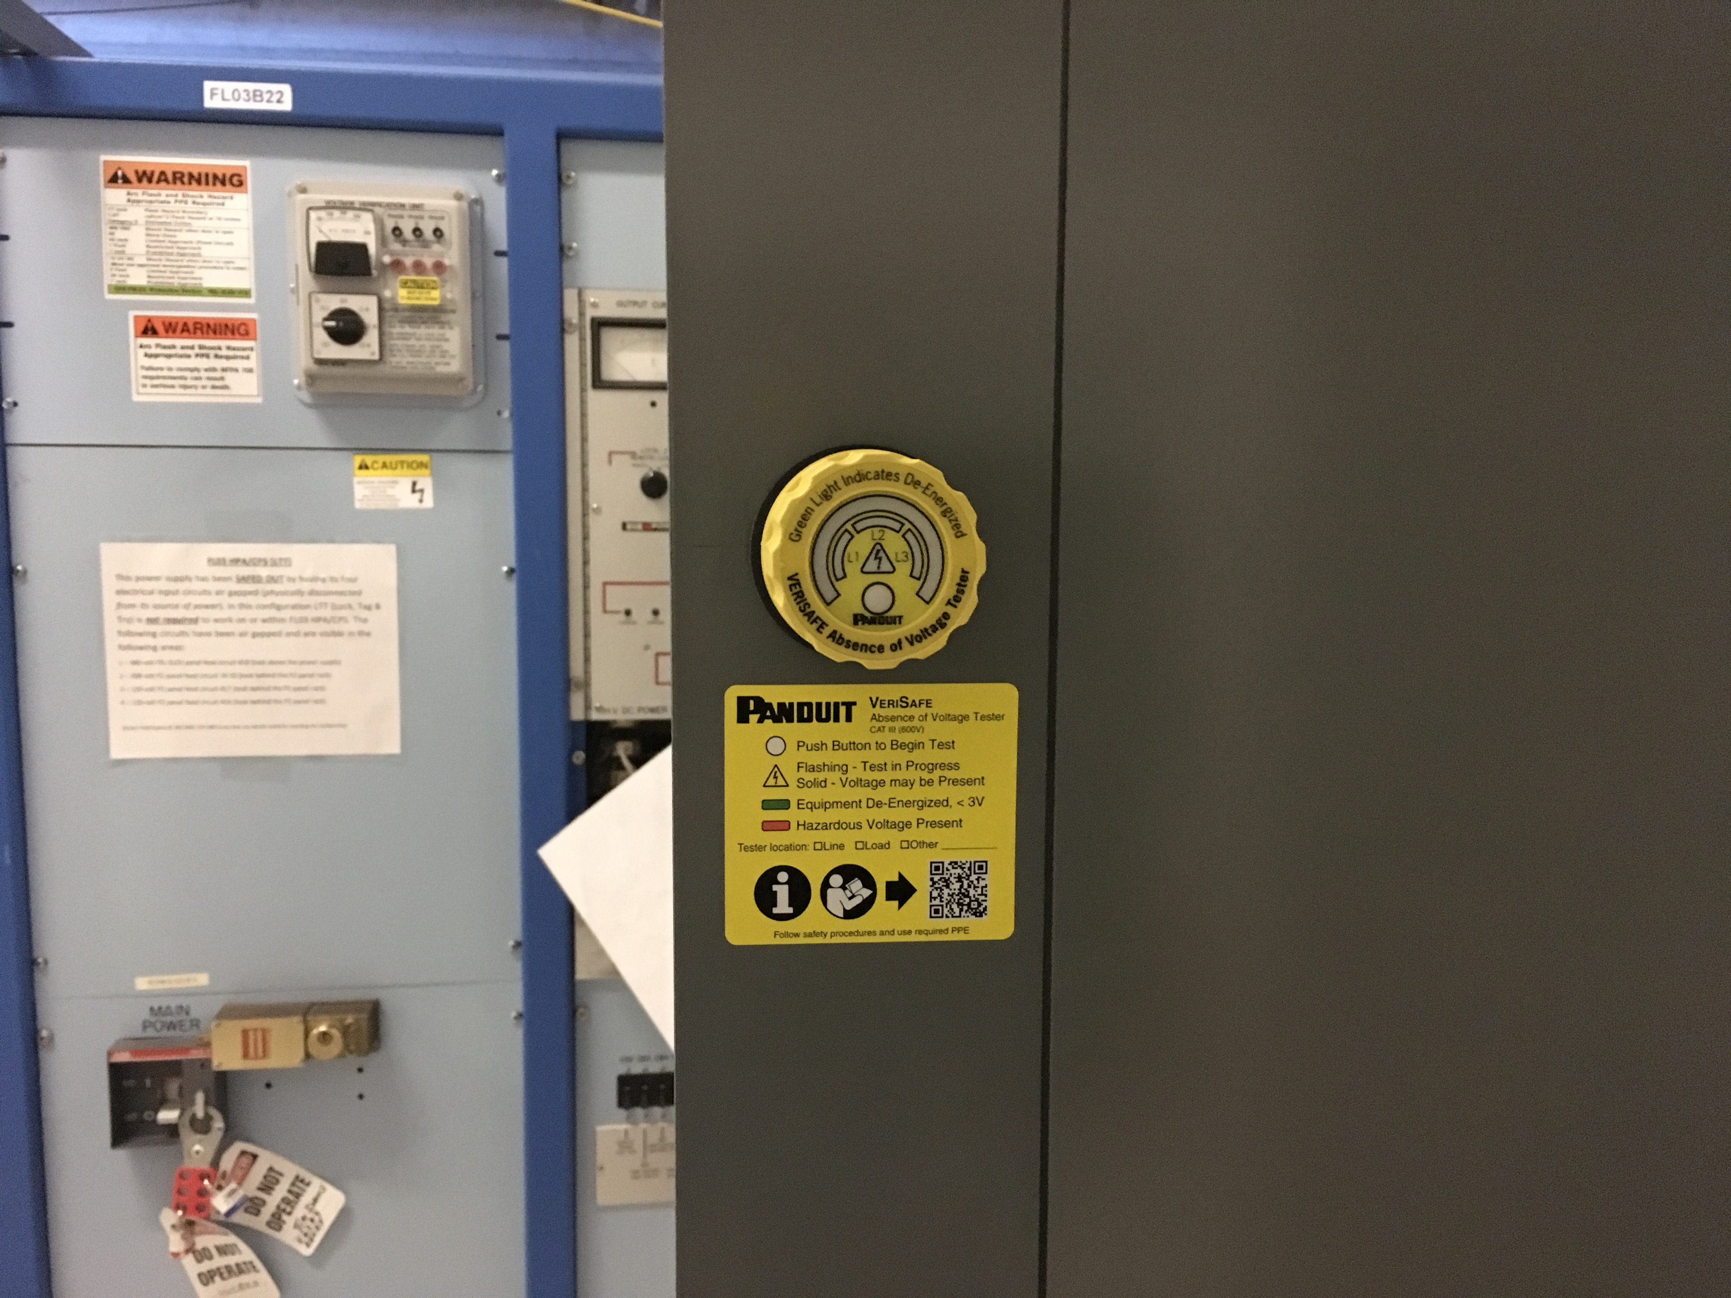
New style, commercial Voltage Verification Unit (VVU) for Lock, Tag, & Try on 480 VAC.

Weekly Reporting
WBS 1.04.08 JLAB Cryoplant System
Week of November 2-8, 2017
Issues:
Accomplishments this week:
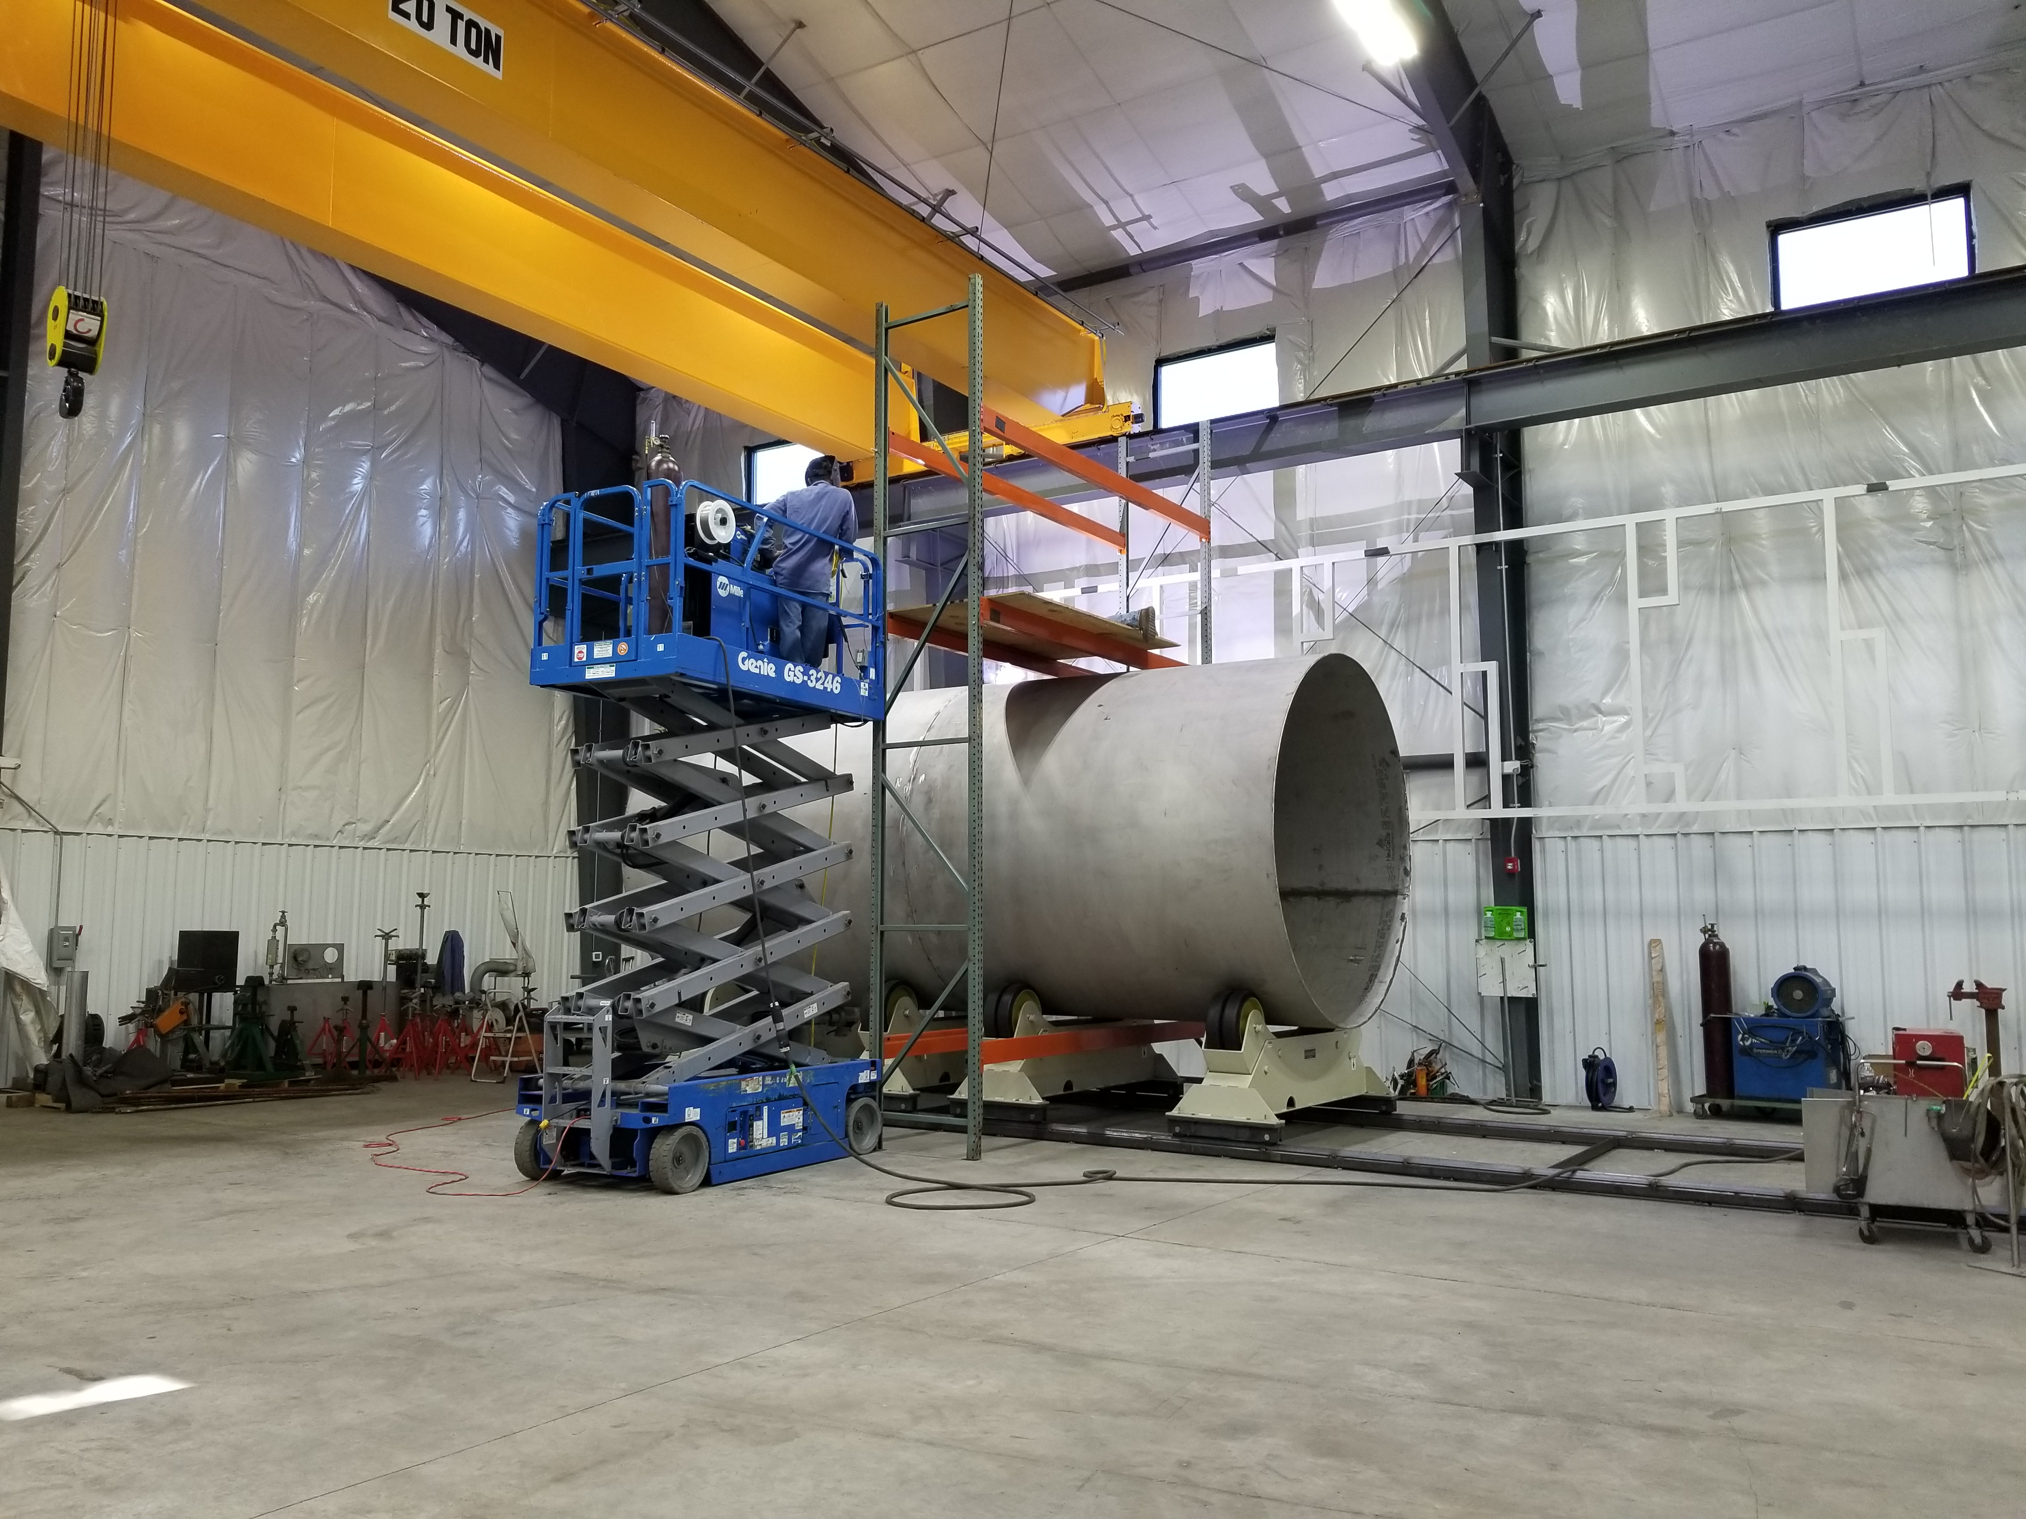
LN2 Dewar Inner Vessel Under Fabrication

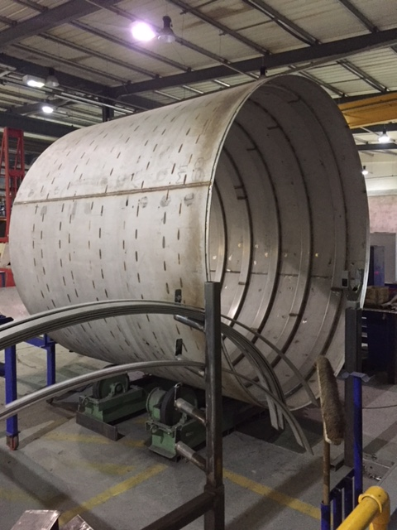
LHe Dewar Outer Vessel Under Fabrication

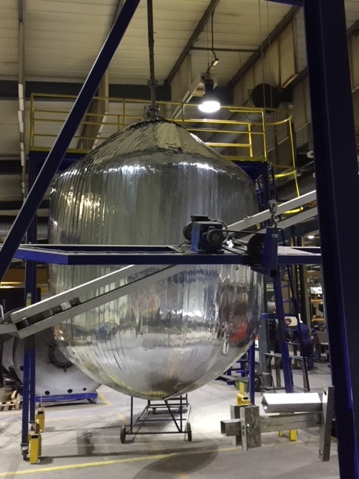
Inner LHe Dewar Under Fabrication

- A preliminary teleconference meeting was held with ALATUS concerning shipping plan.
- JLab has received a preliminary reassembly plan from ALATUS for the 4.5k Cold Boxes.
- ALATUS (PHPK) has begun fabrication of the CP#1 vacuum skid, CP#1 cryoduct and CP#2 upper cold box top dish head assembly. Plans include installation of the CP#1 upper cold box vacuum shell this week.
- ALATUS (PHPK) has completed ~50% of the CP#1 lower cold box piping assembly and is currently planning a leak check of the HP, MP, and LP piping completed to date.
- CP#1 compressors skid oil removal vessels have been received at SLAC.
- CP#1 uppercold box assembly had a successful piping leak recheck prior to installing the lower vacuum shell as the next step.
- November 9-10th CP#1 CC drive testing scheduled at MECOs this week
Control cabinet shipping should follow shortly after successful test.
- Remaining two warm helium compressors (HP) to be shipped to SLAC for Nov 20 and 21.
- December 1 is the target date for control panel procurement PRR.
- Need final disposition on holding gaseous helium storage tanks until March.
- CP1 4.5K Cold Box remains on schedule for January 25, 2017 delivery.

QUALITY:
Mike Martin, Conner Kaufmann, and Melissa Torres traveled to the UK to inspect weldments of the liquid helium dewars prior. The inspection indicated no action items required.

Discussed Equipment Transfer process with SLAC and FNAL. Coordinating Cryoplant information for transmittal to SLAC; need to ascertain if the documents they want are part of our work thus far.

Upcoming Travel/Reviews:
Visit to PHPK – Warm Compressor Skids Nov 8-10
2K Cold Compressor Run Witness Test, MECOS, Switzerland, Nov 10-11

Weekly Reporting
WBS 1.02.03.05.12 LLRF
Week of November 2-8, 2017

Issues: None
Accomplishments this week at JLab:
- LLRF Coordination/Documentation:
  - LERF project: LERF ICD has been released for official review. Met with the SLAC team Friday and finalized delivery dates for RF hardware and racks.

- Resonance/Interlock Chassis:
  - FMC board: The board will be shipped out (for assembly) Wednesday for a first article 10 day turn around. Rama is working on the firmware to test the board.
  - Temperature sensor board: PCB is here and waiting on parts. It will be assembled when they arrive.
  - Power supply distribution board and VAC/Digital I/O boards are being assembled in house.
  - Stepper motor board: Is being manufactured by the PCB board house.

- Interlock Board/Chassis:
  - Work at this time is on hold until needed for 3.9 GHz.

- Common Power Supply/Chassis/Boards:
  - Andre asked us to build another Gun PS chassis. Will order up the power supplies on Wednesday.

- CMTF/LERF
  - Installing the cables, couplers and switches is beginning this week in the CMTF
  - Dave and Larry now have the needed lengths for ordering the Heliax cable for the LERF. This will be completed later this week.
Upcoming Activities:
- CMFT cable/coupler/switch installation.

