Weekly Reporting

WBS 1.01.07 JLAB Management

Week of November 9-15, 2017

**Issues:**

**Accomplishments this week:**

pCM returned to JLab following completion of cold testing at FNAL.

Began cold testing of CM04.

Held internal peer review of LERF infrastructure for CM testing.

Technical experts met at PHPK to work through the assembly plan for the Warm Helium Compressors.

Preparing several BCRs for November presentations including an additional 43 cavities.

**Upcoming Activities:**

28 Nov – 2 Dec 2018 – ESS Cryomodule Review (Drury, Preble)

7 May 2018 - Collaboration Meeting @ SLAC

8–10 May 2018 – OPA Review @ SLAC

Weekly Reporting

WBS 1.04.06 JLAB Cryomodules

Week of November 9-15, 2017

**Issues**:

**Accomplishments this week:**

Conducted BCR facilitation for additional cavities to mitigate schedule delays. Proposing 16 additional cavities from EZ and 11 additional cavities from RI.

Completing specification and package for competitive procurement of cavities to be produced from 133 material order.

U-tubes for fast cooldown are progressing.

J1.3-01 – Returned from FNAL on 13-NOV. Shipping loads were within acceptable limits. Moved to the storage area.

J1.3-03 – Removed from CMTF. Testing caps are being removed.

J1.3-04 – CM is cold and has begun testing. Plan to focus on HOM Qext verification by the end of this week. J. Sekutowicz is participating in CM04 testing.

J1.3-05 – Currently at WS5. Warm coupler installation is in progress. Beam pipe installation is in progress.

J1.3-07 - String alignment complete, Tuners in progress, VV moved to WS4 for demag.

J1.3-08 - Berry bolts complete. Two-phase pipe welding in progress. Heaters attached; Ti sheets in progress.

J1.3-09 – Cavity string assembly pumped down. Leak check is in progress. Plan to roll-out Friday 17-NOV.

J1.3-10 – Six of eight cavities qualified for string assembly. Plan to start string assembly on 3-DEC and roll-out on 15-DEC.

Cavity Tests:

305 NX-A, First test in D5, FE free, Q0(16) = 2.3e10, quench at 23.3 MV/m, plan to retest to verify Qo measurement.

306 NX-A, first test in D5, FE free, Q0(16) = 3.0e10, admin limited to 24 MV/m, qualified.

308 NX-A first test in D5, FE on 20.5 MV/m, Q0(16)=3.2e10, admin limited 24 MV/m, plan to rinse and retest.

288 NX-A retest (complete disassembly for FE), FE free, Q0(16)=3.5e10, admin limited to 24 MV/m, qualified.

134 NX-A first test, FE free, Q0(16)=3.2e10, quench at 23.5MV/m, qualified.

Plan to test 138 and retest 305 in D7 or D8.

Developed proposed order for retro-fit & rework of CMs and plan to discuss with project. Working with JLab Physics Division leadership to coordinate additional space in Test Lab high bay to support this activity.

**QUALITY**:

Working on Equipment Transfer documentation.

**Upcoming Travel/Meetings:**

TTC @ FNAL Nov 14-17 (Wilson, Palczweski)

FNAL Production & Engineering Discussion Nov 17(Preble, Daly-remote)

ESS Cryomodule Review Nov 28-Dec 2 (Drury, Preble)

WUXI Vendor Visit to China Dec 4-8 (Cheng, Legg)

EZ Vendor Visit Dec TBD dates (Burrill)

Weekly Reporting

WBS 1.04.06 Cryomodules - LERF Conversion

Week of November 9-15, 2017

**Issues:** Need SLAC to ship SSAs, they need BCR.

**LERF accomplishments this week:**

Second design review of cryo can has been done – hope is to have bid package out before Christmas. Notes are at: <https://wiki-2015.jlab.org/lerf/index.php/Nov_13_2017_WG>

Safety Assessment document is still in progress

Waveguide bid is back, we shaved off a few components – found parts in trailer & reuse more pieces for savings of ~$50k, award later this week.

3/8” Heliax order of 6,000’ is out for bid

7/8” Heliax for TLM is ordered

Waiting on personnel to do cryomodule shuffle

Continued work on WIKI site for documentation: wiki.jlab.org/lerf

Kevin visited Fermilab

**Upcoming Activities:**

Complete Safety Assessment document

Remove girders and two cryomodules – shuffle the third to the zone 2 position

Weekly Reporting

WBS 1.04.08 JLAB Cryoplant System

Week of November 9-15, 2017

**Issues:**

**Accomplishments this week:**

* Traveled to Mecos to witness the cold compressor motor/bearing spin tests. Testing successfully demonstrated the performance requirements.
* Traveled to PHPK to perform a re-assembly mockup of the HP compressor to refine our installation plans.
* CP1 4.5K upper cold box intermediate internal piping leak check completed and installation of the lower shell is underway.
* Finalized the cryo valve procurement specification and PR submitted to procurement.

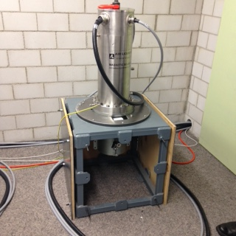

Cold Compressor Motor/Bearing Spin Test at Mecos

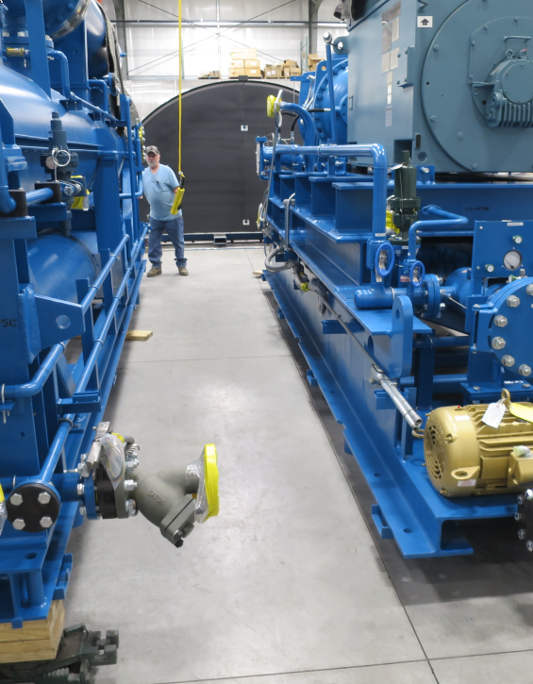

HP Compressor Skid Re-Assembly at PHPK

**QUALITY**:

Discussed Equipment Transfer process with SLAC and FNAL. Coordinating Cryoplant information for transmittal to SLAC; need to ascertain if the documents they want are part of our work thus far.

**Upcoming Travel/Reviews:**

QA Visit to Eden Nov 15-17 (Lenzer)

SLAC visit for installation planning Nov 28th (Kessler/Hogan/Bevins)

QA Visit to PHPK in early Dec (Macha/Lenzer)

Weekly Reporting

WBS 1.02.03.05.12 LLRF

Week of November 9-15, 2017

**Issues:** None

**Accomplishments this week at JLab:**

* LLRF Coordination/Documentation:
  + LERF project: LERF ICD is out for official review.
  + SLAC BCR is working its way through the system (needed to ship hardware to the LERF).
* Resonance/Interlock Chassis:
  + FMC board: The board was shipped out and received. A first article is due back the week after Thanksgiving. Rama is working on the BMB7 firmware to test the board.
  + Temperature sensor board: PCB is waiting to be assembled in house.
  + Power supply distribution board and VAC/Digital I/O boards are being assembled in house.
  + Stepper motor board: Is being manufactured by the PCB board house. Due next week.
  + Chassis parts: Andre is sending enough for two.
  + Piezo boards: Joshua is sending 4 boards.
* Interlock Board/Chassis:
  + Work at this time is on hold until needed for 3.9 GHz.
* Common Power Supply/Chassis/Boards:
  + Andre asked us to build another Gun PS chassis. The power supplies have shipped to JLAB and we are ready to install them. Still waiting on pictures of the front and back of the Gun PS chassis so we can make labels like the last chassis.
* CMTF/LERF
  + Installing the cables, couplers and switches has begun in the CMTF.
  + The Heliax req for the LERF has been written and waiting for signatures.
  + CM04: Testing has started and they are tuning cavities to resonance.

**Upcoming Activities:**

* CMFT cable/coupler/switch installation.