Weekly Reporting

WBS 1.01.07 JLAB Management

Week of November 23-29, 2017

**Issues:**

**Accomplishments this week:**

STL attending ESS CM review.

CM04 is undergoing cold testing.

Small team traveled to SLAC to resolve CP schedule issues.

Preparing several BCRs for December presentations.

Conducted October monthly EV performance review with the project office.

Presented 1.4.8.5 EAC expect to incorporate comments today.

Adding the 1.4.8.5 progress milestone list to the weekly and monthly report.

**Upcoming Activities:**

28 Nov – 2 Dec 2018 – ESS Cryomodule Review (Drury, Preble)

7 May 2018 - Collaboration Meeting @ SLAC

8–10 May 2018 – OPA Review @ SLAC

Weekly Reporting

WBS 1.04.06 JLAB Cryomodules

Week of November 23-29, 2017

**Issues**:

**Accomplishments this week:**

Test lab tour for DOE site office (Korynta, Aurango).

Prepared presentation for monthly JLab Director’s review.

Working on BCR for management and QA LOE adjustments.

Prepared VARs for 1.04.06 accounts.

Reviewing package for competitive procurement of cavities to be produced from 133 material order.

Clean room audit planned at JLab with help from S. Berry during December on CM10 string.

Reviewed procedures with Cryo group for installation of flex U-tubes for fast cooldown. During pre-installation, it was found that the return flex U-tube need minor rework in order to be properly installed. The fast cooldown is planned for Monday 12/4/17.

J1.3-01, J1.3-02 – In storage on Injector Test Cave roof.

J1.3-03 – Removed from CMTF. Bayonet box and end cap removed.

J1.3-04 – Continued cold testing of CM04. Six cavities tested – no sustained FE in five. Cavity 4 has FE at 8 MV/m after initial processing up to 15 MV/m. Testing plan will be updated since fast cooldown flex u-tubes are delayed. CM04 warm-up was planned for 5-DEC due to previous power outage; this date may be extended.

J1.3-05 – Currently at WS5. Warm couplers installation in progress. Reverse plumbing welding in progress. Leak check of helium circuit connections in progress. Light-weight leak check cap for GHRP have been deployed based on lessons learned from CM06 venting. High-pressure test of line A complete.

J1.3-07 – Currently at WS3. RF cabling and heat stationing in progress. Plan to move to WS4 before the week’s end.

J1.3-08 – Currently at WS3. Two-phase pipe leak check complete. MLI and Mag shields installed. Mated to UCM.

J1.3-09 – Currently at WS2. Helium vessel heaters being assembled. Berry bolts being cleaned.

J1.3-10 – Eight cavities qualified for string assembly. Plan to start string assembly on 3-DEC and roll-out on 15-DEC. One cavity is currently NX-900 and may be set aside. This could potentially delay string assembly.

Cavity Tests:

310 NX-A with B end groups first test (D8), FE free, Q0(16) = 2.6e10, quench limited to 20.4 MV/m, Qualified for string assembly.

Plan to test 135 in D7 Tuesday, 28 Nov. Three cavities are loaded onto D5 top plate (293, 314, 327) and planned for testing on Wednesday, 29 Nov. Plan 137 first test in D8 Thursday, 30 Nov.

Awaiting response from JLab Physics Division leadership to coordinate additional space in Test Lab high bay to support rework/retro-fit activity.

**QUALITY**:

Working on Equipment Transfer documentation.

**Upcoming Travel/Meetings:**

ESS Cryomodule Review Nov 28-Dec 2 (Drury, Preble)

Clean Room Audit 4-20 Dec (S. Berry)

WUXI Vendor Visit to China Dec 4-8 (Cheng, Legg)

EZ Vendor Visit Dec 18-20 (Burrill)

EZ Vendor Visit Jan 14-19 (Reece)

Weekly Reporting

WBS 1.04.06 Cryomodules - LERF Conversion

Week of November 23-29, 2017

**Issues:** Short week due to holiday

Need SLAC to ship SSAs, they need to complete BCR

**LERF accomplishments this week:**

Getting the control room workstations re-networked and set up.  Also Sent email to Matt to find out if anything else is needed on getting that PLC shipped to us asap.

Lab electricians are being trained to handle the removal of the klystrons from zone 3 and 4. They will also be able to help out on the installation of the new waveguide.

Safety Assessment document is still in progress

Waveguide procurement contract mod complete, the system was re-designed over the past week to utilize newly found 6” bellows and the SLAC miter design. The final price came in at ~$274k

Waiting on personnel to do cryomodule shuffle, this is now scheduled for next week

Continued work on WIKI site for documentation: wiki.jlab.org/lerf

**Upcoming Activities:**

Complete Safety Assessment document

Weekly Reporting

WBS 1.04.08 JLAB Cryoplant System

Week of November 23-29, 2017

**Issues:**

**Accomplishments this week:**

* Last CP-2 warm helium compressor with all compressor oil is being prepared to be shipped the first week of December to SLAC.
* A 1.4.8.5 Engineering EAC presentation was made to SLAC on Nov 28th.
* Phil Kessler, Mike Bevins, and John Hogan visited SLAC to check coordination of the SLAC installation plan with the scheduled equipment deliveries and to answer any outstanding questions which the installation bidders may have.
* John Hogan, Ted P. and Eric Fauve plan to visit PHPK later this week to review the 4.5K cold box fabrication status and the development of the monthly status report.
* CP1 4.5K upper cold box installation of the lower shell has been completed. The bottom end dish head is now being prepared to be welded on early next week. Instrument tubing has been routed through the lower shell section. A leak check will be conducted of the tubing prior to the bottom dish head weldment.
* CP1 4.5K lower box internal instrumentation and internal piping is 50% complete.
* CP-2 Upper Cold Box internal dished head piping has started
* The oil processor will be leak and pressure tested early December 2017.

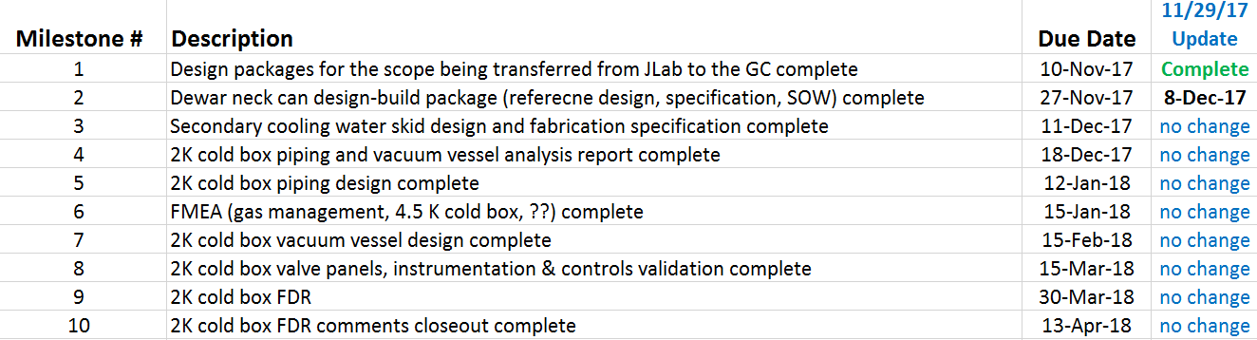

**QUALITY**:

Discussed Equipment Transfer process with SLAC and FNAL. Coordinating Cryoplant information for transmittal to SLAC; need to ascertain if the documents they want are part of our work thus far.

**Upcoming Travel/Reviews:**

QA Visit to PHPK in early Dec (Macha/Lenzer)

Visit AES Dec 5 (Arenius/Torres/Martin)

Weekly Reporting

WBS 1.02.03.05.12 LLRF

Week of November 23-29, 2017

**Issues:** None

**Accomplishments this week at JLab:**

* LLRF Coordination/Documentation:
  + LERF project: LERF ICD is out for review.
  + SLAC BCR is working its way through the system (needed to ship hardware to the JLAB/LERF).
* Resonance/Interlock Chassis:
  + FMC board: The first article board tested perfectly and the other 9 boards are being built. We should see them later next week.
  + Temperature sensor board: The board was assembled and being tested.
  + Power supply distribution board and VAC/Digital I/O boards are assembled and waiting testing.
  + Stepper motor board: The board was assembled and being tested.
  + Chassis parts: Andre has shipped the chassis parts to build up 2 new Res/Int chassis.
  + Piezo boards: Joshua has asked for a BMB-7 and a FMC card so that he can test 4 Piezo boards. JLAB is sending him the FMC card and SLAC is send Joshua a BMB*-7.*
* Interlock Board/Chassis:
  + Work at this time is on hold until needed for 3.9 GHz.
* Common Power Supply/Chassis/Boards:
  + TheGun PS chassis is completed. The chassis is being tested and should ship out tomorrow with 6 cable assemblies*.*
* CMTF/LERF
  + Installing the cables, couplers and switches in the CMTF is on hold because of CM04 testing.
  + A short in the high power coax for cavity 5 is being investigated.
  + The Heliax for the LERF has been awarded and should arrive in late December.
  + LERF LLRF instrumentation cables: We are waiting on final Captar from Andy to start ordering cables.

**Upcoming Activities:**

* Assemble new resonance chassis, December 15
* LERF cable installation ~ January.