Weekly Reporting

WBS 1.01.07 JLAB Management

Week of November 30-Dec 6, 2017

**Issues:**

**Accomplishments this week:**

Gathered CM 1.04.06 and CP 1.04.08 progress information for November.

Conducted CM and CP status meetings.

Preparing several BCRs for December presentations.

The final delivery of Warm Helium Compressor (12 of 12) arrived at SLAC.

Conducted a ‘fast cool down’ cycle on CM04 (30-35 g/s).

DeAnn Maddox joined the Procurement Team on Dec 1.

**Upcoming Activities:**

7 May 2018 - Collaboration Meeting @ SLAC

8–10 May 2018 – OPA Review @ SLAC

Weekly Reporting

WBS 1.04.06 JLAB Cryomodules

Week of November 30-Dec 6, 2017

**Issues**:

**Accomplishments this week:**

Presented update for monthly JLab Director’s review.

Continuing work on BCR for management and QA LOE adjustments. There is concern regarding the difference in the baseline plan for LOE accounts compared with guidance from SLAC project office. FY2018 is currently underfunded by 50%.

Package for competitive procurement of cavities to be produced from 133 material order finalized.

In accordance with the last two cavity BCRs, we awarded 8 additional cavities and additional single cells to RI. Expecting to award 16 + 16 cavities to Zanon later this week.

Clean room audit on-going at JLab with help from S. Berry during December on CM10 string.

Conducted fast cooldown on Monday 04-DEC. Pumped down CM04 and began high-power testing on 05-DEC.

J1.3-01, J1.3-02 – In storage on Injector Test Cave roof.

J1.3-03 – Reconfigured beamline vacuum for storage.

J1.3-04 – Continued cold testing of CM04. HOM Qext’s meet spec. Emax on all Cavities – Average 20.5 MV/m. Plan to complete 1 Hr soak on Cavity 5 after fast cooldown. Cavity 5 coax failure shut down testing of Cavity 5. Waveguide jumper set up to complete Cavity 5 work. Fast Cool-down completed – estimate flow rate of 30 to 35 g/s. Qo retests and multiple cavity extended running tonight thru Thursday 07-DEC. CM warm up to start no later than 07-DEC.

J1.3-05 – Currently at WS5. Warm couplers / MC line complete. JT welding / Pressure tests done. Preparing for Faraday Tee install.

J1.3-07 – Currently at WS4. Completing Instrumentation. Completing final HOM tuning.

J1.3-08 – Currently at WS3. Welding 2 phase piping in progress. Installing heat stations.

J1.3-09 – Currently at WS2. Berry bolts installed. Verifying Alignment. Heaters and Ti sheets in place. UCM QC in progress.

J1.3-10 – Started string assembly on 03-DEC and plan to roll-out on 15-DEC. Four cavities are on the assembly rail as of 06-DEC.

Identified additional space in the TL high bay. Began moving inventory and hardware to Engineering Support Building. Expect area to be ready on 07-DEC.

Cavity Tests:

135 (TD) first test (D8), FE free, Q0(16) = 3.7e10, quench limited to 19.8 MV/m, Qualified for string assembly.

293 (NX-A) first test (D5), FE free, Q0(13.6) = 2.4e10, quench limited to 13.6 MV/m, Optical inspection planned.

314 (NX-A/B) first test (D5), FE onset 11.2 MV/m, Q0(16) = 2.4e10, rad limit 21.6 MV/m, plan to rinse/retest.

327 (TD) first test (D5), FE free, Q0(16) = 2.9e10, Quench limit 25.5 MV/m, Qualified for string assembly.

**QUALITY**:

Working on Equipment Transfer documentation.

**Upcoming Travel/Meetings:**

Clean Room Audit 4-20 Dec (S. Berry)

WUXI Vendor Visit to China Dec 4-8 (Cheng, Legg)

EZ Vendor Visit Dec 18-20 (Burrill)

EZ Vendor Visit Jan 14-19 (Reece)

Weekly Reporting

WBS 1.04.06 Cryomodules - LERF Conversion

Week of November 30-Dec 6, 2017

**Issues:**  None

**LERF accomplishments this week:**

Lab electricians have removed all of the klystrons from zone 3 and 4. They will now move to remove circulators and prepare racks for new waveguide installation.

Safety Assessment document is still in review.

Waiting on personnel to do cryomodule shuffle, this is scheduled for Thursday 12/ 7.

Working on a design for protecting RF cables with a “false floor” – the cables will lay on the floor between the klystron racks & the SSAs, also placed order for ~400 waveguide gaskets.

Continued work on WIKI site for documentation: wiki.jlab.org/lerf

Submitted abstract to IPAC 2018 on the LERF conversion activities.

**Upcoming Activities:**

Complete Safety Assessment document.

Weekly Reporting

WBS 1.04.08 JLAB Cryoplant System

Week of November 30-Dec 6, 2017

**Issues:**

**Accomplishments this week:**

John Hogan, Ted Peshehonoff, and Eric Fauve visited PHPK to review the 4.5K cold box fabrication status and the development of the monthly status report. PHPK is in the progress of welding the lower end bell of the CP#1 Upper Cold Box following a completed intermediate leak check of the remaining piping exiting through the vacuum shell. The intermediate testing of the CP#1 lower cold box is complete and piping spool piece installation continues. Current progress of the CP#1 Upper and Lower cold boxes indicate a possible delivery date at SLAC of Feb 17, 2018/April 28, 2018 respectively and a reassembly complete at SLAC of Sept 14, 2018. Current progress of CP#2 indicates a possible delivery date of the Upper and Lower cold boxes as August 7, 2018/Oct 8, 2018 respectively and a reassembly completion of March 2019.

|  |  |
| --- | --- |
| **Activity** | **Status** |
| **OVERALL CB1** | **71%** |
| **VCB** | **80%** |
| VBC Load #1 – VCB Vessel |
| VBC Load #2 – VCB Platform |
| VBC Load #3 – Vacuum Skids, Cryoduct, HCB Platform, and Remaining VCB (Ext. Pipe, Valve Actuators, PSV) |
| **HCB** | **65%** |
| HBC Load #4 – HCB Vessel |
| HBC Load #5 – HCB External Piping, Actuators, PSVs |
| **OVERALL CB2** | **9%** |
| **VCB** | **15%** |
| VBC Load #1 – VCB Vessel |
| VBC Load #2 – VCB Platform |
| VBC Load #3 – Vacuum Skids, Cryoduct, HCB Platform, and Remaining VCB (Ext. Pipe, Valve Actuators, PSV) |
| **HCB** | **5%** |
| HBC Load #4 – HCB Vessel |
| HBC Load #5 – HCB External Piping, Actuators, PSVs |
| **TOTAL (CB1 & CB2)** | **41%** |

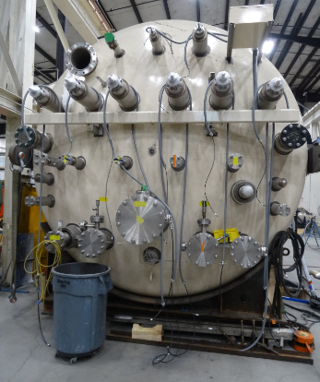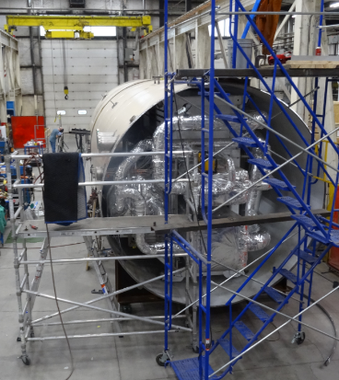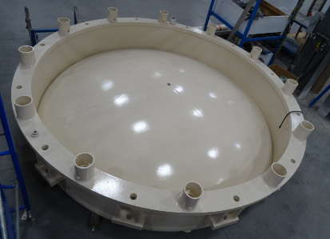

CP#1 Upper Cold Box and Bottom Dished Head

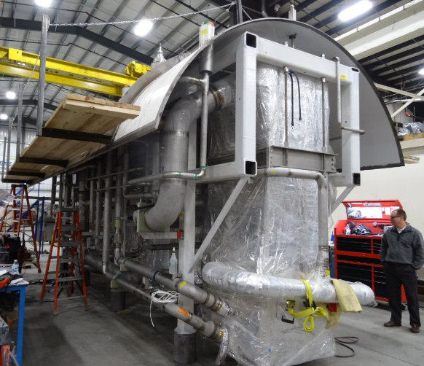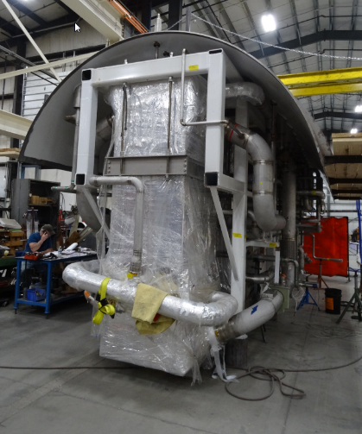

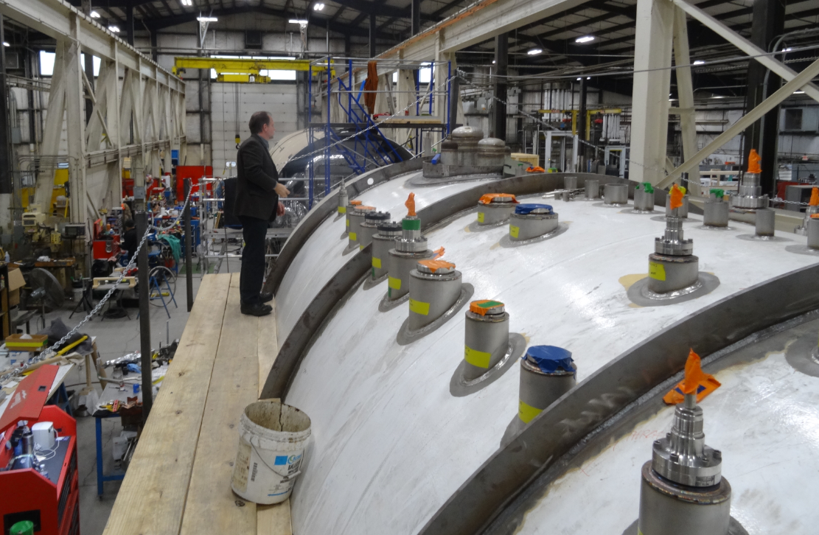

CP#1 Lower Cold Box

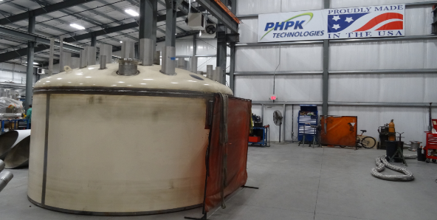

CP#2 Upper Cold Box Top Head Assembly

Dana Arenius and Michael Martin visited AES, Inc to review the LN2 dewar fabrication welding status on December 5th. JLab received final design of the mounting pier details which allow ordering of the external vessel.

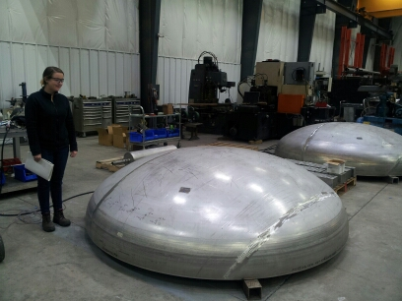 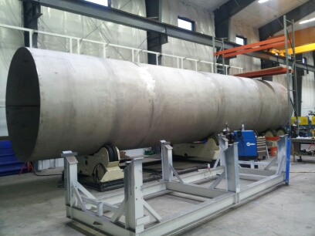

LN2 Dewar #1 Internal Vessel and End Dished Heads

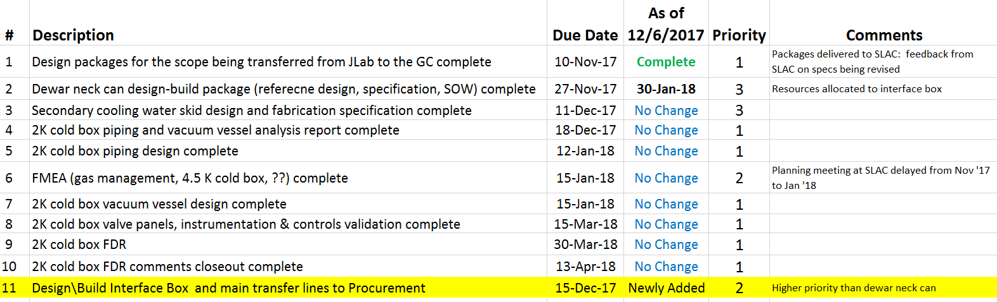

**QUALITY**:

Mike Martin reviewed AES, Inc. welding documentation compliance.

**Upcoming Travel/Reviews:**

QA Visit to PHPK in Dec (Macha/Lenzer)

Weekly Reporting

WBS 1.02.03.05.12 LLRF

Week of November 30-Dec 6, 2017

**Issues:** None

**Accomplishments this week at JLab:**

* LLRF Coordination/Documentation:
  + Meeting weekly now with the SLAC LERF team. SLAC has a working MS project file that they are working to.
  + LERF project: LERF ICD is out for review.
  + SLAC BCR is working its way through the system (needed to ship hardware to the JLAB/LERF).
* Resonance/Interlock Chassis:
  + All of the new boards for the Resonance chassis are in house and the first chassis is being assembled.
  + Piezo boards: We shipped the FMC card so that Joshua can test 4 Piezo boards*.*
* Interlock Board/Chassis:
  + Work at this time is on hold until needed for 3.9 GHz.
* Common Power Supply/Chassis/Boards:
  + TheGun PS chassis was completed and shipped*.*
* CMTF/LERF
  + Installing the cables, couplers and switches in the CMTF is on hold because of CM04 testing.
  + A short in the high power coax for cavity 5 is still under investigation.
  + The Heliax for the LERF has been awarded and should arrive in late December.
  + LERF LLRF instrumentation cables: We are waiting on final Captar from Andy to start ordering cables.

**Upcoming Activities:**

* Assemble new resonance chassis, December 15
* LERF cable installation ~ January.