Weekly Reporting
WBS 1.01.07 JLAB Management
Week of Dec 7-13, 2017

Issues:
Accomplishments this week:
Conducted CM 1.4.6 Accrual Meeting
Preparing several BCRs for December presentations.
Preparing VARs for Friday’s 1.04 Performance Review Meeting.
Preparing to move CM03 into the newly allocated workspace in the Test Lab for retrofit activities.
Awarded contract for the HEP machine.
Conducted an inspection of 4.5K CBs at PHPK.
Updated the JLab Project Risk Registry.
Conducted two of three interviews for the Quality Engineer position.
Upcoming Activities:
21 December 2017 – JLab Director’s Issues & Action Items Review of LCLS-II
25 January 2018 – JLab Director’s Issues & Action Items Review of LCLS-II
22 February 2018 – JLab Director’s Issues & Action Items Review of LCLS-II
20-22 March 2018 – Director’s Review @ SLAC
29 March 2018 – JLab Director’s Issues & Action Items Review of LCLS-II
7 May 2018 - Collaboration Meeting @ SLAC
8–10 May 2018 – OPA Review @ SLAC

Weekly Reporting
WBS 1.04.06 JLAB Cryomodules
Week of Dec 7-13, 2017

Issues: Proposal to increase CM05 testing to include cooldown studies will extend CM testing schedule by two weeks to the end of January.
Accomplishments this week:
Continuing work on BCR for management and QA LOE adjustments. There is concern regarding the difference in the baseline plan for LOE accounts compared with guidance from SLAC project office. FY2018 is currently underfunded by 50%.
Prepared November VARs.
Finalized costs for CM shipping BCR. Plan to present at CCB this Thursday.
HEP tool has been awarded. Preparing BCR for January to adjust p6 cost and schedule.
Package for competitive procurement of cavities to be produced from 133 material order completed and awaiting PRR. Requested waiver to avoid further schedule slippage. Plan to release by the end of this week.
Award 16 + 16 cavities to Zanon was delayed to focus on larger procurement. It may be awarded later this week.
Clean room audit on-going at JLab with help from S. Berry during December on CM10 string.
J1.3-01, J1.3-02 – In storage on Injector Test Cave roof.
J1.3-03 – Awaiting retro-fit and rework due to lack of hardware. Investigated cavity four warm coupler.
J1.3-04 – Currently at WS5. Completed cold testing of CM04. Fast Cool-down initial test completed. Cavities 3 and 4 show Qo degradation attributable to new Field Emitters. Cavity 6 showed improvement. All other cavities essentially unchanged. Multiple cavity run was partially successful. CM warmed up and removed from CMTF on 11-DEC.
J1.3-05 – Currently in CMTF. Bayonet box were installed. Helium circuits leak checked. VV leak check in progress. Installed in CMTF. Preparing for cooldown on Thursday 14-DEC. Plan to begin testing on 18-DEC.
J1.3-07 – Currently at WS4. Final torqueing of heat stations. Review of cable routing and clearances completed. 50K shields trimmed to fit UCM. HOM tuning is complete.
J1.3-08 – Currently at WS3. Welding of 2 phase piping completed. Leak check in progress.
J1.3-09 – Currently at WS2. Magnet installed. Alignment checked. UCM QC complete in preparation for move to WS3.
J1.3-10 – Started string assembly on 03-DEC and plan to roll-out on 15-DEC. String is pumping, preparing for leak check.
Retro-fit / rework area in Test Lab High Bay is ready to receive CMs.
Cavity Tests:
137 (TD) first test (D7), FE onset 12 MV/m, Q0 (16) = 2.8e10, radiation limited to 19.5 MV/m, Plan to rinse and retest.
Upcoming tests:
Cavity 328 first test in D7 Wednesday, 13 Dec.
Cavities 332, 330, 331 first test in D5 Friday, 15 Dec.
QUALITY:
Working on Equipment Transfer documentation.
Upcoming Travel/Meetings:
Clean Room Audit 4-20 Dec (S. Berry)
EZ Vendor Visit Dec 18-20 (Gonnella)
EZ Vendor Visit Jan 14-19 (Reece)
EZ Vendor Visit Feb 12-15 (Wilson, Laney)
RI Vendor Visit Feb 15 (Wilson, Laney)
TTC Milan Feb 6-9 (TBD)

Weekly Reporting
WBS 1.04.06 Cryomodules - LERF Conversion
Week of Dec 7-13, 2017

Issues: None
LERF accomplishments this week:
The PCs for PLC programing have been delivered. They are being setup for the remote programing test – the PLC for the cryo controls is also here. This will be done over the next week.
Safety Assessment document is still in review.
The cryomodule shuffle has been done – there was a hiccup on the location of the base plates – the “C100” has a different saddle location from the original style C20/50s. These were “un-grouted” and moved back to the original position.
Waveguide hardware (nuts & bolts) have been delivered. The gallery HPA racks need to be raised 2” to accommodate the new waveguide, this design is being reviewed
Continued work on WIKI site for documentation: wiki.jlab.org/lerf

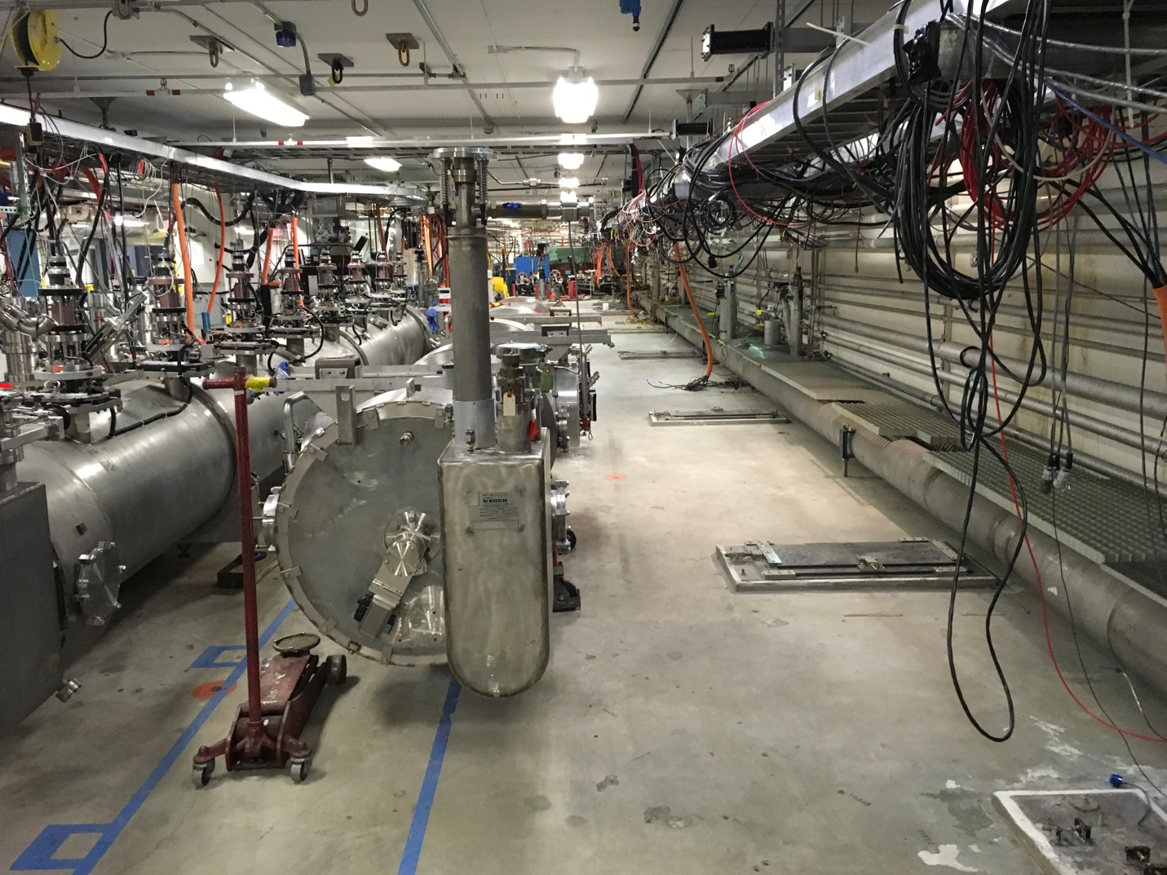
Cryomodule shuffle in place
Upcoming Activities: None
Weekly Reporting
WBS 1.04.08 JLAB Cryoplant System
Week of Dec 7-13, 2017

Issues:
Accomplishments this week:
Kelly Dixon and Dana Arenius visited PHPK to evaluate the status of the 4.5K cold box fabrication for mid-month evaluation on December 10th. SLAC engineering was invited to attend. ALATUS was in attendance.
- CP1 HCB internal piping is complete, work is centered on installing instrumentation and insulation.
- Cold Box control panels for both CPs is complete and ready for shipment with one exception waiting for delivery of two pressure transducers.
- CP2 upper cold box top head has been rotated horizontally and being prep'ed for valve pant leg installation. Large amount of upper head piping spools are complete and ready for installation. Heat exchangers are ready. HX-2 leak repair is completed when end pipe cap is cut off for installation
- Cryoduct assembly is being worked and shows good process. Saw the cryoduct flex was on hand as is the outer vacuum jacket piping and inner piping spools, and spacers.
- Cold Box vacuum skid assemblies is progressing from the Nov 30th report, Parts/pumps are ready to be installed
- CP2 vacuum shells will be sent to Mid Ohio for prep work in the next few weeks.
- ALATUS did not like the lack of UT (non-destructive ultrasonic testing) on the vertical platform supports and requires a redo to meet Hopper seismic compliance, PHPK will use material form CP2 to complete CP1 with new material to be ordered for CP2.
- JLab/SLAC has received 10 week advance notice of shipment of CP#1 Upper Cold Box to SLAC.
- Issue of internal 4.5K cold box flex hose contraction and expansion under operating and non-operation modes is being discussed.
Engineering focused on completion of the 2K cold box design and transfer line/interface box reference design during the past week.

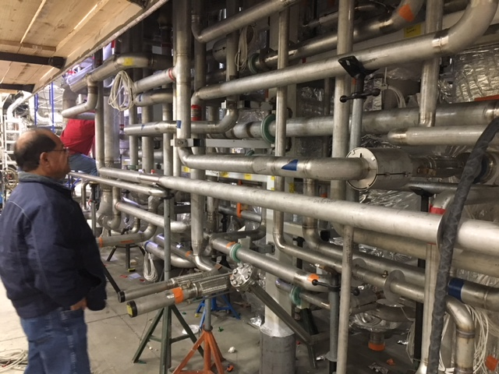
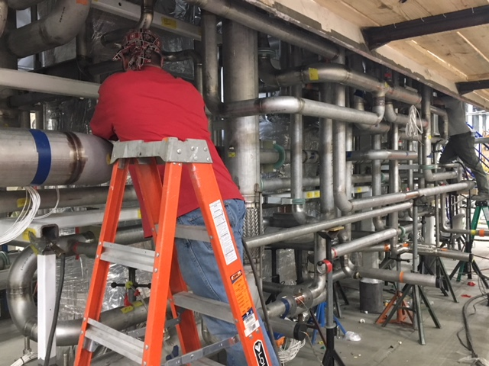
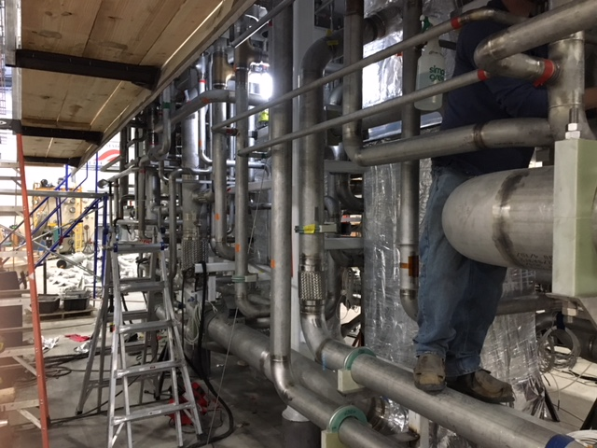
CP#1 HCB Internal Piping Installation Complete

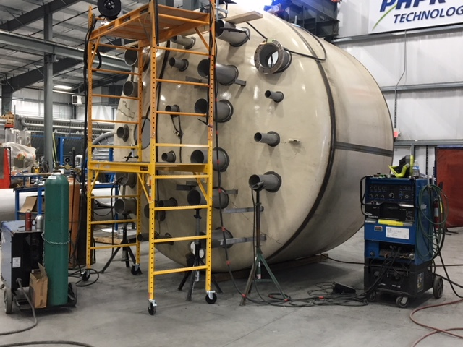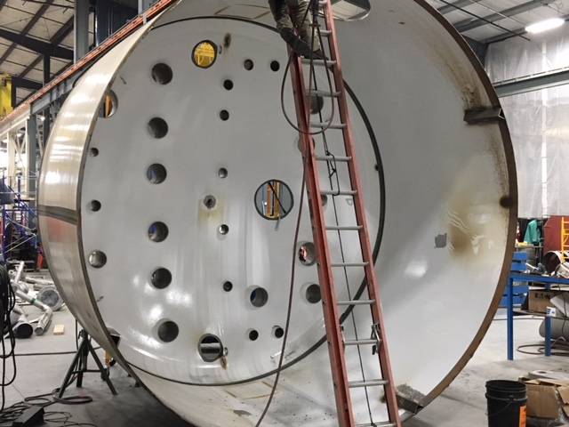
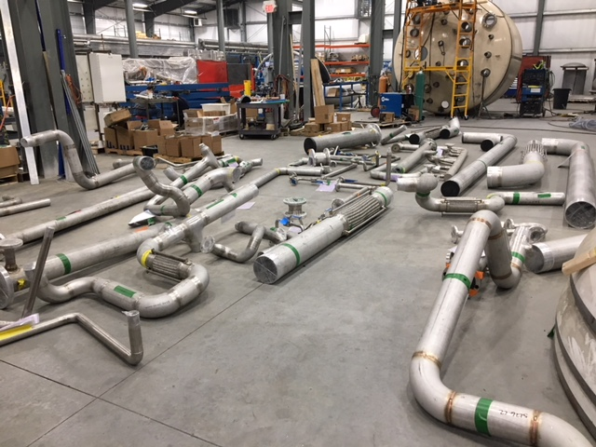
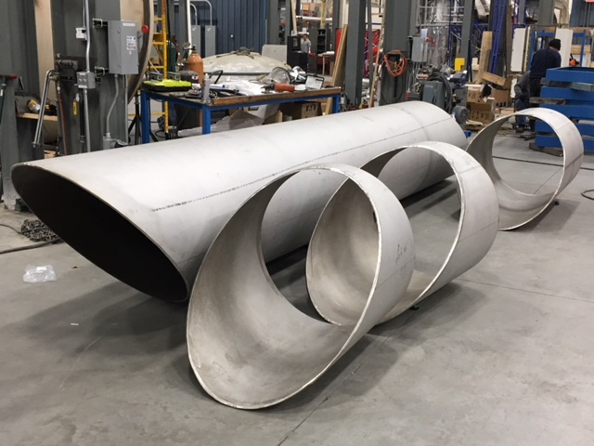
CP#2 Upper Cold Box Top Head and Piping Spools
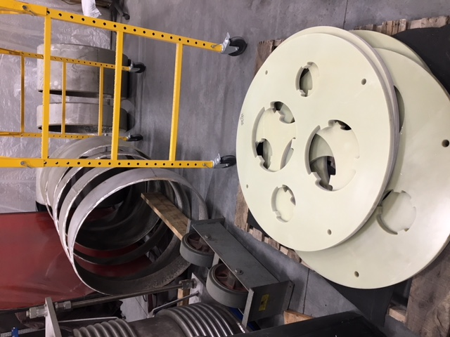

Cryoduct Vacuum Shell and Piping Spacers

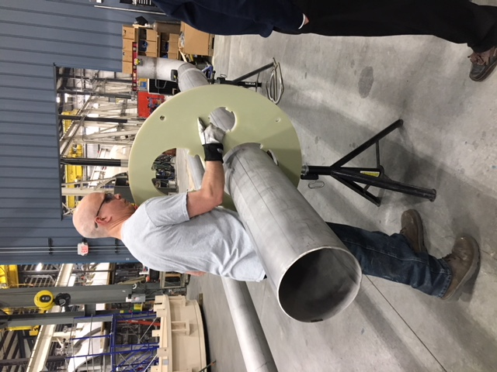
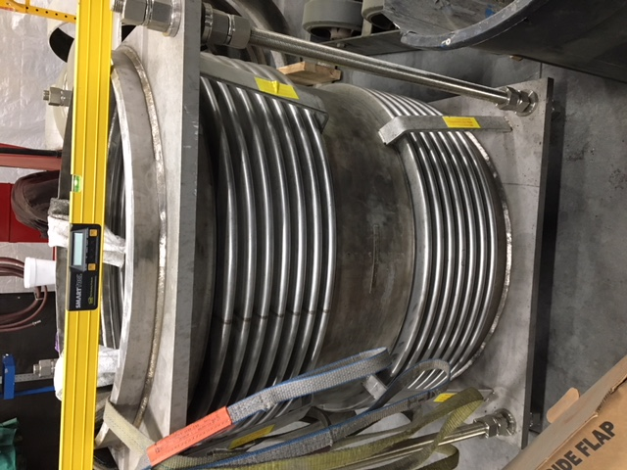

Cryoduct Flex Hose and Internal Piping Fabrication

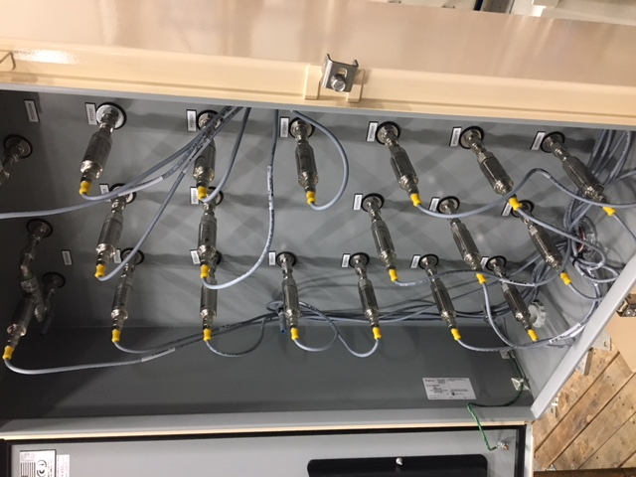
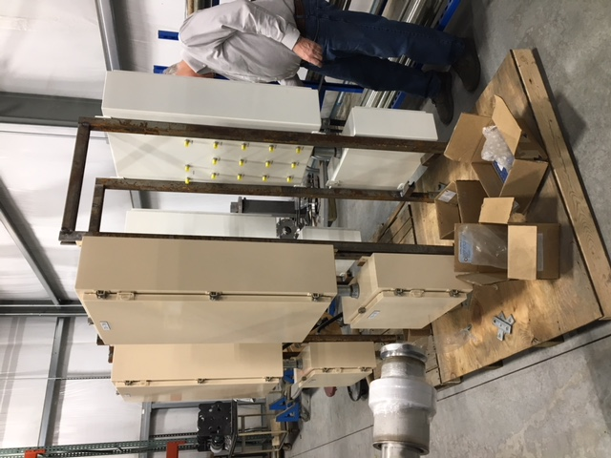

CP#1 and CP#2 4.5K Cold Box Control Panels

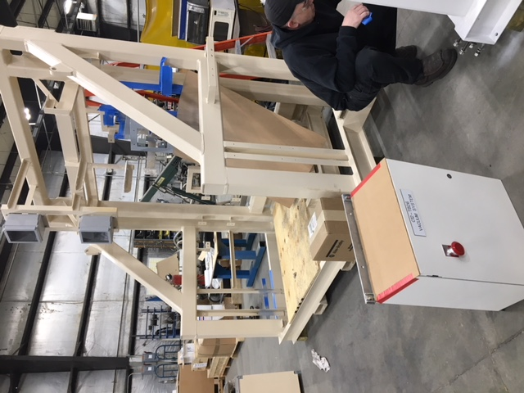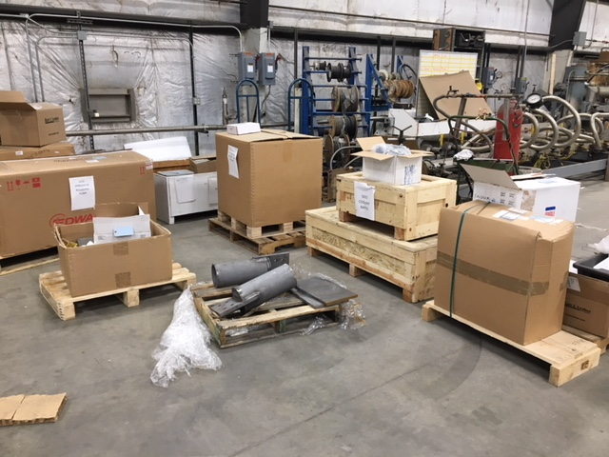
CP#1 4.5K Cold Box Vacuum Skid Assembly and Boxed Parts

Cryoplant Engineering Status
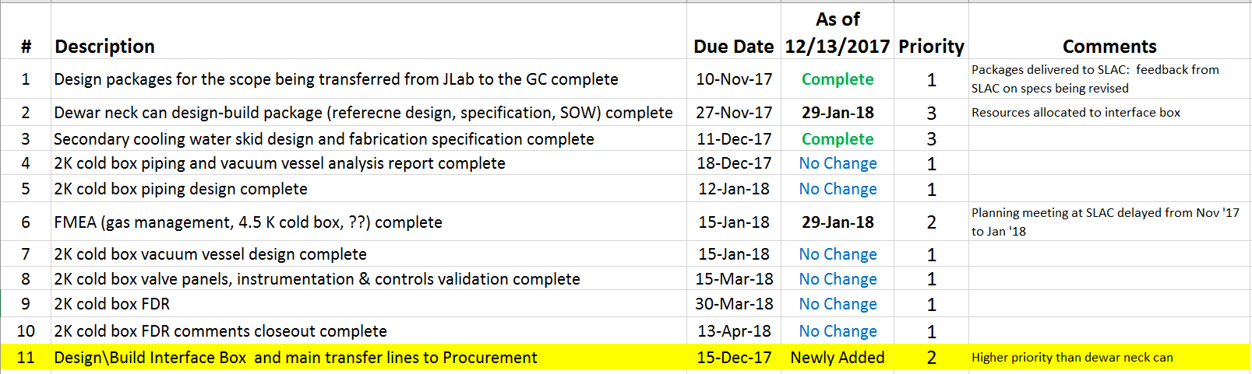

QUALITY:
Planning to attend final leak test of CP#1 Upper Cold Box early January.

Upcoming Travel/Reviews:
Upper 4.5K Cold Box Final Leak test and Fabrication Status, January 15th
FMEA Workshop, SLAC, January 17/18th

Weekly Reporting
WBS 1.02.03.05.12 LLRF
Week of Dec 7-13, 2017

Issues: None
Accomplishments this week at JLab:
- LLRF Coordination/Documentation:
  - SLAC LERF team meeting. Nothing to report.
  - LERF project: LERF ICD is out for review.
  - SLAC BCR is working its way through the system (needed to ship hardware to the JLAB/LERF).
- Resonance/Interlock Chassis:
  - The Resonance chassis is assembled except for piezo cards.
  - Piezo boards: These are being tested at FNAL.

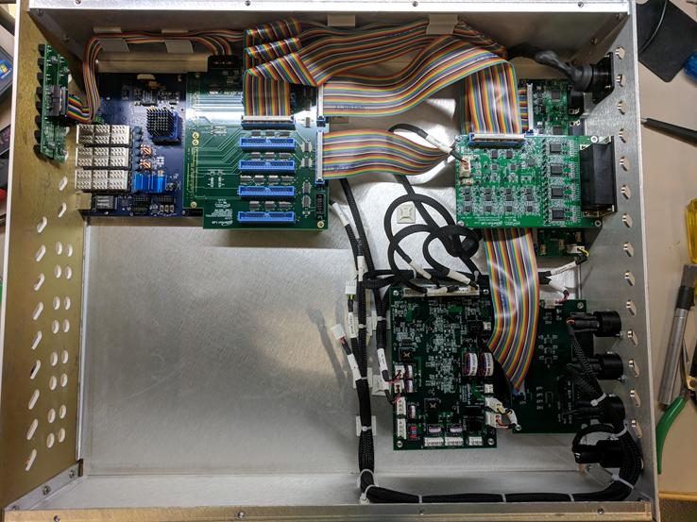
Modified Resonance Chassis
- Interlock Board/Chassis:
  - Work at this time is on hold until needed for 3.9 GHz.
- Common Power Supply/Chassis/Boards:
  - The Gun PS chassis was completed and shipped.
- CMTF/LERF
  - Installing the cables, couplers and switches in the CMTF is on hold because of CM04 testing.
  - LERF LLRF instrumentation cables: Dave is reviewing the LLRF instrumentation cables. We expect to order them in January.
Upcoming Activities:
- Assemble new resonance chassis, December 15
- LERF cable installation ~ January.

