Weekly Reporting

WBS 1.01.07 JLAB Management

Week of Jan 2-10, 2018

**Issues:**

**Accomplishments this week:**

Conducted CM and CP December Progress Meetings.

Conducted CM and CP December Status Meetings.

Finalizing the 2K CB Peer Discussion agenda.

Conducted the PRR and issued RFP for the Interface Box and Main Transfer Lines (before the break)

Preparing multiple BCRs for January business.

**Upcoming Activities:**

25 January 2018 – JLab Director’s Issues & Action Items Review of LCLS-II

22 February 2018 – JLab Director’s Issues & Action Items Review of LCLS-II

20-22 March 2018 – Director’s Review @ SLAC

29 March 2018 – JLab Director’s Issues & Action Items Review of LCLS-II

7 May 2018 - Collaboration Meeting @ SLAC

8–10 May 2018 – OPA Review @ SLAC

Weekly Reporting

WBS 1.04.06 JLAB Cryomodules

Week of Jan 2-10, 2018

**Issues**:

**Accomplishments this week:**

Continuing work on BCR for management and QA LOE adjustments. There is concern regarding the difference in the baseline plan for LOE accounts compared with guidance from SLAC project office. FY2018 is currently underfunded by 50%.

Finalized costs for CM shipping BCR. Presentation at CCB was moved to January.

Preparing award BCR for HEP tool in January to adjust p6 cost and schedule.

Evaluating the bids from the competitive procurement of cavities to be produced from 133 material order was released.

Expect the award for 16+16 optional cavities to Zanon this week.

J1.3-01, J1.3-02 – In storage on Injector Test Cave roof awaiting parts for retro-fit/rework.

J1.3-03 – Investigating cavity four warm coupler.

J1.3-04 – Moved to Retrofit Area.

J1.3-05 – Currently in CMTF. Fast cooldown tripped a breaker on the CTF Main Compressor 3. Reconfiguring to nominal flow configuration. Expect to resume fast cooldown efforts on Saturday.

J1.3-07 – Currently at WS4. HOM tuning complete. MLI installed. Vac Vessel installed. Alignment of cold mass to Vac Vessel in progress.

J1.3-08 – Currently at WS3. Installing MLI on ¼” cool down tubes. Removing split rings for machining. Removed PICs to go to vendor. Magnet lead soldering in progress.

J1.3-09 – Currently at WS3.

J1.3-10 – Currently at WS2.

J1.3-11 – Four cavities qualified for string (135, 328, 330, 332).

Cavity Tests:

328 (TD) D7 first test 14 Dec, Q0(16)~3.2e10, quench 23.7 MV/m, FE free, Qualified for string.

330 (NX950) D5 first test 18 Dec, Q0(16)~3.3e10, quench 26, MV/m, FE free, Qualified for string.

332 (TD/NX950) D5 first test 18 Dec, Q0(16)~2.7e10, quench 23.4 MV/m, FE free, Qualified for J1.3-11

331 (NXA/B 950) D5 first test 18 Dec, Q0(16)~1.8e10, quench 30.6 MV/m, FE onset 28 MV/m, Plan to rinse and retest in D7 or D8 as a cross-check.

Upcoming tests:

L2-116 (NX-900) is planned for R&D testing, Q0 vs magnetic field.

In support of string builds and vendor payments, we have given preference to untested cavities from the vendors. We have a significant backlog of cavities (~17) requiring rinse, retest that we will fit in as testing slots in the queue arise. This list includes eight cavities from string 6 (vented).

**QUALITY**:

Working on Equipment Transfer documentation.

**Upcoming Travel/Meetings:**

EZ Vendor Visit Jan 14-19 (Reece)

EZ Vendor Visit Feb 12-15 (Wilson, Laney)

RI Vendor Visit Feb 15 (Wilson, Laney)

TTC Milan Feb 6-9 (Daly, Huque, Wilson)

Weekly Reporting

WBS 1.04.06 Cryomodules - LERF Conversion

Week of Jan 2-10, 2018

**Issues:**  None

**LERF accomplishments this week:**

Work on stripping out the klystrons and related equipment is nearing completion, there was a break in the action during the holiday break & associated CEBAF accelerator down. The installation crew has positioned the equipment to jack up the rack frame 2” to accommodate the new waveguide installation. I ordered two right angle battery powered wrenches for the troops for the 5k waveguide nuts & bolts.

We had a meeting on the radiation shielding for the accelerator vault – issue is I would prefer not to remove & place the 27 ~10 ton concrete shield blocks each time we change CMs in the vault. George Kharashvili presented latest calculations of source term and potential exposure areas, results are promising for a local shielding solution.

First shipment of the waveguide should be delivered this week.

We will start the PSS Interface boxes assembly this week and should complete them by the end of the January. Next phase after assembly is to install these boxes at LERF and wire them in. We'll use the schematics prepared for the CMTF as these will be nearly identical.

AC power for the racks in the gallery is also being worked.

The server rack is prepared for the power connection, once that is operational the UPS & servers will be mounted and powered up.

The “Total Loss Monitor” system from FermiLab has arrived (intact ;-).

Operational Safety Procedure (OSP) for LERF testing of the LCLS-II CMs is progressing well.

Continued work on WIKI site for documentation: wiki.jlab.org/lerf

**Upcoming Activities:** None

Weekly Reporting

WBS 1.04.08 JLAB Cryoplant System

Week of Jan 2-10, 2018

**Issues:**

**Accomplishments this week:**

**2K Cold Box**

* Is on schedule for March FDR
* Piping stress analysis has been sent to SLAC
* Vacuum shell analysis has been submitted to SLAC for review 14 December, awaiting comments, plan to proceed with RFP ahead of FDR as per SLAC.
* Have received budgetary information on un-machined and machined cold box top plate
* Will receive CP2 cold casings at JLab in January 2018.
* Control panels are being shipped directly to SLAC for installation
* CC cartridges remain at the vendor
* Engineering and Design completion April 2018
* 2K Cold Box assembly award, June 2018
* 2K Cold Boxes delivered to SLAC Feb 2019

**4.5K Cold Box Status**

* CP1 HCB internal piping is complete, work is centered on installing instrumentation and insulation.
* PHPK indicated the manway cover should be completed by the middle of this week and then will be installed on the VCB once it is received.
* Should be ready to start their internal testing on the VCB late next week or early the week of 22 January but will start pulling a vacuum/drying with N2 on the vessel this week after the manway flange is installed.
* Once they are confident in their internal testing they will notify ALATUS when the witness testing, ITP Item 21, will occur.

**HCB 1**

* Welders were continuing the installation of tubing on the HCB and temperature sensors.
* Welders were installing flanges to the spools going through the HCB shell.
* The cryoduct horizontal section fabrication was ongoing and almost complete.
* Two welders were working on the fabrication of the bearing gas vessels for CB1 and CB2

**VCB/HCB 2**

* The VCB upper head/shell section has been elevated and set on stanchions so installation of the interior pipe spools and valves can begin.
  + PHPK indicated this should start today.
* There were two welders continuing to fabricate the frames for CB2 VCB.
* The vacuum skid assemblies were on hold during the holidays but the technician assigned to the skids has returned this week and will continue assembly of the skids.

**Cryoplant En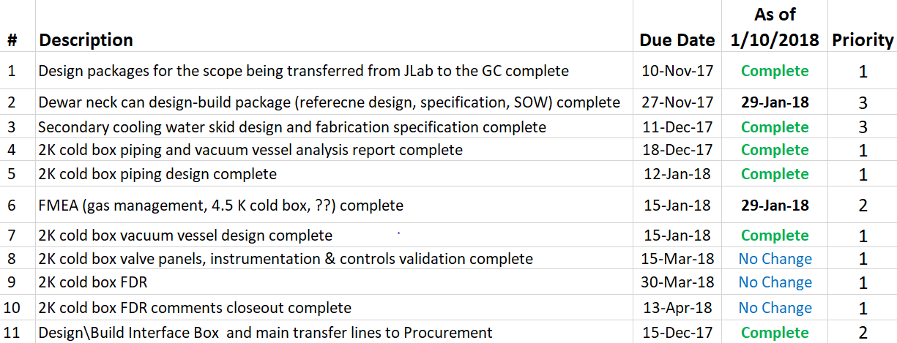gineering Status**

Engineering continued to focus on completion of the 2K cold box assembly design.

**QUALITY**:

Planning to attend final leak test of CP#1 Upper Cold Box early January.

**Upcoming Travel/Reviews:**

* 2K Cold Box overview discussion with @ JLab – 24-Jan-2018
* Purifier FDR……January 15th, Ability Engineering
* FMEA Workshop, SLAC, January 17/18th
* 4.5K Cold Box Upper Cold Box Final Leak Test….Will advise, @ PHPK
* 4.5K Cold Box Reassembly Meeting…..3rd Week January, TBC, SLAC

Weekly Reporting

WBS 1.02.03.05.12 LLRF

Week of Jan 2-10, 2018

**Issues:** None

**Accomplishments this week at JLab:**

* LLRF Coordination/Documentation:
  + SLAC LERF team meeting. Nothing to report.
  + Pulling the PRC and RFS chassis from the CMTF to be shipped back to SLAC
  + 14 SSAs including one spare for the CMTF are to be shipped from SLAC by the end of the week. Expect a delivery by the end of next week.
* Resonance/Interlock Chassis:
  + The Resonance chassis is being tested and the piezo boards were installedin a modified chassis (see below).

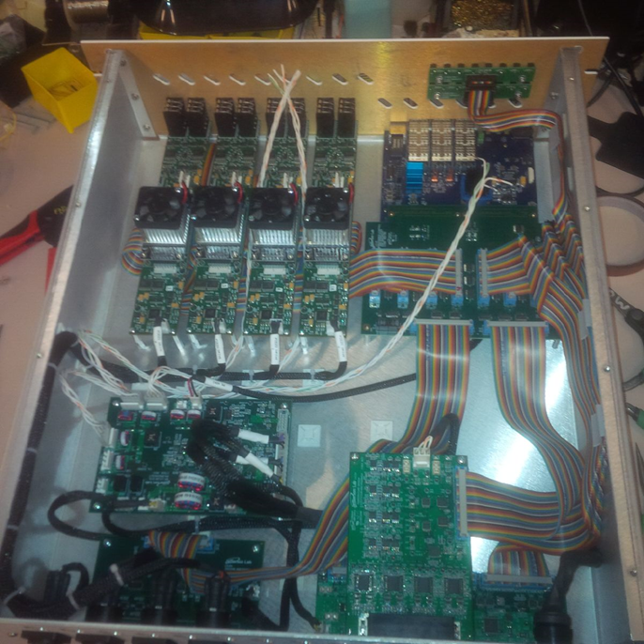

Modified Resonance Chassis with Piezos

* Interlock Board/Chassis:
  + Work at this time is on hold until needed for 3.9 GHz.
* Common Power Supply/Chassis/Boards:
* CMTF/LERF
  + Installing the cables, couplers and switches in the CMTF is on hold because of CM04 testing.
  + LERF LLRF instrumentation cables: Dave met with Larry King to review the instrumentation cables and cryomodule connectors.

**Upcoming Activities:**

* LERF cable installation ~ January