Weekly Reporting
WBS 1.01.07 JLAB Management
Week of January 11-17, 2018

Issues:
Accomplishments this week:
Managing the impacts of the delay in closing December business (no earned value as of Jan 16).
Preparing for the 2K CB Peer Discussion at JLab on Jan 24th.
Preparing for the QA/QC Workshop at JLab on Jan 25th.
Preparing multiple BCRs for January business.
Upcoming Activities:
February – FAC Review
20-22 March 2018 – Director’s Review @ SLAC
April – LCLS-HE Review
7 May 2018 - Collaboration Meeting @ SLAC
8–10 May 2018 – OPA Review @ SLAC
June LCLS-HE Review

Weekly Reporting
WBS 1.04.06 JLAB Cryomodules
Week of January 11-17, 2018

Issues:
Accomplishments this week:
Continuing work on BCR for management and QA LOE adjustments. There is concern regarding the difference in the baseline plan for LOE accounts compared with guidance from SLAC project office. FY2018 is currently underfunded by 50%.
Finalized costs for CM shipping BCR. Presentation at CCB was moved to 25-Jan.
Preparing award BCR for HEP tool in January to adjust P6 cost and schedule.
Evaluating the bids from the competitive procurement of cavities to be produced from 133 material order was released. Expect award by 1-Feb.
Awarded 16+16 optional cavities to Zanon.
J1.3-01, J1.3-02 – In storage on Injector Test Cave roof awaiting parts for retro-fit/rework.
J1.3-03 – Moved to WS6 (retro-fit area).
J1.3-04 – Moved to WS6 for retro-fit. Gas-guard valves welded in. Leak check/pressure test in progress. Planning data review in advance of shipment in early February to SLAC.
J1.3-05 – Currently in CMTF. Fast cooldown attempts continued. Two aging main compressor 480V breakers failed and were replaced on Monday 15-Jan. A spare breaker was procured. Fast cooldown attempt #3 was started on Wednesday 17-Jan. Pumpdown and retesting should start on Thursday 18-Jan. Opportunistically, some passive microphonics data was collected, an extended SEL run of Cavities 1 and 2 at 16 MV/m was conducted, an extended 5 cavity run (varying gradients between 11 MV/m and 15 MV/m) was conducted and the magnet test was completed (1 hour, 18 A). FE current from cavity 6 was captured in the Faraday Cup.
J1.3-07 – Currently at WS5. Beam pipe work in progress. JT and CD installation in progress. Endcap installed.
J1.3-08 – Currently at WS3. Magnet lead soldering complete. VV inspect & demag complete. Alignment in progress.
J1.3-09 – Currently at WS3. Needle bearing installation in progress. Tuner support for cavity 1 gate valve installation complete. ¼” helium lines complete. Leak check in progress. Mate to UCM in progress.
J1.3-10 – Currently at WS2. Ti sheets and 2 phase welding in progress.
J1.3-11 – Six cavities qualified for string (135, 328, 330, 332, 308, 140). Six cavities scheduled for qualification test during last two weeks of January. Eight new cavities on-site awaiting incoming inspection, 18 untested cavities on site in total. String 11 build gated by qualified cavities and tooling maintenance. Tentative build TBD.
Cavity Tests:
L2-140 (TD), L2-144 (TD), L2-145 (NX-900) in D5, first test (Jan 16). Preliminary results indicate that one of three cavities qualified (140), one had low Qo ~1.5e10 at 16 MV/m (145) and one had field emission onset at 15 MV/m (144).
In support of string builds and vendor payments, we have given preference to untested cavities from the vendors. We have a significant backlog of cavities (~17) requiring rinse, retest that we will fit in as testing slots in the queue arise. This list includes eight cavities from string 6 (vented).

QUALITY:
Working on Equipment Transfer documentation.
Upcoming Travel/Meetings:
EZ Vendor Visit Jan 14-19 (Reece)
EZ Vendor Visit Feb 12-15 (Wilson, Laney)
FAC Feb TBD (TBD)
RI Vendor Visit Feb 15 (Wilson, Laney)
TTC Milan Feb 6-9 (Daly, Huque, Wilson, Drury)
EZ Vendor Visit Mar TBD (H. Park)
Directors Review at SLAC (Daly, TBC)

Weekly Reporting
WBS 1.04.06 Cryomodules - LERF Conversion
Week of January 11-17, 2018

Issues: None
LERF accomplishments this week:
The Zone 3 klystron rack is cleaned out and ready to be jacked up 2” for new waveguide layout, Zone 4 should be done in a day or so. The waveguide supports are installed on all 4 sets of waveguides.
The first shipment of waveguide components has arrived, 12 pieces of 12” bellows. Two more shipments are in transit, these will include long strait sections. The puzzle assembly will begin soon. The tunnel waveguide support structure drawings are complete. The installation crew will start drilling holes & mounting anchors in the ceiling.
The radiation shielding assessment for the accelerator vault continues.

The two PSS Interface boxes were mounted in the gallery this week. Assembly and wiring of the internals is progressing and should complete them by the end of the January.

AC power for the racks in the gallery is also being worked. A new 42-slot panel was mounted in the gallery; this will supply all of the power for the new racks & equipment. The server rack is prepared for the power connection, once that is operational the UPS & servers will be mounted and powered up.

The C50 cryomodule was re-surveyed into place.

Operational Safety Procedure (OSP) for LERF testing of the LCLS-II CMs is progressing well.
Continued work on WIKI site for documentation: wiki.jlab.org/lerf
Waveguide support structure
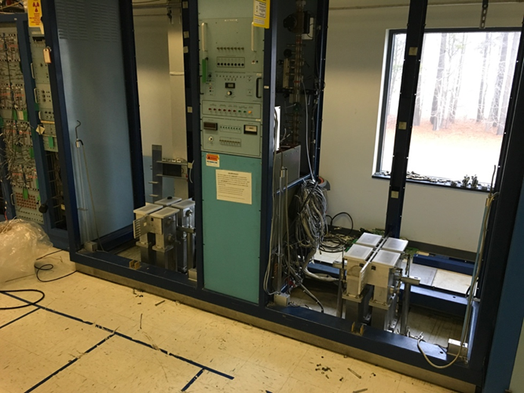  HPA racks cleaned out w/waveguide supports shown. | 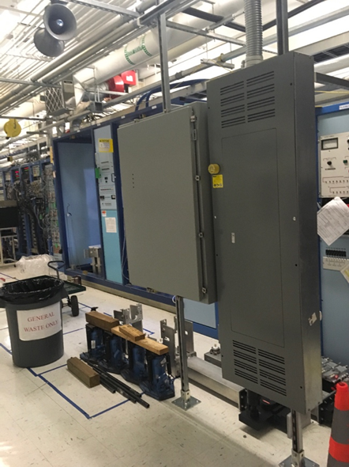  Safety system box mounted in gallery

Upcoming Activities: None
Weekly Reporting
WBS 1.04.08 JLAB Cryoplant System
Week of January 11-17, 2018

Issues:
Accomplishments this week:
2K Cold Box
- Is on Re-plan schedule.
- Allowable load analysis sent to SLAC, 8 Dec.
- Piping stress analysis sent to SLAC, 20 Dec.
- Vacuum shell analysis sent to SLAC, 14 Dec.
- Have vacuum shell top plate budgetary, proceeding with RFQ.
- CP2 cold casings at JLab, January 2018.
- Control panels to SLAC, January.
- CC cartridges remain at Air Liquide.
- Engineering and Design completion April 2018.
- 2K Cold Box assembly award, June 2018.
- 2K Cold Boxes delivered to SLAC Feb 2019.

4.5K Cold Box Status
- VCB CP1
- PHPK welder finished the VCB bottom head seam weld and manway.
- Start pulling a vacuum/drying with N2 on the vacuum shell.
- JLab vacuum SME (Curt Macha) shall visit PHPK this week to consult.

- HCB CP1
- Continuing the installation of tubing and temperature sensors.
- Welders installing flanges for spools going through the shell.
- The cryoduct horizontal section fabrication almost complete.
- Working on CP1 & CP2 bearing gas vessel fabrication.
- VCB/HCB CP2
- The VCB upper head/shell interior pipe spools and valves installation started.
- There were two welders continue to fabricate the frames for CB2 VCB.
- The vacuum skid assembly continue.

Cryoplant Engineering Status
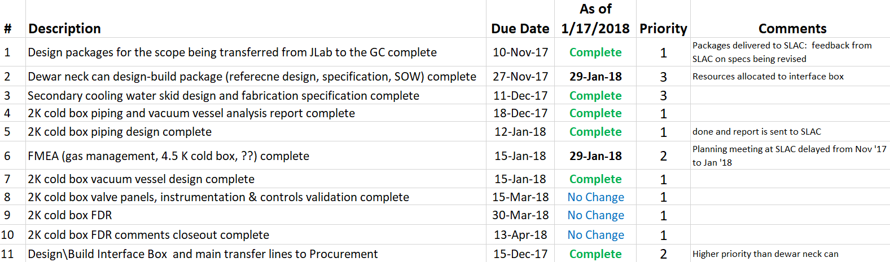

Engineering continued to focus on completion of the 2K cold box assembly design.

QUALITY:
Planning to attend final leak test of CP#1 Upper Cold Box late January.

Upcoming Travel/Reviews:
- 4.5K CP2 Turbine Pods to SLAC, January 2018
- Purifier FDR……February, Ability Engineering
- 4.5K Cold Box Upper Cold Box Final Leak Test….will advise, @ PHPK
- FMEA Workshop @ SLAC, 17-18th January
- 2K Cold Box Status @JLab, 24th January
- 4.5K Cold Box Reassembly Meeting…..not before end of January @SLAC
- Equipment Delivery Schedule….presented this Thursday
- Installation Integration Meeting…Upper CB1 3rd March

Weekly Reporting
WBS 1.02.03.05.12 LLRF
Week of January 11-17, 2018

Issues: None
Accomplishments this week at JLab:
- LLRF Coordination/Documentation:
  - SLAC LERF team meeting. First eight SSAs are on their way. Should be here by the end of the week. There has been some schedule slippage so the SLAC LERF team has revised their schedule.
  - Two RF stations and one PRC are being sent back to SLAC.

- Resonance/Interlock Chassis:
  - A design freeze discussion is planned for this week’s LLRF team meeting.
  - The Resonance chassis is tests continued. A bad cable was found between the FMC board and Piezo board and replaced.
  - Dave is working with Andre in coming up with a solution to quickly purchase the boards for 80 chassis.

- Interlock Board/Chassis:
  - Work at this time is on hold until needed for 3.9 GHz.

- Common Power Supply/Chassis/Boards:
  - No report: Design complete

- CMTF/LERF
  - LERF LLRF instrumentation cables: Dave met with Larry King to review the instrumentation cables and cryomodule connectors. He is also working with Andy over some discrepancies he found in the spreadsheets.
  - We have been given time over the next week to continue piezo testing in the CMTF, with goal being GDR operation using JLAB LLRF.

Upcoming Activities:
- LERF RF cable installation ~ February

