Weekly Reporting

WBS 1.01.07 JLAB Management

Week of January 18-24, 2018

**Issues:**

**Accomplishments this week:**

Conducted 1.04 EV Performance Review.

Estimated 1.04.06 and 1.04.08 Accruals.

Hosted for the 2K CB Peer Discussion at JLab on Jan 24th.

Preparing for the QA/QC Workshop at JLab on Jan 25th.

Preparing multiple BCRs for January business – HEP Award and cavity mods

Installation of the first Warm Helium Compressor began at SLAC.

SSAs for LERF (16) arrived at JLab.

Have conducted multiple fast cool downs on CM05.

**Upcoming Activities:**

24 January 2018 – 2K CB Discussion

25 January 2018 – QA/QC Workshop

6-7 March 2018 – FAC Review

20-22 March 2018 – Director’s Review @ SLAC

April 2018 – LCLS-HE Review

7 May 2018 - Collaboration Meeting @ SLAC

8–10 May 2018 – OPA Review @ SLAC

19-21 June 2018 – LCLS-HE CD-1 Review

Weekly Reporting

WBS 1.04.06 JLAB Cryomodules

Week of January 18-24, 2018

**Issues**:

**Accomplishments this week:**

Continuing work on BCR for management and QA LOE adjustments. The BCR processed at this last CCB does not include what remains for CM management and integration. FY2018 is currently underfunded by 50%.

Finalized costs for CM shipping BCR. Presentation at CCB was moved to 26-Jan.

Preparing award BCR for HEP tool in January to adjust P6 cost and schedule.

Preparing award BCR for cavity contract modifications and planning package BCR for additional cavities. Plan to update LCLS-II project management on cavity procurement strategy with focus on rework of NX-900 cavities.

Evaluating the bids from the competitive procurement of cavities to be produced from 133 material order was released. Expect award by 1-Feb.

J1.3-01, J1.3-02 – In storage on Injector Test Cave roof awaiting parts for retro-fit/rework.

J1.3-03 – Moved to WS6 (retro-fit area) awaiting Gas-guard valves.

J1.3-04 – Moved to WS6 for retro-fit. Data review completed. Final pressure testing (RT) planned for 25-Jan. Received approval from SLAC to ship CM. Planning documentation review in advance of shipment in early February to SLAC.

J1.3-05 – Currently in CMTF. Results from Fast cooldown #2 showed no significant changes in Qo’s. Fast cooldown #3 completed on 23-Jan with cooldown rate of 2.5 to 3 K/min and mass flow greater than 30 g/s. Additional Qo’s measurements are on-going, and indicate same values as previous cooldown. Parasitic microphonics measurements were taken on cavities #1 and #2. Planning pre-warm up review for 25-Jan with warm-up to follow on 26-Jan. Plan to remove from CMTF on 29-Jan.

J1.3-07 – Currently at WS5. Pressure testing in progress. Bayonet box installation in progress. Final pressure testing (RT) planned for 25-Jan. Plan to install in CMTF next Tuesday 30-Jan.

J1.3-08 – Currently at WS3. Magnet lead soldering complete. Alignment complete. Magnetic shield Installation in progress. Tuners prepped for installation.

J1.3-09 – Currently at WS3. Needle bearing installation completed. Attachment to UCM complete. Lollipops returned to string assembly. Leak check of 2 phase pipe in progress.

J1.3-10 – Currently at WS2. Ti sheets welding complete. Two-phase pipe welding in progress.

J1.3-11 – Seven cavities qualified for string (135, 328, 330, 332, 308, 140, 137). Four cavities scheduled for qualification test during last week of January. String 11 build gated by qualified cavities and tooling maintenance. String prep week begins 29-Jan with string assembly starting the following week assuming another cavity qualifies.

Cavity Tests:

Two Zanon cavities were tested and did not qualify. Cavity 321 failed due to quench at 12 MV/m and cavity 253 failed due to early FE onset.

In support of string builds and vendor payments, we have given preference to untested cavities from the vendors. We have a significant backlog of cavities (~17) requiring rinse, retest that we will fit in as testing slots in the queue arise. This list includes eight cavities from string 6 (vented).

**QUALITY**:

Working on Equipment Transfer documentation.

**Upcoming Travel/Meetings:**

EZ Vendor Visit Feb 12-15 (Wilson, Laney)

RI Vendor Visit Feb 15 (Wilson, Laney)

TTC Milan Feb 6-9 (Daly, Huque, Wilson, Drury)

FAC Mar 6-7

EZ Vendor Visit Mar TBD (H. Park)

Directors Review at SLAC (Daly, TBC)

Weekly Reporting

WBS 1.04.06 Cryomodules - LERF Conversion

Week of January 18-24, 2018

**Issues:**  None

**LERF accomplishments this week:**

Both zones HPS racks have been jacked up and are now ready to start installation of the new waveguide. The tunnel has also been prepped and installation can begin. The survey crew has marked the ceiling for the waveguide supports, those ~70 holes can now be drilled and the threaded rod and unistrut can be installed.

~80% of the waveguide has been delivered, most all of the strait sections & bellows but no mitered elbows yet.

16 SSAs have been delivered, one goes to test lab so still waiting on one then we will schedule crane to move them into the gallery. We are working out the logistics of keeping space clear where work is going on…

Electrical work continues in the gallery, racks should be powered up by next week.

Three of the LERF control room workstations are rebuilt with the initial LCLS-II environment.  They are monitored and under configuration control.  The VDI systems were updated after the main server was upgraded.  Connectivity to all systems was verified afterwards.  All systems received the latest OS patches.  The servers are still awaiting power to the rack.

The 200 connectors for the CM cables have been ordered, cabling will follow this week.

I hosted a visit from Elvin Harms, he is in Hampton teaching at the USPAS.

Continued work on WIKI site for documentation: wiki.jlab.org/lerf

The radiation shielding assessment for the accelerator vault continues.

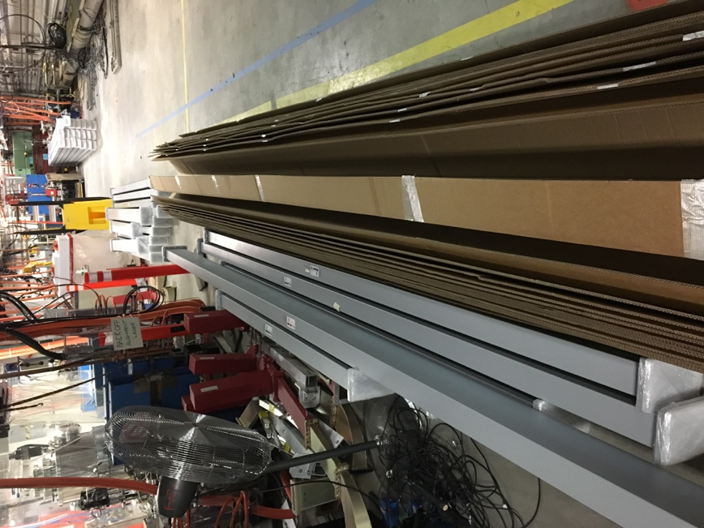

Waveguide in vault, including 21 pieces 20’ long.

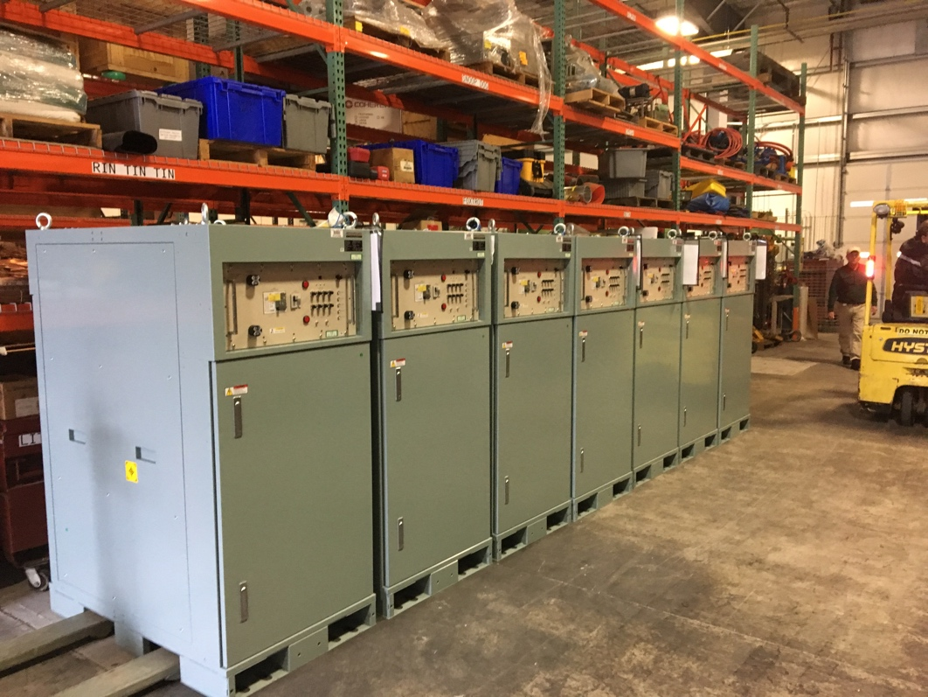

16 SSAs have been delivered.

**Upcoming Activities:** None

Weekly Reporting

WBS 1.04.08 JLAB Cryoplant System

Week of January 18-24, 2018

**Issues:**

**Accomplishments this week:**

**2K Cold Box**

* + On site meeting with SLAC 24-Jan-2018 to review design status.
  + RFI due back next week.
  + Top plate RFP issued – response due back next week.

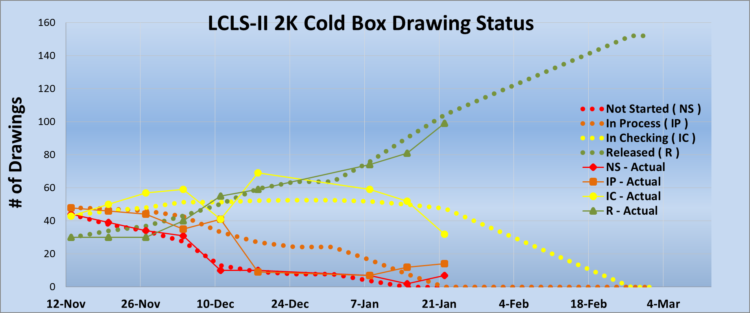

**4.5K Cold Box Status**

1. On schedule for 3 March Delivery but Feb 12th is deadline for completion of leak test.
2. Shipper (Miller) is confident of delivery.
3. Details of packing list and actual shipment delivery dates for turbine casings, final shipment and delivery dates will be provided.
4. PHPK is double checking anchor bolt hole locations and rotational clocking.
5. January monthly report will be on Feb 6th.
6. 30th January is P&ID conformity for LCB CP1 on site with PHPK.
7. CP2 UCB has 30% of piping in upper dished head and all upper head valves are installed.
8. CP1 LCB piping penetrations are being closed off for purposes of in process pressure/leak testing.
9. CP1 UCB has been pumped down 3 times and backfilled, initial problems with sealing of piping test blank offs leaking.

**Cryoplant Engineering Status**

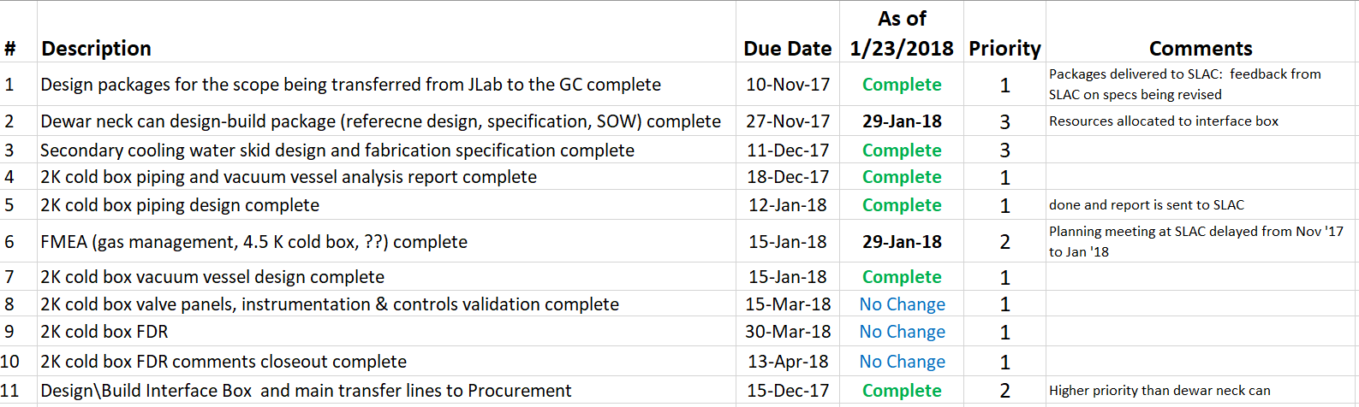

Engineering continued to focus on completion of the 2K cold box assembly design.

**QUALITY**:

Planning to attend final leak test of CP#1 Upper Cold Box late January.

**Upcoming Travel/Reviews:**

* 2K cold box design status discussion Jan 24th
* 4.5K cold box final leak check ~Week of Jan 29th
* 4.5K cold box re-assembly meeting @SLAC ~Week of Jan 29th
* PHPK P&ID and schedule review Jan 30th & 31st
* Purifier FDR @ vendor (AET) Feb 9th
* MCC Vendor Site visit Feb 5th & 27th acceptance
* FAC Review Mar 6-7th
* Director Review Mar 20-22nd
* DOE Review May 8-10th

Weekly Reporting

WBS 1.02.03.05.12 LLRF

Week of January 18-24, 2018

**Issues:** None

**Accomplishments this week at JLab:**

* LLRF Coordination/Documentation:
  + The other eight SSAs arrived yesterday.
* Resonance/Interlock Chassis:
  + After the design freeze last week the individual boards were handed out and assigned for review.
  + The Resonance chassis is tests are complete*.*
  + We are purchasing enough parts and boards to make 5 more Resonance Hybrid chassis for the LERF.
  + Stepper test board is under review and will go out later this week.
  + JLAB and SLAC people are discussing a way to purchase all the parts and boards for this chassis using JLAB vendor.
* Interlock Board/Chassis:
  + Work at this time is on hold until needed for 3.9 GHz.
* Common Power Supply/Chassis/Boards:
  + No report: Design complete
* LERF
  + LERF LLRF instrumentation cables: Dave is in process of getting the correct information to purchase the cables*.*
  + I met with Mike McCaughan to discuss CM automated tests in the LERF. A list of tests has been complied with estimated labor resources. The plan is review this with EPICs controls people next week.
* CTMF
* Piezo/GDR testing towards the latter part of this week.

**Upcoming Activities:**

* LERF RF cable installation ~ February