Weekly Reporting

WBS 1.01.07 JLAB Management

Week of January 25-31, 2018

**Issues:**

**Accomplishments this week:**

Conducted CM Progress Meeting

Hosted SLAC for 2K Cold Box and Interface Box discussions on January 24th.

Hosted SLAC and FNAL for the CM QA/QC Workshop on Jan 25th.

Presented Cavity Bundle BCR, HEP machine award BCR, 133 cavity planning package BCR. CCB approved cavity bundle and HEP award BCRs. Doing homework on 133 cavity planning package BCR.

Warmed up CM05 and removed from it CMTF.

Installed CM07 in CMTF.

CM04 retrofit completed.

Awarded Cryo valve contract.

**Upcoming Activities:**

6-7 March – FAC Review

20-22 March – Director’s Review @ SLAC

1-3 May – LCLS-II HE ICR

7 May – Collaboration Meeting @ SLAC

8-10 May – OPA Review @ SLAC

15-17 May – LCLS-II HE Director’s CD-1 Review

19-21 June – LCLS-HE CD-1 Review

Weekly Reporting

WBS 1.04.06 JLAB Cryomodules

Week of January 25-31, 2018

**Issues**:

**Accomplishments this week:**

Provided January progress to JLab PMO team.

Continuing work on BCR for management and QA LOE adjustments. The BCR processed at this last CCB does not include what remains for CM management and integration. FY2018 is currently underfunded by 50%.

Finalized costs for CM shipping BCR. Presentation at CCB TBD.

Finalizing award BCR for HEP tool in January to adjust P6 cost and schedule.

Preparing award BCR for cavity contract modifications and planning package BCR for additional cavities. Updated LCLS-II project management on cavity procurement strategy with focus on additional required quantity for the order and rework of NX-900 cavities.

Evaluating the bids from the competitive procurement of cavities to be produced from 133 material order was released. Expect award early Feb.

Hosted 2nd CM QA/QC Workshop in collaboration with FNAL. Updated agenda and presentations can be found here - https://indico.fnal.gov/event/16256/.

J1.3-01, J1.3-02 – In storage on Injector Test Cave roof awaiting parts for retro-fit/rework.

J1.3-03 – At WS6 (retro-fit area) awaiting Gas-guard valves. Warm coupler rework complete. Modification of HOM mu metal shields in progress.

J1.3-04 – At WS6. Retro-fit complete. Planning documentation review in advance of shipment in early February to SLAC.

J1.3-05 – Test completed. Warmed up and U-tubes removed. Rad surveyed and removed from the cave. Currently at WS5 to remove cryo hardware.

J1.3-07 – Currently in CMTF. Beam pipe work completed. RT of closure weld completed. Warm coupler installation completed. HOM final warm measurements completed. Insulating vacuum leak check in progress. SSA#8 was replaced with new unit.

J1.3-08 – Currently at WS3. Alignment completed. Tuners installed. RF instrumentation in progress.

J1.3-09 – Currently at WS3. Leak check of two-phase pipe in progress. Magnet lead soldering in progress.

J1.3-10 – Currently at WS2. Two-phase welding completed. Leak check completed. MLI installed. Mag shields installation in progress. Instrumentation in progress.

J1.3-11 – Eight cavities qualified for string (135, 328, 330, 332, 308, 140, 137, 278). String prep week begins 29-Jan with string assembly starting 5-Feb with roll out planned for 16-Feb.

J1.3-12 – Continuing qualification tests this week. K. Davis summarized tests on six cavities.

Cavity Tests:

Cavity 278 (TD) second test after re-rinse, D7, Q0 (16) = 3.6e10, Quench 28.0 MV/m

FE free. Qualified for string.

Planned tests for this week:

L2-315 (TD), L2-325 (TD), L2-167 (TD) first test in D5 on Wednesday, 31 January.

L2-152 (TD) first test in D7 Thursday

L2-153 (TD) first test in D8 Friday

**QUALITY**:

Preparing for Equipment Transfer and possible documentation or information transfers to SLAC.

**Upcoming Travel/Meetings:**

EZ Vendor Visit Feb 12-15 (Wilson, Laney)

RI Vendor Visit Feb 15 (Wilson, Laney)

EZ Vendor Visit Feb 13-19 (D. Gonella)

TTC Milan Feb 6-9 (Daly, Huque, Wilson, Drury)

FAC Mar 6-7 (Attendees TBD)

EZ Vendor Visit Mar TBD (K. Macha)

EZ Vendor Visit Apr TBD (Gonella)

Directors Review including HE at SLAC Mar 20-22 (Daly, TBC)

DOE CD-1 LCLS-II HE Jun 19-22

Weekly Reporting

WBS 1.04.06 Cryomodules - LERF Conversion

Week of January 25-31, 2018

**Issues:**  None

**LERF accomplishments this week:**

The waveguide supports in the tunnel are complete, there are 38 hangers:  
<https://wiki.jlab.org/lerf/images/a/a1/Vault_WG_Support.pdf>  
100% of the waveguide strait sections were delivered; and most all of the & bellows but no mitered elbows yet.

16 SSAs were delivered; the crane is scheduled for tomorrow Feb. 1 to move them into the gallery.

Electrical work continues in the gallery, the server rack was powered up and the servers were installed.

Computer center is working to get the full two-factor logins operational for SLAC remote access to the LLCLS network & computers.

The connectors for the CM cables are arriving. The cable order is being finalized, we are able to use a fair amount of surplus cable left over from other projects.

Continued work on WIKI site for documentation: wiki.jlab.org/lerf

The radiation shielding assessment for the accelerator vault continues.

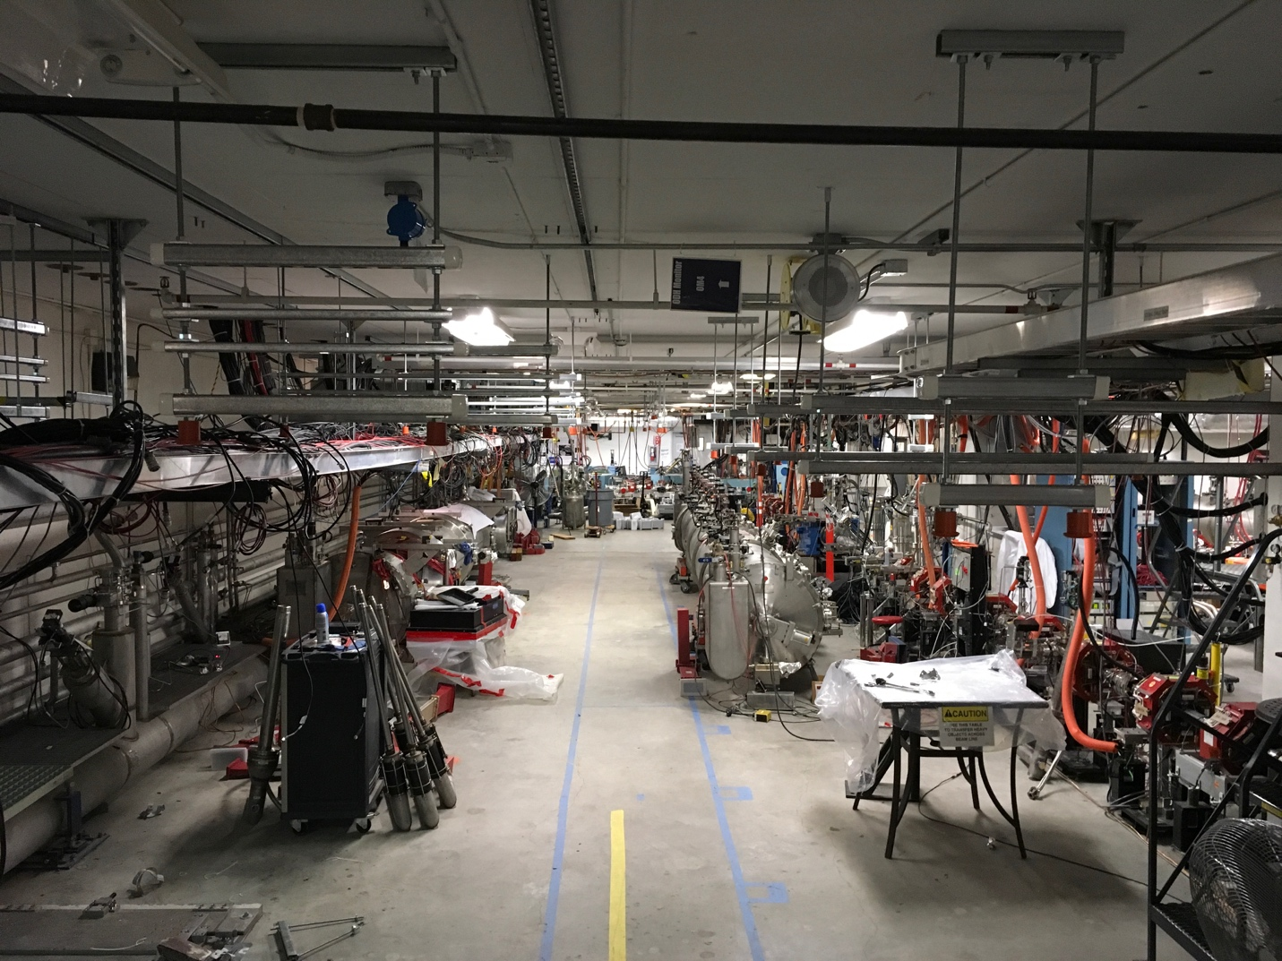

Waveguide supports are complete in the tunnel, installation to begin in the next days.

**Upcoming Activities:** None

Weekly Reporting

WBS 1.04.08 JLAB Cryoplant System

Week of January 25-31, 2018

**Issues:**

**Accomplishments this week:**

**2K Cold Box**

1. RFI due this week.
2. 2K CB design discussion on Jan 24th was productive. Working on a few action items as a result of the meeting.
3. No significant changes to the design, procurement and fabrication plan as presented.
4. Top plate RFP issued – response due this week.

**4.5K Cold Box Status**

1. Dana Arenius is at PHPK for a PnID and schedule review.
2. On schedule for 3 March delivery.
3. Feb 12th is deadline for completion of leak test for CP1 Lower CB.

**Warm Helium Compressors**

1. JLab team at SLAC working through installation process with PHPK and SLAC staff.

**Cryoplant Engineering Status**

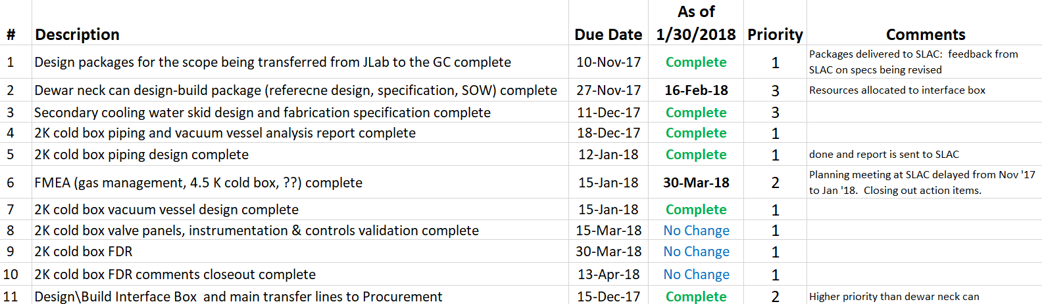

Engineering continued to focus on completion of the 2K cold box assembly design.

**QUALITY**:

Planning to attend final leak test of CP#1 Upper Cold Box late January.

**Upcoming Travel/Reviews:**

* 4.5K cold box re-assembly meeting @SLAC ~Week of Feb 5nd
* 4.5K cold box final leak check ~Week of Feb 5nd
* Purifier FDR @ vendor (AET) Feb 9th
* MCC Vendor Site visit Feb 27th
* FAC Review Mar 6-7th
* Director Review Mar 20-22nd
* DOE OPA Review May 8-10th

Weekly Reporting

WBS 1.02.03.05.12 LLRF

Week of January 25-31, 2018

**Issues:** None

**Accomplishments this week at JLab:**

* LLRF Coordination/Documentation:
  + We have 15 SSAs ready for the LERF. They will be craned in tomorrow.
* Resonance/Interlock Chassis:
  + Individual boards are out for final review.
  + Dave is coordinating the purchasing of parts and boards for the LERF.
  + Dave got production quotes from Tiger for parts and boards. This information was sent to Andre at SLAC too.
* Interlock Board/Chassis:
  + Work at this time is on hold until needed for 3.9 GHz.
* Common Power Supply/Chassis/Boards:
  + No report: Design complete.
* LERF
  + LERF LLRF instrumentation cables: Dave is working with Kevin to get the cables ordered or use existing cables from JLAB overstock*.*
  + I met the JLAB controls group (HL & LL Apps) to discuss CM automated tests in the LERF. Meeting went well we are to supply them with a more complete list of tests, procedures and hardware.
  + Worked with SLAC to help define their resource needs for LERF commissioning.
* CTMF
* We got booted from the program on the last CM. Plan is to get time for Piezo/GDR testing on the next CM.

**Upcoming Activities:**

* LERF RF cable installation ~ April when the LLRF Racks arrive.