Weekly Reporting

WBS 1.01.07 JLAB Management

Week of February 1-7, 2018

**Issues:**

**Accomplishments this week:**

Conducted CM and CP Status Meetings.

Implemented the CCB comments for several BCRs including the Cavity Bundle (give back), Planning Package for 16 New Cavities and Instrument Air Descope BCRs. Updated presentation and forms sent to SLAC for final approval.

Convened a pre-award conference for the Interface Box procurement.

Preparing CM04 for shipment to SLAC.

Received 2K cold box RFI input from vendors.

**Upcoming Activities:**

6-7 March – FAC Review

20-22 March – Director’s Review @ SLAC

1-3 May – LCLS-II HE ICR

7 May – Collaboration Meeting @ SLAC

8-10 May – OPA Review @ SLAC

15-17 May – LCLS-II HE Director’s CD-1 Review

19-21 June – LCLS-HE CD-1 Review

Weekly Reporting

WBS 1.04.06 JLAB Cryomodules

Week of February 1-7, 2018

**Issues**:

**Accomplishments this week:**

Continuing work on BCR for management and QA LOE adjustments. The BCR processed at this last CCB does not include what remains for CM management and integration. FY2018 is currently underfunded by 50%.

Finalized costs for CM shipping BCR was approved at CCB on 2-FEB.

Award BCR for HEP tool was approved including ~$200K give-back.

Award BCR for cavity contract modifications was approved at CCB including ~$300K give-back.

Planning package BCR for additional cavities was approved. Received direction to order 16 cavities as part of award for additional cavities from 133 mat’l. Revised instructions will be sent to vendors. Finalizing technical evaluation. Expect award mid-Feb.

J1.3-01, J1.3-02 – In storage on Injector Test Cave roof awaiting parts for retro-fit/rework. Verified beamline vacuum integrity on pCM (1e-6 torr).

J1.3-03 – At WS6 (retro-fit area) awaiting Gas-guard valves. JT Valves cut out; prep for Gasguards started. Modified HOM mu metal shields.

J1.3-04 – At WS6. Retro-fit complete. Prep for shipping in progress. Alignment check in progress. Shipping cap installation in progress. Documentation review prep is on-going.

J1.3-05 – Bayonet box removed. Gasguard retrofit prep in progress. Prep for storage on-going.

J1.3-07 – Currently in CMTF. CM is at 2K and cavity testing has started. SSA#8 was replaced. Coax waveguide #5 was repaired. During initial RF check some excess heating in one elbow was observed. Plan to replace elbow and re-check prior to cavity #5 testing.

J1.3-08 – Currently at WS4. Rf instrumentation in progress. Final torque of heat stations in progress.

J1.3-09 – Currently at WS3. Leak check of two-phase pipe complete. Magnet lead soldering complete. Alignment in progress.

J1.3-10 – Currently at WS2. Mag shields installation complete. Instrumentation in progress.

J1.3-11 – String assembly started 5-Feb with roll out planned for 16-Feb.

J1.3-12 – Three cavities have been qualified for the string.

Cavity Tests:

Cavity 152 (TD) first test, D7, Q0 (16) = 3.1e10, Quench 24.5 MV/m, No FE, qualified.

Cavity 153 (TD) first test, D8, Q0 (16) = 3.2e10, Quench 20.0 MV/m, No FE, qualified.

Cavity 156 (TD) first test, D7, Q0 (16) = 2.7e10, Quench 23.5 MV/m, No FE, qualified.

**QUALITY**:

Preparing for Equipment Transfer and possible documentation or information transfers to SLAC.

**Upcoming Travel/Meetings:**

EZ Vendor Visit Feb 12-15 (Wilson)

RI Vendor Visit Feb 15 (Wilson)

EZ Vendor Visit Feb 13-19 (D. Gonella)

TTC Milan Feb 6-9 (Daly, Huque, Wilson, Drury)

FAC Mar 6-7 (Attendees TBD)

EZ Vendor Visit Mar TBD (K. Macha)

EZ Vendor Visit Apr TBD (Gonella)

Weekly Reporting

WBS 1.04.06 Cryomodules - LERF Conversion

Week of February 1-7, 2018

**Issues:**  None

**LERF accomplishments this week:**

15 (of 16) SSAs have been moved to LERF gallery. Personnel Safety System (PSS) wiring is in progress in Zone 3, AC power is being run to SSAs.

Waveguide installation has begun, 100’s of feet have been hung & is moving forward. Here is a comment from the techs:  
“*Mounted 18 waveguide bellows to long sections to get started*

*with bolt together. New style nuts and hardware work nice*

*with electric wrenches and going together easily. Techs: C.*

*Kerns and M. Diaz.*”

Spreadsheet for all cryomodule to rack connections is in progress. Rack nomenclature has been work out. Racks and SSAs have been labeled.

All connectors for CMs have arrived as well as some of the cable. A spreadsheet for routing of each of the cables from CM to rack is progressing well.

Radiation assessment is complete and found that a 3’ wall is sufficient shielding. The external shield blocks are 4’ cubes, my thought was that all 27 were way overkill… The first test cycle will have all 27 blocks installed with TLD radiation monitors at the joints in the first row (of the two rows) of the blocks. These will be analyzed for actual (total) dose. We will not build any movable shielding in the vault, and in fact the difference in time to move 12 vs 27 blocks may not be a significant cost difference.  
<https://wiki.jlab.org/lerf/index.php/File:LERF_TRUCK_ENTRANCE_SHIELDING.pdf>

For software environment, we received the draft specifications.  Also have a copy of SLAC's build script.  We won't be able to use it out of the box, but it's great insight to their normal configuration.  The necessary setup for the LERF servers has been sorted out after we got clarification about disk storage requirements.

The server rack is now full populated with UPS, network switch, servers, and the Windows PCs.  The test PLC will also be moved into this rack.  The server builds haven't taken place yet, but as previously described, we have the expected environment well defined now.  Very little preparation left before we do the initial server builds.  We will also be enforcing 2-factor authentication on our VDI VMs, once that takes place.

Continued work on WIKI site for documentation:   
<http://wiki.jlab.org/lerf>

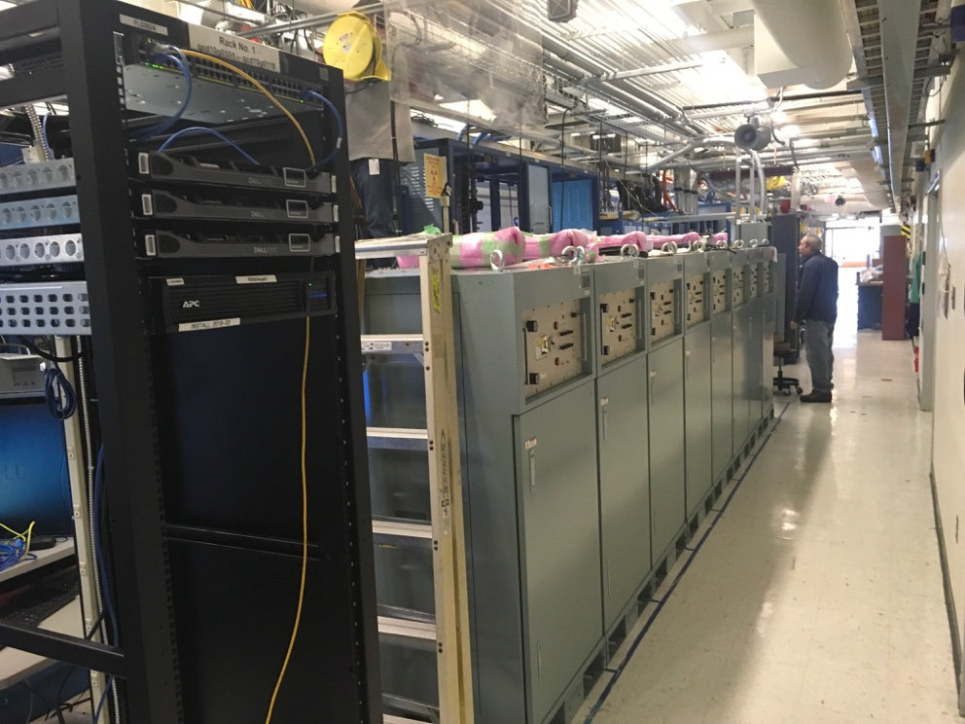

SSAs located in the gallery in Zone 3

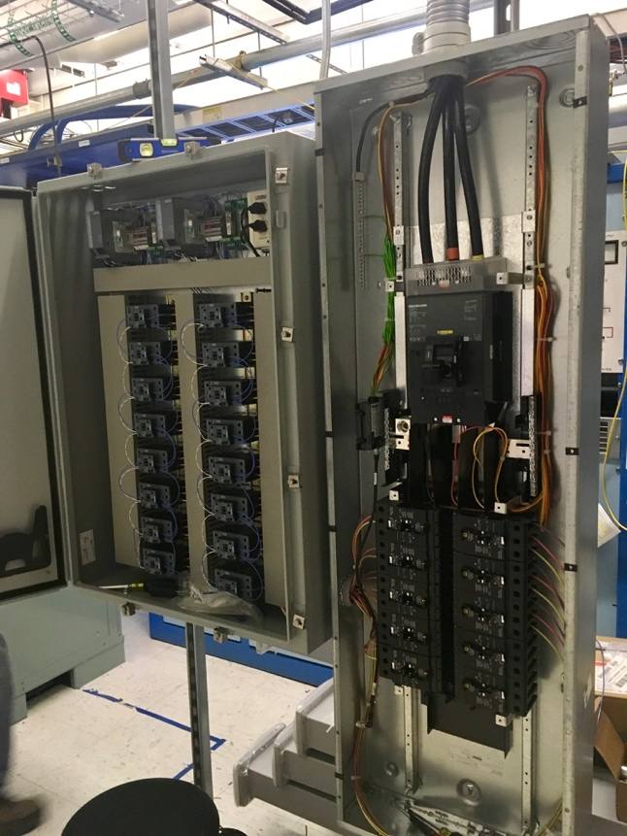

PSS interface box in Zone 3 wiring

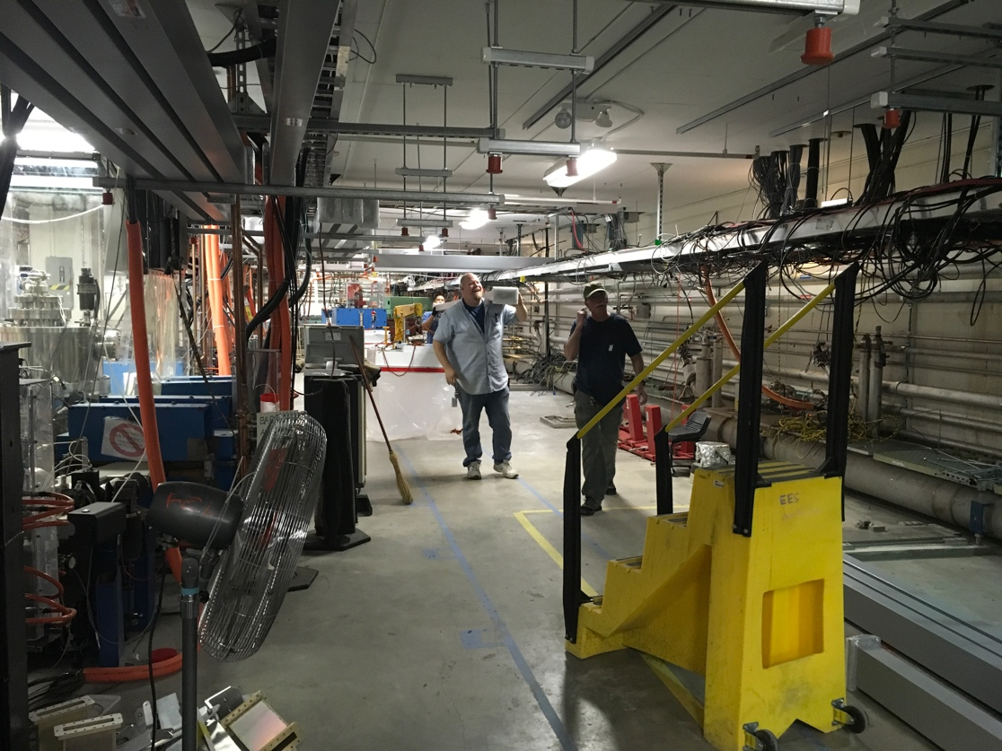

Waveguide installation has begun

Weekly Reporting

WBS 1.04.08 JLAB Cryoplant System

Week of February 1-7, 2018

**Issues:**

**Accomplishments this week:**

**2K Cold Box**

1. Evaluating RFI responses from prospective vendors.
2. Design continues on schedule to be complete and ready for March FDR.
3. Scope change (increase bypass flow) notice received from SLAC – request is under evaluation.
4. Top plate RFP received – award expected this month.

**4.5K Cold Box Status**

1. PHPK has identified a leak in the tubing manifold – repairs underway.
2. Shipment for delivery schedule revised to 23-March-2018.
3. Feb 12th is deadline for completion of leak test for CP1 Lower CB.

**Warm Helium Compressors**

1. JLab team at SLAC last week to oversee installation process with PHPK and SLAC staff.
2. First warm helium compressor installation complete through skid mounting and interconnection.

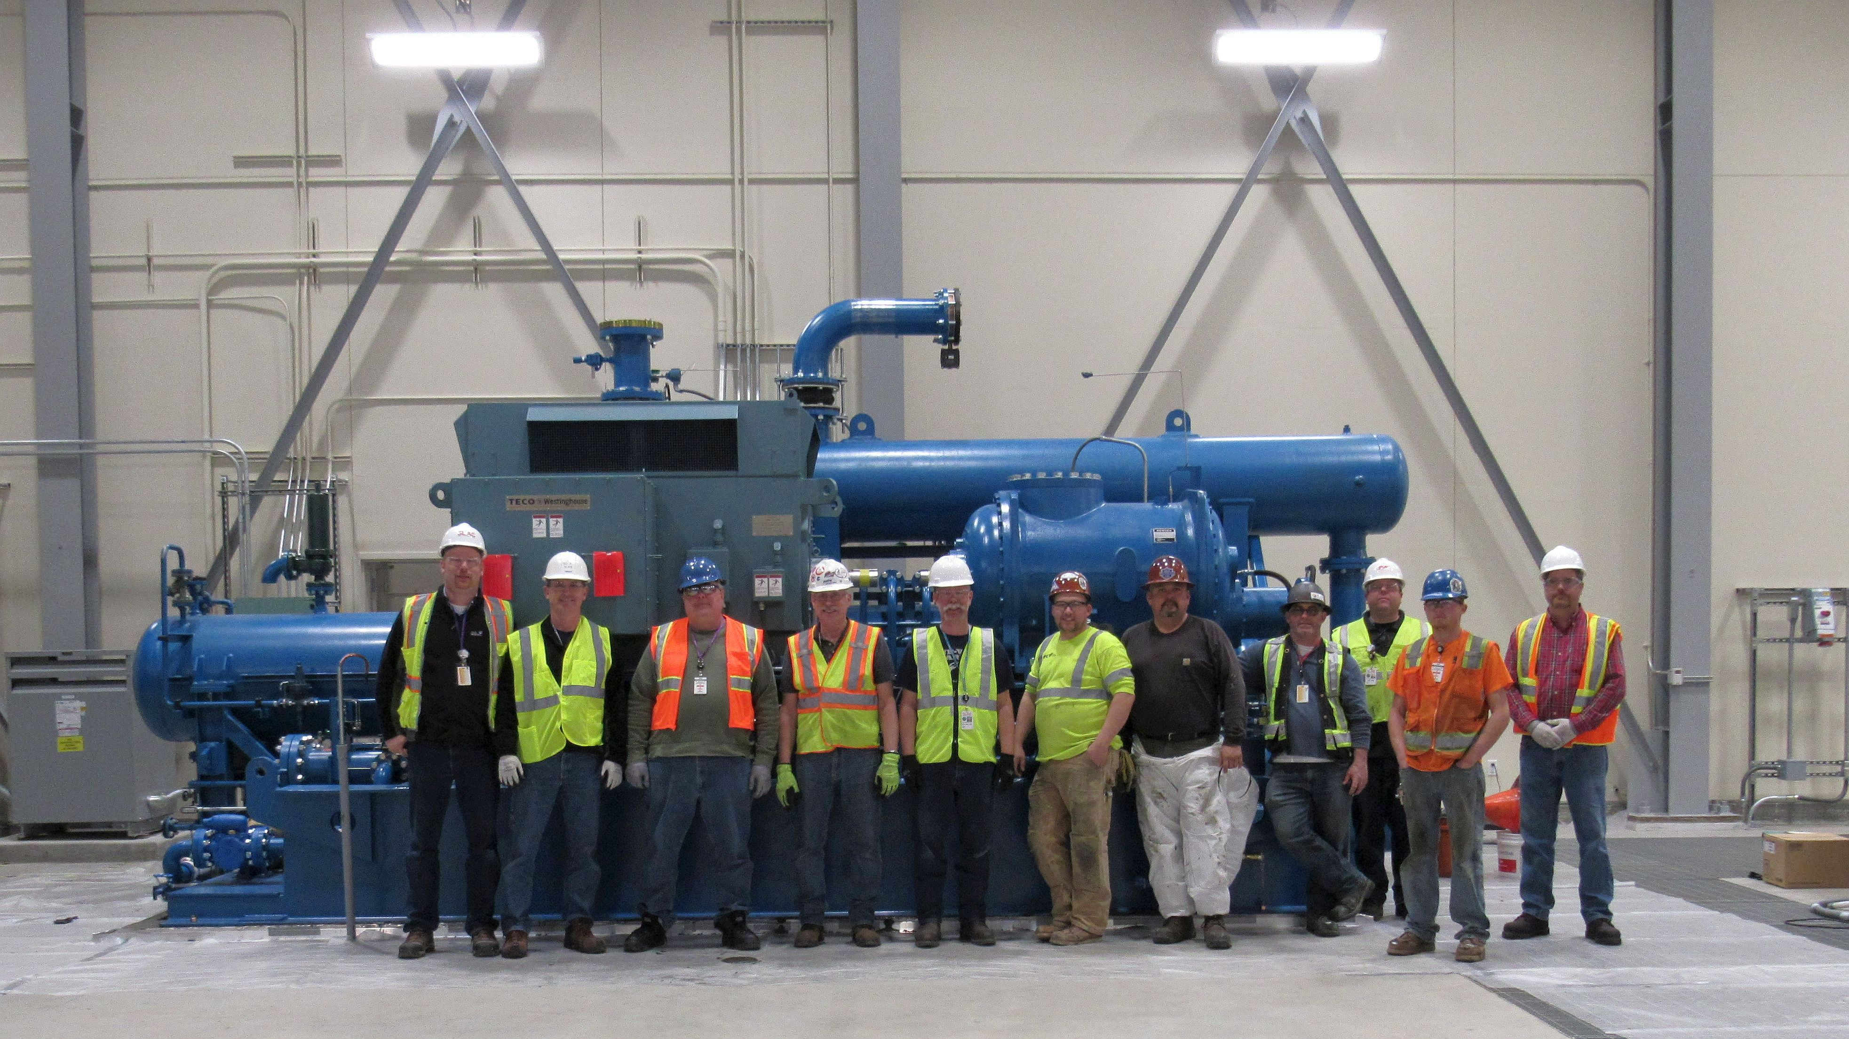

**Cryoplant Engineering Status**

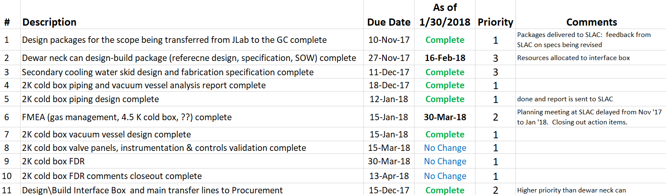

Engineering continued to focus on completion of the 2K cold box assembly design.

**QUALITY**:

Planning to attend final leak test of CP#1 Upper Cold Box late January.

**Upcoming Travel/Reviews:**

* Preproposal Technical Review of IBX 07-Feb-2018
* Final leak check for He gas storage tanks 08-Feb-2018
* Purifier FDR @ vendor (AET) 09Feb-2018
* 4.5K cold box final leak check ~Week of Feb 12th
* 4.5K cold box re-assembly meeting @SLAC ~Week of Feb 19th
* MCC Vendor Site visit (acceptance testing) 8-9-March-2018
* FAC Review Mar 6-7th
* Director Review Mar 20-22nd
* 2K Cold box FDR 28-Mar-2018
* DOE OPA Review May 8-10th

Weekly Reporting

WBS 1.02.03.05.12 LLRF

Week of February 1-7, 2018

**Issues:** None

**Accomplishments this week at JLab:** No report.