Weekly Reporting

WBS 1.01.07 JLAB Management

Week of February 15-21, 2018

**Issues:**

**Accomplishments this week:**

Preparing a bundled BCR for the CP that includes MCC mods, Oil Processing mod and the Cryogenic valve award waiting for month to close to do a what-if file.

Held February accrual meetings for CM and CP.

Participating in FAC dry runs.

JLab BPM Working Group continues work to understand issues associated with the BPM joint.

Ran CM07 in GDR mode for ~4hrs.

Conducted the Purifier FDR at AET.

**Upcoming Activities:**

6-7 March – FAC Review

20-22 March – Director’s Review @ SLAC

1-3 May – LCLS-II HE ICR

7 May – Collaboration Meeting @ SLAC

8-10 May – OPA Review @ SLAC

15-17 May – LCLS-II HE Director’s CD-1 Review

19-21 June – LCLS-HE CD-1 Review

Weekly Reporting

WBS 1.04.06 JLAB Cryomodules

Week of February 15-21, 2018

**Issues**:

**Accomplishments this week:**

Awaiting submission of CM management LOE BCR.

Prepared FAC presentations and participated in dry runs.

Planning package BCR for additional cavities was approved via email. Received updated direction to order 32 cavities as part of award for additional cavities from 133 mat’l. Finalizing technical evaluation. Expect award before end of February pending DOE approval.

Evaluating BPM assemblies on first five CMs to verify hermeticity and developing plans for bolting hardware change-out on other BPM assemblies as part of BPM working group. Results from torque testing on grade 2 bolts is consistent with our expectations.

J1.3-01 - Moved to WS5. Warm coupler 8 in progress. Beam line Leak Check complete and verified leak-tight. Ready for Gas Guard valves. Other work contingent on BPM rework path forward.

J1.3-02 – Moved to WS6. Removing HOM mag shield caps. Ready for Gas Guard valves. Other work contingent on BPM rework path forward.

J1.3-03 – Moved to storage. Ready for Gas Guard valves. Other work contingent on BPM rework path forward.

J1.3-04 – At WS6. Shipping traveler in progress. Documentation roll up in progress in preparation for Pre-shipment Readiness Review.

J1.3-05 – Moved to storage. Beam line Leak Check complete and verified leak-tight. Ready for Gas Guard valves. Other work contingent on BPM rework path forward.

J1.3-07 – Currently in CMTF. Another round of Qo measurements showed no appreciable difference in Qo after last thermal cycle. Achieved 8-cavity GDR control for ~4 hrs at 10 MV/m working with Hovater and Rama. Collected microphonics data during GDR mode. SSA#1 faulted twice during the run. Cause is being investigated. Conducted specific Qo measurement studies in preparation for Qo meeting at FNAL on 2/22. Need to complete magnet testing. Warm up will be extended several more days to support thermal shield temperature studies and impact on Qo. Planning for pre-warm up review with SLAC.

J1.3-08 – Currently at WS4. On hold pending resolution of BPM issue.

J1.3-09 – Currently at WS3. Tuner installation complete. Instrumentation in progress.

J1.3-10 – Currently at WS3. Leak check two-phase piping in progress. Magnet lead soldering in progress.

J1.3-11 – String assembly started 5-Feb with roll out planned for 16-Feb. String is verified as leak-tight. On hold pending resolution of BPM issue. String roll-out date has been delayed.

J1.3-12 – Seven cavities have been qualified for the string.

Cavity Testing Results

155 (TD) 1st test, D7, Quench limit 22.3 MV/m following initial quench at 23.7 MV/m, Q0(16) = 3.5e10 , FE free, Qualified.

165 (TD) first test, D5 pos 1, Q0(16) = 3.5e10, Quench 25.5 MV/m, FE free, Qualified.

166 (TD) first test, D5 pos 3, Q0(16) = 2.7e10, Quench 27.0 MV/m, FE free, Qualified.

278 (TD) retest (HOM dent), D5 pos 2, Q0(16) = 2.4e10 (was 3.6e10 in D7), Quench 27.0 MV/m (was 28.0 MV/m in D7), FE free, Qualified. Dewar 5 position 2 shows systematically low Qo – investigating magnetic hygiene and compensation settings. In addition, we plan to review previous testing results as there may be several cavities that previously showed low Qo in that position.

Planned Cavity Tests:

L2-250 (TD) first test in D7 on Tuesday, 20 Feb.

L2-252 (TD) first test in D7 on Friday, 23 Feb.

Reloading D5 with three more cavities.

**QUALITY**:

No report.

**Upcoming Travel/Meetings:**

FAC Mar 6-7 (K. Jordan, K. Wilson, B. Legg)

EZ Vendor Visit Mar TBD (K. Macha)

EZ Vendor Visit Apr TBD (Gonella)

Weekly Reporting

WBS 1.04.06 Cryomodules - LERF Conversion

Week of February 15-21, 2018

**Issues:**  None

**LERF accomplishments this week:**

Many parts for the wheel assemblies, interconnect, and return caps have arrived.

Electricians are finishing the CA power connections to SSAs and assorted rack power and cable tray.

All waveguide parts are here except for “40” H miters, the assembly is progressing well.

CM floor plate bolt patterns were laid out by survey crew.

All cable & connectors have been delivered, cable pulls will begin shortly.

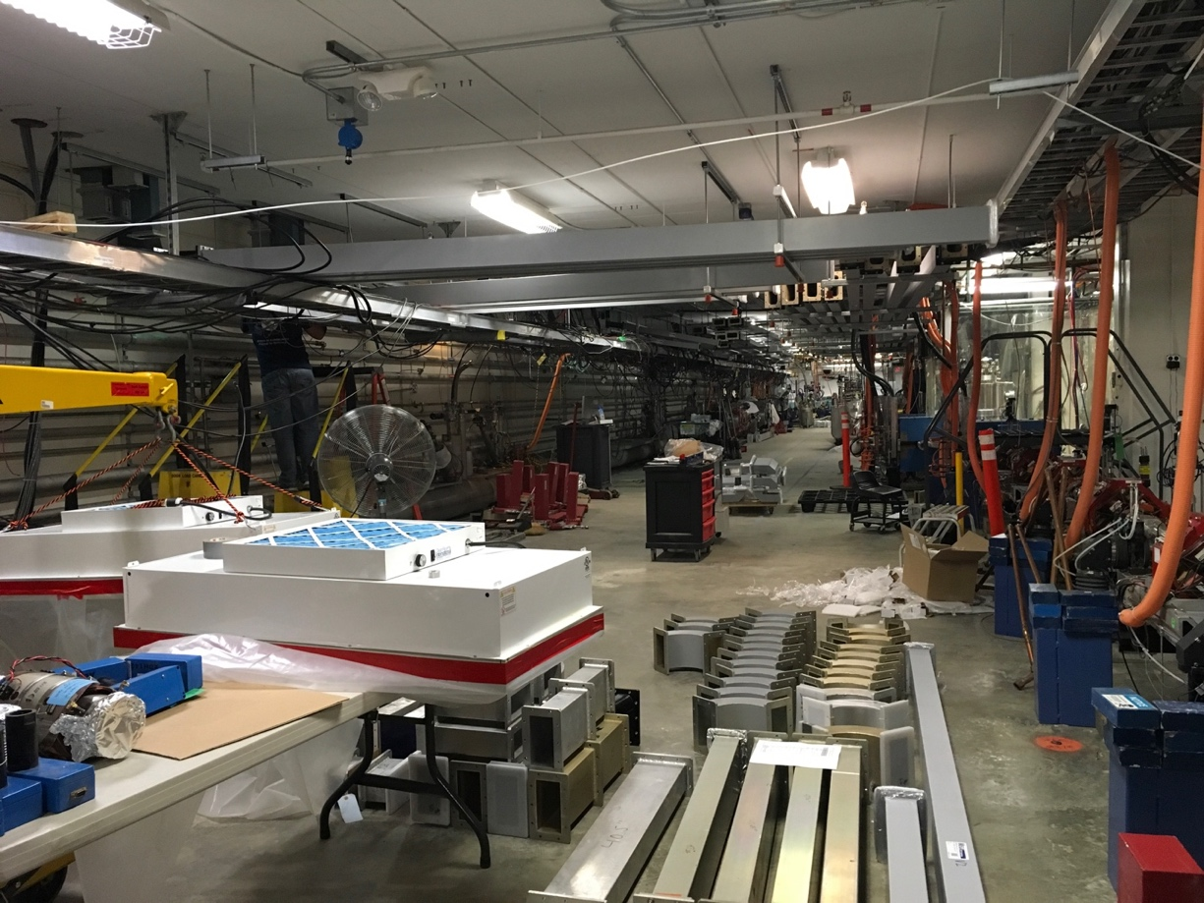

Progress on waveguide assembly

Weekly Reporting

WBS 1.04.08 JLAB Cryoplant System

Week of February 15-21, 2018

**Issues:**

**Accomplishments this week:**

**2K Cold Box**

1. Implementation of engineering change request (ECR) from SLAC complete.
   * Bypass flow performance requirement changed from 36 g/s to 80g/s.
2. Top plate awarded – Vendor kickoff meeting this week.
3. Rerun of engineering analysis of vacuum vessel & piping complete.
   * Results under internal review
4. Holding FDR date of 28-March despite change in performance requirements.
   * Charge for FDR being developed.
5. P&ID updates along with process flow modeling nearing completion.

**4.5K Cold Box Status**

1. PHPK is continuing to pump/backfill to reduce the helium background.
   1. This effort has not progressed in the past week.
   2. JLab is sending vacuum SME out to PHPK to help push progress.
2. Feb 12th was deadline for completion of leak test for CP1 Lower CB without an impact on delivery date to SLAC.
3. Shipment for delivery schedule moved out to 12-April-2018.
4. Progress on the remaining 4.5K cold boxes components continues.
   1. Leak check on CP1 LCB is in progress.

**Warm Helium Compressors**

1. Lessons learned from the first warm helium compressor installation are being collected and evaluated.
2. Awaiting installation plan for the remaining 11 warm compressor systems.

**Oil Removal Vessels**

1. 9 of 11 vessels for CP1 have been delivered onsite @ SLAC.
   1. Last two vessels for CP1 scheduled to be delivered next week.
2. First three vessels for CP2 are scheduled for delivery @ SLAC next week.

**Cryoplant Engineering Status**



Engineering continued to focus on completion of the 2K cold box & Interface box assembly design.

**QUALITY**:

Planning to attend final leak test of CP#1 Upper Cold Box late February.

**Upcoming Travel/Reviews:**

* ~~Preproposal Technical Review of IBX~~ 07-Feb-2018 - Complete
* ~~Final leak check for He gas storage tanks~~ 08-Feb-2018 - Complete
* ~~Purifier FDR @ vendor (AET) 09Feb-2018~~ 
  + ~~Postponed due to weather new date 20-Feb-2018~~
* 4.5K cold box final leak check ~Week of Feb 26th
* 4.5K cold box re-assembly meeting @SLAC ~Week of Mar 05th
* MCC Vendor Site visit (acceptance testing) 8-9-March-2018
* FAC Review Mar 6-7th
* Director Review Mar 20-22nd
* 2K Cold box FDR 28-Mar-2018
* DOE OPA Review May 8-10th

Weekly Reporting

WBS 1.02.03.05.12 LLRF

Week of February 15-21, 2018

**Issues:** None

**Accomplishments this week at JLab:**

* Resonance/Interlock Chassis:
  + Individual boards are out for final review.
  + Ongoing: Dave is coordinating the purchasing of parts and boards for the LERF. We have all of the parts and boards in house to build a total of 10 each. The FMC boards are complete and tested. The Stepper, Temperature, and Digital VAC/IO boards are assembled and on its way from the assembly houses. They will be here by the end of the week. The last board to go out is the PS distribution board. That will be out later today for assembly due next week.
  + Test board for stepper is ready and reviewed. Will get back to it once we finalize the production files for all the other boards. (Early next week)
* Interlock Board/Chassis:
  + Work at this time is on hold until needed for 3.9 GHz.
  + Contacted Andrew Burrill to set up a discussion for 3.9 GHz interlock needs.
* Common Power Supply/Chassis/Boards:
  + Design complete out for production.
* LERF
  + LERF LLRF instrumentation cables: Dave is working with Kevin to get the cables ordered or use existing cables from JLAB overstock*.* All of the Heliax cable and connectors have arrived. As soon as the cable trays and SSA are installed we will start cable layout.
  + Ongoing, Mike McCaughan and I are working on functional procedures for the cavity tests.
  + LLRF Front end requirements edited/added Larry’s comments and sent out for further review.
  + Sent out the cavity tests expected in the LERF to the LCLSII LLRF team for comments.
* CMTF
  + Ran 8 cavities in GDR using the piezo tuner. The algorithm was a simple integrator to track He pressure. The cavities topped out at 10 MV/m because of the cryo plant limit.

**Upcoming Activities:**

* LERF RF cable installation ~ April when the LLRF Racks arrive.