Weekly Reporting

WBS 1.01.07 JLAB Management

Week of April 12-18, 2018

**Issues:**

Need a decision on how many SRF cavities to procure.

**Accomplishments this week:**

Lots of CP vendor activities ongoing. FATs and status meetings at multiple vendors.

Hosting SLAC I&C staff with focus on CP controls.

Finalizing CM rework P6 input and restart documentation.

Moved J1.3-05 to LERF vault.

**Upcoming Activities:**

7 May – Collaboration Meeting @ SLAC

8-10 May – OPA Review @ SLAC

15-17 May – LCLS-II HE Director’s CD-1 Review

19-21 June – LCLS-HE CD-1 Review

Weekly Reporting

WBS 1.04.06 JLAB Cryomodules

Week of April 12-18, 2018

**Issues**:

Production hold due to BPM leaks.

**Accomplishments this week:**

Refined EAC for cryomodule control accounts.

Provided estimate for CM maintenance to SLAC/Schmerge for complete tear-down and rebuild of a returned CM.

Working on OPA presentations. Participated in dry runs.

Cavity award package approved by DOE. Received direction from project not to proceed with any award or action for additional cavities including rework. Currently on hold.

Retro-fit travelers and procedures have been reviewed and minor edits are being implemented. Restart for retro-fit is awaiting final approval from SLAC.

Developing BCR presentation for CM rework that includes cost for additional fixtures and equipment.

Developing BCR for LERF transfer line award.

HX modifications to piping are complete. Leak check and pressure testing in progress. MLI re-installation and thermal strap mods on-going for 50 K shield.

Preparing list of activities requested by SLAC staff upon receipt of CM-07 in early May. Held internal pre-shipment review in advance of discussion with SLAC.

J1.3-01 - @ WS6; Idle; Waiting to move to WS4 for VV removal

J1.3-02 - @ WS6; Idle

J1.3-03, J1.3-04 - @ Storage atop UITF. Waiting to move to WS4 for VV removal.

J1.3-05 - @ WS5; Shipped to LERF on April 12th.

J1.3-07 - @ WS5. Survey of string cavity flange positions complete. Checking / loctiting all reachable tuner hardware. Beam pipe prep on-going. Documentation review in progress. Plan pre-shipment review with SLAC for this week.

J1.3-08 - @ WS4; Portable cleanroom installed in preparation for beamline vent. UCM hardware rework procedure and checklist in progress. Slow bleed up / pump down procedure signed off. BPM hardware replacement procedure signed off. Retrofit traveler signed off. Fastener rework awaiting sign-off.

J1.3-09, J1.3-10 @ WS3 – UCM hardware rework in progress; Waiting for BPM hardware replacement.

J1.3-11 – Idle; Waiting to move to WS3. Working on fastener spreadsheet and checklist.

J1.3-12 – String build began 08-APR. All cavities on the rails. Leak check in progress. Roll-out planned for 20-APR or sooner.

J1.3-13 – All cavities have been qualified for the string.

J1.3-14 – Four cavities qualified. Results presented at SRF weekly meeting.

Spare SSA and eight production SSAs upgraded. Lifting bolts also changed out. SSAs 1 and 2 were tested into loads located inside the Cave, Pf = 3.8 kW. LCW and over power interlocks were tested and behaved correctly. Ran 1 1/2 hours without problem. SSAs 1 – 8 tested into shorts located inside the cave. Ran at 3.8 kW each for 40 minutes without problem. LCW and over power interlocks were tested and behaved correctly. Over temp interlock tested successfully on SSA 1. Work completed on Thursday – 04/12/18.

**QUALITY**:

The final, approved version of the Project Cryomodule Assembly QA report was posted and sent to the Partner Labs last week, with direction to the LCLS-II Project Cryogenics Systems Manager to incorporate the recommendations into the restart plan.

Code and SCI compliant eyebolts for the SLAC SSAs were 100% replaced by the SSA vendor last week. All non-compliant eyebolts were photographed as a group prior to turnover and then shipped back to SLAC per their instructions. JLab QA now considers this issue closed.

**Upcoming Travel/Meetings:**

EZ Vendor Visit Apr 16-20 (Gonella)

Wuxi Vendor Visit April 16-20 (Cheng, Fischer)

EZ Vendor Visit May/June TBD (C. Reece)

Weekly Reporting

WBS 1.04.06 Cryomodules - LERF Conversion

Week of April 12-18, 2018

**Issues:** None

**Accomplishments this week:**

First LCLS-II cryomodule (CM #5) has been moved to the LERF vault.

Waveguide in vault is awaiting the couplers.

SLAC provided equipment arrived on Tuesday.

First 4 isolators have been installed, remaining isolators and waveguide are in progress.

Cable list for printing lables has been posted to the WIKI:

<https://wiki.jlab.org/lerf/index.php/Cable_by_rack_location>

Base plates for both CMs have been grouted, wheel extension plates and bolts are here.

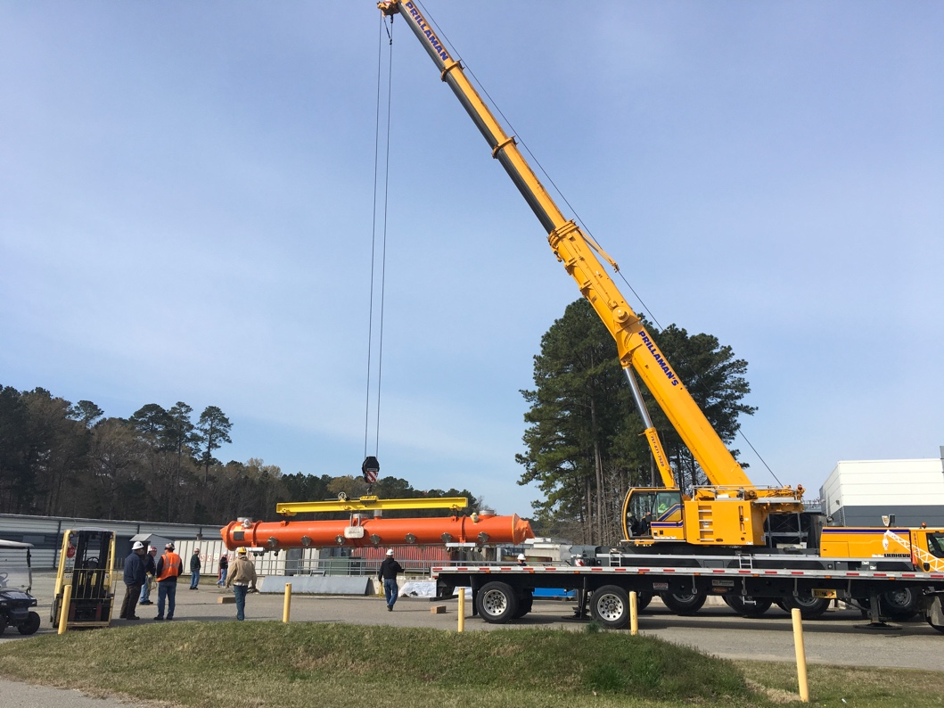

CM # 5 arrives

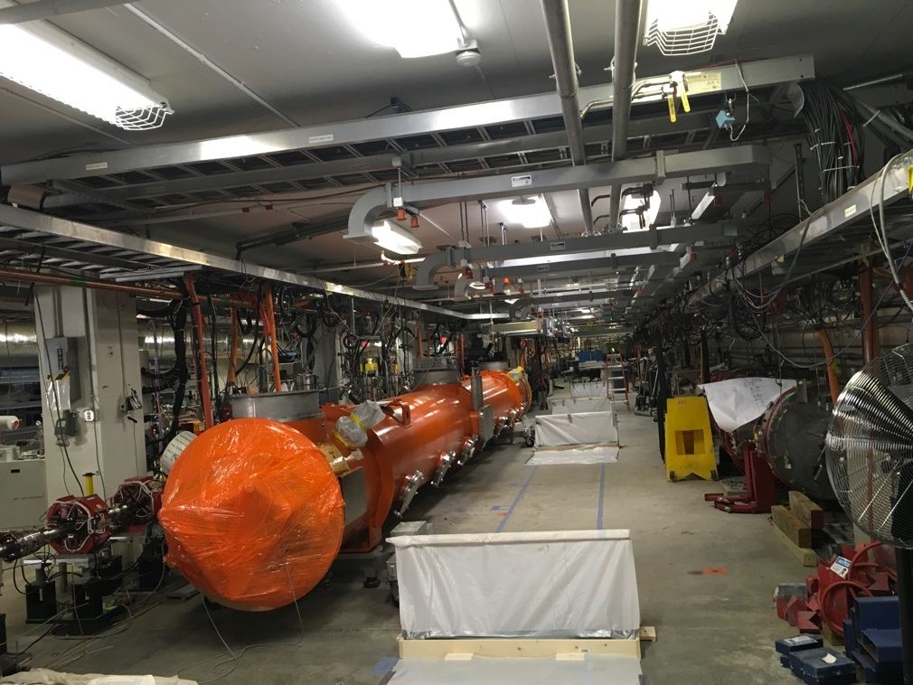

CM #5 in vault, stands shown awaiting grout & waveguide awaiting couplers

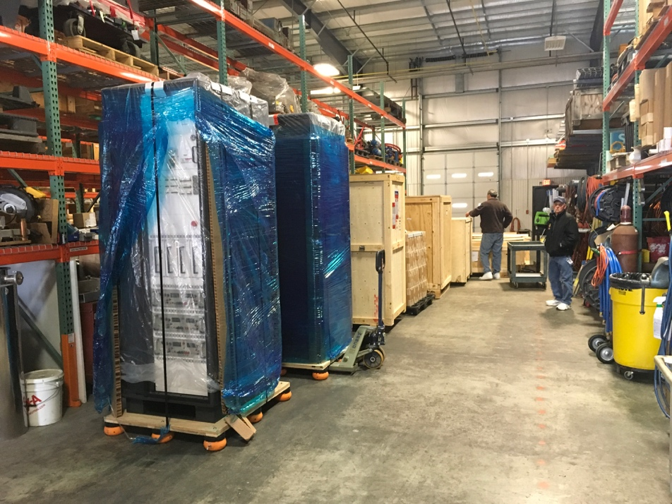

First load of SLAC equipment

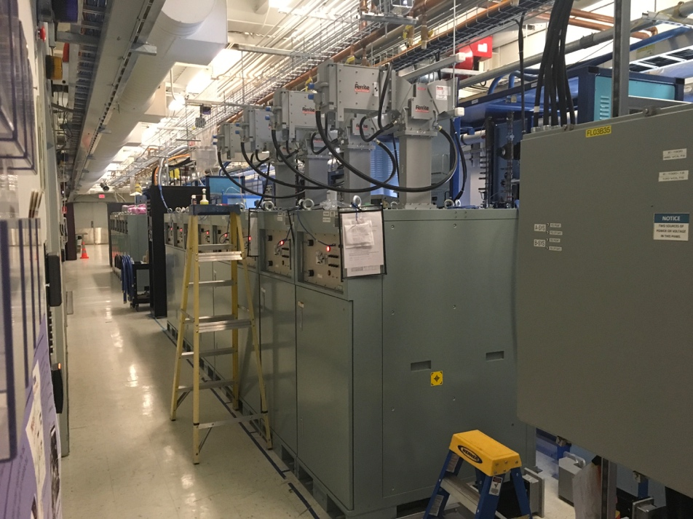

First four isolators installed

Weekly Reporting

WBS 1.04.08 JLAB Cryoplant System

Week of April 12-18, 2018

**Issues:**

**Accomplishments this week:**

**2K Cold Box (no change)**

1. The vendor proposals received on 09-Apr-2018.
   * Technical evaluations have begun.
2. Award is expected June 2018.

**4.5K Cold Box Status**

1. UCB1: SO, SOTR & vacuum SME onsite for FAT of the final leak check.
   1. JLab, SLAC and ALATUS staff will be at PHPK 19-Apr-2018.
2. LCB1: JLab provided guidance for final leak check internal piping systems.
3. UCB2 - piping on schedule to complete this week, tubing & electrical installation has begun. Installing nozzles onto lower shell; lower head, skirt base ring has been blasted and prepped for paint.
4. LCB2 - internal frame subassemblies are being installed this week.
5. Vacuum Skids are ~90% complete.
6. Cryoduct - Complete.

**Interface Boxes**

1. Final (revised) proposals received 12-Apr-2018.
2. Award expected April 2018
3. Engineering change request (ECR) received from SLAC 05-Mar-2018.
   1. Need to mitigate maintenance issue created by permanent connection to 2K cold box.
   2. JLab & SLAC are working through the details of u-tube crossover.
   3. Crossover U-tube will isolate flow from 2K cold box.
      1. This solution will not fully mitigate thermal link caused by permanent connection.

**Factory Acceptance Testing**

1. 4.5K cold box – FAT of final assembly leak check 19-Apr-2018
2. He Purifier - FAT scheduled for 23-Apr-2018.
3. MCC- FAT scheduled for 23-Apr-2018.

**Cryoplant Engineering Design Status**

* The FMEA and specifications for the Instrumentation & controls effort are on schedule to complete this month.
* SLAC I&C staff onsite at JLab this week (17-19 Apr)

**QUALITY**:

* Attend several (see below) factory acceptances testing of equipment in April.

**Upcoming Travel/Reviews:**

* 4.5K cold box final leak check 19-April-2018
* 4.5K cold box re-assembly meeting @SLAC Postponed
* 2nd MCC Vendor Site visit (acceptance testing) Week of 23-April-2018
* Visit to GHe vendor for acceptance Week of 23-April-2018
* Helium Processor FAT Week of 23-April-2018
* DOE OPA Review May 8-10th

Weekly Reporting

WBS 1.02.03.05.12 LLRF

Week of April 12-18, 2018

**Issues:** None

**Accomplishments this week at JLab:**

* Resonance/Interlock Chassis:
  + Ongoing: Chassis assembly is complete. Testing status is TBD.
  + We ordered up a sample board of the C1635 (Res/Int Power distribution board). STATUS
* Interlock Board/Chassis:
  + Work at this time is on hold until needed for 3.9 GHz.
* Common Power Supply/Chassis/Boards:
  + Stickers for each of the fuse locations have been produced and mailed out.
* LERF
  + LERF LLRF instrumentation cables: Ready for installation.
* CMTF
  + HOM: Putting together a similar automated HOM measurement for the CMTF. Sent it to Larry King for review.
  + CMTF Resonance Automation

**Upcoming Activities:**

* LERF RF cable installation: This may take place before racks arrive.