Weekly Reporting

WBS 1.01.07 JLAB Management

Week of April 19-25, 2018

**Issues:**

Need a decision on if/how many SRF cavities to procure.

**Accomplishments this week:**

Lots of CP vendor activities ongoing. FATs and status meetings at multiple vendors.

CP machine control centers FAT completed and shipment to SLAC started.

Completed first BPM flange hardware rework. No problems noted.

Continue to have a lot going on with the LERF configuration as a test stand.

**Upcoming Activities:**

7 May – Collaboration Meeting @ SLAC

8-10 May – OPA Review @ SLAC

15-17 May – LCLS-II HE Director’s CD-1 Review

19-21 June – LCLS-HE CD-1 Review

Weekly Reporting

WBS 1.04.06 JLAB Cryomodules

Week of April 19-25, 2018

**Issues**:

Obtaining more high-performing cavities to finish CM assembly.

**Accomplishments this week:**

Restart approved on 20-April for BPM replacement hardware.

Finalizing OPA presentations.

Developing the draft presentation for LCLS-II-HE Director’s Review. Providing back-up documentation for HE BOE.

Cavity award package approved by DOE. Received direction from project not to proceed with any award or action for additional cavities including rework. Currently on hold. Developing alternate plans for discussion with project.

Working with SLAC to integrate overall schedule on BCR for CM rework that includes cost for additional fixtures and equipment.

Processed BCR for LERF transfer line award.

HX modifications to piping are complete. Initial leak check complete. Pressure testing in progress. Final leak check will follow.

J1.3-01 - @ WS6; Idle; Waiting to move to WS4 for VV removal

J1.3-02 - @ WS6; Idle

J1.3-03, J1.3-04 - @ Storage atop UITF. Waiting to move to WS4 for VV removal.

J1.3-05 - @ LERF

J1.3-07 - @ WS5. Cryomodule survey complete. Beam pipe work complete. Modification of shipping end cap complete Pre-shipment review with SLAC complete. Received direction from project to hold on shipment. Plan to discuss prior to stopping work.

J1.3-08 - @ WS4; Fastener rework procedure and checklist I.P. String bled up on 20 April; took about 11.5 hours. BPM hardware replaced and slow pump down started on 24 April.

J1.3-09, J1.3-10 @ WS3 – UCM hardware rework in progress; Waiting for BPM hardware replacement.

J1.3-11 – Idle; Waiting to move to WS3. Working on fastener spreadsheet and checklist.

J1.3-12 – String rolled out on 20-APR. Alignment in progress. Magnet installed. Two-phase pipe welding in progress.

J1.3-13 – All cavities have been qualified for the string. String build will be gated by return of lollipops, best estimate is last week of May.

J1.3-14 – Four cavities qualified.

No cavity tests this past week. Planned cavity tests:

245, 169, 246 first test in D5 Tuesday, 24 April

305 (previous FE) retest in D8 Wednesday, 25 April

325 (previous low Q0 in D5) retest in D7 Thu, 26 April

**QUALITY**:

The JLab internal QA report was provided to SLAC per their request.  This internal assessment was conducted prior to the Partner Lab QA assessment.

An SSA arrived from SLAC last week; due to the recency of the non-code compliant eyebolt issue, it was inspected upon uncrating. There were no problems.

**Upcoming Travel/Meetings:**

EZ Vendor Visit May/June TBD (C. Reece)

Weekly Reporting

WBS 1.04.06 Cryomodules - LERF Conversion

Week of April 19-25, 2018

**Issues:** None

**Accomplishments this week:**

Updates & photos can be seen on the WIKI

Waveguide installation is at 90% - waiting on air taps for pressurization, these should be completed in the next days then upstairs can be finished (photo).

The first LCLS-II module (CM5) has been delivered to the LERF vault and positioned.

Base plates for both CMs (4) have been surveyed in and 3 of them have been grouted, the last one (at east side of vault) will not be grouted since it would impede the movement of modules in & out of the vault.

Vender visit was held for the cryo-can contract with Eden, in Columbus Ohio. The transferline assembly is due at the end of May & the cryo-can is scheduled for delivery in July.

Several SLAC users now have accounts and successfully logged in.  Network diagram was drafted to help show hostnames, where they are physically, and how they relate to each other.  The SLAC requested changes to the fileserver were implemented.  Conference call is being setup with controls staff to get all parties on the same page moving forward.

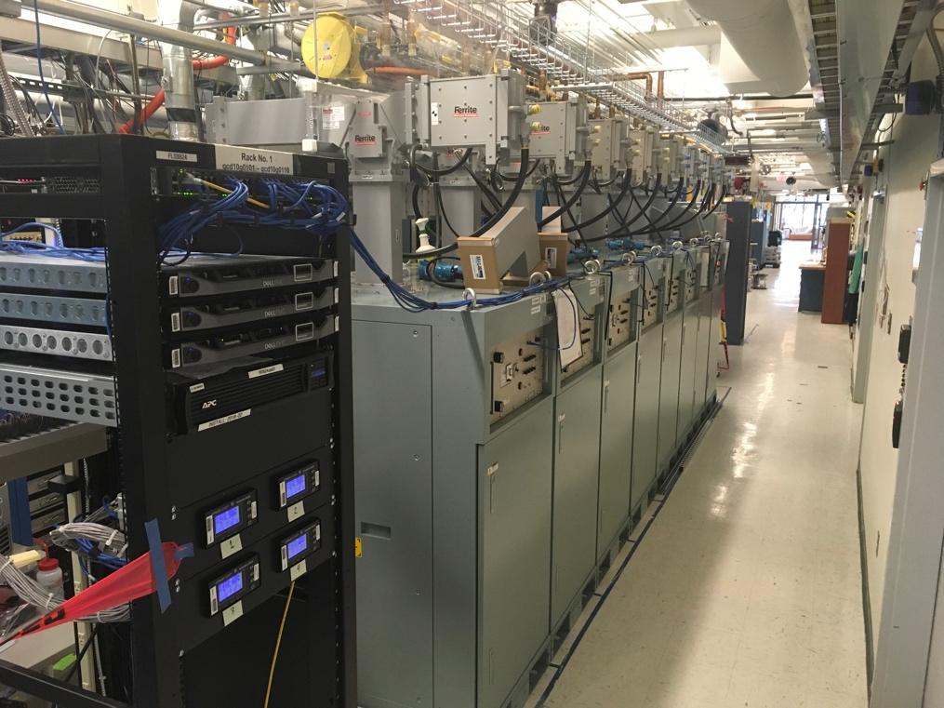

Isolators mounted to SSAs

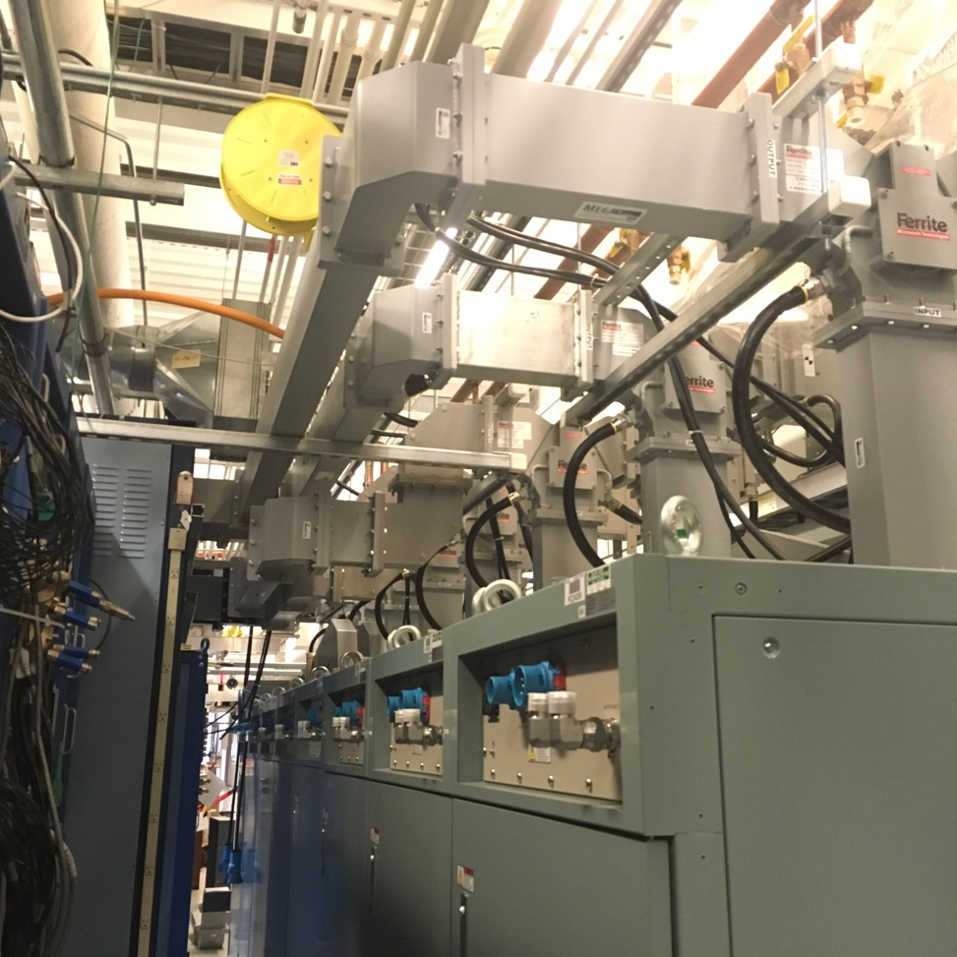

Waveguide connections between SSA & penetrations

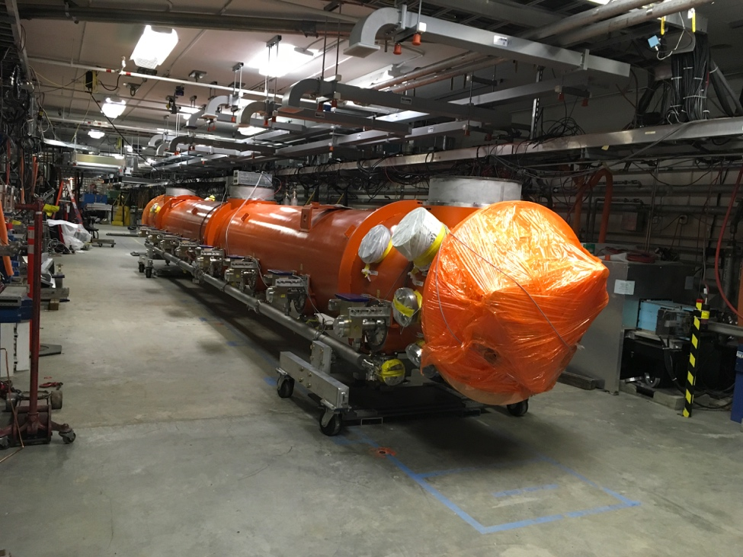

First LCLS-II cryomodule in the tunnel

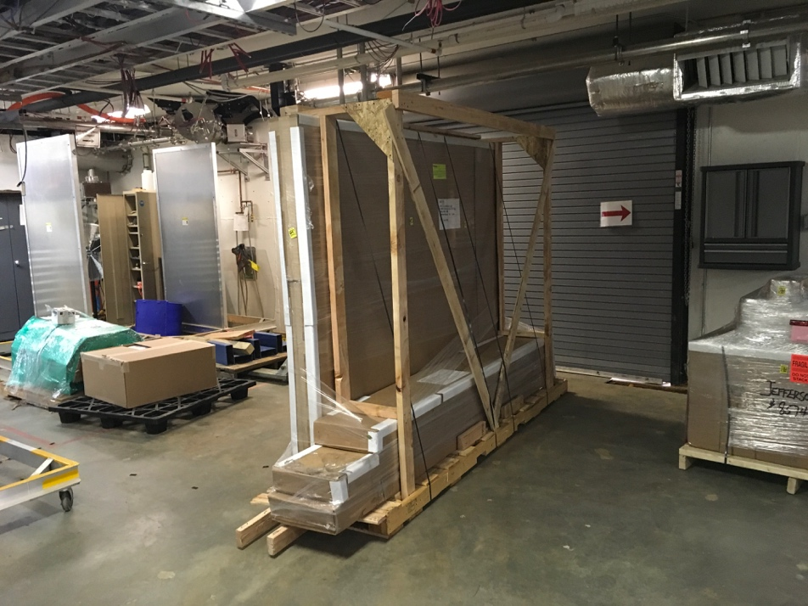

Clean room for connecting clean beamline delivered

Weekly Reporting

WBS 1.04.08 JLAB Cryoplant System

Week of April 19-25, 2018

**Issues:**

**Accomplishments this week:**

**2K Cold Box (no change)**

1. The vendor proposals received on 09-Apr-2018.
   * Technical evaluations are complete.
2. Award is expected May 2018.

**4.5K Cold Box Status**

1. UCB1: Final leak check complete.
   1. JLab, SLAC and ALATUS staff onsite for witness at PHPK 19-Apr-2018.
   2. Shipment to SLAC expected May 2018
2. LCB1: Final leak check internal piping systems expected next week.
3. UCB2 – Skirt base ring out of paint booth; pressure boundary flanges ready for installation.
4. LCB2: Lower shell staged for move into fab shop and assembly.
5. Vacuum skids: final inspections begin this week.

**Interface Boxes**

1. Final (revised) proposals received 12-Apr-2018.
2. Award expected May 2018 – DOE approval may be required.
3. Engineering change request (ECR) received from SLAC 05-Mar-2018.
   1. Need to mitigate maintenance issue created by permanent connection to 2K cold box.
   2. JLab & SLAC are working through the details of u-tube crossover.
   3. Crossover U-tube will isolate flow from 2K cold box.
      1. This solution will not fully mitigate thermal link caused by permanent connection.

**Factory Acceptance Testing**

1. 4.5K cold box – FAT complete 19-Apr-2018;
2. MCC- FAT complete 23-Apr-2018; shipment to SLAC next week.
3. GHe tanks – FAT scheduled for 25-April-2018.
4. He Processor - FAT scheduled for 27-Apr-2018.

**Cryoplant Engineering Design Status**

* The FMEA and specifications for the Instrumentation & controls effort are on schedule to complete this month.
* SLAC I&C staff onsite at JLab this week (17-19 Apr)
  + Discussions on software specifications & bench testing of EPICs/PLC’s

**QUALITY**:

* Attend several (see below) factory acceptances testing of equipment in April.

**Upcoming Travel/Reviews:**

* Visit to GHe vendor for acceptance 25-April-2018
* Helium Processor FAT 27-April-2018
* 4.5K cold box monthly schedule/shipment review 01-May-2018
* DOE OPA Review May 8-10th
* 4.5K cold box re-assembly meeting @SLAC Postponed