Weekly Reporting
WBS 1.01.07 JLAB Management
Week of April 26-May 2, 2018

Issues:
Accomplishments this week:
Cryomodule J1.3-07 shipping test went well.
Good progress on the LERF conversion.
Cryomodule rework is getting into full swing.
Last major cryoplant equipment awards are in process.
Upcoming Activities:
7 May – Collaboration Meeting @ SLAC
8-10 May – OPA Review @ SLAC
23-25 May – LCLS-II HE Director’s CD-1 Review
19-21 June – LCLS-HE CD-1 Review

Weekly Reporting
WBS 1.04.06 JLAB Cryomodules
Week of April 26-May 2, 2018

Issues:
Risk of lack of high-performing cavities to finish CM assembly.
Accomplishments this week:
Prepared EAC summary presentation.
Finalizing OPA presentations.
Finalizing the draft presentation for LCLS-II-HE Director’s Review. Not planning to attend. Providing back-up documentation for HE BOE.
Revised approach for cavity procurement to rework 27 low performing cavities. After receiving direction from project.
Working with SLAC to integrate overall schedule on BCR for CM rework that includes cost for additional fixtures and equipment.
HX modifications to piping are complete. Pressure testing is complete. Final leak in progress.
J1.3-01 - @ WS6; Idle; Waiting to move to WS4 for VV removal
J1.3-02 - @ WS6; Idle
J1.3-03, J1.3-04 - @ Storage atop UITF. Waiting to move to WS4 for VV removal.
J1.3-05 - @ LERF; Idle
J1.3-07 - @ WS5. Conducted shipping test to Bristol VA and back. Beamline and coupler vacuum is intact after shipment. Cavity pass bands and HOM Qexts are acceptable. Internal inspection showed one tuner safety rod loose, one nut loose from two-phase line and loose nut on line D restraint. This CM was not fully disassembled. No noteworthy scraping or signs of slippage. Alignment verification is on-going. Accelerometer data is being analyzed by JLab and FNAL colleagues. Planning for long distance road test in near future.
Huque, J. Martin (rigging expert) and C. Dreyfuss (UHV, particulate-free expertise) visited SLAC to meet with counterparts in advance of receiving CMs on-site at SLAC.
J1.3-08 - @ WS4; BPM leak checked. HOM’s checked and retuned as necessary. Fastener checklists reviewed. 50K Shields welded on. MLI applied. VV installation on-going.
J1.3-09 @ WS3 – Received BPM hardware. Slow pump/bleed up cart installed. Bleed up has started.
J1.3-10 @ WS3 – UCM hardware rework in progress; Waiting for BPM hardware replacement.
J1.3-11 – Idle; Waiting to move to WS3. Working on fastener spreadsheet and checklist.
J1.3-12 – Alignment complete. Two-phase pipe welding complete. Instrumentation for WS2 complete.
J1.3-13 – All cavities have been qualified for the string. String build will be gated by return of lollipops, best estimate is last week of May.
J1.3-14 – All cavities qualified for the string.
Cavity tests were reported verbally at the SRF weekly. K. Davis is updating & uploading recent test data. It is noteworthy that cavity 272 reached 30 MV/m, 2.5e10 in vertical testing.

QUALITY:
No report.

Upcoming Travel/Meetings:
EZ Vendor Visit May/June TBD (C. Reece)

Weekly Reporting
WBS 1.04.06 Cryomodules - LERF Conversion
Week of April 26-May 2, 2018
Issues: None
Accomplishments this week:
Updates & photos can be seen on the WIKI
All major equipment from SLAC has been delivered and craned into place. The truck was a day late so we had to do 2 crane lifts/rentals. The magnet racks have been placed and the LLRF & Cryo racks will be located in the next day or so.
There were a couple locations where the tray/box ducts were a bit low for passage of the magnet racks. These were easily raised by jacking up the threaded support rods.
Waveguide installation is finished in the gallery, except for SSA # 16 which was just craned into place.

Progress continues on the controls and network side.

Next activity is get the cables pulled and terminated.

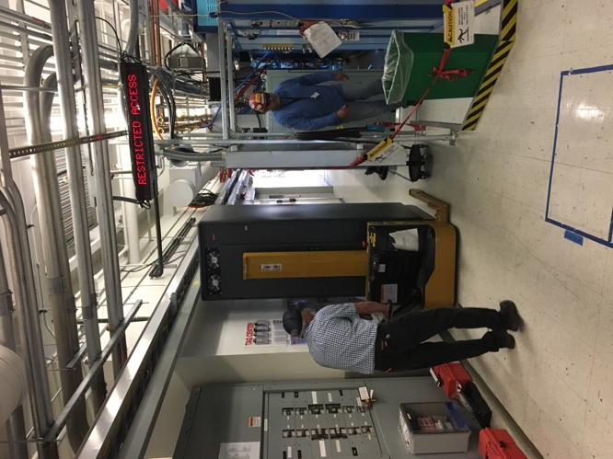
Moving the magnet racks into position

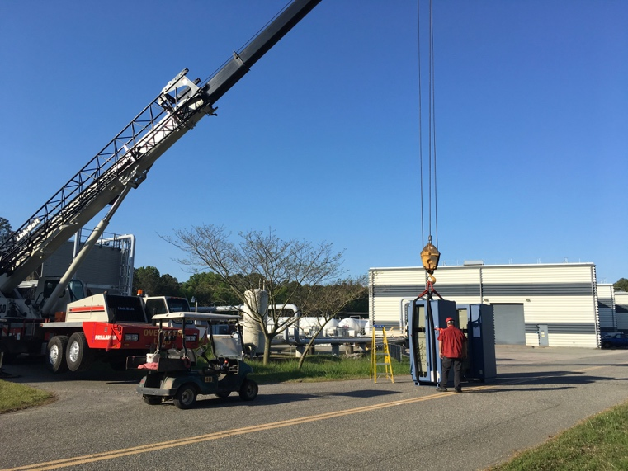
Crane lift to the LERF gallery.

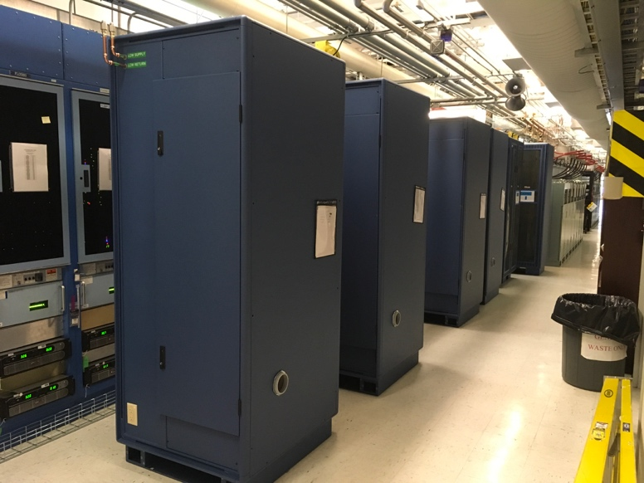
LLRF & Cryo racks staged in gallery.

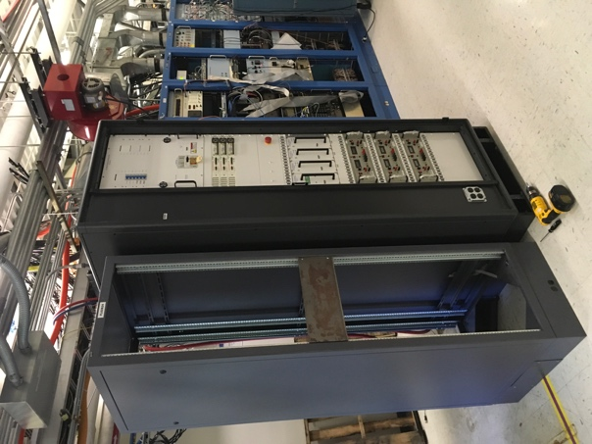
Magnet & Vacuum rack installed.

Weekly Reporting
WBS 1.04.08 JLAB Cryoplant System
Week of April 26-May 2, 2018

Issues:
Accomplishments this week:
2K Cold Box
- Technical evaluations complete.
- Procurement is reviewing best options to minimize schedule and cost.
- Award is scheduled for May 2018.

4.5K Cold Box Status
- Delivery of the first upper cold box to SLAC expected this month.
  - UCB1: Being prepared for shipment.
  - JLab, SLAC and ALATUS staff onsite this week
    - Monthly schedule update meeting.
    - Shipment kickoff, planning and coordination meeting

Interface Boxes
- Award recommendation to DOE May 2018
- Award expected June 2018 – Pending DOE approval.

Factory Acceptance Testing
- MCC- FAT complete
- GHe tanks – FAT complete
- He Processor - FAT complete

Deliveries and Installation
MCC- FAT complete; shipment to SLAC complete (received @SLAC).
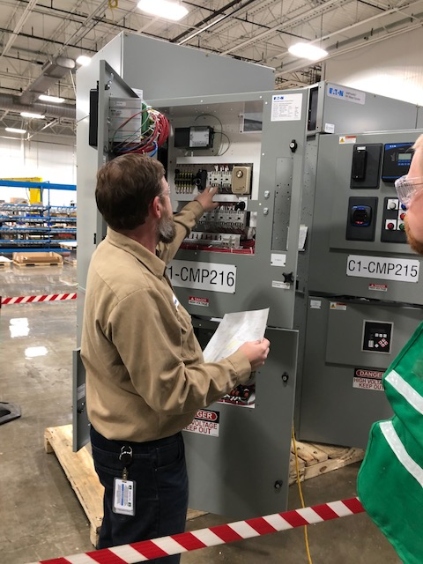 | 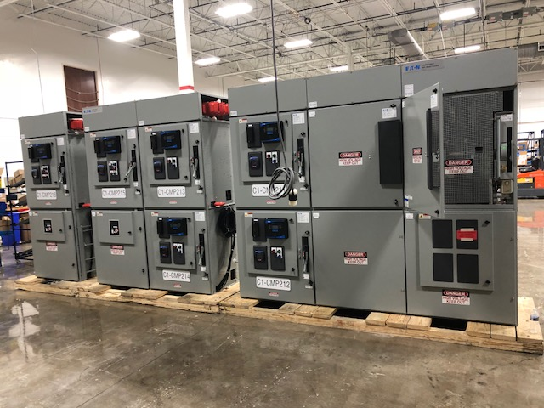
Factory acceptance testing of MCC units for C1 & C2; 23-April-2018.

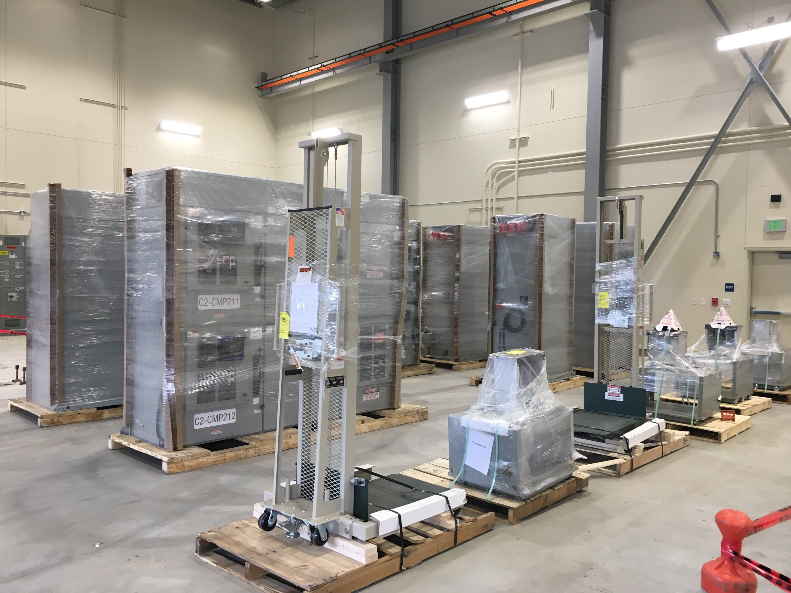
MCC units for C1 & C2 received @SLAC 27-April-2018.

Warm helium compressor installation proceeding as planned.
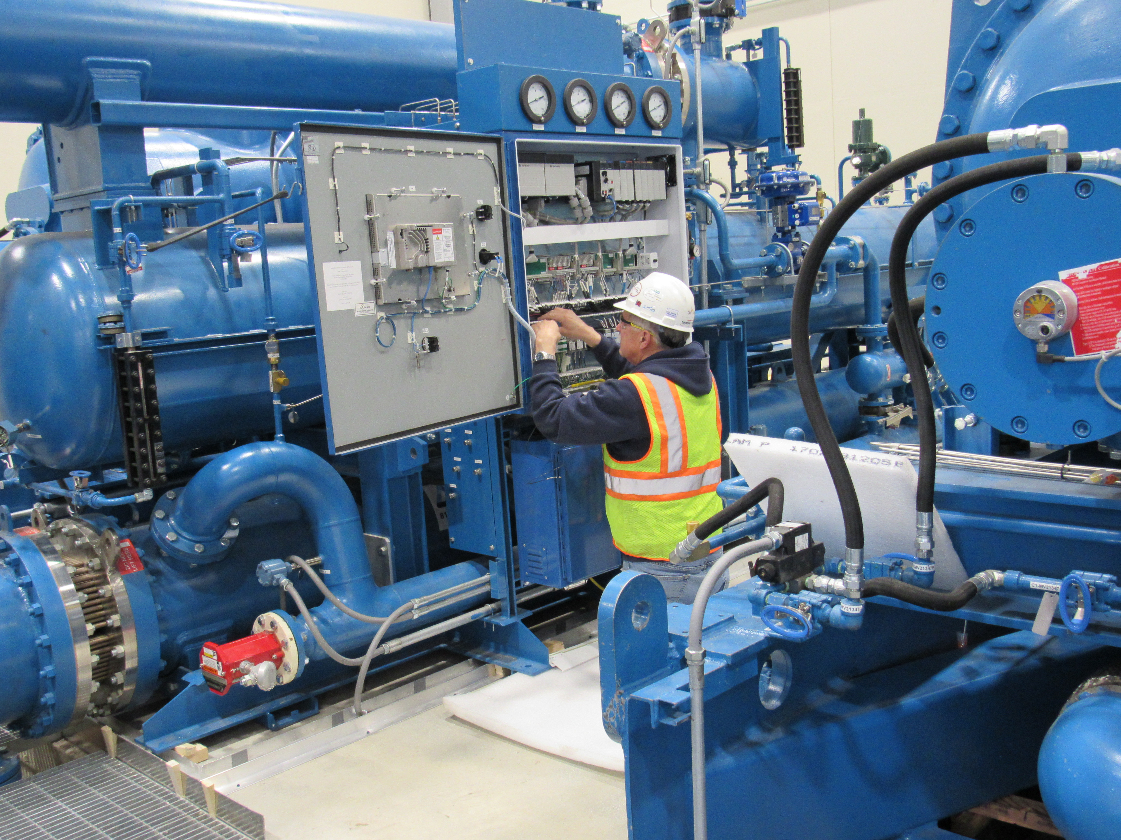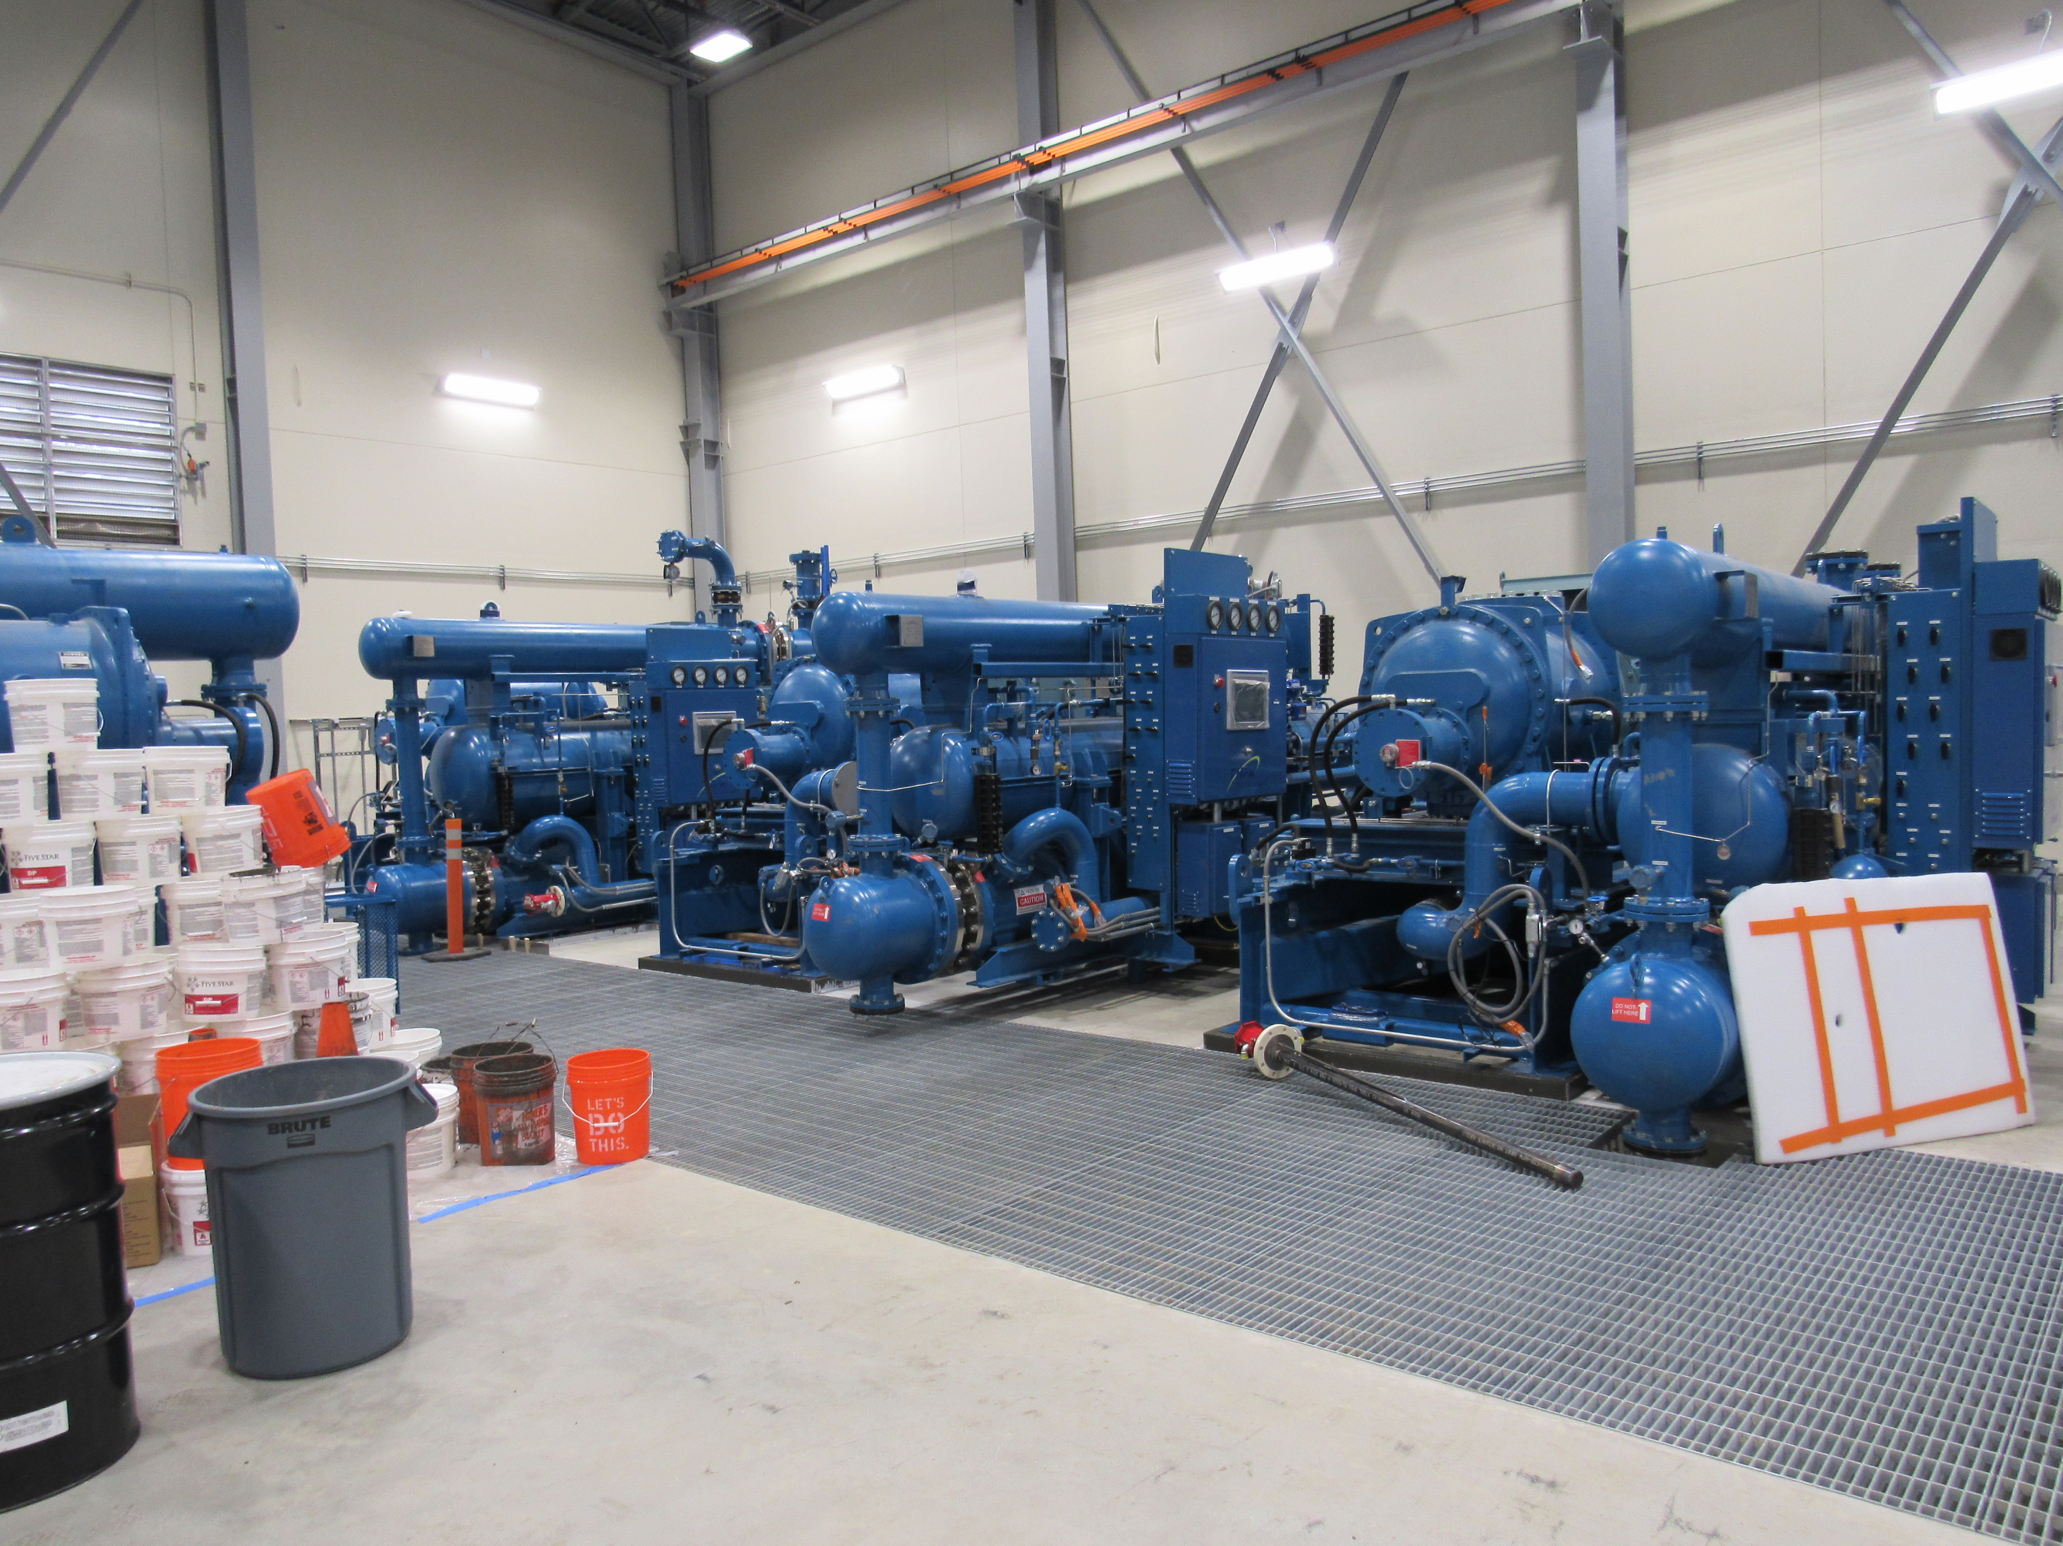
The installation and assembly of the Warm Helium Compressors for C1 in the CryoPlant (B905).

Upcoming Travel/Reviews:
- 4.5K cold box monthly schedule/shipment review 01-May-2018
- Controls Enclosures FAT 03May-2018
- SLAC technical staff @JLAB for training 7-11 May-2018
- DOE OPA Review 8-10th May-2018
- 4.5K cold box re-assembly meeting @SLAC Postponed

Weekly Reporting
WBS 1.02.03.05.12 LLRF
Week of April 26-May 2, 2018

Issues: None
Accomplishments this week at JLab:
- Resonance/Interlock Chassis:
  - All chassis assembled and four have been tested.
  - We ordered up a sample board of the C1635 (Res/Int Power distribution board). STATUs.
  - Four BMB7s arrived on the truck today for the Resonance and Interlock chassis.

- Interlock Board/Chassis:
  - Work at this time is on hold until needed for 3.9 GHz.

- Common Power Supply/Chassis/Boards: Work complete.

- LERF
  - LERF LLRF instrumentation cables: Ready for installation.
  - HOM Measurement: The switch matrix is at JLAB. We will set it up so Wes Moore can begin programing it.
  - Reference system and LO: Chassis has been given to MECad for lay out. Most parts are here. Still waiting on a few couplers but the installation can proceed. Have asked for tech support from EESRFOps to fabricate chassis and pull/calibrate cables.
  - Met with SLAC EPICS/Software people earlier this week and ironed out some network details.
  - Racks will be moved in on Wednesday.

- CMTF: CMTF Resonance Automation no work because of CM assembly stand down.

Upcoming Activities:
- LERF RF cable installation: This will take place over the next month.

