Weekly Reporting
WBS 1.01.07 JLAB Management
Week of May 3-9, 2018

Issues:
Accomplishments this week:
Preparations for the DOE OPA review.
Review EAC with project management.
Preparations for the CM rework BCR.
Upcoming Activities:
7 May – Collaboration Meeting @ SLAC
8-10 May – OPA Review @ SLAC
23-25 May – LCLS-II HE Director’s CD-1 Review
19-21 June – LCLS-HE CD-1 Review

Weekly Reporting
WBS 1.04.06 JLAB Cryomodules
Week of May 3-9, 2018

Issues:
Risk of lack of high-performing cavities to finish CM assembly.
Accomplishments this week:
Reviewed EAC summary presentation.
Participated in DOE OPE Review.
LCLS-II-HE Director’s Review - not planning to attend but will dial in. Providing back-up documentation for HE BOE.
Planning to award rework of 27 cavities this week.
Working with SLAC to integrate overall schedule on BCR for CM rework that includes cost for additional fixtures and equipment.
HX final leak is complete. Re-assembly is in progress.
J1.3-01,J1.3-02 - @ WS6; Idle; Waiting to move to WS4 for VV removal
J1.3-03, J1.3-04 - @ Storage atop UITF. Waiting to move to WS4 for VV removal.
J1.3-05 - @ LERF; Idle
J1.3-07 - @ WS5. Planning for next shipping test - long distance road test in near future. Developed detailed plan for test that includes displacement measurements of 50K flanges during shipment. Departure date targeted for 22-May TBC.
J1.3-08 - @ WS5; VV installed on cold mass. Cold mass aligned in vacuum vessel. Fastener checklists completed for QC, WS2, 3 and 4. CM moved to WS5. Coupler installation in progress. Beam pipe work started.
J1.3-09 @ WS3 – String was slow-bled up and BPM hardware replaced. String slow pumped down and leak checked. Vac vessel moved to cantilever fixture and demagnetized in preparation for cold mass installation.
J1.3-10 @ WS3 – UCM hardware rework in progress. BPM hardware replacement planned for 10 May 2018.
J1.3-11 @ WS2 – Idle; Waiting to move to WS3. Working on fastener spreadsheet and checklist.
J1.3-12 @ WS2 – Alignment complete. Two-phase pipe welding complete. Instrumentation complete.
J1.3-13 – All cavities have been qualified for the string. String build will be gated by return of lollipops, best estimate is last week of May.
J1.3-14 – All cavities qualified for the string.
J1.3-15 - 1 of 8 cavities qualified for the string.
Cavity tests were reported verbally at the SRF weekly. K. Davis is updating & uploading recent test data. It is noteworthy that cavity 272 reached 30 MV/m, 2.5e10 in vertical testing.

Cavity 272 (TD) retested (previous FE), D8, Tue. 1 May. Q0(16)~3.1e10; FE onset at 18 MV/m; Rad limit 29.5 MV; Plan to re-rinse and retest.

Cavity 245 (TD rework) retested (previous low Q2), D7, Fri. 4 May. Q0(16)~2.9e10; Quench 21.7 MV/m; No FE; Qualified for string.

QUALITY:
No report.

Upcoming Travel/Meetings:
EZ Vendor Visit May/June TBD (C. Reece)

Weekly Reporting
WBS 1.04.06 Cryomodules - LERF Conversion
Week of May 3-9, 2018

Issues: None
Accomplishments this week:
Updates & photos can be seen on the WIKI wiki.jlab.org
All of the SLAC racks have been installed in the final locations
Cable installation has begun, first goal is to complete the Cryo rack cables (~80) so they will be ready for the SLAC folks that are arriving tomorrow afternoon.
Electricians are connecting up AC power to all of the racks.
The software environment is progressing quite well. Sorted out ssh tunneling out of the LERF servers, making code/data transport from SLAC easy. EPICS base, EDM, ALH, and StripTool are complete. The EPICS environment itself, should be wrapping up soon. Focus has moved to finishing the linuxRT setup required for LLRF.

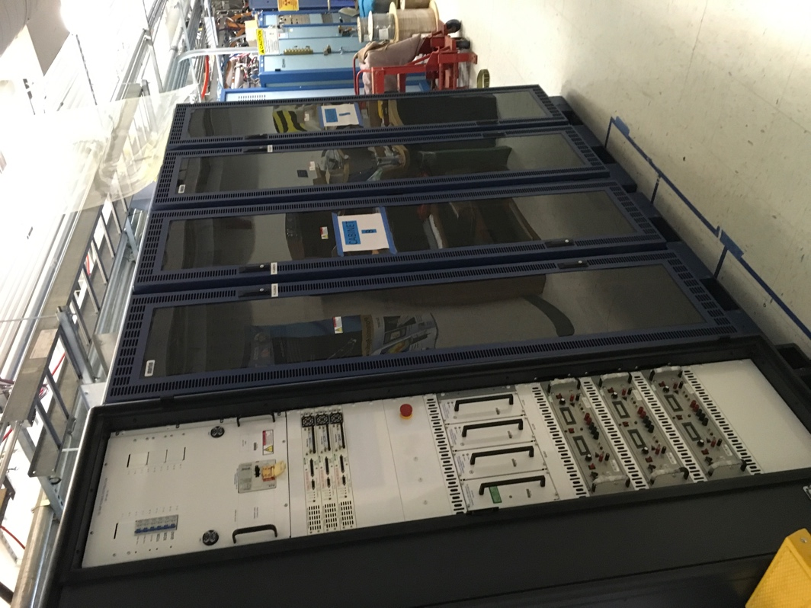
CM #2 Magnet rack & both sets of Cryo racks.

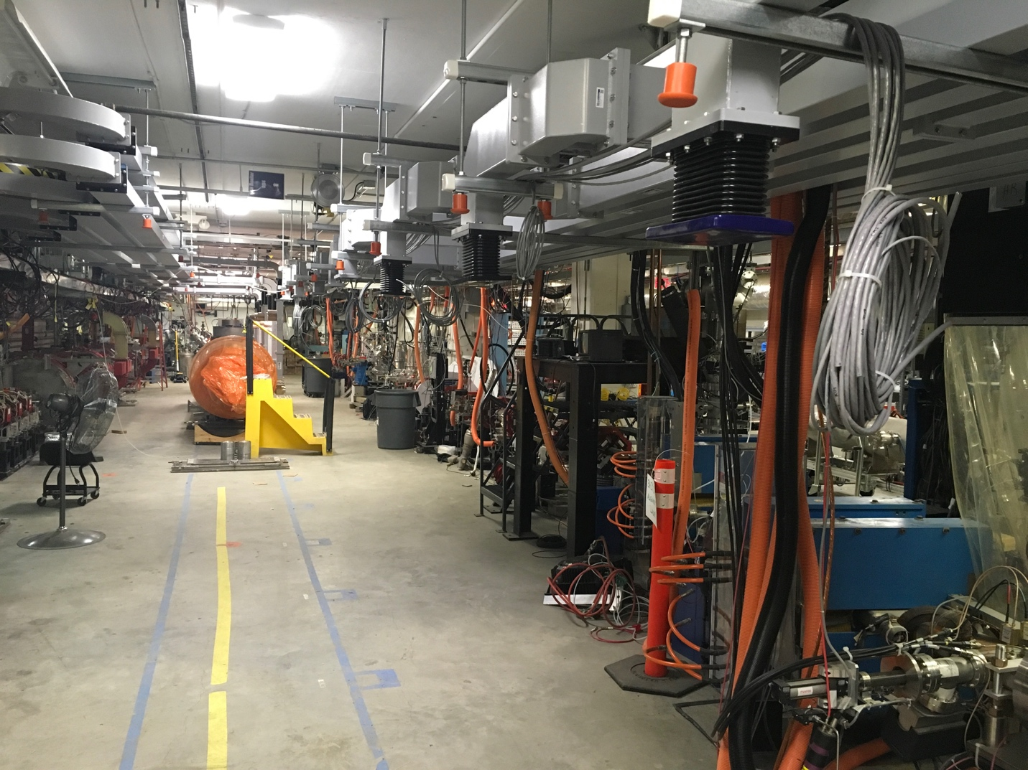

Cable installation began this past week

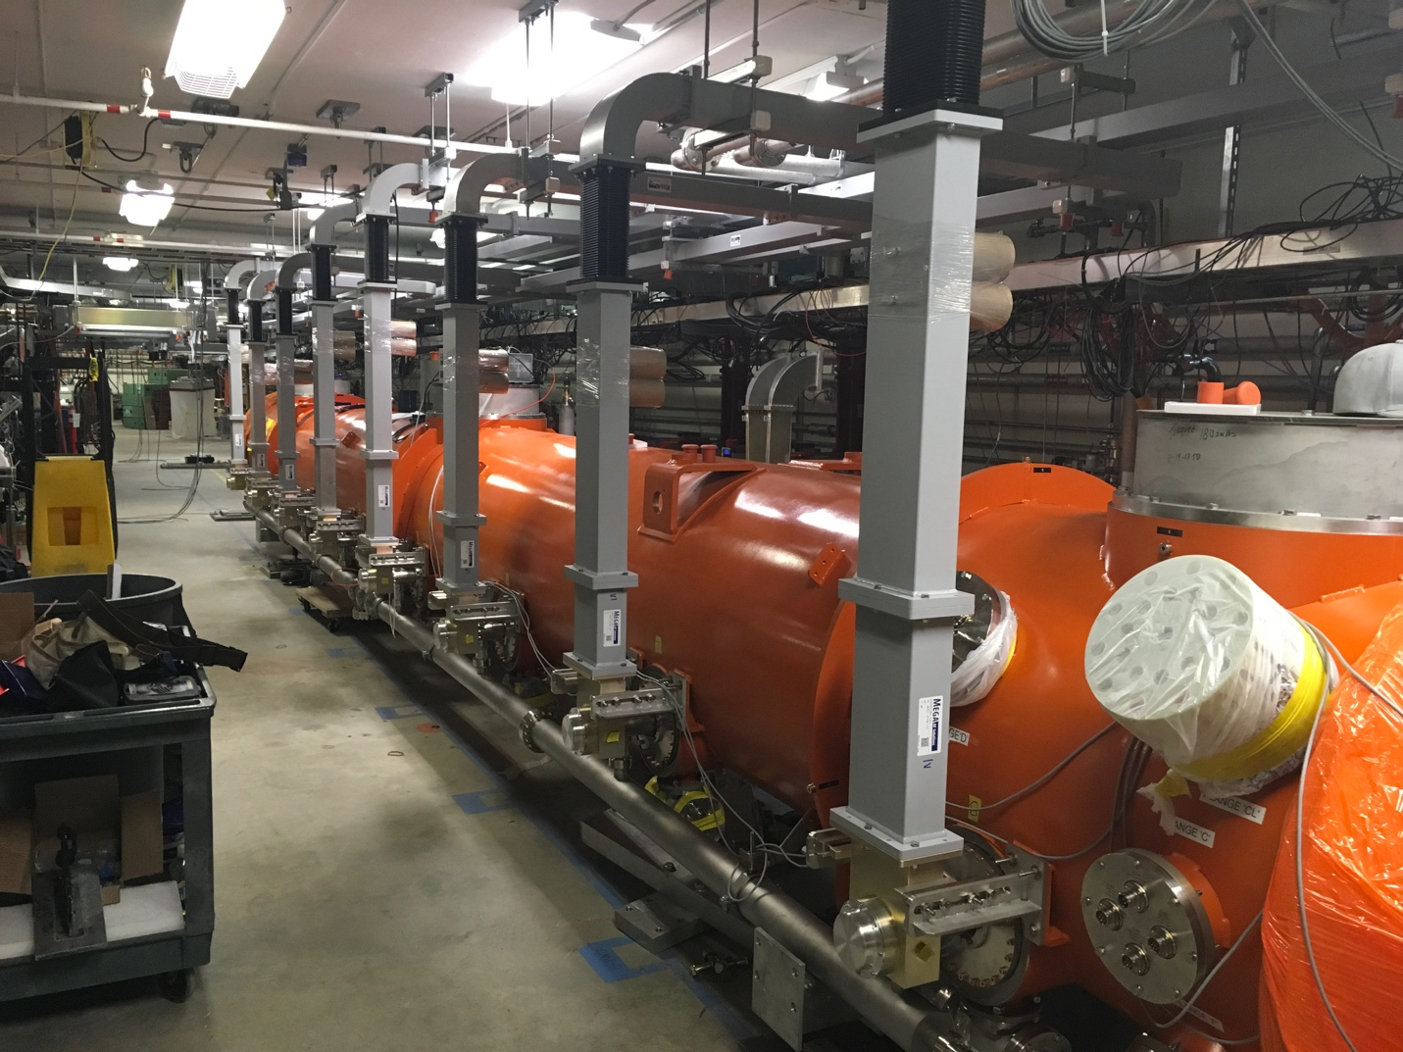

Waveguide has been ‘dry fit’ to CM #1

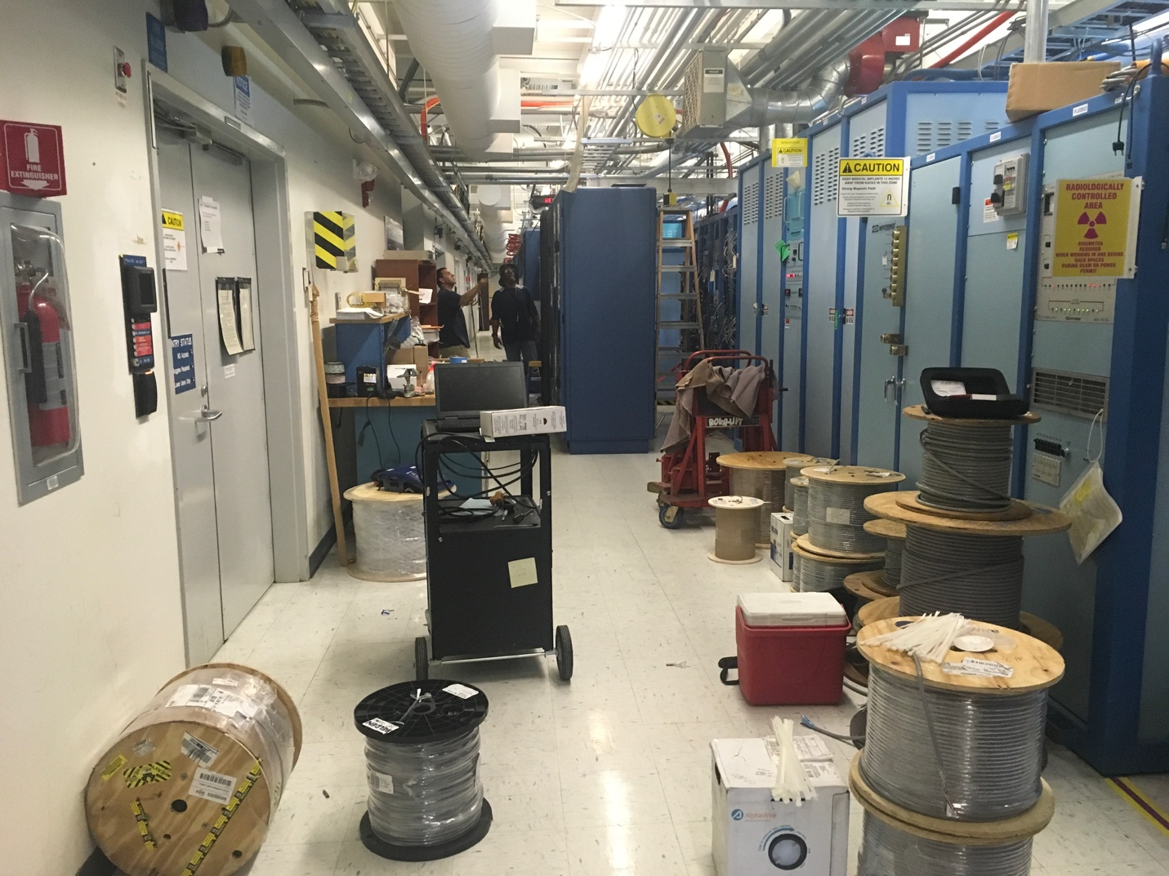
Magnet & Vacuum rack in.

Weekly Reporting
WBS 1.04.08 JLAB Cryoplant System
Week of May 3-9, 2018

Issues: Timely delivery of equipment in support of the installation effort
Accomplishments this week:
2K Cold Box (No change)
- Technical evaluations complete.
- Procurement is reviewing best options to minimize schedule and cost.
- Award is scheduled for May 2018.
4.5K Cold Box Status
- CB1 VCB Vessel shipment scheduled for pickup from PHPK on 11 May 2018; approximate arrival at SLAC guaranteed by 21 May 2018 (3 days float).
- CB1 HCB Intermediate (process piping) leak testing witness point is expected on 09 May 2018.
  - After successful completion of the intermediate leak test, the remaining MLI will be installed and the 20k absorber will be filled.
- CB2 VCB tubing installation is nearly complete, internal piping installation is complete. Base ring assembly has been fully blasted and coated and ready for shell attachment.
- CB2 HCB internal pipe spool fabrication is complete; frame fabrication is nearly complete; lower vacuum shell has now been moved into paint booth (critical path task).
Interface Boxes
- Award recommendation to DOE May 2018
- Award expected June 2018 – Pending DOE approval.

Deliveries and Installation
- Three Oil Removal Vessels shipping this week
  - 2 - HP Oil Coalescer
  - 1 – Main Oil Coalescer
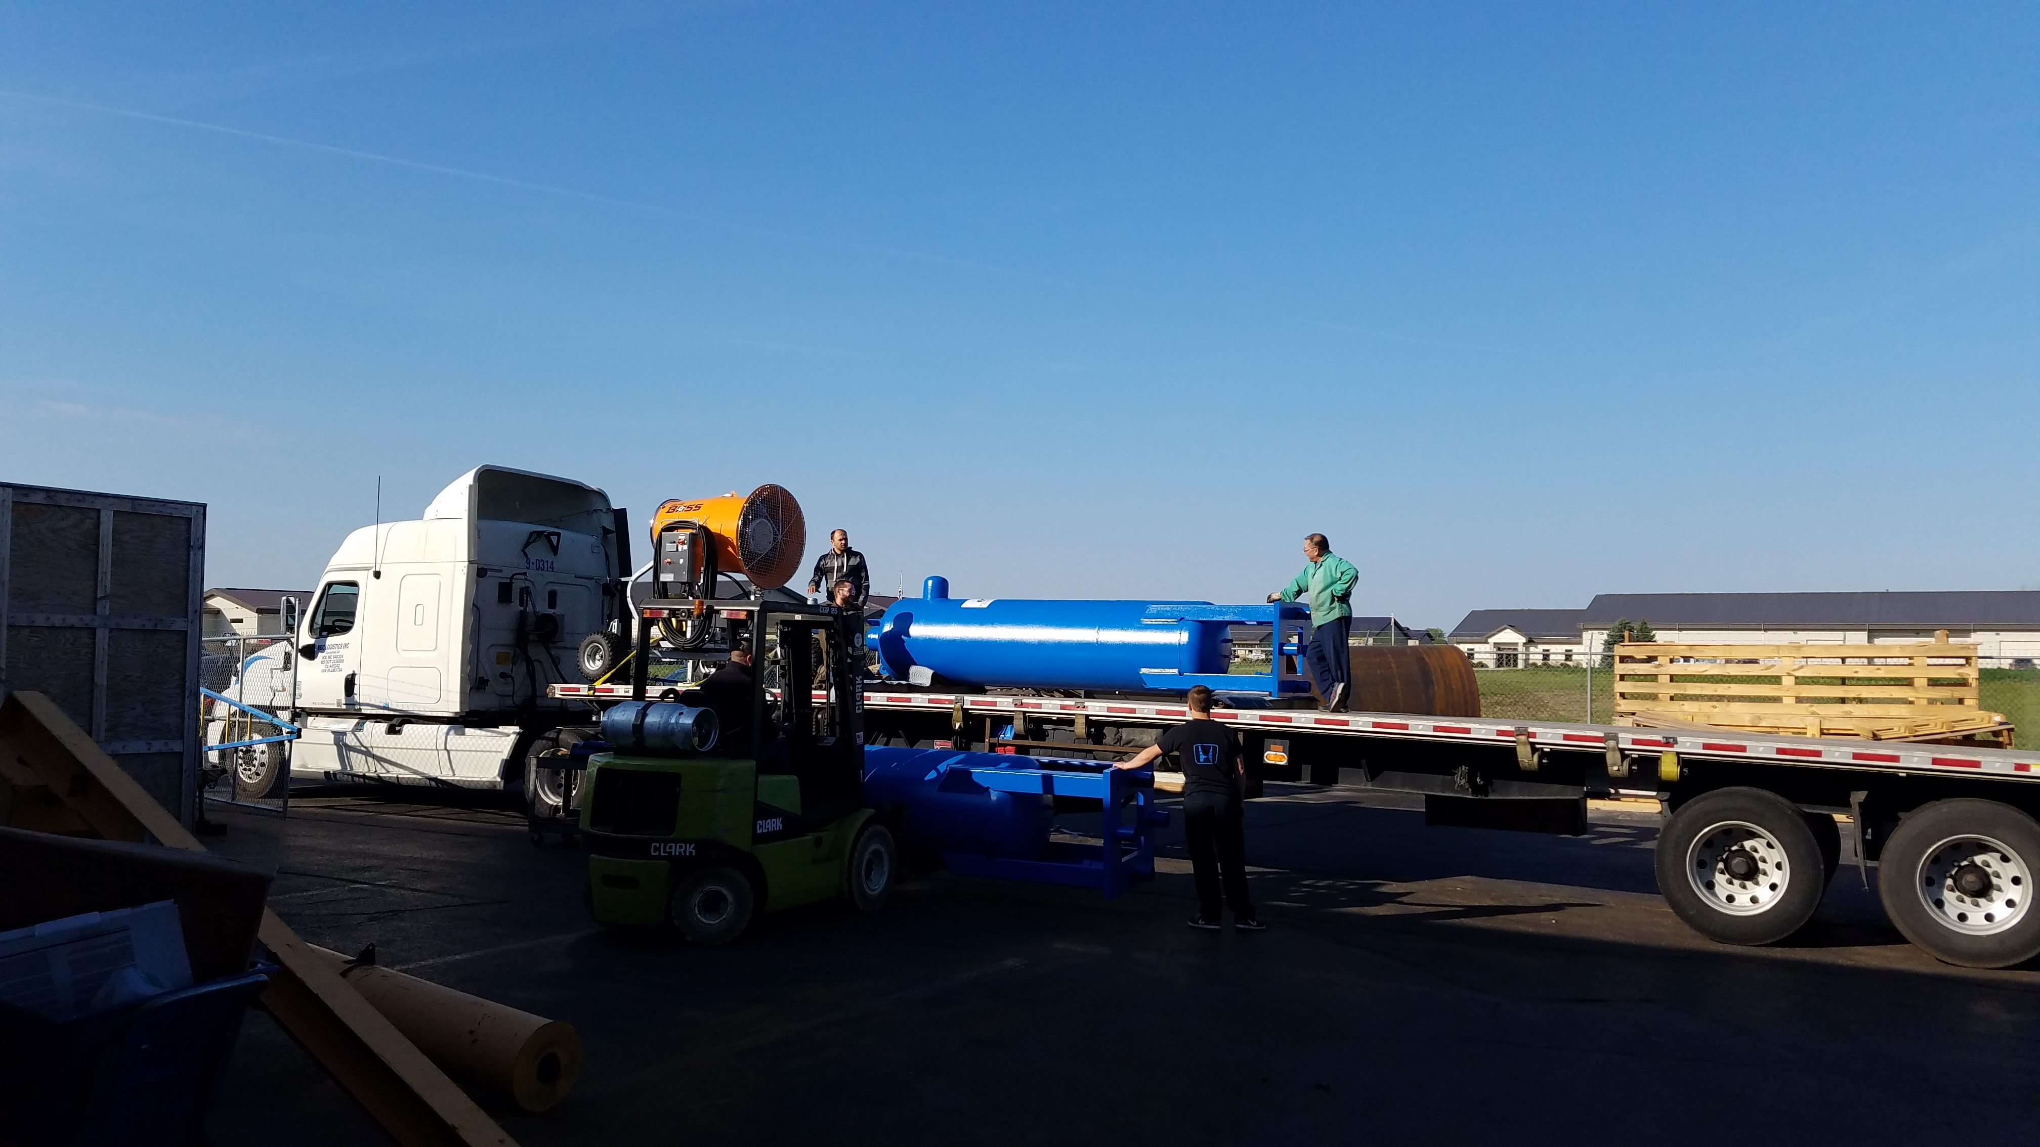

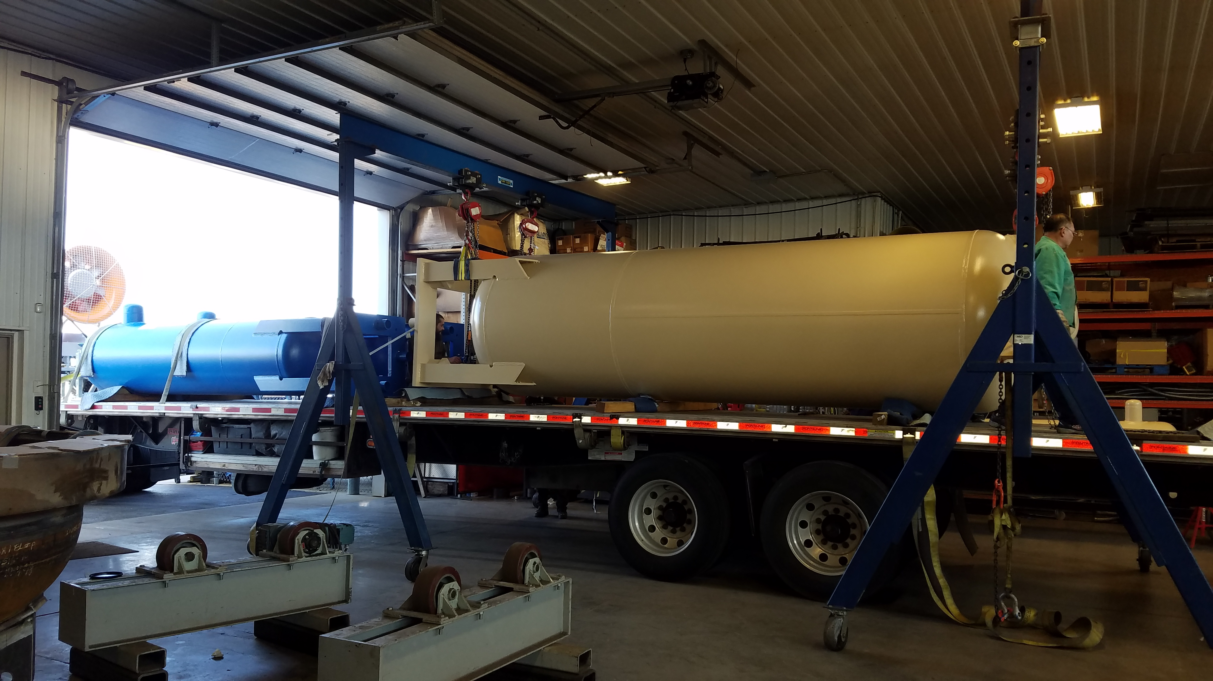
Oil removal vessels shipping to SLAC this week (08-May-2018).

- Warm helium compressor installation complete for the first (C1) cryoplant.
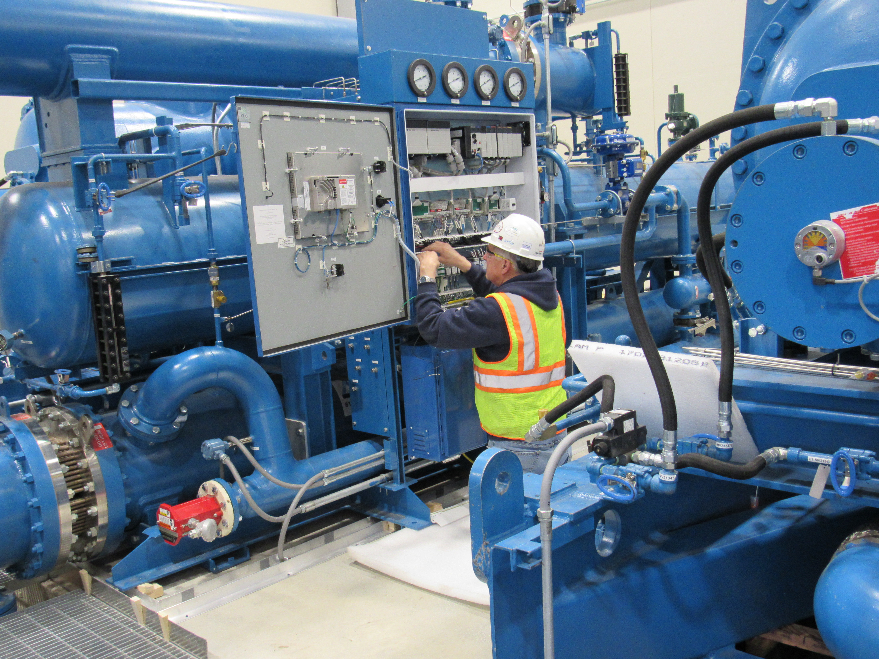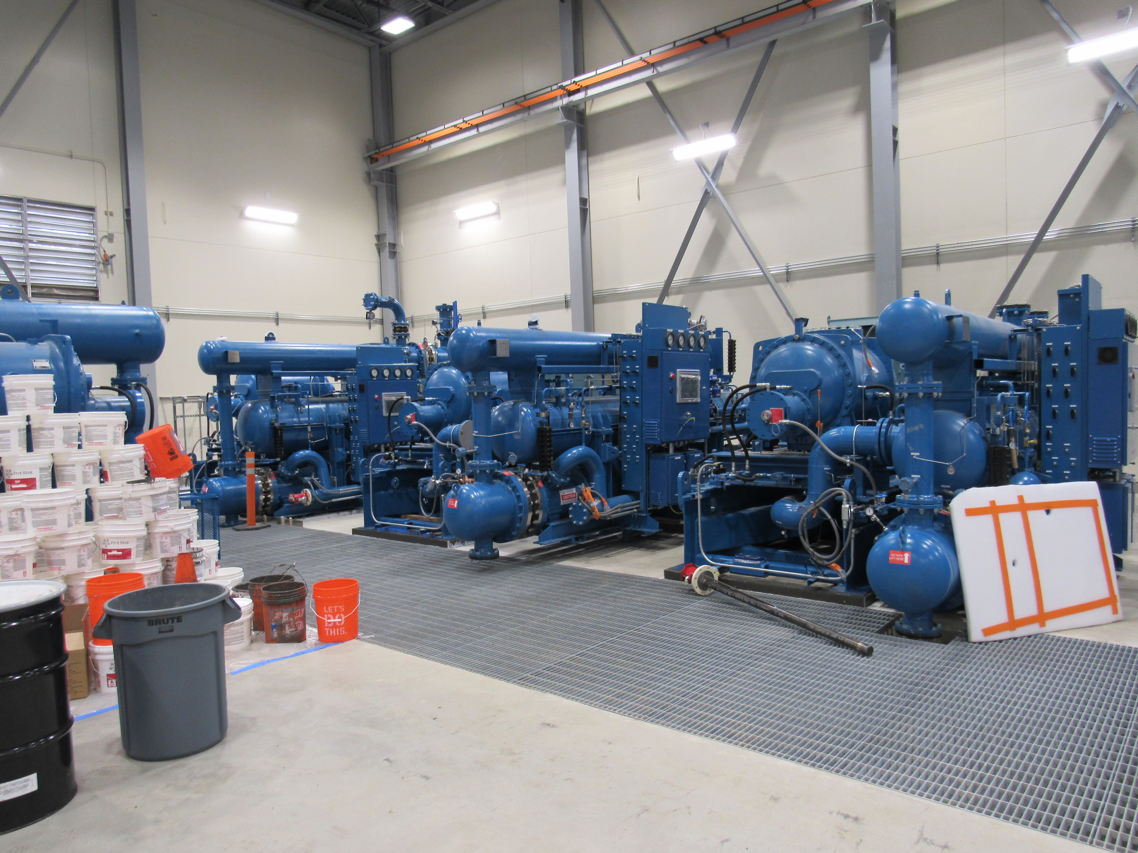
Installation and assembly of the Warm Helium Compressors for C1 in the CryoPlant (B905).
Quality
JLab site Certified Weld Inspector was onsite at PHPK to review welding performance and documentation for the 4.5K cold box platform this past week. There were a number of identified issues discussed with the vendor, JLab Engineers and Procurement, but no discrepancies were significant enough to negatively impact welding work / progress. A report is forthcoming.

Upcoming Travel/Reviews:
- SLAC technical staff @JLAB for training 7-11 May-2018
- DOE OPA Review 8-10th May-2018
- 4.5K cold box Loading for shipment to SLAC 11-May-2018
- 4.5K cold box Receipt of shipment to SLAC 21-May-2018
- 4.5K cold box re-assembly meeting @SLAC Postponed

Weekly Reporting
WBS 1.02.03.05.12 LLRF
Week of May 3-9, 2018

Issues: None
Accomplishments this week at JLab: No report; next report May 16.

