Weekly Reporting

WBS 1.01.07 JLAB Management

Week of May 10-16, 2018

**Issues:**

**Accomplishments this week:**

Participated in DOE OPA review at SLAC.

4.5 K Cold Box shipment en route to SLAC.

Continued preparations for the CM rework BCR.

**Upcoming Activities:**

23-25 May – LCLS-II HE Director’s CD-1 Review

19-21 June – LCLS-HE CD-1 Review

Weekly Reporting

WBS 1.04.06 JLAB Cryomodules

Week of May 10-16, 2018

**Issues**:

Risk of lack of high-performing cavities to finish CM assembly.

**Accomplishments this week:**

Participated in DOE OPA Review.

LCLS-II-HE Director’s Review - not planning to attend but will dial in. Providing back-up documentation for HE BOE.

Awarded rework of 27 cavities to RI. Shipping first batches of cavities to be reworked this week from JLab.

Zanon has received material for 32 optional cavities.

Continuing to work with SLAC to integrate overall schedule on BCR for CM rework that includes cost for additional fixtures and equipment.

HX final leak is complete. Re-assembly is in progress and expected complete by 18-May.

J1.3-01 - @ WS6; Idle; Waiting to move to WS4 for VV removal

J1.3-02 – Prepping for placement in shipping frame for JLab Open House 19-May.

J1.3-03, J1.3-04 - @ Storage atop UITF. Waiting to move to WS4 for VV removal.

J1.3-05 - @ LERF; Used for fit up of waveguide.

J1.3-07 - @ WS5. Planning for next shipping test - long distance road test in near future. Developed detailed plan for test that includes displacement measurements of 50K flanges and GHRP during shipment. Departure date targeted for 22-May.

J1.3-08 - @ WS5; Coupler installation in progress. Beam pipe work started. More fasteners require rework.

J1.3-09 @ WS4 – String was verified leak tight and moved to WS4. Tuning HOM's, one instrumentation repair in progress.

J1.3-10 @ WS3 – UCM hardware rework in progress. BPM hardware replaced. String verified as leak tight.

J1.3-11 @ WS2 – UCM for CM11 moved to WS3; fastener spreadsheet and checklist in progress.

J1.3-12 @ WS2 – Idle. Awaiting move of J1.3-10 to cantilever.

J1.3-13 – All cavities qualified. String build will be gated by return of lollipops, best estimated start is first week of June.

J1.3-14 – All cavities qualified for the string.

J1.3-15 - 2 of 8 cavities qualified for the string.

Cavity Tests –

Cavity 261 (TD) retest (previous FE), D5, Wed. 9 May, Q0(16)~3.0e10, FE free, Quench 32.7 MV/m, Qualified.

Cavity 286 (NX-A) retest after FP replacement, D5, Wed. 9 May, Q0(11)~2.5e10, FE on 7.6 MV/m, Aborted test, Not Qualified. Plan to rinse, retest.

Cavity 305 (NX-A) retest (previous FE), D5, Wed. 9 May, Q0(16)~3.3e10, Quench 26.9 MV, No FE, Q2 ~ 6.4e12, Not Qualified due to low Q2. Plan to replace FP & retest.

**QUALITY**:

No report.

**Upcoming Travel/Meetings:**

EZ Vendor Visit June 4-9 (C. Reece)

Weekly Reporting

WBS 1.04.06 Cryomodules - LERF Conversion

Week of May 10-16, 2018

**Issues:** None

**Accomplishments this week:** No report.

Weekly Reporting

WBS 1.04.08 JLAB Cryoplant System

Week of May 10-16, 2018

**Issues:** On schedule delivery of equipment in support of the installation effort.

**Accomplishments this week:**

**2K Cold Box**

1. Procurement clearance request (PCR) submitted approval.
2. Award is scheduled for May 2018.

**4.5K Cold Box Status**

1. CB1 VCB Vessel shipment
   1. The cold box shipment departed for SLAC from Ohio 11-May-2018.
   2. The shipment is scheduled to arrive at SLAC 18-May-2018.
2. CB1 HCB Intermediate (process piping) leak testing.
   1. Witness point is expected next week.

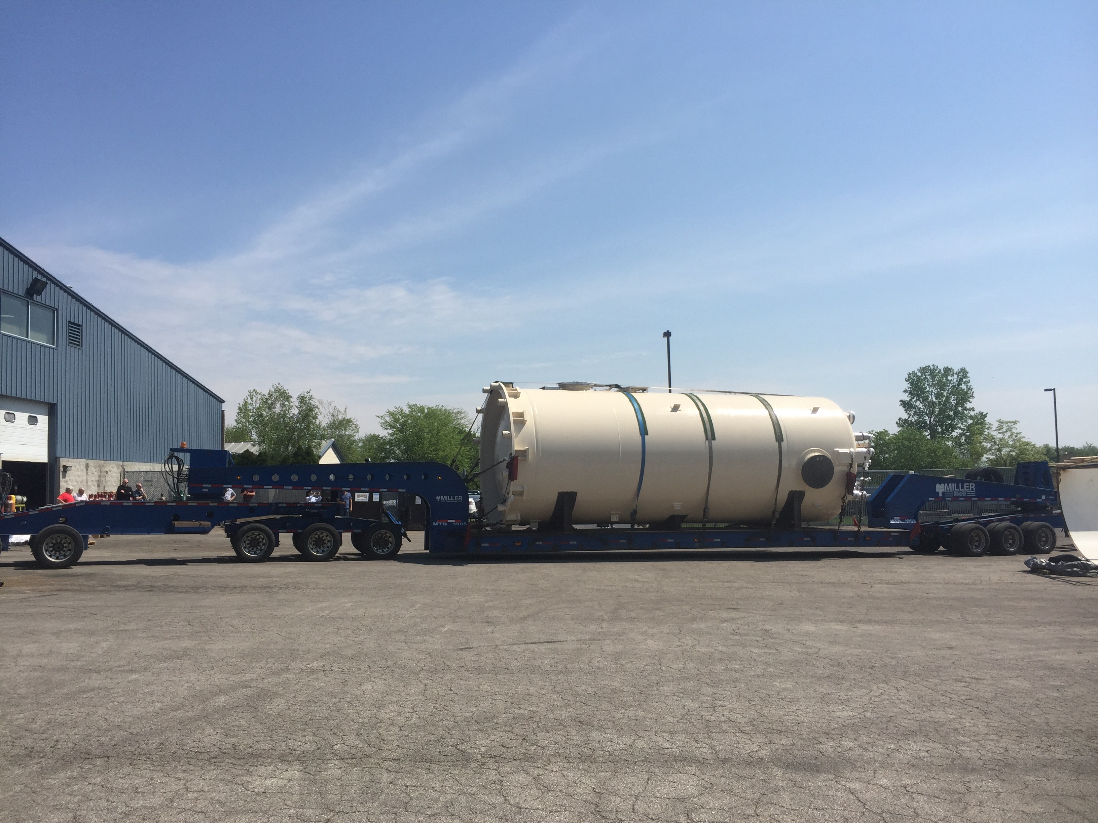 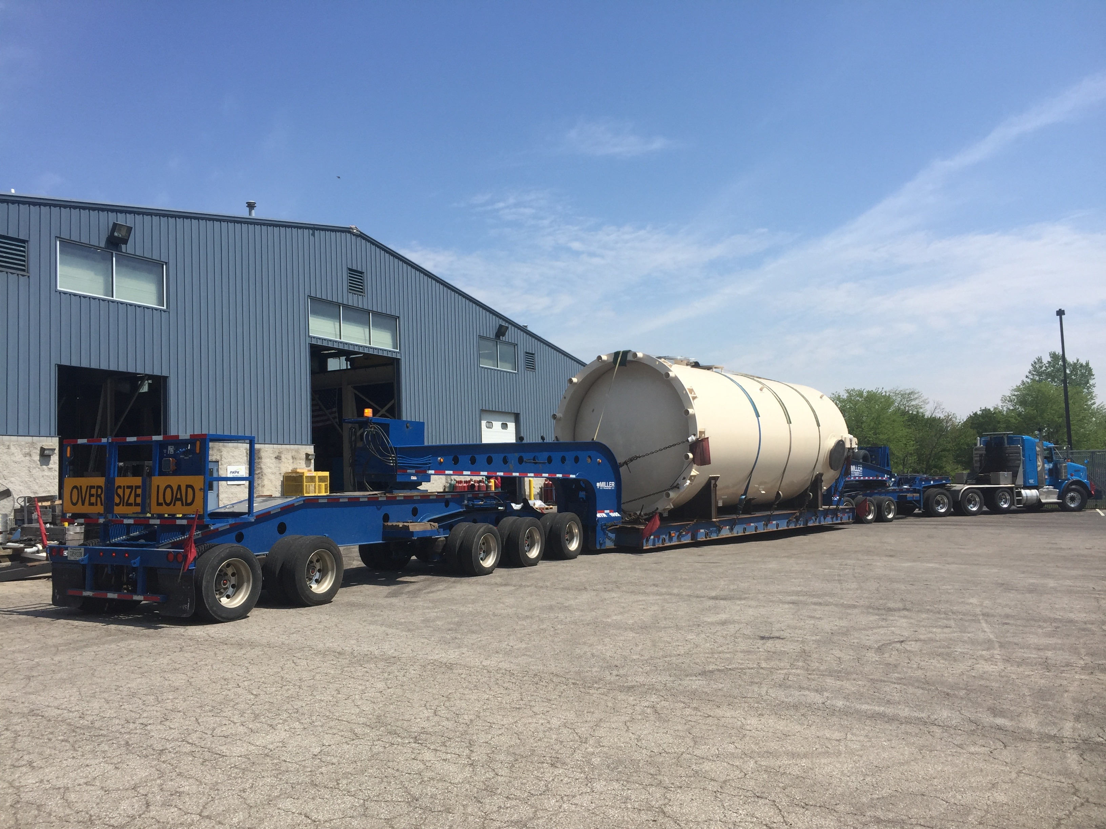

4.5K Cold Box shipment leaving vendor site (11-May-2018)

**Interface Boxes**

1. Procurement clearance request (PCR) submitted approval.
   1. Award expected June 2018 – Pending DOE approval.

**Deliveries and Installation**

* Three C2 Oil Removal Vessels received @SLAC this week
  + 2 - HP Oil Coalescer
  + 1 – Main Oil Coalescer

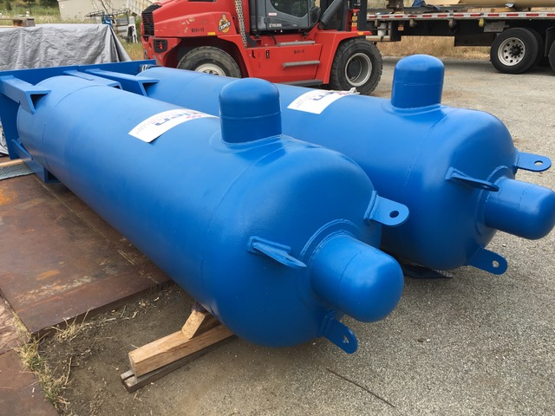

Oil removal vessels received @SLAC this week (14-May-2018)

**Quality**

JLab QACI group working with JLab Engineers and Procurement to finalize the documentation package for the first 4.5K upper cold box.

**Upcoming Travel/Reviews:**

* 4.5K upper cold box shipment to SLAC (11-18)-May 2018
* 4.5K upper cold box off-loading @SLAC 21-May-2018
* JLab staff onsite at SLAC for receipt of 4.5K CB (17-23)-May 2018
* JLab staff onsite at SLAC for receipt of LHe Dewars (24-25)-May 2018
* 4.5K cold box re-assembly meeting @SLAC Postponed

Weekly Reporting

WBS 1.02.03.05.12 LLRF

Week of May 10-16, 2018

**Issues:** None

**Accomplishments this week at JLab:** No report.