Weekly Reporting

WBS 1.01.07 JLAB Management

Week of May 17-23, 2018

**Issues:**

**Accomplishments this week:**

4.5K Cold Box shipment arrived and placed at SLAC.

Awarded 2K Cold Boxes to two vendors.

Awarded Interface Box.

Continued preparations for the CM rework BCR.

**Upcoming Activities:**

23-25 May – LCLS-II HE Director’s CD-1 Review

19-21 June – LCLS-II HE CD-1 Review

Weekly Reporting

WBS 1.04.06 JLAB Cryomodules

Week of May 17-23, 2018

**Issues**:

Risk of lack of high-performing cavities to finish CM assembly.

**Accomplishments this week:**

LCLS-II-HE Director’s Review - not planning to attend but will dial in. Providing back-up documentation for HE BOE.

Next deliveries from RI and EZ expected in early June to both labs.

Continuing to work with SLAC to integrate overall schedule on BCR for CM rework that includes cost for additional fixtures and equipment.

J1.3-01 - @ WS6; Idle; Waiting to move to WS4 for VV removal

J1.3-02 – Stored in shipping frame.

J1.3-03, J1.3-04 - @ Storage atop UITF. Waiting to move to WS4 for VV removal.

J1.3-05 - @ LERF; Used for fit up of waveguide.

J1.3-07 - @ WS5. Shipping tests cancelled by SLAC/LCLS-II. Preparing for storage and rework. Significant waste of money and effort due to this last-minute cancellation. This is the second cancellation of the long distance shipping test.

J1.3-08 - @ WS5; Coupler installation in progress. Beam pipe installation in progress. High Pressure Test complete. RT is planned for this coming Saturday.

J1.3-09 @ WS4 – HOM tuning complete. Check List and Fastener review complete. Lower shields welding in progress.

J1.3-10 @ WS3 – BPM hardware replaced/Leak check completed. Fastener rework in progress.

J1.3-11 @ WS2 – Unite UCM to Cavity String in progress.

J1.3-12 @ WS2 – Idle. Awaiting move of J1.3-10 to cantilever.

J1.3-13 – All cavities qualified. String build will be gated by return of lollipops, best estimated start is first week of June.

J1.3-14 – All cavities qualified for the string.

J1.3-15 - 4 of 8 cavities qualified for the string. Need to clarify upper limit for Q2. Most recent cavity test showed Q2 ~ 1.8e12.

Cavity Tests –

Cavity 151 (TD) retest (previous FE), D7, Tue. 15 May, Q0(16)~3.2e10, FE free, Quench 22.6 MV/m, Q2 ~1.8e12, Need to decide if Q2 is acceptable. Tentatively qualified.

Cavity 272 (TD) retest (FE), D8, Fri. 18 May, Q0(16)~3.1e10, FE on 22.3 MV/m, Not Qualified. Plan to rinse and retest.

Cavity 305 (NX-A) retest (replaced FP, HOMs), D7, Mon. 5/21, Q0(16) ~3.0e10, Quench at 24 MV/m, No FE, qualified.

**QUALITY**:

No report.

**Upcoming Travel/Meetings:**

EZ Vendor Visit June 4-9 (C. Reece & M. McCrea)

Shipping Review at FNAL June 12 (via telecon)

Weekly Reporting

WBS 1.04.06 Cryomodules - LERF Conversion

Week of May 17-23, 2018

**Issues:** None

**Accomplishments this week:**

Updates & photos can be seen on the WIKI wiki.jlab.org

RF cable installation has begun.

Still waiting on a few pieces of cable tray in the tunnel to dress in the cables & then begin to terminate the cables (electricians are working PM in CHL).

First module (CM #1) waveguide had been leak checked OK (PSS pressure interlock).

Raised floor behind modules has been cut and installed.

Much progress has continued.

|  |  |
| --- | --- |
| Waveguide has been leak checked for CM #1 | Raised floor sections have been cut, clearing way for RF cable installation |

Weekly Reporting

WBS 1.04.08 JLAB Cryoplant System

Week of May 17-23, 2018

**Issues:** On schedule delivery of equipment in support of the installation effort.

**Accomplishments this week:**

**2K Cold Box**

1. Purchase orders awarded to two separate vendors (Linde & PHPK).
   1. Dual award will facilitate parallel fabrication.
   2. This reduces time to delivery for the second 2K cold box.

**4.5K Cold Box Status**

1. CB1 Upper (Vert) Cold Box
   1. Delivered to SLAC @ 19-May-2018.
   2. Cold Box lifted and placed into permanent position 22-May-2018.
2. CB1 HCB Intermediate (process piping) leak testing.
   1. Scheduled to complete Sept 2018.
3. CryoDuct scheduled to be deliver to SLAC next week.

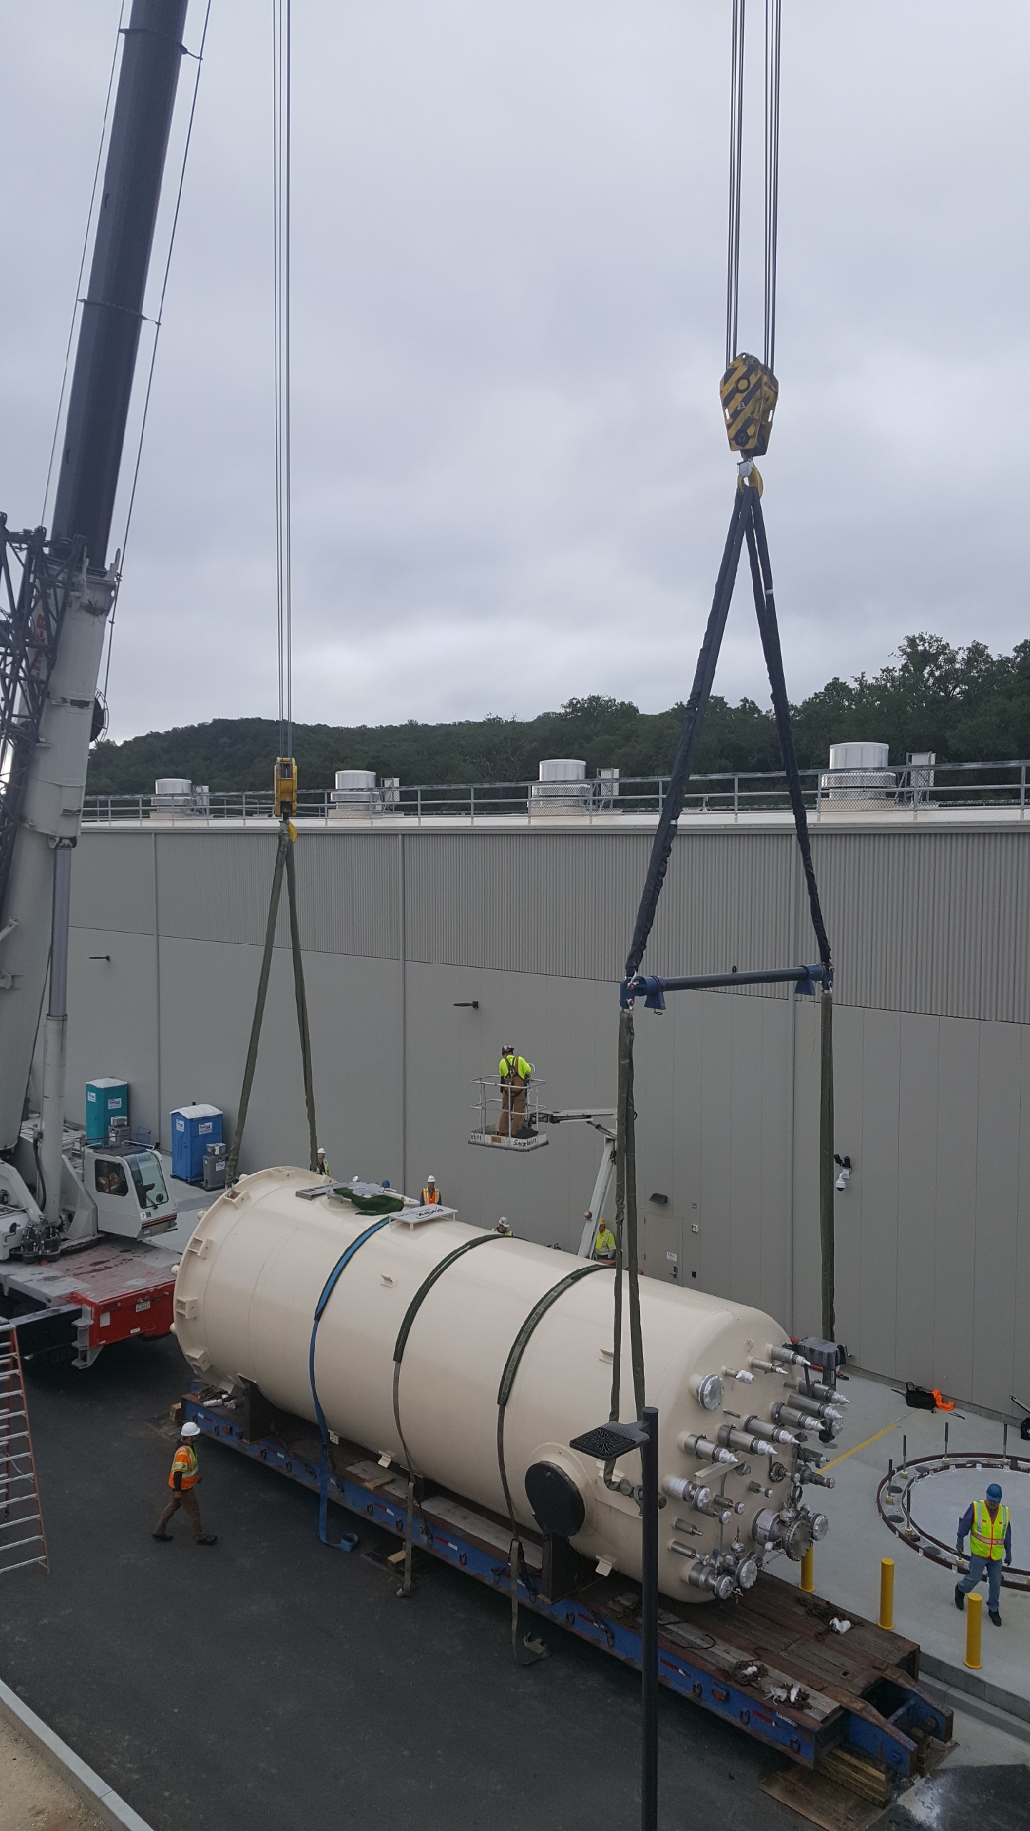 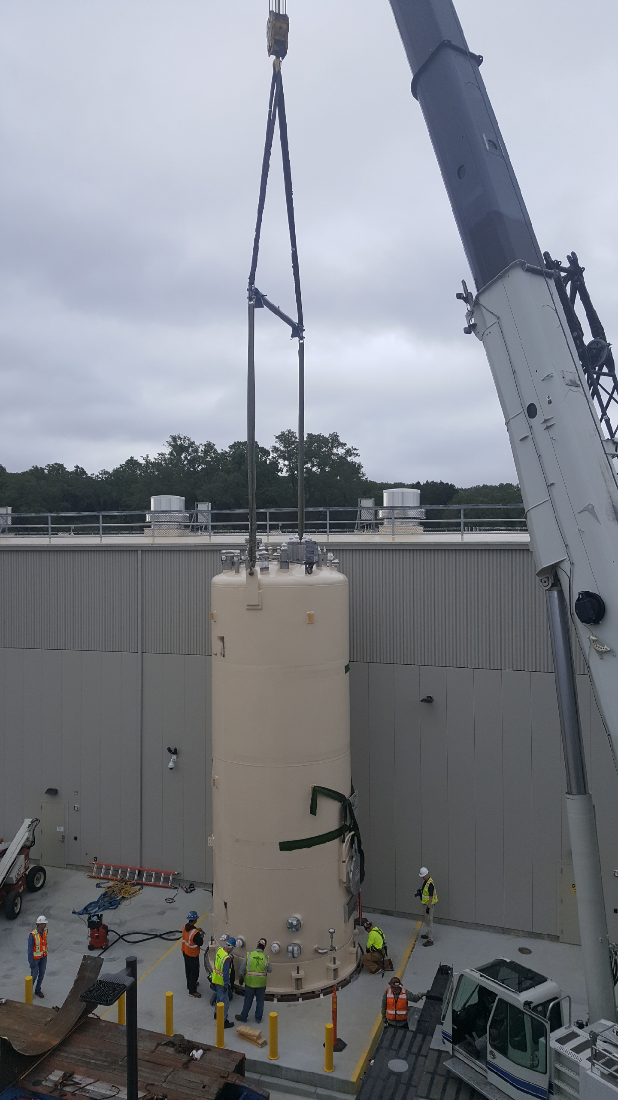

**Interface Boxes**

1. Purchase order awarded to Demaco.
   1. Design/build procurement will begin with preliminary design review.

**Deliveries and Installation**

* Two C2 Oil Removal Vessels shipping to SLAC this week.
  1. 2 – Main Oil Coalescers.

**Quality**

JLab QACI group working with JLab Engineers and Procurement to finalize the documentation package for the first 4.5K upper cold box.

**Upcoming Travel/Reviews:**

* JLab staff onsite at SLAC for receipt of LHe Dewars 24-25 May 2018
* 2K cold box kickoff meetings 4-6 June 2018
* 4.5K cold box re-assembly meeting @SLAC Postponed

Weekly Reporting

WBS 1.02.03.05.12 LLRF

Week of May 17-23, 2018

**Issues:** None

**Accomplishments this week at JLab:**

* Resonance/Interlock Chassis:
  + All chassis assembled and four have been tested.
  + Installed in LERF Racks.
  + Waiting for Larry Doolittle to send Rama the information so that he can code the firmware for these chassis.
* Interlock Board/Chassis: Work at this time is on hold until needed for 3.9 GHz.
  + Common Power Supply/Chassis/Boards: Work Done.
* LERF
  + LERF LLRF instrumentation cables: Waiting on cable tray in vault so that we can pull cables.
  + HOM Measurement: The switch matrix is installed in the LERF rack. Wes Moore is programing it.
  + Reference system and LO: Cables are being pulled in the LERF. Chassis is being fabricated.
  + LLRF: We are talking to one rack from SLAC (using EPICS) and in the process of trouble shooting the chassis.
  + SSAs: EPICS control software is in place to operate these.

* CMTF: No work.