Weekly Reporting
WBS 1.01.07 JLAB Management
Week of May 24-30, 2018

Issues: Concern with delays related to processing CM rework BCR impacting April and May progress reporting.
Accomplishments this week:
4.5K Cold Box (lower) leak check completed.
2K Cold Boxes – Kick-off meetings scheduled.
Interface Box - Kick-off meeting scheduled.
Both (C1 & C2) LHe Dewars delivered to SLAC on 25-May.
Working on the CM rework BCR.
Evaluating potential scope reductions and cost-cutting measures.
Upcoming Activities:
12 June – LCLS-II Shipping Review @ FNAL
19-21 June – LCLS-II HE CD-1 Review

Weekly Reporting
WBS 1.04.06 JLAB Cryomodules
Week of May 24-30, 2018
Issues:
Risk of lack of high-performing cavities to finish CM assembly.
Accomplishments this week:
LCLS-II-HE Director’s Review - not planning to attend but will dial in. No further back-up documentation for HE BOE at this time.
Next deliveries from RI and EZ expected in early June to both labs.
Continuing to work with SLAC to integrate overall schedule on BCR for CM rework that includes cost for additional fixtures and equipment.
J1.3-01 - @ WS6; Idle; Waiting to move to WS4 for VV removal
J1.3-02 – Stored in shipping frame.
J1.3-03, J1.3-04 - @ Storage atop UITF. Waiting to move to WS4 for VV removal.
J1.3-05 - @ LERF; Used for fit up of waveguide.
J1.3-07 - @ WS5. Preparing for storage and rework.
J1.3-08 - @ WS5; Coupler installation in progress. Beam pipe in progress. MC line in progress. Pressure tests complete. RT of welds complete. Plan to move to cave on 04-June.
J1.3-09 @ WS4 – 50K shields complete. MLI complete. Vac vessel installed. Alignment in progress.
J1.3-10 @ WS3 – Tuner fastener rework in progress.
J1.3-11 @ WS2 – Cavity tuner to cold gate valve bracket installed. Unite UCM to Cavity String in progress. Return lollipops.
J1.3-12 @ WS2 – Idle. Awaiting move of J1.3-10 to cantilever.
J1.3-13 – All cavities qualified. String prep begins 4 June. String build begins 11 June. String rollout by 22 June.
J1.3-14 – All cavities qualified. String prep begins 25 June. String build begins 2 July. String rollout by 13 July.
J1.3-15 - 4 of 8 cavities qualified for the string.
Cavity Tests –
Cavity 286 (NX-A) retest (previous FE), D8, Thu. 24 May, Q0 (16)~3.0e10, Initial power rise FE onset 18.0 MV/m, Quench at 18.5 MV/m, Not Qualified. Plan to rinse then retest.

No production LCLSII vertical testing planned for next week. CTF down planned for June 4-6.

QUALITY:
No report.

Upcoming Travel/Meetings:
EZ Vendor Visit June 4-9 (C. Reece & M. McCrea)
Shipping Review at FNAL June 12 (via telecon)
EZ Vendor Visit July 9-13 (H. Park)

Weekly Reporting
WBS 1.04.06 Cryomodules - LERF Conversion
Week of May 24-30, 2018

Issues: No installation support for cable tray which is delaying dressing in and termination.
Accomplishments this week:
Work continues on RF cable in gallery and network installation.
Software effort continues.

Weekly Reporting
WBS 1.04.08 JLAB Cryoplant System
Week of May 24-30, 2018

Issues: On schedule delivery of equipment in support of the installation effort.
Accomplishments this week:
2K Cold Box
- Kick-off site visits scheduled for both next week.
  - GFE is being planned for timely delivery to each vendor.
4.5K Cold Box Status
- CB1 Upper (vert) Cold Box
  - Installed SLAC @ 22-May-2018.
- CB1 Lower (horz) Cold Box Intermediate (process piping) leak testing.
  - Intermediate (internal piping) leak-check complete.
  - Fabrication scheduled to complete Sept 2018.
- CryoDuct en-route to be delivered to SLAC this week.
Interface Boxes
- Purchase order awarded to Demaco.
  - Kick-off meeting scheduled for this week.
  - Design/build procurement will begin with preliminary design review.
Deliveries and Installation
- Both (C1 & C2) LHe Dewars delivered to SLAC last week 25-May-2018
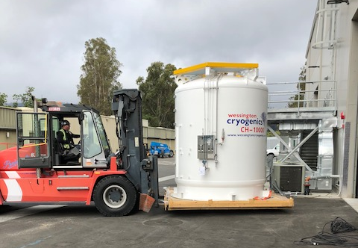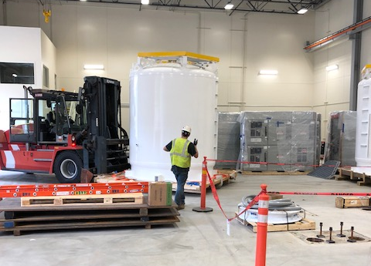
- Two C2 Oil Removal Vessels shipping to SLAC this week.
  - 2 – Main Oil Coalescers.
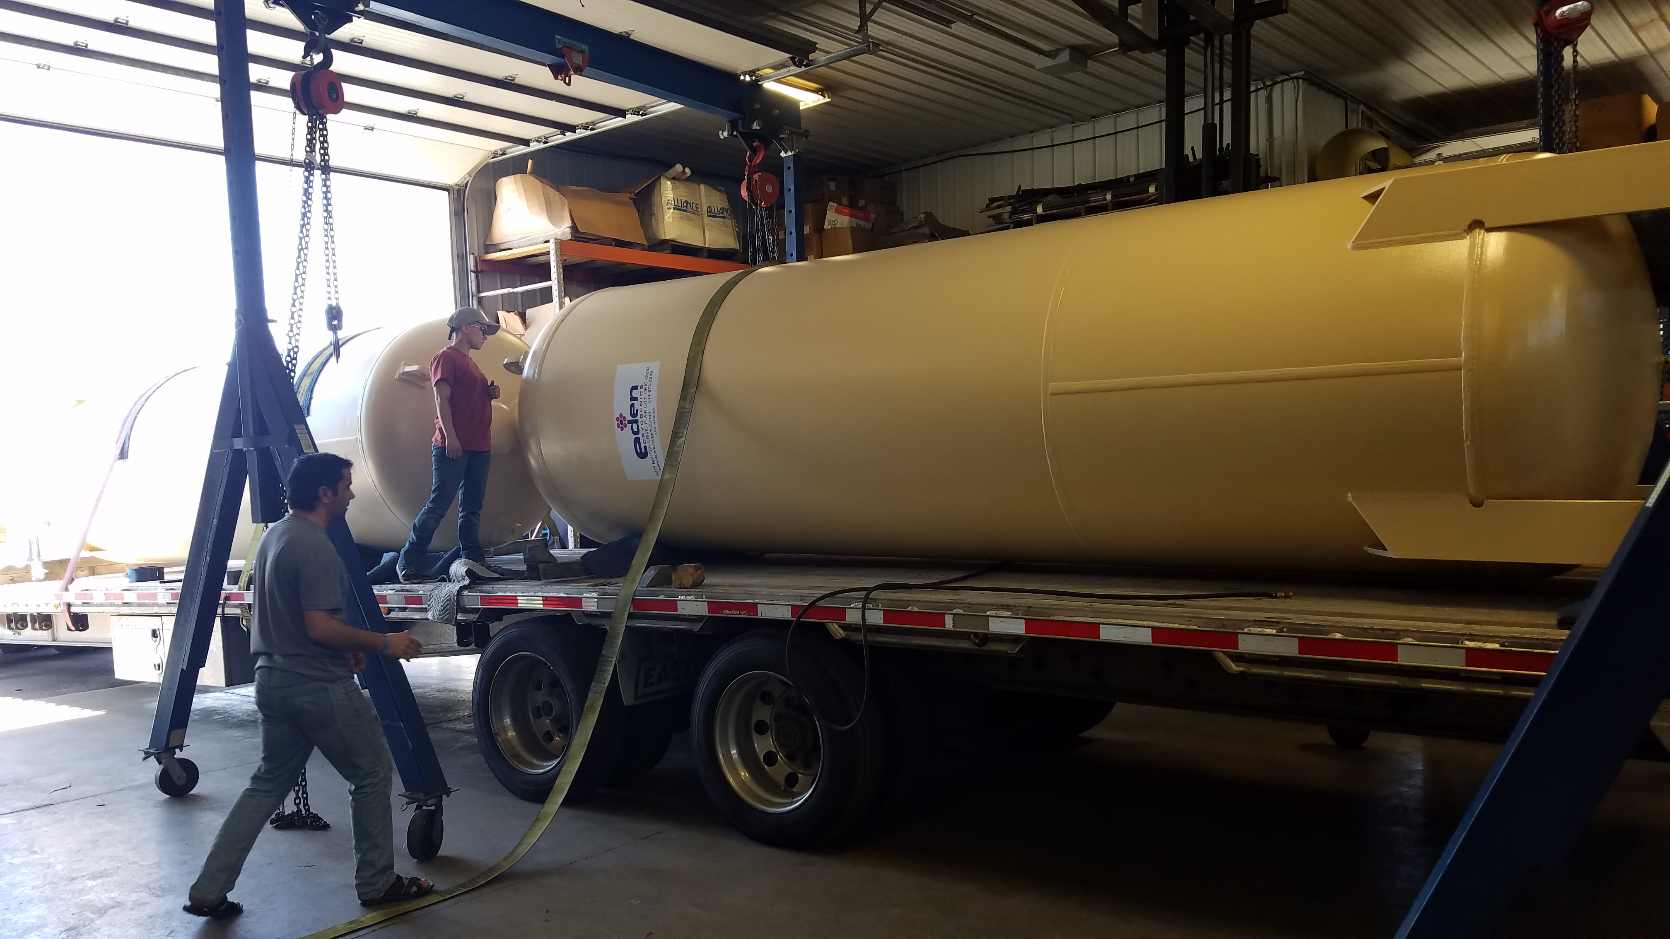
Quality
An electronic copy of QA documents for the 4.5K cold box (CP1) was received on Tuesday, May 29, 2018. It is being reviewed this week.

Upcoming Travel/Reviews:

- 2K cold box kickoff meetings 4-6 June 2018
- Top Plate (2K GFE) fabrication 5-June-2018
- 4.5K cold box re-assembly meeting @SLAC Postponed

Weekly Reporting
WBS 1.02.03.05.12 LLRF
Week of May 24-30, 2018

Issues: None
Accomplishments this week at JLab: No report.

