Weekly Reporting

WBS 1.01.07 JLAB Management

Week of May 31-June 6, 2018

**Issues:** Concern with delays related to processing CM rework BCR impacting April and May progress reporting.

**Accomplishments this week:**

2K Cold Boxes – This week

Interface Box - Kick-off meeting held

Signed off on the CM rework BCR.

Evaluating potential scope reductions and cost-cutting measures.

**Upcoming Activities:**

12 June – LCLS-II Shipping Review @ FNAL

19-21 June – LCLS-II HE CD-1 Review

Weekly Reporting

WBS 1.04.06 JLAB Cryomodules

Week of May 31-June 6, 2018

**Issues**:

Risk of lack of high-performing cavities to finish CM assembly.

**Accomplishments this week:**

LCLS-II-HE CD-1 Review – prepared slides for JLab management presentation.

Approved JLab portion of the CM rework BCR that includes cost for additional fixtures and equipment. PR for four post fixture has been re-submitted with charge code. Procurement for additional shipping caps is on hold pending decisions on design and use of modified DESY shipping caps.

Concerned that first shipment (27-Jul as shown in recovery schedule) will be delayed due to availability of new shipping hardware.

Developed list of potential returns to contingency that include descoping portions of the current baseline plan. SOTRs and work center leads met to develop list of proposed reductions in work plan for CM assembly (reducing or deleting inspections, deleting assembly procedure steps, etc.)

Preparing for shipping review at FNAL. JLab staff will attend remotely.

Next deliveries of cavities from RI and EZ expected in early June to both labs.

J1.3-01, J1.3-03 and J1.3-04 - @ Storage; Idle; Waiting to move to WS4 for VV removal

J1.3-02 – @ Stored; no further work planned.

J1.3-05 - @ LERF; Used for fit up of waveguide.

J1.3-07 - @ WS6 ; Prep for rework.

J1.3-08 - @ CMTF; Completed remaining WS-5 activities. Moved to cave on 05-June. Cooldown planned for 8-June. Testing planned to start on 11-June. SLAC staff will participate in testing. Revised testing plan to collect Qo data at 16 MV/m after fast cooldown only.

J1.3-09 @ WS5 – Cold mass alignment to VV completed. Moved to WS5 on 05-June.

J1.3-10 @ WS3 – Vac Vessel Demag in progress at WS4; Fastener checklists signed off.

J1.3-11 @ WS3 – Welding is complete. Bagged for leak check. Prep for BPM hardware replacement in progress.

J1.3-12 @ WS2 – Idle. Awaiting move of J1.3-10 to cantilever.

J1.3-13 – All cavities qualified. String prep began 4 June. String build begins 11 June. String rollout by 22 June.

J1.3-14 – All cavities qualified. String prep begins 2 July. String build begins 9 July. String rollout by 22 July. Assembly was moved by one week to avoid conflict with mid-week holiday.

J1.3-15 - 4 of 8 cavities qualified for the string.

Cavity Tests –

No production LCLSII vertical testing planned. CTF down proceeded as planned and is complete. VTA returned to normal operations.

**QUALITY**:

Added Primary Flow Signal as an approved vendor for cryogenic flow valves.

**Upcoming Travel/Meetings:**

EZ Vendor Visit June 4-9 (C. Reece & M. McCrea)

Shipping Review at FNAL June 12 (via telecon)

LCLS-II-HE CD-1 Review 19-21 June (E. Daly, J. Preble)

TTC 26-29 June (K. Wilson, A. Palczewski)

EZ Vendor Visit July 9-13 (H. Park)

LINAC 2018 Sep 14-19 (A. Solopova)

Weekly Reporting

WBS 1.04.06 Cryomodules - LERF Conversion

Week of May 31-June 6, 2018

**Issues:** No installation support for cable tray which is delaying dressing in and termination.

**Accomplishments this week:** No report due to travel.

**Upcoming Travel/Meetings:**

Eden Cryogenics Vendor Visit June 6-7 (Jordan, Macha, Maddox)

Weekly Reporting

WBS 1.04.08 JLAB Cryoplant System

Week of May 31-June 6, 2018

**Issues:**

1. Resolution of interferences created during the design of the platforms and cable trays support systems (identified in 2017).
2. Installation of the LN2 Dewar and helium ‘tank farm’ foundations. The warm helium tanks have been in storage for several months awaiting completion of these supports.
3. Changing the LN2 piping design from a build-to-print to an unidentified source and fabrication.

**Accomplishments this week:**

**2K Cold Box**

1. Dual award to Linde & PHPK
2. Kick-off site visits to both vendors this week.
   1. GFE is being planned for timely delivery to each vendor.
3. February 2019 delivery scheduled.

**4.5K Cold Box Status**

1. CB1 Upper (vert) Cold Box
   1. Installed SLAC @ 22-May-2018.
2. CB1 Lower (horz) Cold Box Intermediate (process piping) leak testing.
   1. Intermediate (internal piping) leak-check complete.
   2. Fabrication scheduled to complete Sept 2018.
3. CryoDuct en-route to be delivered to SLAC this week.

**Interface Boxes**

1. Awarded to Demaco (Holland).
   1. Kick-off meeting complete.
   2. Preliminary design review scheduled for July 2018.
2. Weekly conference call scheduled for Thursdays.

**Venturi & Control Valves**

1. Venturi awarded.
   1. Expediting venture for critical cold box systems.
2. Control valves award this week.
   1. Priority shall be coordinated with installation schedule.

**Deliveries & Installation**

* Controls enclosures delivery this week.
* 4.5K cold box ancillary components scheduled for delivery this month.

**Procurement Status**

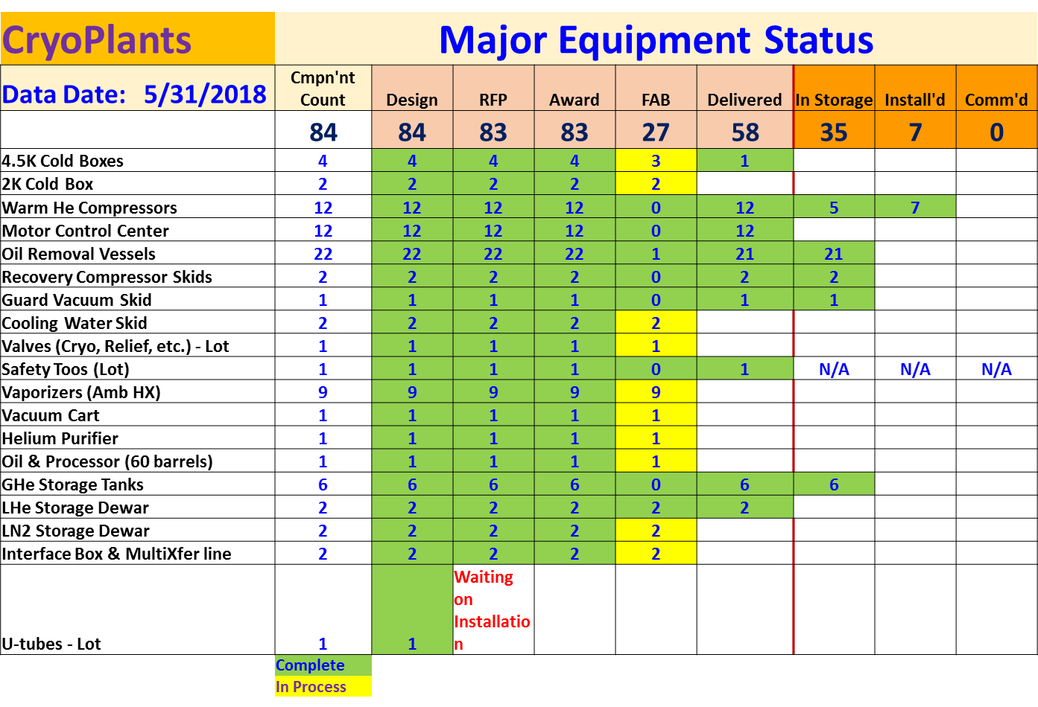

**Quality**

An unacceptable quality issue was identified with the transportation of the most recent Oil removal vessel delivery. This issue was reported, lessons distributed and resolved with the vendor to omit this transportation company from any further deliveries.

Participated in kick off meeting for Demaco, vendor for Cryoplant Transfer / Interphase piping. Future coordination includes ensuring compliance with AWS welding requirements and Demaco subcontractor certs and processes, to include copper brazing certs and welding documentation / mapping plans.

Continued review of 4.5K Cold box (CP1) QA documentation.

**Upcoming Travel/Reviews:**

* 2K cold box kickoff meetings 4-6 June 2018
* Top Plate (2K GFE) fabrication 5-June-2018
* LN2 Dewar 6-June-2018
* Onsite @JLab technical training for SLAC 4-8-June-2018
* Oil processing training for SLAC (PHPK) 25-June-2018
* 4.5K cold box re-assembly meeting @SLAC Pending

Weekly Reporting

WBS 1.02.03.05.12 LLRF

Week of May 31-June 6, 2018

**Issues:** None

**Accomplishments this week at JLab:**

* Resonance/Interlock Chassis:
  + Chassis are installed in LERF Racks.
  + Waiting for Larry Doolittle to send Rama the information so that he can code the firmware for these chassis.

* LERF
  + LERF LLRF instrumentation cables: Cable tray has been installed in the vault. Cavity probe, forward, reverse and HOM cables are being installed this week.
  + HOM Measurement: The switch matrix is installed in the LERF rack. Wes Moore is programing it. The power head is also ready for tests.
  + Reference system and LO: Last LO couplers have been installed. Cables are being terminated. Chassis fabrication should be complete this week.
  + LLRF: The two LLRF racks are powered up and talking across the network.
  + SSAs: There is a safety meeting today to discuss the step forward from single SSA operation to multiple SSA operation.
  + Sonya Hoobler is here from SLAC this week to help integrate the LLRF systems.

* CMTF
  + The next CM is expected to cool down at the end of this week. We will see if we get time for resonance activities.
* Interlock Board/Chassis:
  + Work at this time is on hold until needed for 3.9 GHz.
* Common Power Supply/Chassis/Boards:
  + Work Done.