Weekly Reporting

WBS 1.01.07 JLAB Management

Week of June 7-13, 2018

**Issues:**

Need to finalize shipping plans and hardware so we can ship CMs.

**Accomplishments this week:**

4.5 K CB vendor visit for updating progress and schedule. Look like we will have 2 additional cold boxes delivered in September/October.

4.5 K CB vendor wants to visit SLAC site with sub-contractor(s).

Kick off meetings with 2K CB vendors.

Participated in the CM shipping review.

Evaluating potential scope reductions and cost-cutting measures.

**Upcoming Activities:**

19-21 June – LCLS-II HE CD-1 Review

Weekly Reporting

WBS 1.04.06 JLAB Cryomodules

Week of June 7-13, 2018

**Issues**:

Risk of lack of high-performing cavities to finish CM assembly.

**Accomplishments this week:**

LCLS-II-HE CD-1 Review – planning to attend next week.

PR for four post fixture has been approved.

Participating in shipping review at FNAL. JLab staff will attend remotely.

Procurement for additional shipping caps is on hold pending decisions on design and use of modified DESY shipping caps.

Concerned that first shipment (27-Jul as shown in recovery schedule) will be delayed due to availability of new shipping hardware.

Updated list of potential returns to contingency that include descoping portions of the current baseline plan. SOTRs and work center leads developing list of proposed reductions in work plan for CM assembly (reducing or deleting inspections, deleting assembly procedure steps, etc.) – due later this week.

Received cavity 025 – cavity was repaired by vendor due to damage in helium vessel bellows during handling at FNAL.

Next deliveries of cavities from RI and EZ are en route to both labs.

J1.3-01, J1.3-03 and J1.3-04 - @ Storage; Idle; Waiting to move to WS4 for VV removal

J1.3-02 – @ Stored; no further work planned.

J1.3-05 - @ LERF; Used for fit up of waveguide.

J1.3-07 - @ WS6 ; Prep for rework.

J1.3-08 - @ CMTF; CM cooled down over the weekend. Repaired problem with CM cooldown valve actuator. Tuners have been set to frequency. Setting FPC Q external. Planning to obtain Emax and FE data. Fast cooldown planned for end of the week.

J1.3-09 @ WS5 – Warm coupler installation in progress.

J1.3-10 @ WS4 – Vac Vessel demag complete. HOMs tuned. 50K shields installed. MLI installation complete.

J1.3-11 @ WS3 – BPM hardware replacement complete. BPM leak check completed.

J1.3-12 @ WS2 – Idle. Awaiting move of J1.3-10 to cantilever. Inspection of UCM hardware in progress at WS3. Plan to move to WS3 on 13-June.

J1.3-13 – String build began 4 June. String build began 11 June. 4 cavities on the assembly rail as of end of day 12-June. String rollout by 22 June.

J1.3-14 – All cavities qualified. String prep begins 2 July. String build begins 9 July. String rollout by 22 July. Assembly was moved by one week to avoid conflict with mid-week holiday.

J1.3-15 - 4 of 8 cavities qualified for the string.

Cavity Tests –

No production LCLSII vertical testing planned. CM cooldown proceeded as planned and is complete. VTA returned to normal operations.

**QUALITY**:

No report – on travel

**Upcoming Travel/Meetings:**

Shipping Review at FNAL June 12 (via telecon)

LCLS-II-HE CD-1 Review 19-21 June (E. Daly, J. Preble)

TTC 26-29 June (K. Wilson, A. Palczewski)

EZ Vendor Visit July 9-13 (H. Park)

LINAC 2018 Sep 14-19 (A. Solopova)

Weekly Reporting

WBS 1.04.06 Cryomodules - LERF Conversion

Week of June 7-13, 2018

**Issues:** None

**Accomplishments this week:**

Updates & photos can be seen on the WIKI wiki.jlab.org

First three SSAs have been run into shorts and controlled through EPICS interface.

All LLRF racks are now powered up.

RF cable installation continues as well as terminations.

The cable tray in the tunnel is complete; we can now dress in the cables and then begin to terminate the cables.

First module (CM #1) waveguide had been leak checked OK (PSS pressure interlock).

Three Coriolis flow meters have had the cable modifications done (per Fermi Lab note) and have been shipped to Eden Cryogenics. We visited Eden to examine schedule, the transfer line may slip another week; they claim the cryo-can is still on schedule but it looks to slip a bit as well.

Raised floor for protecting the RF cables is finished, there were a few anchors that needed to be installed.

LCLS-II controls environment now working for selected JLAB accounts, as well as the previously used SLAC group accounts.  Verified new user was able to login to control room workstations and run RF EDM screens easily.  Additional JLAB staff accounts are being added.  For controls infrastructure, servers and workstations were modified to allow for direct NFS mounts.  This was needed to accommodate the SLAC EPICS build system and LinuxRT hosts.  VDI hosts have been migrated to this new NFS scheme also, matching the behavior of the control room workstations.  Software ready for SSA testing to begin.

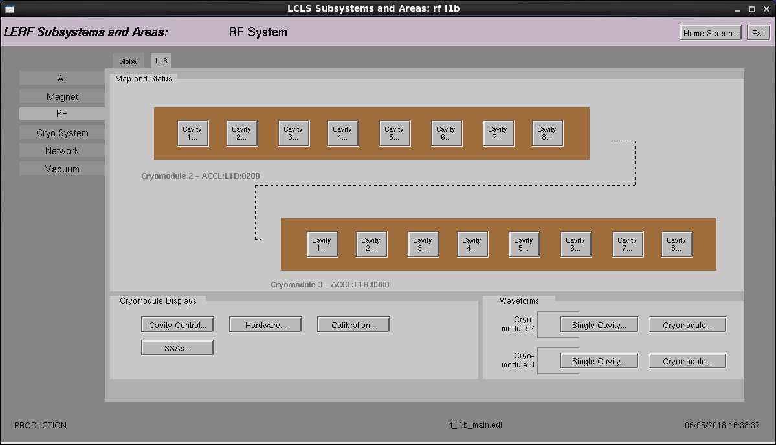

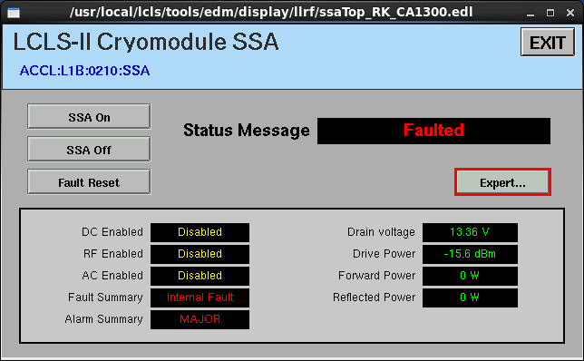

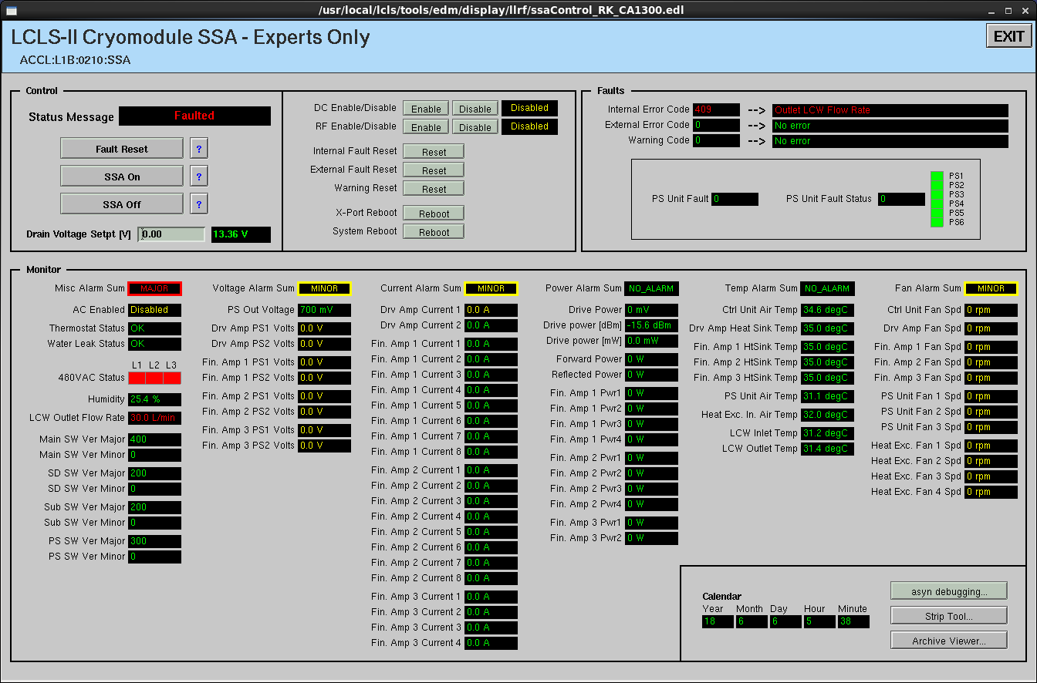

New control screens for RF

**Upcoming Travel/Meetings:** None

Weekly Reporting

WBS 1.04.08 JLAB Cryoplant System

Week of June 7-13, 2018

**Issues:**

1. Resolution of interferences created during the design of the platforms and cable trays support systems (identified in 2017).
2. Installation of the LN2 Dewar and helium ‘tank farm’ foundations. The warm helium tanks have been in storage for several months awaiting completion of these supports.
3. Changing the LN2 piping design from a build-to-print to an unidentified source and fabrication.

**Accomplishments this week:**

**2K Cold Box**

1. Evaluating the expediting of the top plate (GFM) directly to CB vendors
2. Kick-off site visits to both vendors complete.
3. February 2019 delivery scheduled.

**4.5K Cold Box Status**

1. C1 Upper cold box vacuum components being shipped to SLAC this week.
   1. Delivery expected early next week.
2. C1 Lower Cold Box.
   1. Heat exchangers being installed.
   2. Fabrication scheduled to complete Sept 2018.
3. CryoDuct received @SLAC.

**Interface Boxes**

1. Interferences created by platform design need to be mitigated.
2. Weekly conference calls initiated.
3. Preliminary design review scheduled for July 2018.

**Venturi & Control Valves**

1. Venturi awarded.
   1. Expediting venture for critical cold box systems.
2. Control valves award delayed on technical response.
   1. Award expected next week.
   2. Priority shall be coordinated with installation schedule.

**Deliveries & Installation**

* First phase of controls enclosures delivered and received @SLAC.
  + Second phase of enclosures scheduled for delivery next month.

**Procurement Status**

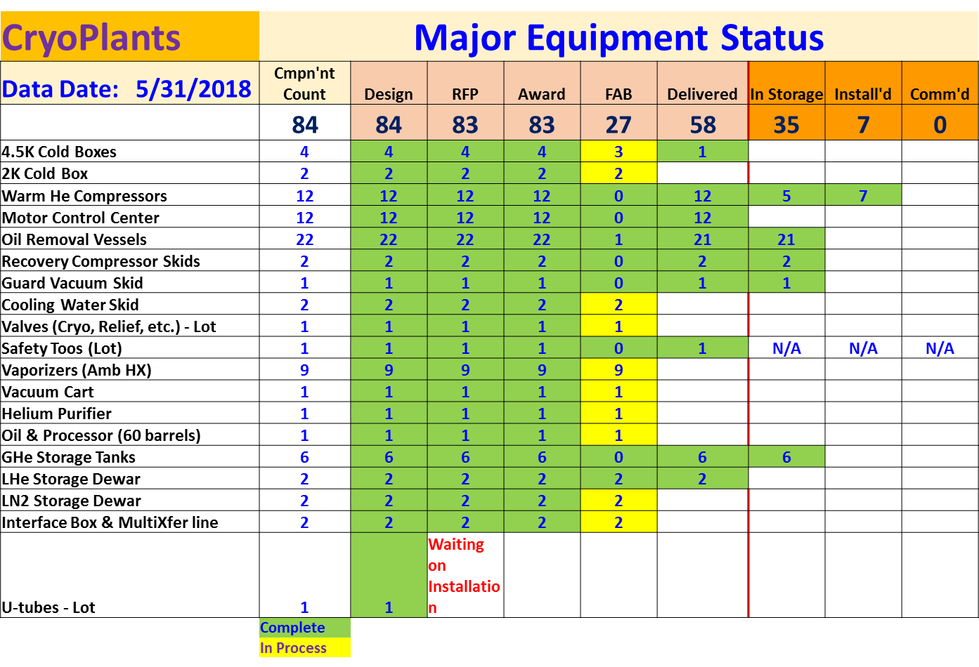

**Quality** - No report.

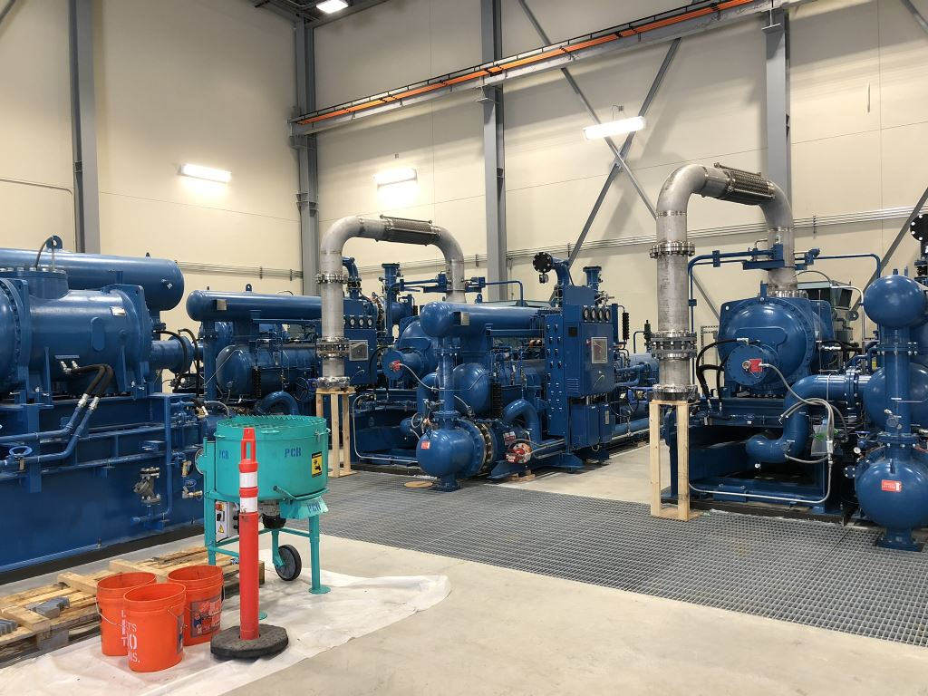

Warm Helium Compressor Installation proceeding with connection of suction spools.

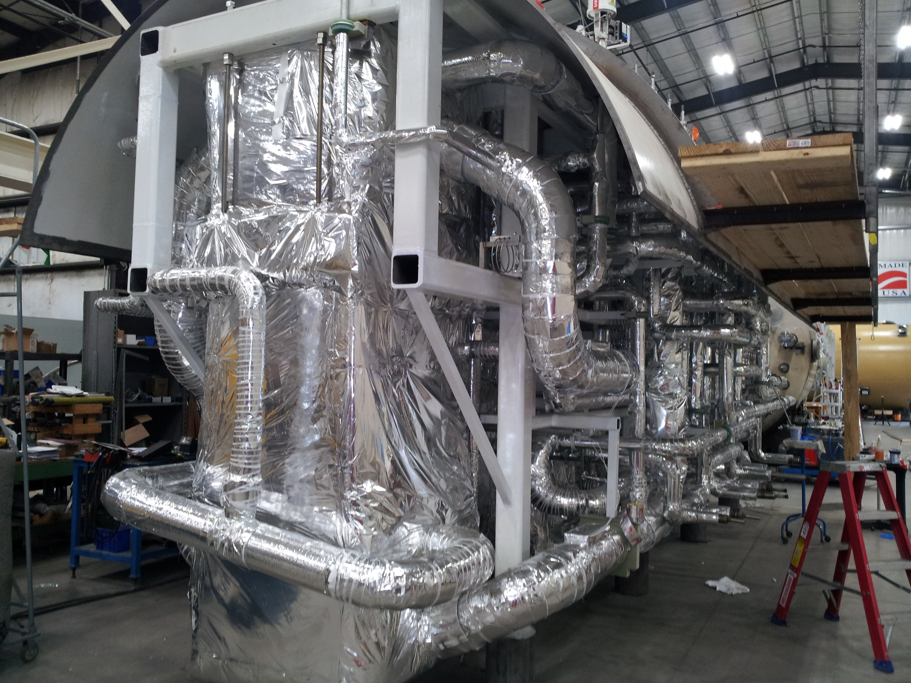

C1 Lower Cold Box – final internal assembly in preparation for lower shell installation.

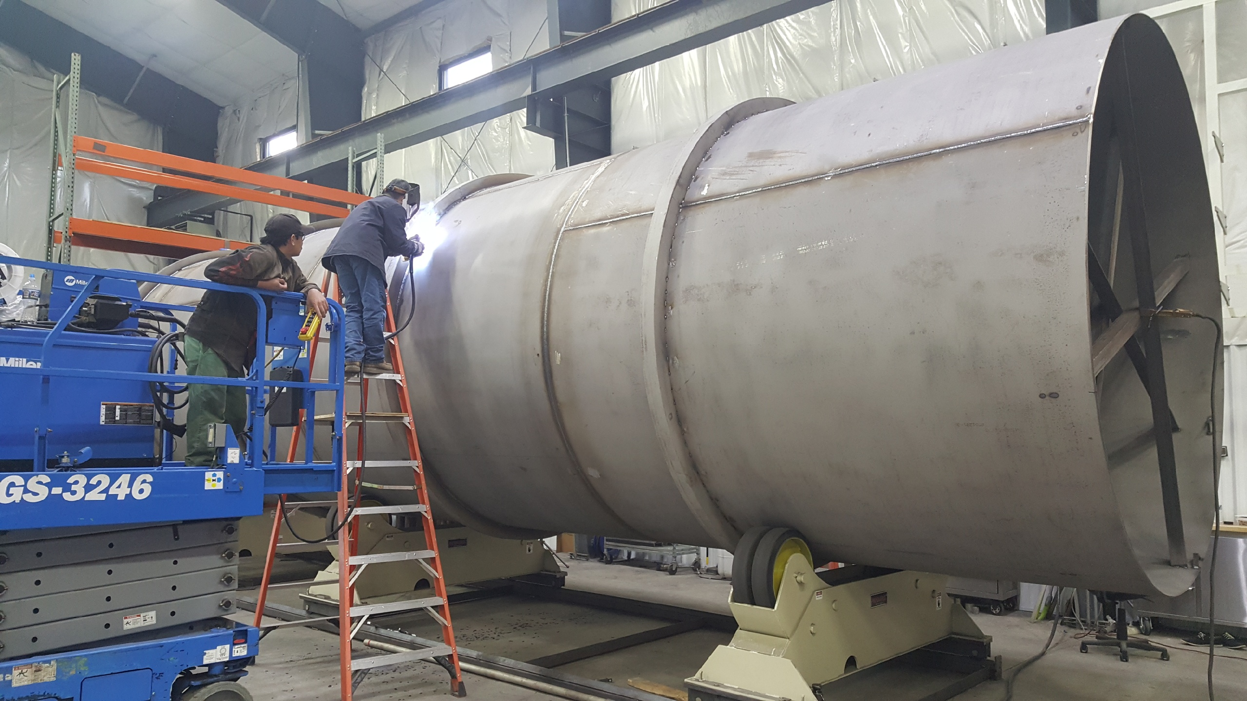

LN2 Dewar in fabrication – Outer vessel welding of stiffing rings; Inner shell, head and piping spool subassemblies complete.

**Upcoming Travel/Reviews:**

* Oil processing training for SLAC (PHPK) 25-June-2018
* SLAC I&C staff onsite at JLab for coordination meeting 27-28-June-2018
* 4.5K cold box re-assembly meeting @SLAC Late-July-2018

Weekly Reporting

WBS 1.02.03.05.12 LLRF

Week of June 7-13, 2018, 2018

**Issues:** None

**Accomplishments this week at JLab:**

* Resonance/Interlock Chassis:
  + Chassis are installed in LERF Racks.
  + Waiting for information so that Rama can code the firmware for these chassis.

* LERF
  + LERF LLRF instrumentation cables: RF cables are being installed slowly due to competing priorities.
  + HOM Measurement: No change from last week.
  + Reference system and LO: Cables have been pulled and chassis installed. Waiting for cables to be terminated and measured for loss.
  + LLRF: All four LLRF racks have been powered up.
  + SSAs: We tested the SSAs on cavities 5-8 for CM1. EPICS was used with LLRF driving the SSAs. All four reached 4 kWs with no RF leaks.
  + Sonya Hoobler from SLAC helped us get the CM LLRF racks up and running last week.
  + Working with EES, Ops and Accelerator to find individuals for LERF CM tests.
* CMTF
  + The next CM is cold we are waiting for a chance to complete the resonance control firmware.
* Interlock Board/Chassis:
  + Work at this time is on hold until needed for 3.9 GHz.
* Common Power Supply/Chassis/Boards:
  + Work Done.

**Upcoming Activities:**