**LCLS-II JUNE PROJECT STATUS REPORT**

**DATE:** July 2, 2018

**LOCATION OF PROJECT:** Jefferson Lab

**SENIOR TEAM LEAD:** Joe Preble

**MONTHLY PROGRESS**

Summary

JLab continues to make significant progress in all areas. Cost, schedule, and scope are being managed to the baseline. We received earned value and variance reports, analyzed data and submitted VARs.

Developed list of potential returns to contingency that included descoping portions of the current baseline plan and procurement award cost savings.

Attended 4.5K Cold Box Monthly progress and scheduling meeting at vendor.

Attended 2K Cold Box Kick-off meetings at both vendors.

Participated in Cryomodule Shipping Review which was held at FNAL.

The 2K cold box top weldment award was moved from Eden Cryogenics, Plain City, Ohio, to a local vendor, Craft in Newport News.

Management

Awarded:

1. Venturi

Approved BCRs:

* JLab Cryomodule Bundle
* JLab Cryoplant Bundle

Cryoplant System:

2K Cold Box: Attended kick-off meetings at both vendor sites. The top plate manufacturing was re-awarded to Craft (from Eden Cryogenics) to expedite delivery to 2K CB vendors.

4.5K Cold Box Status: The heat exchangers were installed on the lower cold box for Cryoplant 1. Helicoflex seals for lower cold box were installed on 20K adsorber, no leaks detected after seal installation. Wiring is complete on the upper cold box for Cryoplant 2.

Venturi & Control Valves: Venturi was awarded.

Deliveries and Installation: First phase of controls enclosures and 4.5K cold box ancillary components were delivered to SLAC.

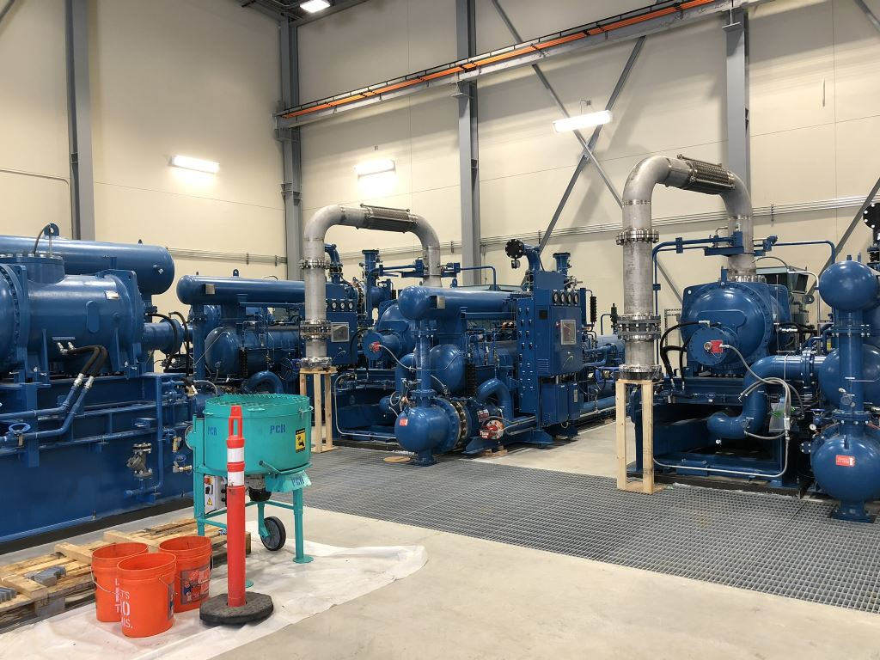

Warm Helium Compressor Installation proceeding with connection of suction spools.

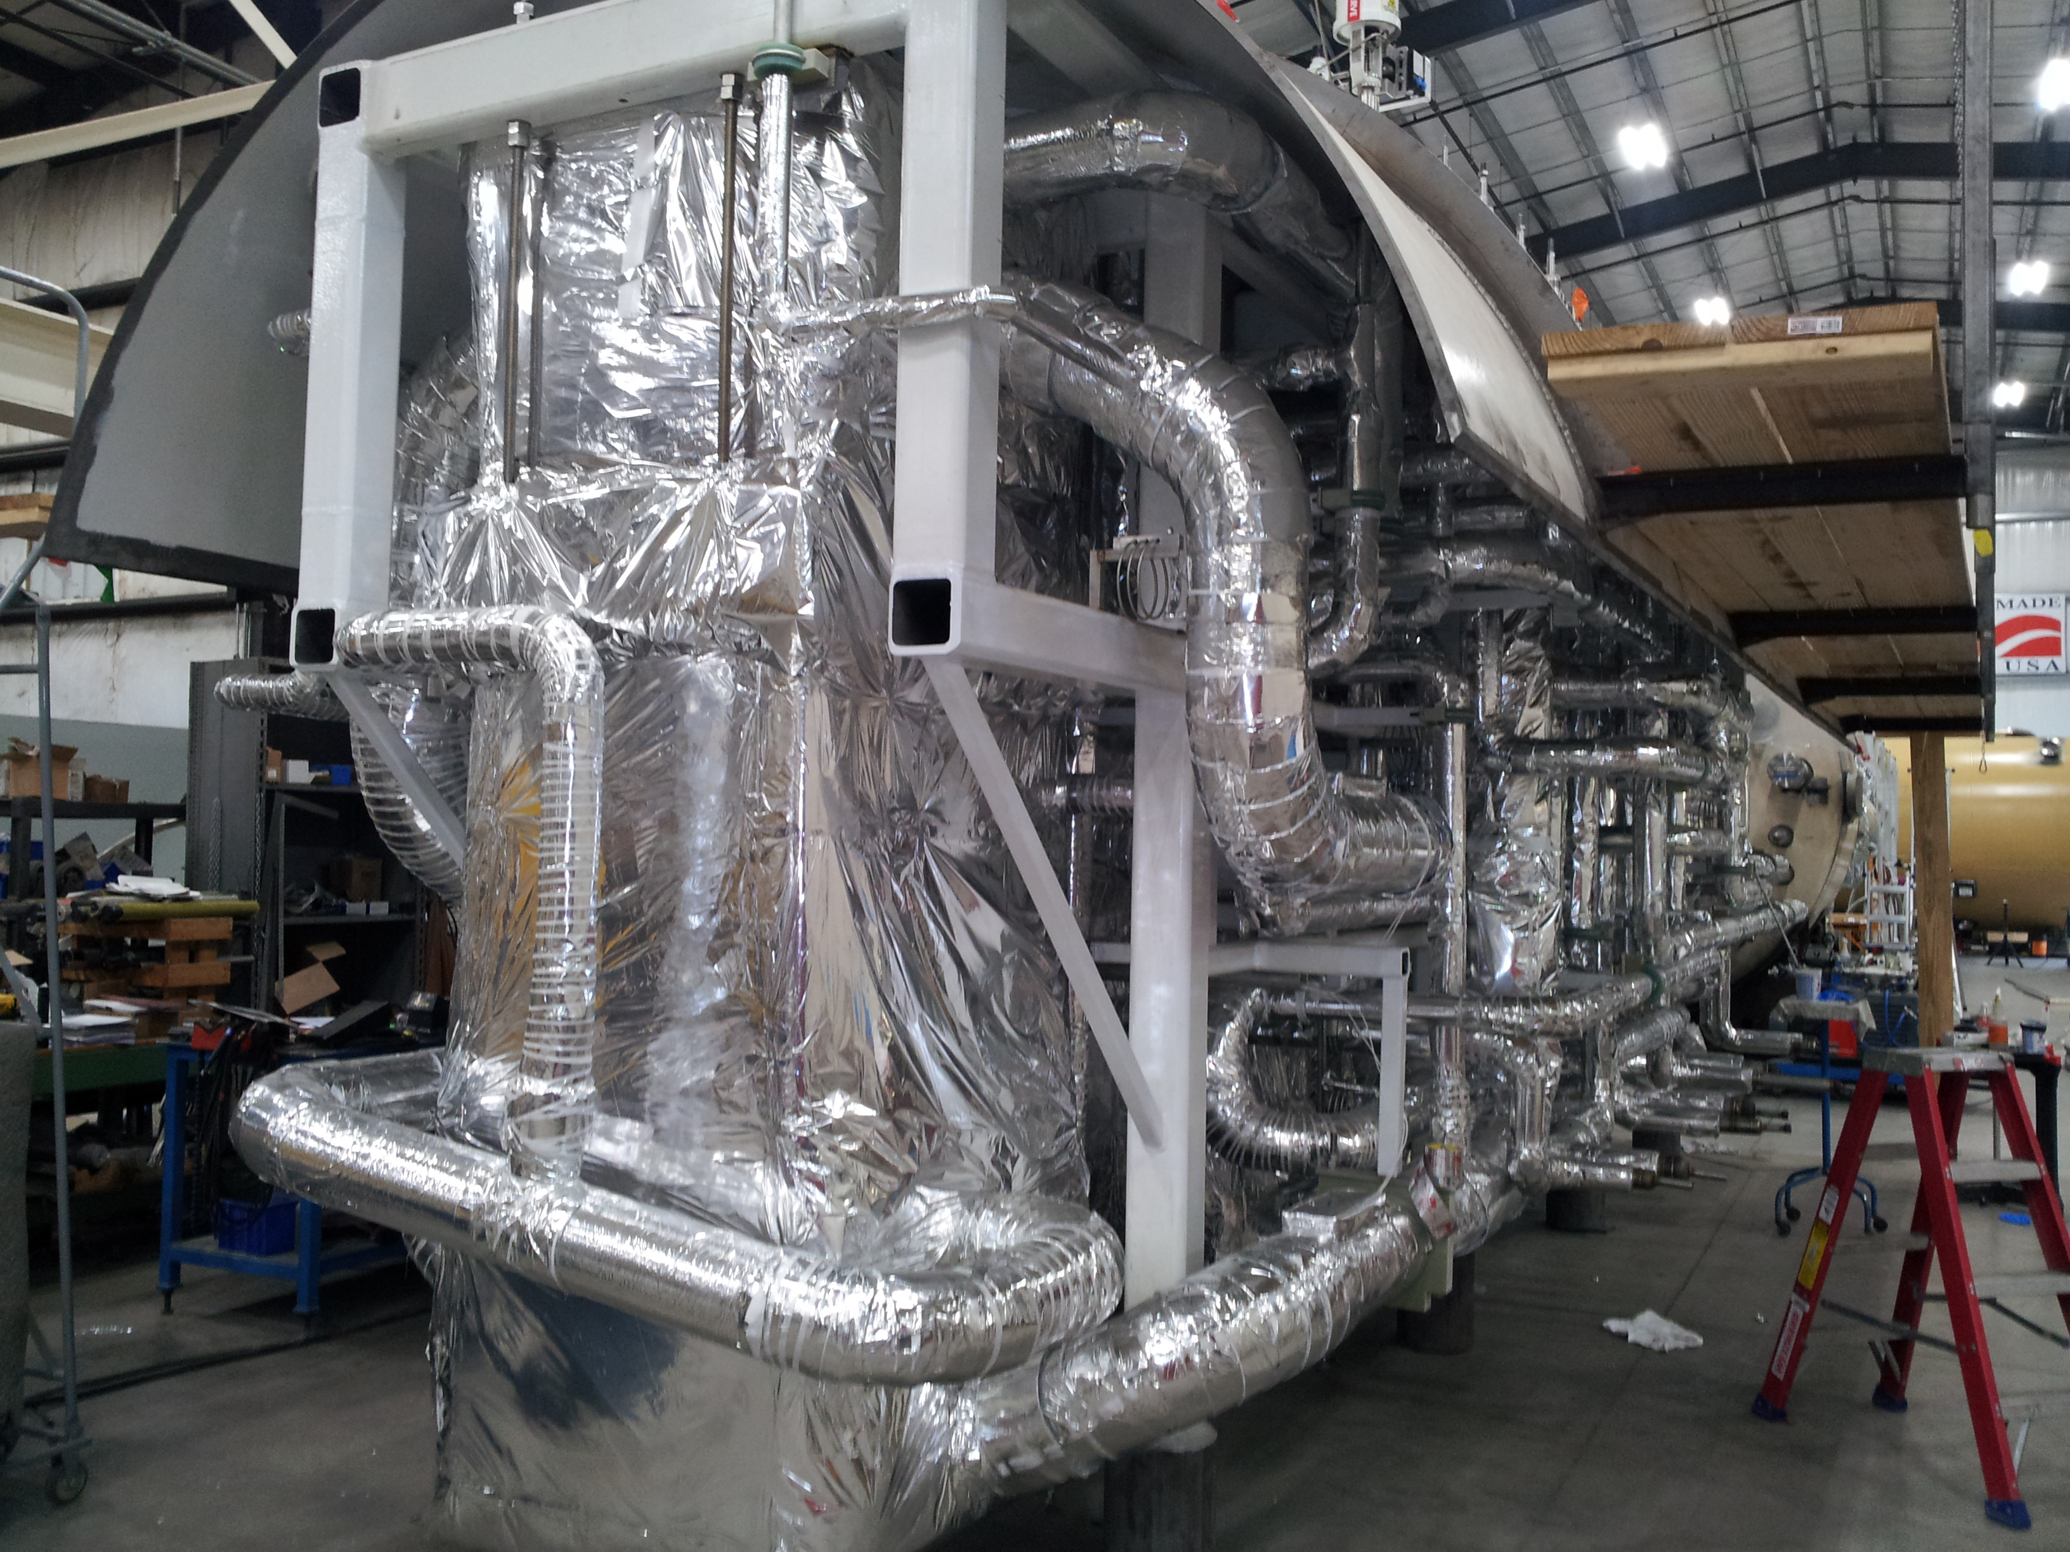

C1 Lower Cold Box – final internal assembly in preparation for lower shell installation.

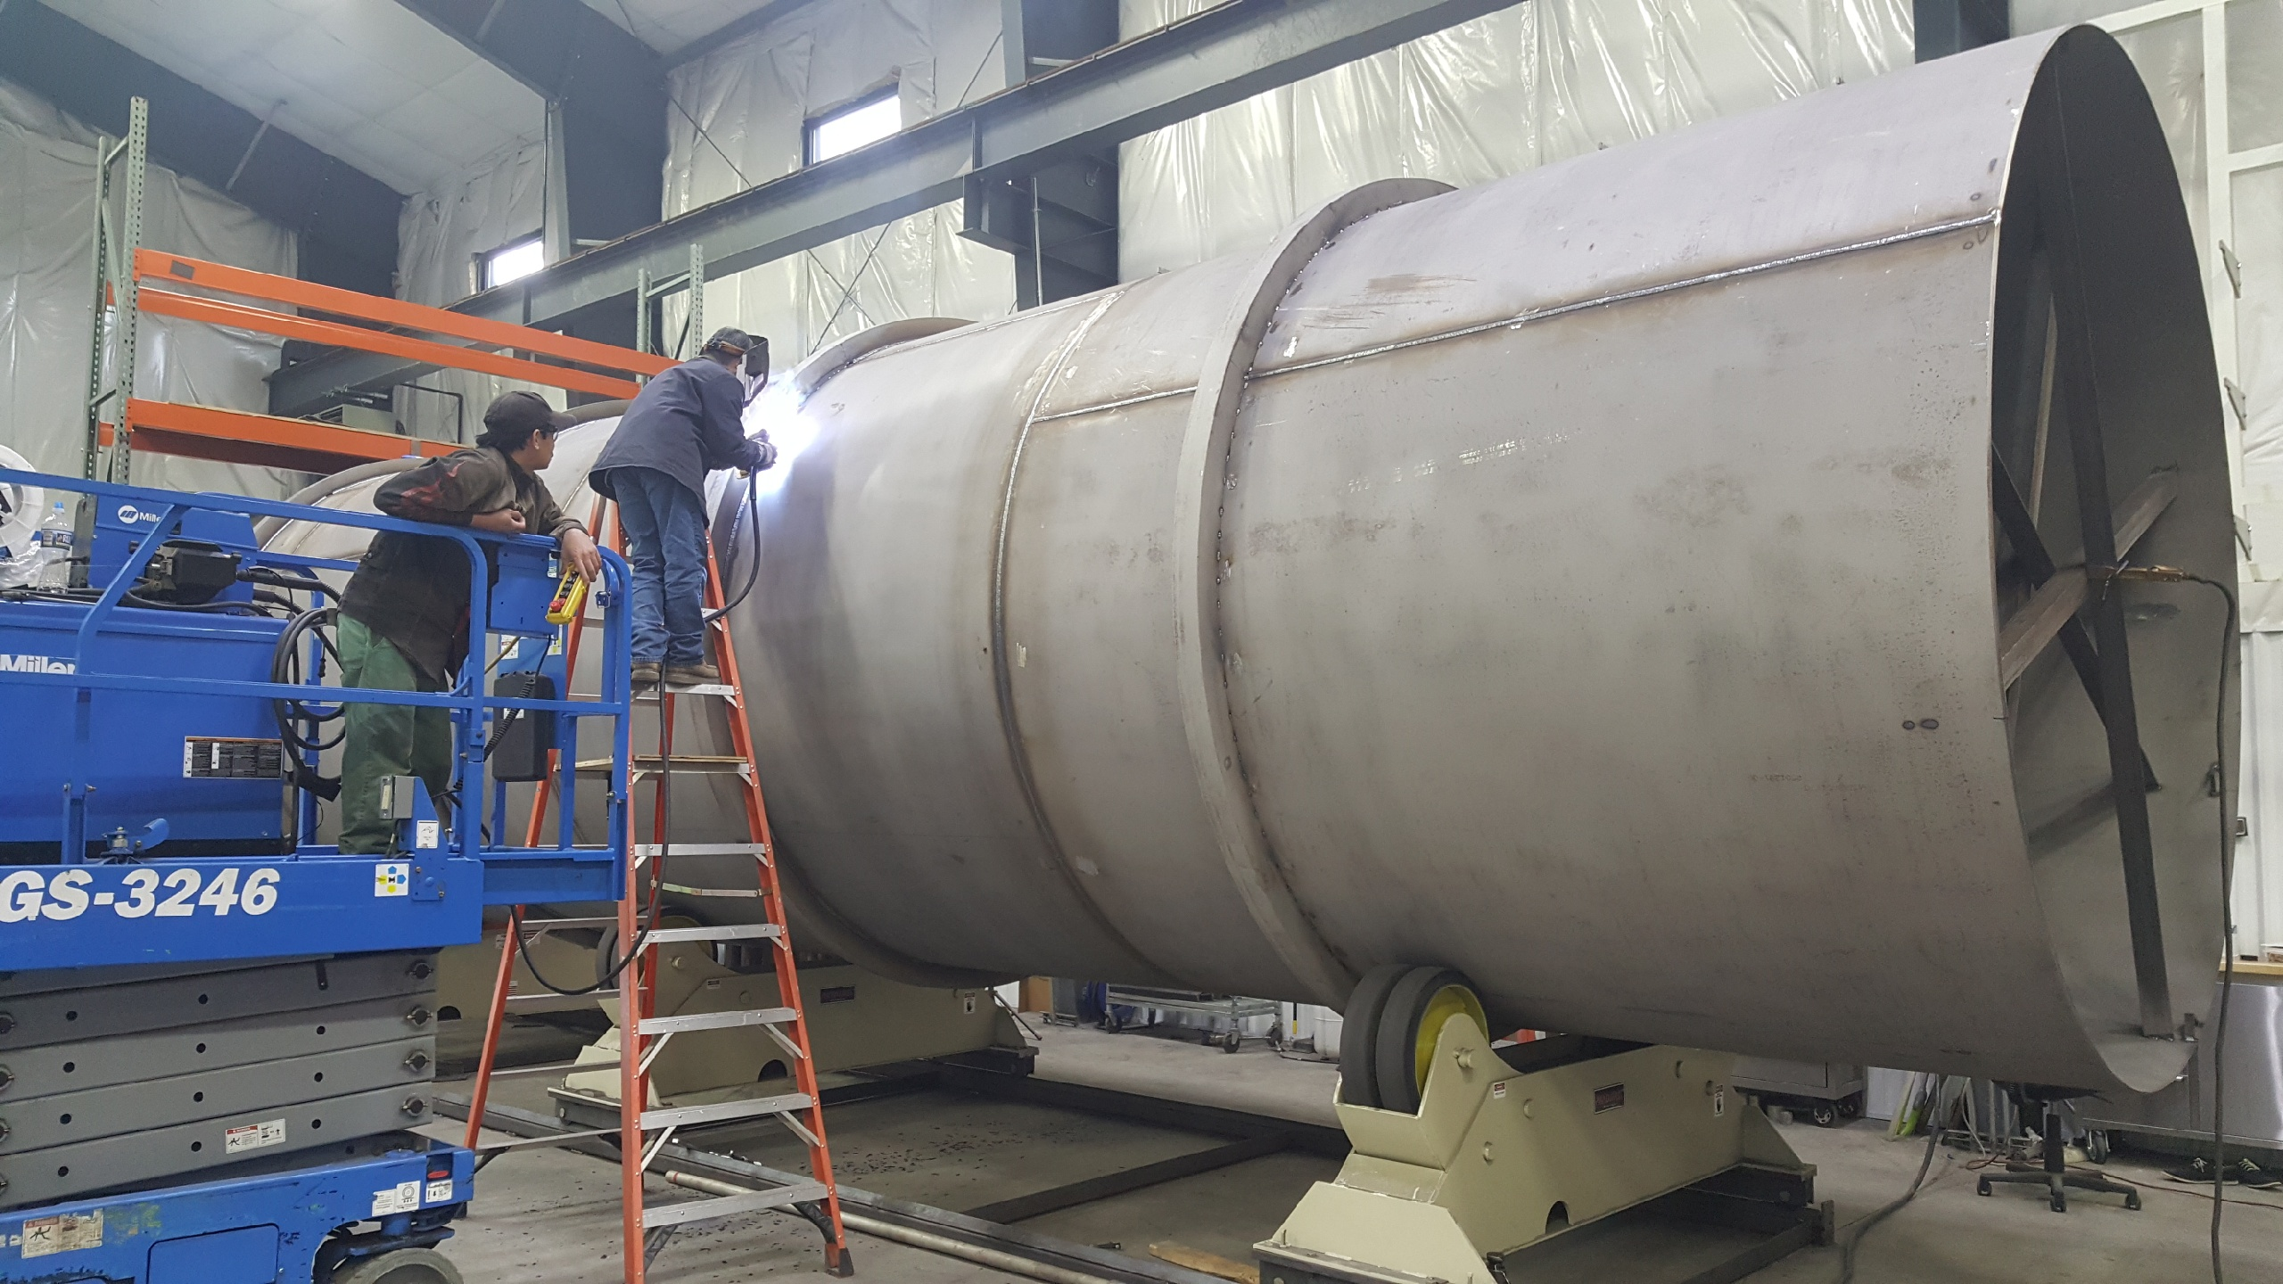

LN2 Dewar in fabrication – Outer vessel welding of stiffening rings; Inner shell, head and piping spool subassemblies complete.

Cryomodules: Purchase order for four-post fixture was approved. Received cavity 025 which was repaired by vendor due to damage in helium vessel bellows during handling at FNAL.

J1.3-01, J1.3-03 & J1.3-04 – Storage; Idle; Waiting to move to WS4 for VV removal.

J1.3-02 – Stored; no further work planned.

J1.3-05 – at LERF; used for fit up of waveguide.

J1.3-07 – at WS6; prep for rework.

J1.3-08 – At CMTF; Performed multiple fast cooldown cycles. Overall performance indicates that heat exchanger design modification was successful, cooldown rate is sufficient for achieving high Q0 in cavities.

J1.3-09 – WS5 – Leak from insulating vacuum space to helium circuit localized near the front of cavity 3. Removed warm couplers and plan to move to WS4 to remove VV and lower thermal shield. Delay in move of J09 to LERF.

J1.3-10 @ WS5 – Faraday cup installed. Warm couplers in progress.

J1.3-11 @ WS 3 – Magnet leads soldering and torqueing complete. Alignment in progress.

J1.3-12 @ WS3 – Cold gate valve support complete.

J1.3-13 @ WS2 – RF measurements complete.

J1.3-14 – All cavities qualified. String prep begins 2 July.

J1.3-15 – 6 of 8 cavities qualified for the string.

Low Energy Recirculating Facility (LERF): First set of 8 SSAs have been run into shorts and controlled through EPICS interface. All LLRF racks are powered up. The cable tray in the tunnel is complete; we can now dress in the cables and then begin to terminate the cables. First module (CM #1) waveguide was leak checked. Raised floor for protecting the RF cables is complete. The stepper, RTD & tuner cables were installed.

LCLS-II controls environment is now working for selected JLAB accounts. For controls infrastructure, servers and workstations were modified to allow for direct NFS mounts. VDI hosts have been migrated to this new NFS scheme also, matching the behavior of the control room workstations.

LLRF: Chassis were installed in LERF Racks. Cable tray was installed in the vault. The switch matrix was installed in the LERF rack. The power head is ready for tests. LO couplers were installed. Cables were pulled and chassis was installed. All four LLRF racks are powered up and talking across the network. Tested the firmware from the cold repository; all steppers and piezos were tested.

ESH – QA: CP - An unacceptable quality issue was identified with the transportation of the most recent Oil removal vessel delivery. This issue was reported, lessons distributed and resolved with the vendor to omit this transportation company from any further deliveries.

Participated in kick off meeting for Demaco, vendor for Cryoplant Transfer / Interphase piping. Future coordination includes ensuring compliance with AWS welding requirements and Demaco subcontractor certs and processes, to include copper brazing certs and welding documentation / mapping plans.

CM - Site CWI conducted receipt inspection and document review for LERF return end caps from AES. Rejected both caps for missing welds and missing AES CWI inspections; JLab to repair.