Weekly Reporting

WBS 1.01.07 JLAB Management

Week of July 12-18, 2018

**Issues:**

Need to finalize shipping plans and hardware so we can ship CMs.

Need to understand damaged bellows on CM09&11.

**Accomplishments this week:**

Continue investigation into bellows damage.

IB&MTL PDR

Neck can awarded.

**Upcoming Activities:**

July – LCLS-II HE ICR Review

Sep – LERF Readiness Review

Weekly Reporting

WBS 1.04.06 JLAB Cryomodules

Week of July 12-18, 2018

**Issues**:

Risk of lack of high-performing cavities to finish CM assembly. Possible delay of first shipment from JLab due to availability of modified shipping caps. Work stoppage due to damage to HV bellows on CM-09 and CM-11.

**Accomplishments this week:**

Preparing bundled BCR for the single cell cavities and four more reworked cavities.

Prepared table detailing list of exchange rate adjustments for cavity vendors.

Provided proposed list of restart conditions to CS SM and Deputy for their review and comment.

Resolved final HOM BLA shipping configuration. Plan to ship first set of five to SLAC in three to four weeks.

Continuation with preparation of procedures for shipping of CMs together with FNAL. Developing instrumentation plan together with FNAL. L. King was at FNAL last week supporting the next shipping test.

Cavity shipment (4) en route from RI to FNAL. Cavity shipment (5) planned this week from RI to JLab.

J1.3-01, J1.3-03, J1.3-04 and J1.3-07 - @ Storage; Idle; Waiting to move to WS4 for VV removal

J1.3-02 – @ Stored; no further work planned.

J1.3-05 - @ LERF; Used for fit up of stands.

J1.3-08 - @ WS5 - CM was removed from test cave on 11 July. Insulating vacuum verified as leak tight. Preparing CM for shipping.

J1.3-09 @ WS4 – Leak from ins vacuum space to Helium circuit. NCR #1466. Coupler side helium vessel bellows on cavity 3. Plan to install cold mass into VV and store CM until rework path is identified.

J1.3-10 @ WS5 – Welds at JT assembly were reworked. X-ray of welds planned for Tues 7/17. Bayonet box is on and leak checking is in progress.

J1.3-11 @ WS3 – On hold pending investigation of damaged bellows. NCR #1477. Plan to install cold mass into VV and store CM until rework path is identified.

J1.3-12 @ WS3 – On hold pending investigation of damaged bellows. Only specific action approved is magnet lead soldering.

J1.3-13 @ WS2 – Two phase pipe welding in progress.

J1.3-14 – All cavities placed on the rail. String is being leak checked. String rollout by 20 July.

J1.3-15 – All cavities qualified for the string.

J1.3-16 – 1 of 8 cavities qualified for string.

Cavity Test Results

Cavity 201 (NX-C), first test since back from vendor, D5, Fri., 13 July, Q0(16)~3.5e10, FE free, Quench 16.2 MV/m , Not qualified. Set aside for now.

Cavity 209 (NX-B), first test since back from vendor, D5, Fri., 13 July, Q0(16)~2.7e10, FE free, Quench at 17.6 MV/m, Not qualified. Set aside for now.

Cavity 210 (NX-B), first test since back from vendor, D5, Fri., 13 July, Q0(16)~2.6e10, FE free, Quench at 17.7 MV/m, Not qualified. Set aside for now.

Cavity 506 (TD) first test, D8, Mon., 16 July, Q0(16)~3.4e10, FE free, Mode mixing started at 18 MV/m, Quench at 25.3 MV/m, Qualified for string.

Cavity 272 (TD) re-test D7 (FE previous test), Tue. 3 July. Q0(16)~2.7e10; Quench 29.4 MV/m; FE free. Qualified for string.

Planned tests –

L2-502(TD, first test), 503(TD, first test), 505 (TD, first test) in D5, Wed., 18 July.

L2-508(TD, first test) in D7, Wed., 18 July

**QUALITY**: LCLS II walkthrough welding inspections and random inspections on installation in TED SRF. Welding inspection passed for RT for repaired CM010 welds.

Receipt Inspection and document review for LCLS PO 18-P0412 from Amtech Machine for Test Cave Stand Assemblies. (Rejected documents and inspection results now acceptable and will be delivered this week.)

**Upcoming Travel/Meetings:**

EZ Vendor Visit late August (D. Gonnella)

EZ/RI Vendor Visit TBD (K. Wilson, M. Laney, A. Palczewski)

LINAC 2018 Sep 14-19 (A. Solopova)

Weekly Reporting

WBS 1.04.06 Cryomodules - LERF Conversion

Week of July 12-18, 2018

**Issues:** None

**Accomplishments this week:**

Updates & photos can be seen on the WIKI wiki.jlab.org

Last week, Friday, we visited Eden cryogenics to observe the final leak check and pressure test, the cold shock was done on Thursday. These all passed without any issues. Transfer line was delivered. We met to discuss the installation and what tooling is required to get the field fit welds done. (See photos below.)

Progress has been on the cryo-can as well at Eden, most all of the pieces have been delivered and sub-assemblies are coming together. There were a few long lead parts that we will ‘loan’ them, they still hope to finish on schedule and ship at the end of July – I suspect that they will be a couple weeks late. (See photos below.)

Four sets of wheels were delivered to enable shuffling of the cryomodules in & out of the LERF vault.

Cable terminations are well under way – finally.

|  |  |
| --- | --- |
| ½ of Transfer line | 2/2 Transfer line |

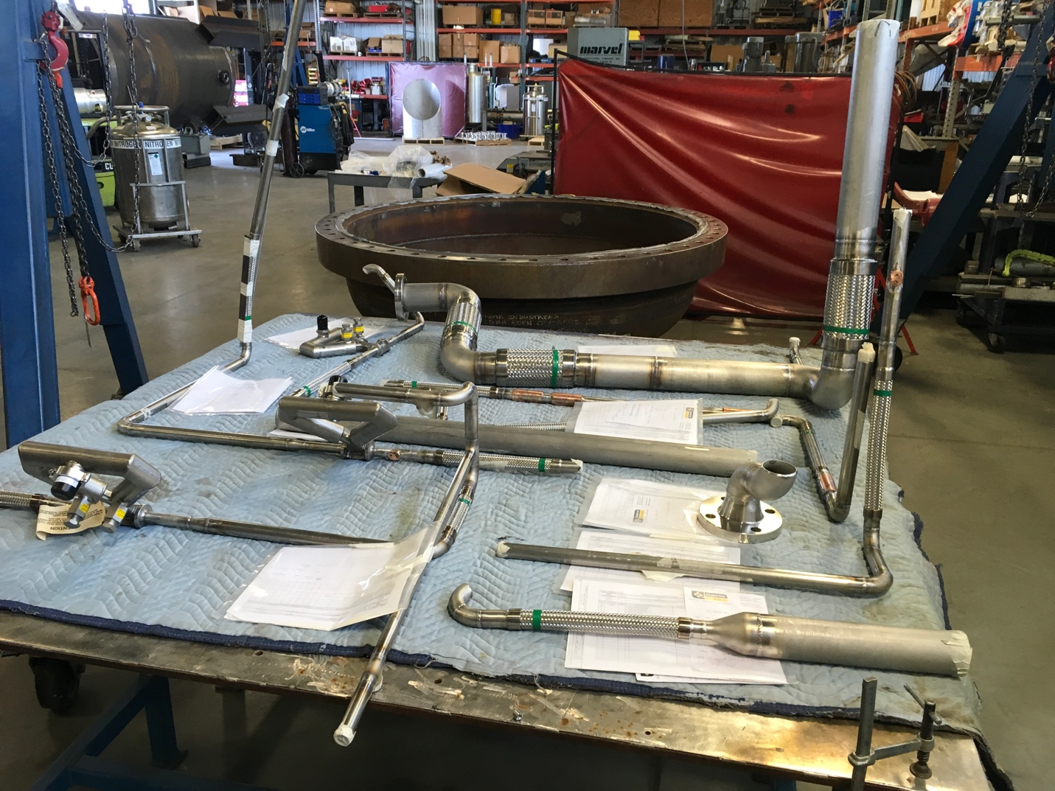

Cryo-can parts being assembled.

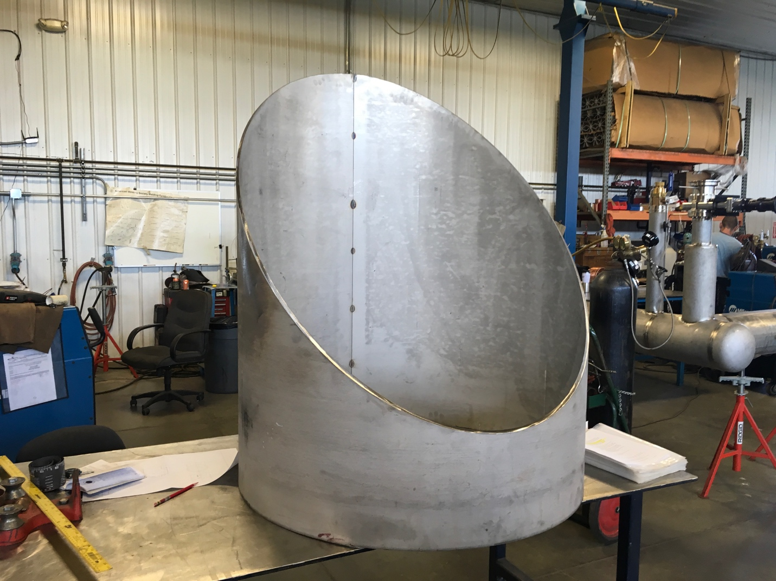

Top piece of the cryo-can being laid out for piping.

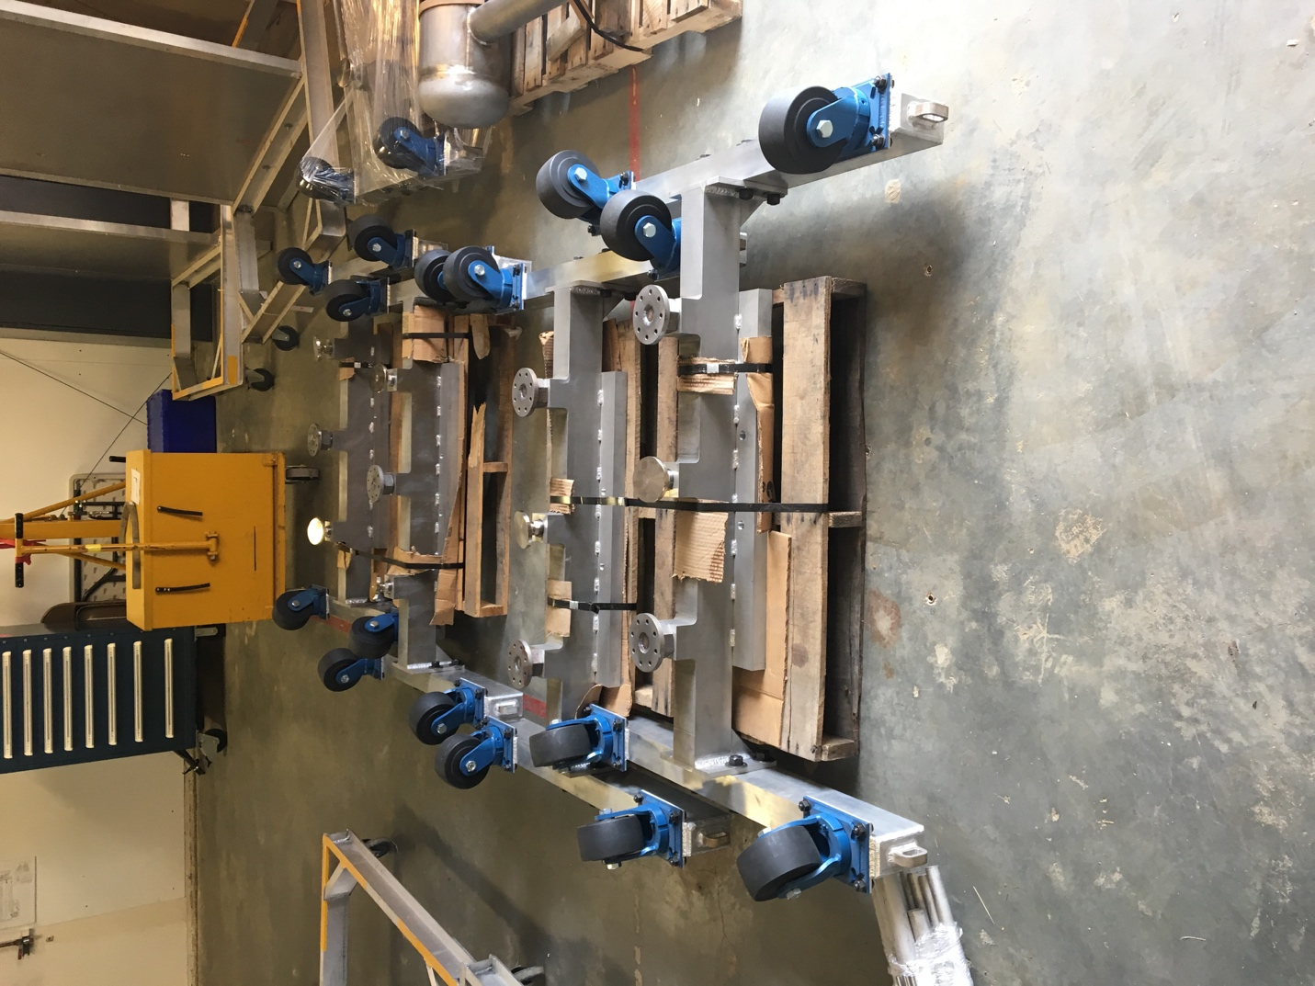

Stands for shuffling of CMs.

Weekly Reporting

WBS 1.04.08 JLAB Cryoplant System

Week of July 12-18, 2018

**Issues:**

1. Resolution of interferences created during the design of the platforms and cable trays support systems (identified in 2017).
2. Installation of the LN2 Dewar and helium ‘tank farm’ foundations. The warm helium tanks have been in storage for several months awaiting completion of these supports.
3. Return funding to contingency; this effort will result in reduction of remaining cryoplant scope.

**Accomplishments this week:**

**2K Cold Box**

1. Top plate manufacturing back on track with new vendor.
   1. Delivery to 2K CB vendors on schedule for August.
2. Both CB vendors have commenced fabrication efforts with material orders and subassembly fabrication (see below).
3. Delivery of 2K CB’s to SLAC scheduled for February 2019.

**4.5K Cold Box Status**

1. UCB1
   1. Platform hardware shipment en route to SLAC.
      1. Scheduled to arrive early next week.
2. LCB1
   1. Final insulation in progress prior to installing lower shell section.
3. UCB2
   1. Lower shell installed.
      1. Closure welding in progress.

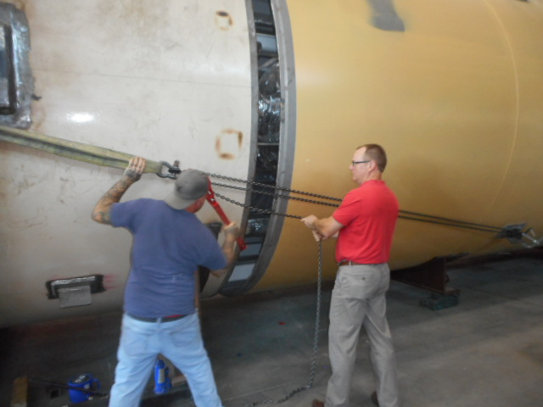 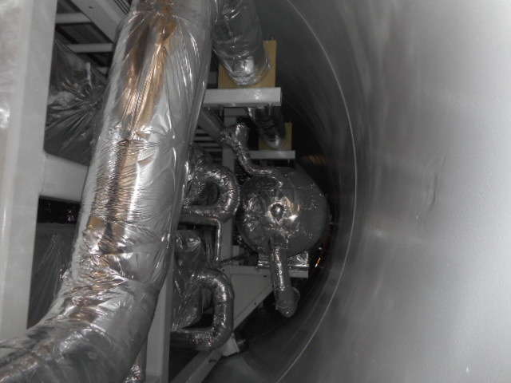

1. LCB2
   1. Installation of final heat exchanger in progress.

**Interface Boxes**

1. Preliminary design review scheduled for July 2018.
   1. Demaco, JLab and SLAC staff in attendance.
   2. Minutes & Action items distributed.
2. Follow up to PDR action items in progress.

**Venturi & Control Valves**

1. Venturi awarded.
   1. Delivery scheduled for August.
2. Control valves awarded.
   1. Working with vendor to expedite delivery.
   2. Priority shall be coordinated with installation schedule.
3. Relief valves
   1. Vendor proposals under evaluation.

**Deliveries & Installation**

* Last two Oil removal vessels scheduled for late July delivery.

**Major Procurement Status**



**QUALITY**: 4.5K CBX documentation package was reviewed by the site CWI for required items; issues with the submission were identified. Detailed feedback on documents, drawings, inspections and stamps was provided to the CAM and other Managers.

SOTR & CWI for the 2K cold box top plate fabrication are onsite at the vendor to witness the root weld pass for compliance with code and subcontract performance requirements.

Closure welds for the first LN2 Dewar inner vessel are undergoing x-ray examination in accordance with ASME code compliance.

**Upcoming Travel/Reviews:**

* ALATUS-vendor site visit to SLAC (Reassembly) Week of 23-July-2018
* Monthly schedule status @PHPK 26-July*-2018
* 4.5K cold box re-assembly meeting @SLAC 15-August-2018
* Control Enclosures (2nd phase) FAT 07-August-2018

Weekly Reporting

WBS 1.02.03.05.12 LLRF

Week of July 12-18, 2018

**Issues:** None

**Accomplishments this week at JLab:**

* Resonance/Interlock Chassis:
  + Rama has the code working from LBNL. The next step is to begin building the EPICS interface with Sonya.
* LERF
  + RF cables: CM2 cables assembly have slowed due to CEBAF priorities.
  + LLRF communication: We currently can only communicate with the CM1 LLRF racks. We are trouble shooting CM2 racks.
  + HOM Measurement: No change from last week.
  + SSAs: Dian will be here from SLAC to discuss the isolator issue.
  + Cavity Test High Level Apps: Michelle Joyce is on vacation and will be back Wednesday.
  + LERF RR: Decided to hold preliminary reviews on cryo control/process and the remote operations in August. The readiness review will be in September.
* CMTF
  + Scott Higgins is investigating porting over the LERF SSA controls to the CMTF. These are much more functional with full fault screens.
  + SSA5: Larry Farrish has been trouble shooting this amplifier.
* Interlock Board/Chassis:
  + Work at this time is on hold until needed for 3.9 GHz.

**Upcoming Activities:**

* LERF Reviews (Cryo and Remote operation) in August
* LERF Readiness review in September.