Weekly Reporting

WBS 1.01.07 JLAB Management

Week of July 19-25, 2018

**Issues:**

**Issues:**

Need to understand damaged bellows and restart production.

Need to understand the impact of the EAC.

**Accomplishments this week:**

ALATUS visited SLAC with their potential installation sub-contractors.

PHPK at SLAC this week for WHC installation.

Reviewed CM08 documents for shipping release, plan to ship the first week of August.

Multiple BCRs for July are being prepared.

**Upcoming Activities:**

Sep – LERF Readiness Review

Weekly Reporting

WBS 1.04.06 JLAB Cryomodules

Week of July 19-25, 2018

**Issues**:

Risk of lack of high-performing cavities to finish CM assembly. Shipment of first cryomodule from JLab to SLAC contingent upon successful shipment of first CM from FNAL to SLAC. Work stoppage due to damage to HV bellows on CM-09 and CM-11. JLab currently lacks cold coupler PICs needed for CM15 assembly.

**Accomplishments this week:**

RI was given authorization to proceed with order for 8 additional single cell cavities; contract mod to follow later this week.

Zanon was given authorization to rework 8 additional cavities (per CRN 24); contract mod to follow later this week. Cavities are at JLab and FNAL and being packaged for shipment on 20 August (to avoid Zanon’s August shutdown).

Shipment of J1.3-08 to SLAC scheduled for 3 August.

Cavity shipment (4) en route from RI to JLab. Next cavity shipment from Zanon scheduled for 3 August.

J1.3-01, J1.3-03, J1.3-04 and J1.3-07 - @ Storage; Idle; Waiting to move to WS4 for VV removal

J1.3-02 – @ Stored; no further work planned.

J1.3-05 - @ LERF; Used for fit up of stands.

J1.3-08 - @ WS5 - CM was removed from test cave on 11 July. Insulating vacuum verified as leak tight. Preparing CM for shipping.

J1.3-09 @ WS4 – Leak from insulating vacuum space to Helium circuit. NCR #1466. Coupler side helium vessel bellows on cavity 3. Cold mass is installed into VV. CM will be stored until rework path is identified.

J1.3-10 @ WS5 – Welds at JT assembly were reworked. X-ray of welds successful. Bayonet box is on and leak checking is complete. CM is in CMTF awaiting testing.

J1.3-11 @ WS3 – On hold pending investigation of damaged bellows on cavity 4. NCR #1477. Bellows restraints removed from cavities and tuners installed. Vacuum vessel moved to cantilever fixture to prepare for installing cold mass into VV. CM will be stored until rework path is identified.

J1.3-12 @ WS3 – Magnet lead soldering is complete.

J1.3-13 @ WS2 – Two phase pipe leak check in progress.

J1.3-14 @ WS2 – Bellows protectors on.

J1.3-15 – All cavities qualified for the string.

J1.3-16 – 2 of 8 cavities qualified for string.

Cavity Test Results

Cavity 502 (TD) first test, D5, Wed 18 July, Q(16) = 3.6E10, FE free, Quench at 18.1 MV/m. Not technically qualified; acceptance status undetermined..

Cavity 505 (TD), first test, D5, Wed 18 July, Q(16) = 3.9E10, FE free, Quench at 23.6 MV/m. Qualified for string.

Cavity 503 (TD), first test, D5, Wed, 18 July, Quench at 13.4 MV/m, FE free. Not qualified.

Cavity 508 (TD), first test, D7, Tues 24 July, Q(16) = 3.8E10, FE free, Quench at 19.2 MV/m. Qualified for string.

Planned tests:

L2-508(TD, first test) in D7, Tues 24 July

L2-521 (bare nine-cell for material qualification), D7, Fri 27 July

EZ-SSC-01 (single cell), D8, Fri 27 July

**QUALITY**: Conducted receipt inspection and document review for LERF Transfer Lines from Eden Cryogenics.  
  
Added new Calibration Hold Point for Orbital welding of LCLS Helium String line cavities; these will be shown on weld maps with pipe component ID.

**Upcoming Travel/Meetings:**

EZ Vendor Visit late August 6 (D. Gonnella)

EZ/RI Vendor Visit 20-28 Aug (K. Wilson, A. Palczewski)

LINAC 2018 Sep 14-19 (A. Solopova)

Weekly Reporting

WBS 1.04.06 Cryomodules - LERF Conversion

Week of July 19-25, 2018

**Issues:** None

**Accomplishments this week:**

Updates & photos can be seen on the WIKI wiki.jlab.org

Transferline is being staged for installation (photo). Folks from the cryo group will do the fit up and field fit welding, they will also work on the warm Helium lines that tie into the cryo-can. We meet with Matt Marchlik (design authority) & Mike Martin (weld/pressure system inspector) to ensure that material certifications and weld procedures are all in line with lab requirements.

Progress has been on the cryo-can as well at Eden. All of the pieces and parts have been delivered and sub-assemblies are coming together. Should get a firm(er) delivery date at Thursdays weekly call.

Leak in the gallery CM #2 water manifold has been repaired, we can now move forward with high power operation of these SSAs and LLRF.

Cable terminations are nearly complete for CM #1, Dayne is here to continue with commissioning of the cryo controls.

The cryo group has tentatively accepted ownership of the control interface for the cryo-can. The cryo-can & transferline are nearly identical to a pair of supply & return end cans on a CEBAF style cryomodule so the required rework is very minimal. The existing electric vale control channels will be used. The existing cables will be extended to reach the new installation.



New transferline being staged for installation

Weekly Reporting

WBS 1.04.08 JLAB Cryoplant System

Week of July 19-25, 2018

**Issues:**

1. Resolution of interferences created during the design of the platforms and cable trays support systems (identified in 2017).
2. Installation of the LN2 Dewar and helium ‘tank farm’ foundations. The warm helium tanks have been in storage for several months awaiting completion of these supports.
3. Return funding to contingency; this effort will result in reduction of remaining cryoplant scope.

**Accomplishments this week:**

**2K Cold Box**

1. Top plate manufacturing on track with new vendor.
   1. Delivery to 2K CB vendors on schedule for August.
2. Both CB vendors have commenced fabrication efforts with material orders and subassembly fabrication (see below).
   1. Raw plate welding is in progress – machining will be next step.

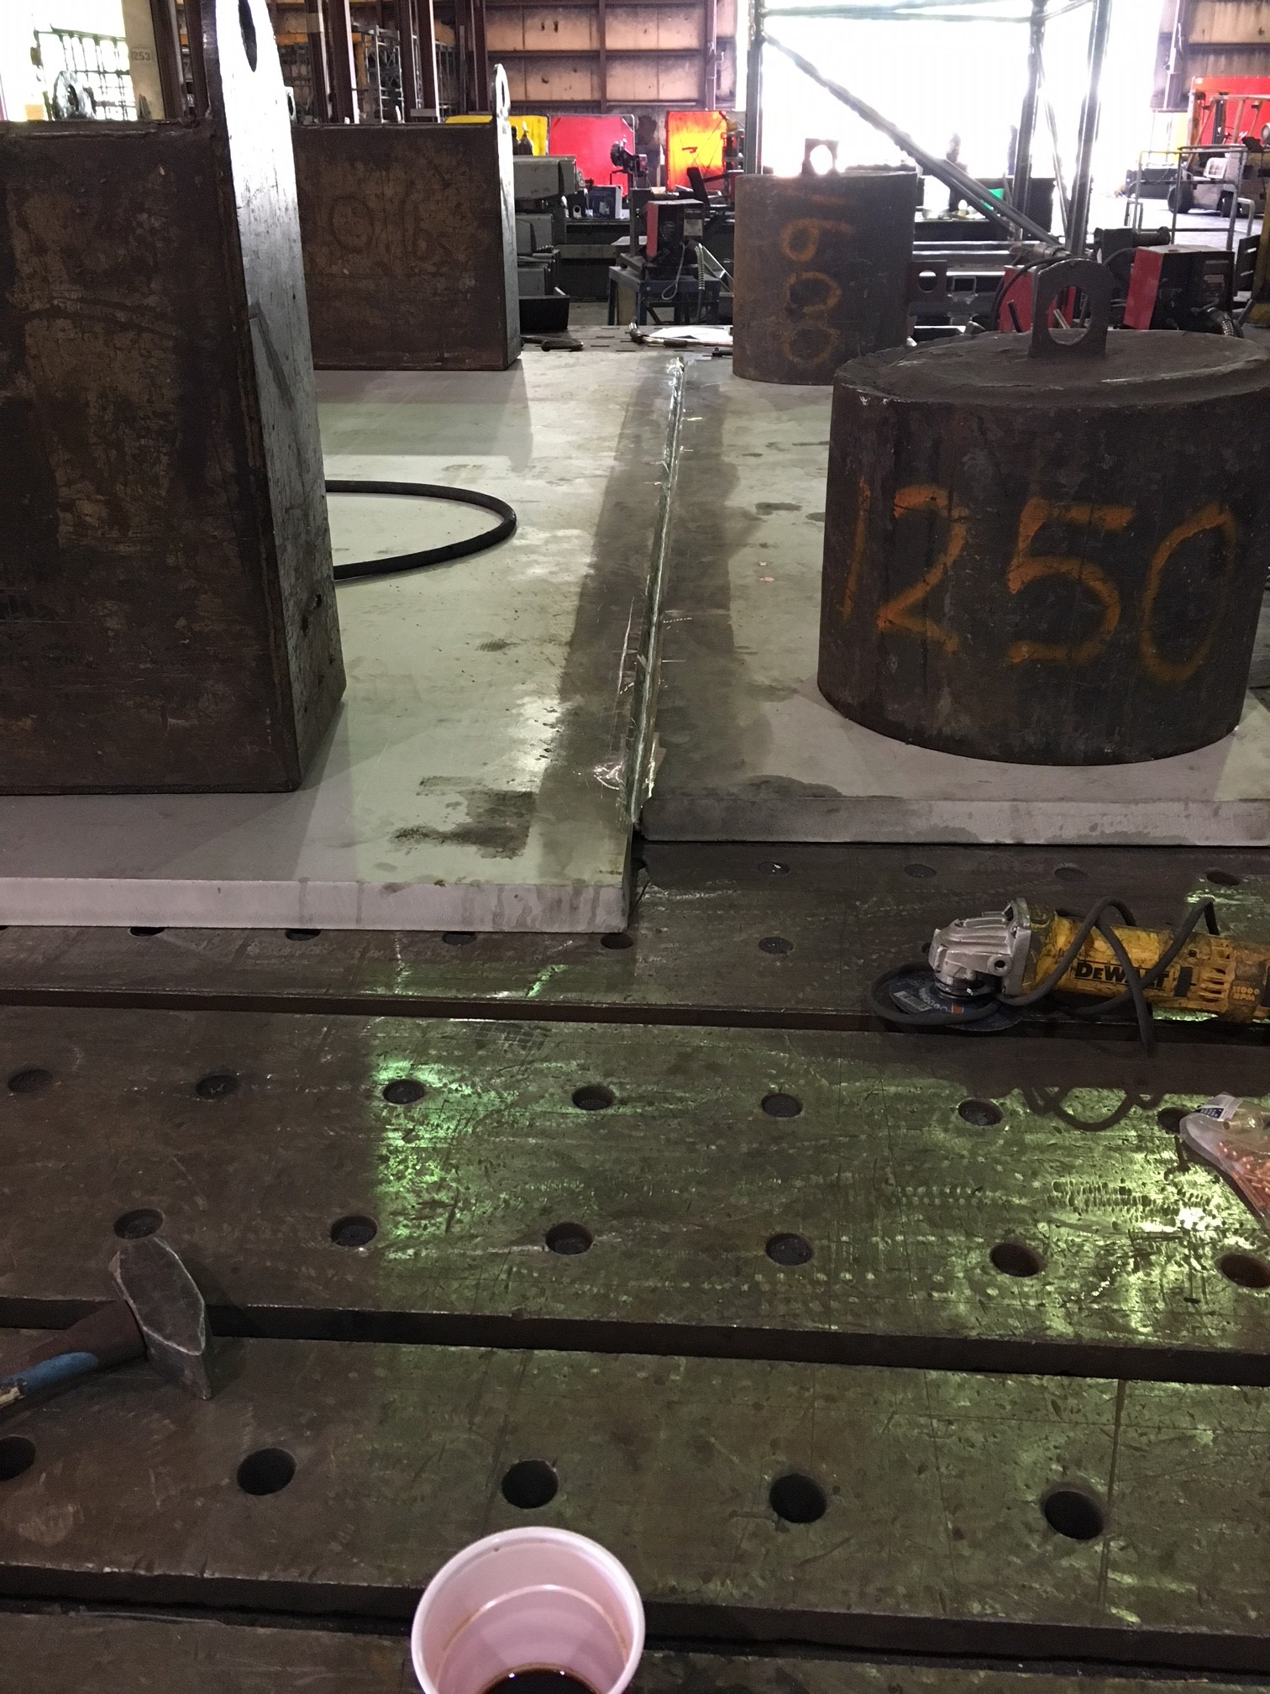

1. Delivery of 2K CB’s to SLAC scheduled for February 2019.

**4.5K Cold Box Status**

1. UCB1
   1. Platform hardware shipment delivered to SLAC this week.
      1. ALATAUS on site @SLAC with potential reassembly vendors.
2. LCB1
   1. Lower shell has been turned over, pipe supports are being removed from lower shell interior as part of preparation to mate the shell sections together. Welding on head manway ongoing.
3. UCB2
   1. Root pass welding ongoing between the head and lower shell. Tubing welds (to bulkhead nozzles) have been completed. Vacuum is being pulled on tubing lines to check for leaks prior to installing bottom head.
4. LCB2
   1. Final HX (3/4) and LHe subcooler have been installed, welding on support sections ongoing. Nozzle openings in shell are being fit checked.

**Interface Boxes**

1. Preliminary design review held was held 12-July 2018.
   1. Action items being tracked to closure.
2. FDR scheduled for October 2018.

**Cryo, Control, Releif Valves & Venturi**

1. Cryogenic valves – received; being prepared for distribution to vendors
2. Venturi – awarded; delivery scheduled for August.
3. Control valves awarded.
   1. Expediting long lead valves.
   2. Priority shall be coordinated with installation schedule.
4. Relief valves – preparing RFP

**Deliveries & Installation**

* Platforms for C1 upper cold box delivered to SLAC this week.
  + ALATUS visiting SLAC with potential reassembly vendors.
* Last two Oil removal vessels scheduled for delivery next week.
* Control enclosures scheduled for late August.

**Major Procurement Status**



**QUALITY**: Participated in a weekly call with Demaco, working to resolve action items from PDR.

Receipt inspection ongoing for assorted Cryogenic control valves from WEKA (waiting for documentation from vendor).

4.5K CBX documentation package was reviewed by the site CWI for required items; issues with the submission were identified. Detailed feedback on documents, drawings, inspections and stamps was provided to the CAM and other Managers.

SOTR & CWI for the 2K cold box top plate fabrication are onsite at the vendor to witness the root weld pass for compliance with code and subcontract performance requirements.

Closure welds for the first LN2 Dewar inner vessel are undergoing x-ray examination in accordance with ASME code compliance.

**Upcoming Travel/Reviews:**

* ALATUS-vendor site visit to SLAC (Reassembly) Week of 23-July-2018
* Monthly schedule status @PHPK 26-July-2018
* 4.5K cold box re-assembly meeting @SLAC 15-August-2018
* Control Enclosures (2nd phase) FAT 7&8-August-2018

Weekly Reporting

WBS 1.02.03.05.12 LLRF

Week of July 19-25, 2018

**Issues:** None

**Accomplishments this week at JLab: No updates from last week.**

* Resonance/Interlock Chassis:
  + Rama has the code working from LBNL. The next step is to begin building the EPICS interface with Sonya.
* LERF
  + RF cables: CM2 cables assembly have slowed due to CEBAF priorities.
  + LLRF communication: We currently can only communicate with the CM1 LLRF racks. We are trouble shooting CM2 racks.
  + HOM Measurement: No change from last week.
  + SSAs: Dian will be here from SLAC to discuss the isolator issue.
  + Cavity Test High Level Apps: Michelle Joyce is on vacation and will be back Wednesday.
  + LERF RR: Decided to hold preliminary reviews on cryo control/process and the remote operations in August. The readiness review will be in September.
* CMTF
  + Scott Higgins is investigating porting over the LERF SSA controls to the CMTF. These are much more functional with full fault screens.
  + SSA5: Larry Farrish has been trouble shooting this amplifier.
* Interlock Board/Chassis:
  + Work at this time is on hold until needed for 3.9 GHz.

**Upcoming Activities:**

* LERF Reviews (Cryo and Remote operation) in August
* LERF Readiness review in September.