Weekly Reporting

WBS 1.01.07 JLAB Management

Week of August 9-15, 2018

**Issues:**

Need to understand damaged bellows and restart production.

Need to understand the impact of the EAC.

**Accomplishments this week:**

Continue to participate in the shipping failure meetings.

Working on several shipping investigation LOI.

Acceptance testing of CM10 is completed and produced good results. Warm-up review was held.

Received the 10-week notice for the delivery of the 4.5 CB C2 UCB.

**Upcoming Activities:**

28-29 Aug DOE OPA Technical Review at FNAL

Sep 2018 LERF Readiness Review

Weekly Reporting

WBS 1.04.06 JLAB Cryomodules

Week of August 9-15, 2018

**Issues**: Risk of not having enough high performing cavities to complete the project.

**Accomplishments this week:**

Investigation and report writing on the bellows damage is completed. Currently on a production hold at work stations 3 & 4. The remaining items to release the production hold are: 1) LCLS-II project validation of JLab deliverables and 3) Approval by JLab and LCLS-II Directors.

Planning for visit by SLAC management (G. Hays, M. Weibel) to review production restart proposed by JLab.

J1.3-01, 03 & 07 – Waiting for cantilever fixture.

J1.3-02 – @ Stored; no further work planned.

J1.3-04 - @ WS4 - VV and 50K shield removed. Beamline bleed-up started on 14-Aug. Fastener rework started. Some delays due to priority for supporting FNAL visit to collaborate on FPC handling and installation procedures.

J1.3-05 - @ LERF; Used for fit up of stands.

J1.3-08 - @ WS5 - Beam pipe work complete. DESY shipping caps modified. HOM repair in progress.

J1.3-09 @ WS4 – Leak from insulating vacuum space to Helium circuit. NCR #1466. Coupler side helium vessel bellows on cavity 3. Cold mass is installed into VV. CM will be stored until rework path is identified.

J1.3-10 in the CMTF and cold at 2K. All cavities have been tested – total useable voltage is 156 MV. Seven cavities have no FE – three required pulsed processing to clean up. Cavity 1 FE onset at 12.5 MV/m. Qo measurements are completed with average Qo ~ 3.1e10. See table in SRF weekly presentation for details. Pre-warm up review planned for 15-August.

J1.3-11 @ WS3 – On hold pending investigation of damaged bellows on cavity 4. NCR #1477. Bellows restraints removed from cavities and tuners installed. Vacuum vessel moved to cantilever fixture to prepare for installing cold mass into VV. CM will be stored until rework path is identified.

J1.3-12 @ WS3 – On hold due to production stand down. Ready for WS3 pending restart. Tuner installation next step.

J1.3-13 @ WS2 – Ready for WS3 pending restart.

J1.3-14 @ WS2 – Two-phase pipe welding in progress. Titanium sheet welding in progress.

J1.3-15 – All cavities have been qualified. Awaiting string tooling removal from J1.3-13 contingent on production restart. Should be passed back to the string assembly team two weeks after restart.

Cavity qualification – Zanon has delivered 25/25 of tanked rework cavities (CRN18). Pass rate is 2 of 14 tested so far.

Four cavities (all RI 32+3 cavities) have been qualified for string 16.

First batch of 5 HOM BLAs expected to ship within two weeks. Some delay introduced due to visit by FNAL colleagues studying FPC handling and installation procedures.

**QUALITY**: Performed the first orbital welding calibration hold point for LCLS Helium string line 14 (both welds good).

Final inspection for LCLS LERF Optical Cavity Lift Rail welding by SRF.

**Upcoming Travel/Meetings:**

DOE OPA Technical Review at FNAL Sep 28-29 (E. Daly, N. Huque)

EZ/RI Vendor Visit 20-28 Aug (K. Wilson, A. Palczewski)

LINAC 2018 Sep 14-19 (A. Solopova)

Weekly Reporting

WBS 1.04.06 Cryomodules - LERF Conversion

Week of August 9-15, 2018

**Issues:** None

**Accomplishments this week:**

Updates & photos can be seen on the WIKI wiki.jlab.org

The I-Beam & trolley that will allow ease of movement of the ~500 Lbs bellows from CM #2 to the cryo-can has been machined, welded, inspected, painted & mounted to the ceiling. The beam will be load tested in a couple weeks when the trolley arrives.

Progress has been slow on the cryo-can at Eden, all of the pieces and parts have been delivered and sub-assemblies are coming together. Delivery is delayed and now looks like the first week of September.

RF cables for the waveguide couplers on CM #2 will be terminated in the next days. Once these are done and tested the SSA commissioning will continue.

SLAC folks will arrive Friday to continue commissioning the cryo control racks.

Weekly Reporting

WBS 1.04.08 JLAB Cryoplant System

Week of August 9-15, 2018

**Issues:**

1. Request to recreate P&IDs for the CryoPlant – There is no scope identified for this task. Current P&IDs are official reference documents for GC installation subcontract.
2. Resolution of interferences created during the design of the platforms and cable trays support systems (identified in 2017).
3. Installation of the LN2 Dewar and helium ‘tank farm’ foundations. The warm helium tanks have been in storage for several months awaiting completion of these supports.
4. Return funding to contingency; the top-down EAC has resulted in reduction of remaining cryoplant scope.

**Accomplishments this week:**

**2K Cold Box**

1. PHPK (2K CB):
   1. Received bottom shell material.
   2. Completed the inner piping spools.
2. Linde (2K CB):
   1. Materials on order.
   2. Fabrication has slipped due to materials and tooling not proceeding as planned. SO & SOTR have requested the schedule be recovered.
3. Top plate manufacturing holding schedule with new vendor (Craft).
   1. Delivery to 2K CB vendors on schedule for August.
   2. Second round (finish) machining of top plate in progress.
   3. As per direction from the project;
      * The first top plate will be delivered to Linde.
      * The second top plate shall be delivered to PHPK.

**4.5K Cold Box Status**

1. UCB1
   1. Cold box; CryoDuct & Platforms received @SLAC. (See below.)
2. LCB1
   1. Lower shell has been installed.
   2. Inner piping extensions through shell in progress.
   3. Heads will be installed followed by final closure welding.
3. Upper Cold Box (C2)
   1. Outer vacuum shell and heads installed.
   2. Initial pump-down for leak check in progress.
4. Lower Cold Box (C2)
   1. All heat exchangers installed; remaining piping spools being installed.

**LN2 Dewars**

1. Fabrication of the first dewar is holding schedule for September 2018 delivery at SLAC.
2. Inner vessel helium leak check successfully completed.
3. Outer vessel staged for integration once inner vessel completes He-leak check.

**Interface Boxes**

1. Action items being tracked to closure.
2. Design change request from SLAC forwarded to vendor for impact
   1. Integration with cold box room platform on going
3. FDR scheduled for October 2018.

**Cryo, Control, Relief Valves & Venturi**

1. Cryogenic valves – received; being prepared for shipment to vendors
2. Venturi – delivery scheduled early September.
3. Control valves awarded.
   1. Long lead valves expedited by 10-weeks.
   2. Priority assigned to valves needed for C1 cryoplant.
4. Relief valves – Procurement in progress.
   1. Award expected this month.

**Deliveries & Installation**

1. Installation of final spools for warm helium compressors complete.
   1. Punch list still remains open
2. Control enclosure delivery scheduled for late August.
3. Last two Oil removal vessels delivered to SLAC today.
   1. Surface corrosion discovered on inside of vessels.

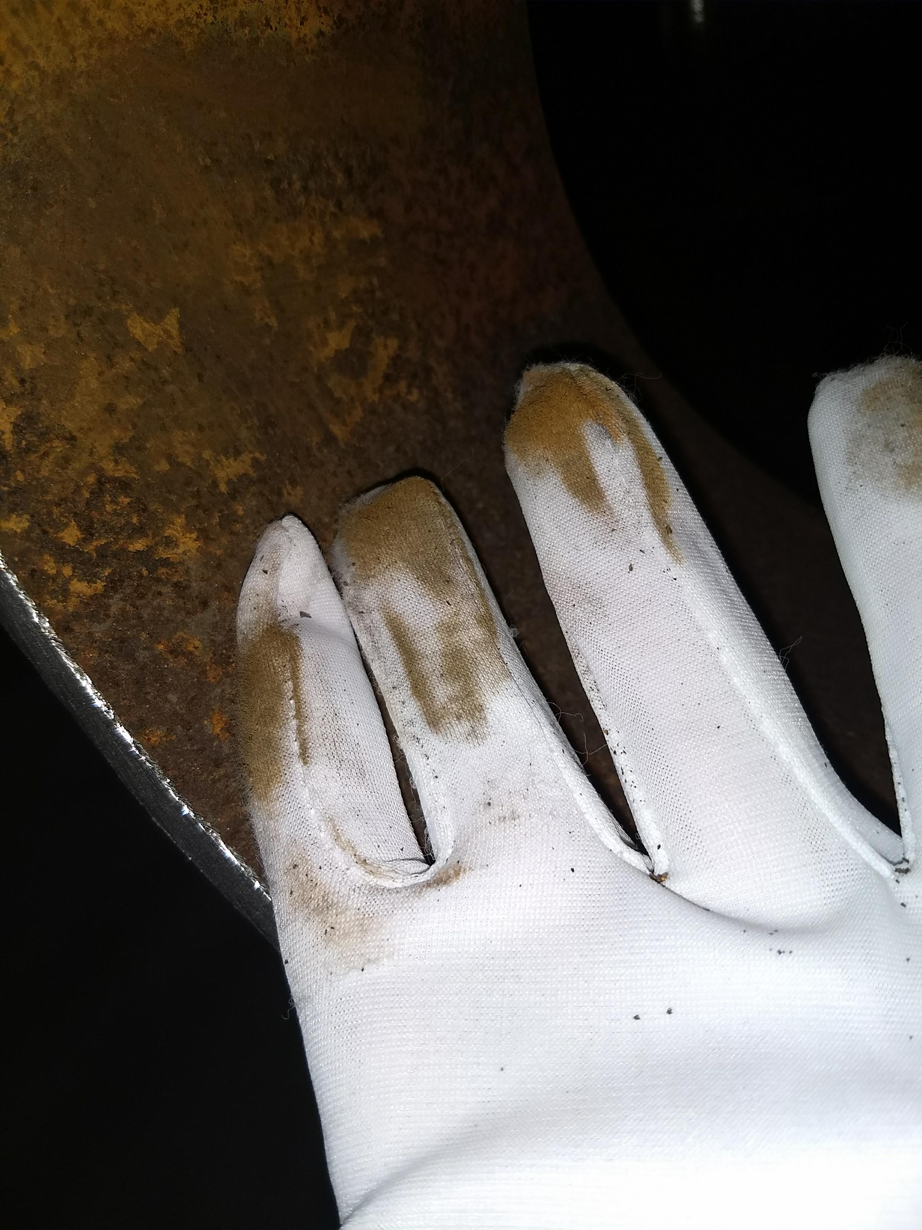

* 1. Investigation of additional oil removal vessels showed similar corrosion.
  2. Mitigation plan shall modify existing filtration system to capture and remove all contamination in order to prevent equipment damage and ensure no performance loss.
  3. Lessons learned are being documented and vendor shall be held accountable for providing poor quality.

**Major Procurement Status**



**QUALITY**: Conducted two weld reviews at Craft for LCLS 2K Cold Box Top Plates.

Working closely with Ability to get their plan for improving welding QA program/performance.

**Upcoming Travel/Reviews:**

* Site Visit @ PHPK Review Pump down Setup 15-August 2018
* Site Visit @ PHPK Review Leak check & Fab 23-August 2018
* IPR Review Support @FNAL 28-August-2018
* Site Visit @ PHPK Monthly Schedule Meeting 28-August 2018
* 4.5K Cold Box Re-assembly Meeting @SLAC 29-August-2018

Weekly Reporting

WBS 1.02.03.05.12 LLRF

Week of August 9-15, 2018

**Issues:** None

**Accomplishments this week at JLab:** No update.

**Upcoming Activities:**

* LERF Reviews (Cryo and Remote operation) in August
* LERF Readiness Review in September.