Weekly Reporting

WBS 1.01.07 JLAB Management

Week of August 16-22, 2018

**Issues:**

Need to understand the impact of the EAC.

Need to get the 1.04.06.07 EAC done.

**Accomplishments this week:**

Continue to participate in the shipping failure meetings.

Working on several shipping investigation LOI.

Preparing for the upcoming OPA review, 28-29 August.

**Upcoming Activities:**

28-29 Aug DOE/OPA IPR at FNAL

Sep 2018 LERF Readiness Review

22-27 Oct DOE OPA Mini Review at SLAC

Weekly Reporting

WBS 1.04.06 JLAB Cryomodules

Week of August 16-22, 2018

**Issues**: Risk of not having enough high performing cavities to complete the project.

**Accomplishments this week:**

Restarted production at work stations 3 & 4 on 20-Aug after completion of following items: 1) LCLS-II project validation of JLab deliverables recommended by Hays & Weibel (after visit on 16-Aug ) Approval by JLab Director and LCLS-II Project Director.

Continuing to support shipping work groups that have 13 LOIs. Completed activities for work group that described shipping differences for J1.3-07 compared with F1.3-05. Provided input to alternate shipping methods work group.

Developing proposed shipping test aimed at reducing shock and vibration loads to CMs during shipping by reducing and reconfiguring existing isolators on shipping fixture. Need concrete CM in order to perform first testing phase.

Prepared EAC slides for 1.04.06.07 CM procurements account. We are currently exceeding budget authority for this account. Presentation to CCB has been delayed several times during August. Need authorization from project to raise budget authorization.

Preparing impact statements for June EAC to be presented at CCB this Friday 24-Aug.

Preparing talks for DOE OPA Technical Review next week at FNAL.

Need to identify which CMs will be sent to LERF for first testing cycle. LERF will be ready by October but due to the production hold, CMs will not be available for testing for at least 2 months. Need to consider re-testing several reworked CMs in order to verify LERF test stand functionality.

J1.3-01, 03 & 07 – Waiting for cantilever fixture.

J1.3-02 – @ Stored; no further work planned.

J1.3-04 - @ WS4 - BPM hardware completed successfully and string pumped down. Fastener rework still in progress on UCM.

J1.3-05 - @ LERF; Used for fit up of stands.

J1.3-08 - @ WS5 - HOM repair in progress. First CM proposed for shipping to SLAC once shipping method is verified.

J1.3-09 @ WS6 – Moved to WS6. Preparing to move to offsite storage.

J1.3-10 in the CMTF and warm. U-tubes were removed on 20-Aug. CM will rest idle in cave until space at WS5 is available.

J1.3-11 @ WS6 – Moved to WS6. Preparing to move to offsite storage.

J1.3-12 @ WS3 – Tuner installation in progress.

J1.3-13 @ WS3 – Moved to WS3 on 20-Aug.

J1.3-14 @ WS2 – Two-phase pipe welding completed. Leak check in progress.

J1.3-15 – All cavities have been qualified. Awaiting string tooling removal from J1.3-13. Start is contingent pending receipt and inspection of four more couplers due at Jlab on 24-Aug due to availability of PICs. Planning string prep week for 04-Sep.

J1.3-16 – Six of eight cavities have been qualified for the string.

First batch of 5 HOM BLAs expected to ship within one week. Some delay was introduced due to visit by FNAL colleagues studying FPC handling and installation procedures.

**QUALITY**: Contributed to and submitted final report for bellows damage to J1.3-09 and J1.3-11, accepted by JLab and SLAC. Participated in SLAC visit to verify implementation of actions.

**Upcoming Travel/Meetings:**

DOE OPA Technical Review at FNAL Sep 28-29 (E. Daly, N. Huque)

EZ/RI Vendor Visit 20-28 Aug (K. Wilson, A. Palczewski)

LINAC 2018 Sep 14-19 (A. Solopova)

Weekly Reporting

WBS 1.04.06 Cryomodules - LERF Conversion

Week of August 16-22, 2018

**Issues:** None

**Accomplishments this week:**

Updates & photos can be seen on the WIKI wiki.jlab.org

The warm Helium piping work has begun; this includes cooldown and purge lines and flow meters.

SLAC folks (Kevin, Dayne, & Carolina) arrived on Friday to continue commissioning the cryo control racks. They have made good progress, both on checking out cables as well as the EPICS interface (see screen shots below).

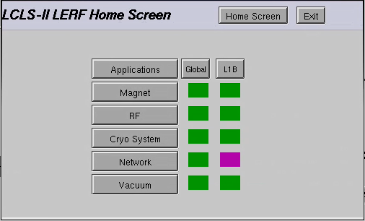

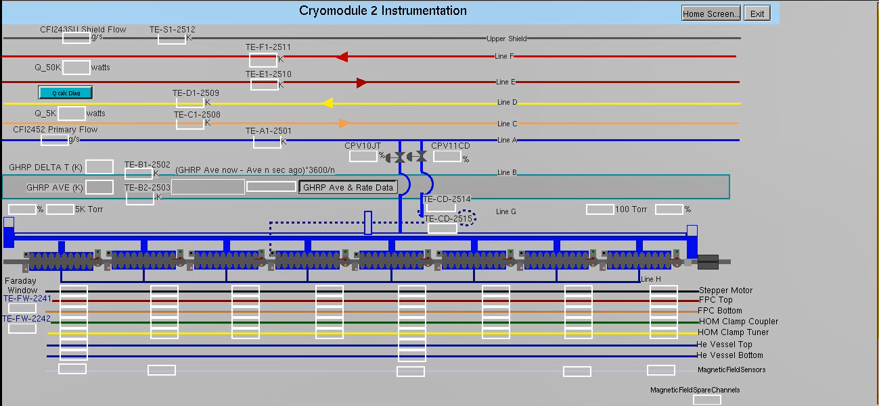

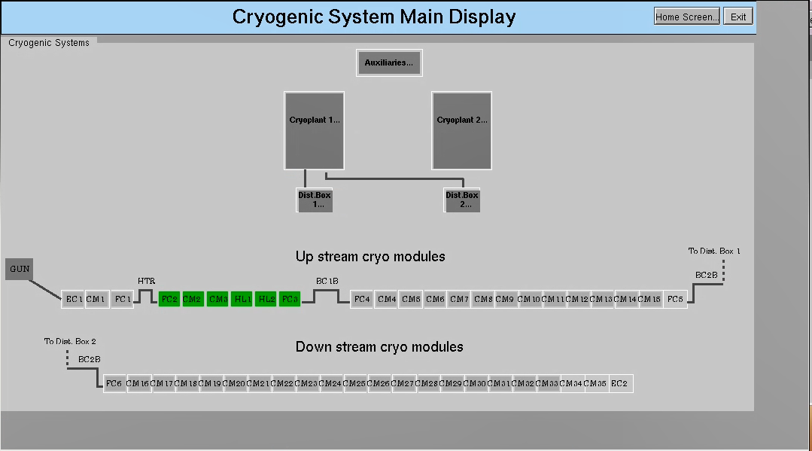

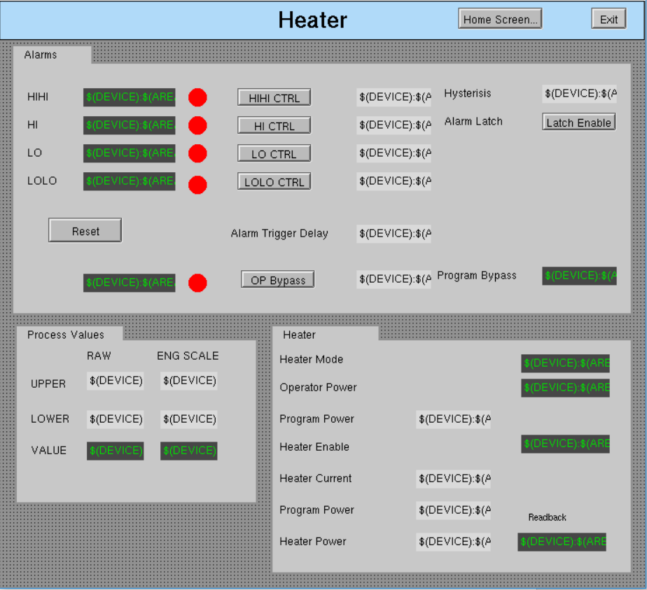

Weekly Reporting

WBS 1.04.08 JLAB Cryoplant System

Week of August 16-22, 2018

**Issues:**

1. Request to recreate P&IDs for the CryoPlant – There is no scope identified for this task. Current P&IDs are official reference documents for GC installation subcontract.
2. Resolution of interferences created during the design of the platforms and cable trays support systems (identified in 2017).
3. Installation of the LN2 Dewar and helium ‘tank farm’ foundations. The warm helium tanks have been in storage for several months awaiting completion of these supports.
4. Return funding to contingency; the top-down EAC has resulted in reduction of remaining cryoplant scope.

**Accomplishments this week:**

**2K Cold Box**

1. PHPK (2K CB):
   1. Staging shell material for assembly.
   2. Completed the inner piping spools.
2. Linde (2K CB):
   1. Fabrication has slipped due to materials and tooling not proceeding as planned. SO & SOTR have requested the schedule be recovered.
3. Top plate manufacturing holding schedule with new vendor (Craft).
   1. Delivery to 2K CB vendors on schedule for August.
   2. Second round (finish) machining of top plate in progress.
   3. As per direction from the project:
      * The first top plate will be delivered to Linde.
      * The second top plate shall be delivered to PHPK.

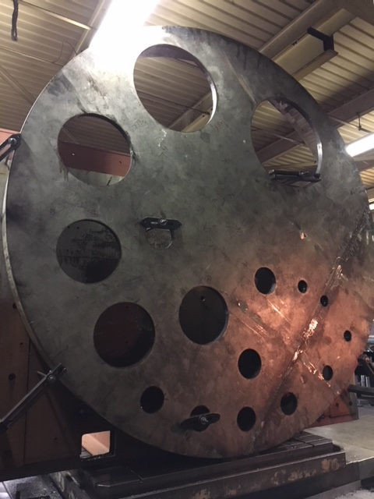

**4.5K Cold Box Status**

1. JLab technical staff onsite @PHPK every week to witness/report progress.
2. UCB1
   1. Cold box; CryoDuct & Platforms received @SLAC.
3. LCB1
   1. Welding legs; turbine nozzle's; instrumentation.
4. Upper Cold Box (C2)
   1. Pumped down; leak-checking shell in progress.
5. Lower Cold Box (C2)
   1. Nozzle's; valves; stiffening rings.

**LN2 Dewars**

1. Fabrication of the first dewar is holding schedule for September 2018 delivery at SLAC.
2. JLab procurement, technical and QA staff scheduled site visit next week.

**Interface Boxes**

1. Action items 14/17 actions items from PDR closed.
2. Design change request from SLAC forwarded to vendor for impact.
   1. Integration with cold box room platform design is a challenge.
3. FDR scheduled for October 2018.

**Cryo, Control, Relief Valves & Venturi**

1. Cryogenic valves – received; being prepared for shipment to vendors
2. Venturi – delivery scheduled next week.
3. Control valves awarded.
   1. Long lead valves expedited by 10-weeks.
   2. Priority assigned to valves needed for C1 cryoplant.
4. Relief valves – Procurement in progress.
   1. Award expected this month.

**Deliveries & Installation**

1. Installation of final spools for warm helium compressors complete.
   1. Punch list still needs to be completed.
2. Control enclosure delivery scheduled for early September.
3. Last two Oil removal vessels delivered to SLAC.
   1. Surface corrosion discovered on inside of vessels.
   2. Investigation of additional oil removal vessels showed similar corrosion.
   3. Mitigation plan shall modify existing filtration system to capture and remove all contamination in order to prevent equipment damage and ensure no performance loss.
   4. Lessons learned documented and vendor held accountable for providing poor quality.

**Major Procurement Status**



**QUALITY**: Issued formal answer to SLAC for welding concerns on Oil Removal Vessel manufactured by Eden Cryogenics for LCLS Cryoplant. Welds we reviewed were acceptable.

Conducted on-site welding reviews at Craft, provided feedback for 2K Cold Box Top Plates and Cold Mass assembly fixture.

Technical staff onsite at 4.5K cold box vendor every week to review progress.

SO, SOTR & CWI scheduled for site visits to He Purifier, Oil processing & LN2 Dewar manufacturing vendors next week to witness/review in-process QC.

**Upcoming Travel/Reviews:**

* Site Visit @ PHPK Review Leak check & Fab 23-August 2018
* IPR Review Support @FNAL 28-August-2018
* Site Visit @ PHPK 4.5K Schedule Meeting 28-August 2018
* Site Visit @ AET – He purifier fabrication 29-August 2018
* Site Visit @ PHPK – Oil processor & Cold box 30-August 2018
* Site Visit @ AES – LN2 Dewar fabrication 31-August 2018
* 4.5K Cold Box Re-assembly Meeting @SLAC 06-September-2018

Weekly Reporting

WBS 1.02.03.05.12 LLRF

Week of August 16-22, 2018

**Issues:** None

**Accomplishments this week at JLab:**

* Resonance/Interlock Chassis:
  + EPICS driver is slowly coming together. Summer vacations are taking their toll.
* LERF
  + RF cables: CM2 RF cables are partially terminated. CEBAF priorities are slowing this down.
  + LLRF Chassis communication: Bugs are still being worked out in CM 1 and 2.
  + HOM Measurement: No change from last week.
  + LERF Readiness Review: Matt Marchlik has drafted cryo processes (Cool down, Warm up etc.) that are being reviewed by the cryo group. Wes Moore has a draft presentation of the remote access and IOC access. We are looking at a review in late September.
* CMTF
  + SSA Control Screens: Higher priorities are keeping controls from moving this over from the LERF.
* Interlock Board/Chassis:
  + Work at this time is on hold until needed for 3.9 GHz.

**Upcoming Activities:**

* LERF Readiness review in September.