Weekly Reporting

WBS 1.01.07 JLAB Management

Week of August 23-29, 2018

**Issues:**

Need to understand the impact of the EAC.

Need to get the 1.04.06.07 EAC done.

**Accomplishments this week:**

Continue to participate in the shipping failure meetings.

Working on several shipping investigation LOI.

Participate in the OPA review, 28-29 August.

**Upcoming Activities:**

Sep 2018 LERF Readiness Review

Weekly Reporting

WBS 1.04.06 JLAB Cryomodules

Week of August 23-29, 2018

**Issues**: Risk of not having enough high performing cavities to complete the project.

**Accomplishments this week:**

Continuing to support shipping work groups that have 13 LOIs as requested.

Developing proposed shipping test aimed at reducing shock and vibration loads to CMs during shipping by reducing and reconfiguring existing isolators on shipping fixture. Concrete CM arrived at JLab on 28-Aug.

Results from initial hammer tests on J1.3-07 cold bellows flange have been completed and data analysis is underway.

Developing removable shipping restraints for cold coupler bellows to be used with follow-on shipping tests.

Working on month’s end progress for August.

Prepared EAC slides for 1.04.06.07 CM procurements account. Need authorization from project to raise budget authorization.

Preparing impact statements for June EAC to be presented at CCB in the future (cancelled on Friday 24-Aug).

Preparing talks for and participating in DOE OPA Technical Review this week at FNAL.

Need to identify which CMs will be sent to LERF for first testing cycle. LERF will be ready by October but due to the production hold, CMs will not be available for testing for at least 2 months. Need to consider re-testing several reworked CMs in order to verify LERF test stand functionality.

J1.3-01, 03 & 07 – Waiting for cantilever fixture.

J1.3-02 – @ Stored; Plan to move off-site (Blue Crab) on 29-Aug.

J1.3-04 - @ WS4 - Fastener rework complete. He vessel bellows inspected. Changes that correspond with latest drawing complete. HOMs checked.

J1.3-05 - @ LERF; Used for fit up of cabling.

J1.3-08 - @ WS5 - HOM repair complete. Ready to ship. Note that HV bellows have not been inspected.

J1.3-09 @ WS6 – Moved to WS6. Preparing to move to offsite storage on 29-Aug.

J1.3-10 in the CMTF and warm. U-tubes were removed on 20-Aug. CM will rest idle in cave until space at WS5 is available to inspect HV bellows.

J1.3-11 @ WS6 – Moved to WS6. Preparing to move to offsite storage on 29-Aug.

J1.3-12 @ WS3 – Tuner installation in progress.

J1.3-13 @ WS3 – Lollipops returned for next string. Cooldown lines welding in progress.

J1.3-14 @ WS2 – Leak check complete. Instrumentation in progress.

J1.3-15 – All cavities have been qualified. Received string tooling removal from J1.3-13. Start is contingent pending receipt and inspection of four more couplers due at Jlab on 24-Aug due to availability of PICs. Planning string prep week for 04-Sep.

J1.3-16 – Seven of eight cavities have been qualified for the string.

First batch of 5 HOM BLAs expected to ship within one week. Currently on hold to evaluate furnace run data.

**QUALITY**: no report.

**Upcoming Travel/Meetings:**

DOE OPA Technical Review at FNAL Sep 28-29 (E. Daly, N. Huque)

EZ/RI Vendor Visit 20-28 Aug (K. Wilson, A. Palczewski)

LINAC 2018 Sep 14-19 (A. Solopova)

Weekly Reporting

WBS 1.04.06 Cryomodules - LERF Conversion

Week of August 23-29, 2018

**Issues:** None

**Accomplishments this week:** No report.

Updates & photos can be seen on the WIKI wiki.jlab.org

Weekly Reporting

WBS 1.04.08 JLAB Cryoplant System

Week of August 23-29, 2018

**Issues:**

1. Request to recreate P&IDs for the CryoPlant – There is no scope identified for this task. Current P&IDs are official reference documents for GC installation subcontract.
2. Resolution of interferences created during the design of the platforms and cable trays support systems (identified in 2017).
3. Installation of the LN2 Dewar and helium ‘tank farm’ foundations. The warm helium tanks have been in storage for several months awaiting completion of these supports.
4. Return funding to contingency; the top-down EAC has resulted in reduction of remaining cryoplant scope.

**Accomplishments this week:**

**2K Cold Box**

1. PHPK (2K CB):
   1. Completed the inner piping spools.
   2. Shell and heads prepared for painting.

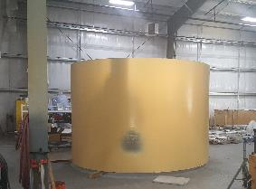 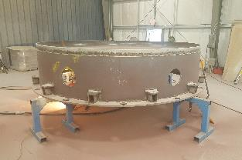

1. Linde (2K CB):
   1. Fabrication materials were received.
   2. Fabrication has slipped due to materials and tooling not proceeding as planned. SO & SOTR have requested the schedule be recovered.
2. Top plate manufacturing holding schedule with new vendor (Craft).
   1. Delivery to 2K CB vendors is now expected for early September.
   2. Second round (finish) machining of top plate in progress.
   3. As per direction from the project:
      * The first top plate will be delivered to Linde.
      * The second top plate shall be delivered to PHPK.

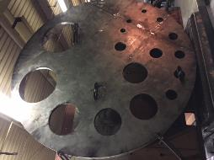

**4.5K Cold Box Status**

1. JLab technical staff onsite @PHPK every week to witness/report progress.
2. Monthly progress meeting held this week 28-Aug-2018.
3. UCB1
   1. All materials received @SLAC.
   2. Reassembly coordination meeting scheduled for 06-Sep-2018 @SLAC
4. LCB1
   1. Welding legs; turbine nozzle's; valves& instrumentation.

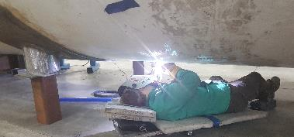

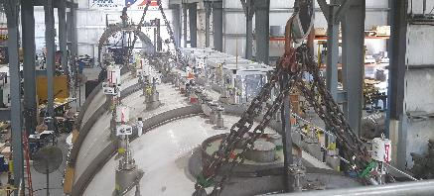

1. Upper Cold Box (C2)
   1. Pumped down; leak-checking shell in progress.

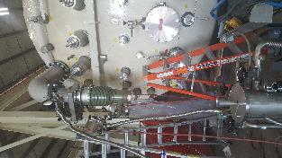 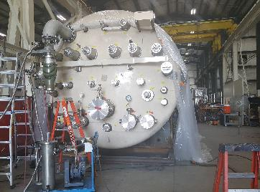

1. Lower Cold Box (C2)
   1. Nozzle's; valves; stiffening rings & process piping in progress.

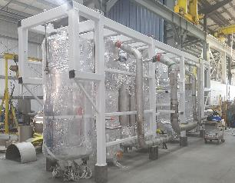

**LN2 Dewars**

1. Fabrication of the first dewar is holding schedule for September 2018 delivery at SLAC.
2. JLab procurement, technical and QA staff scheduled site visit this week.

**Interface Boxes**

1. Action items 14/17 actions items from PDR closed.
2. Design change request from SLAC forwarded to vendor for impact.
   1. Integration with cold box room platform design is a challenge.
3. FDR scheduled for October 2018.

**Cryo, Control, Relief Valves & Venturi**

1. Cryogenic valves – received; being prepared for shipment to vendors
2. Venturi – delivery scheduled for next week.

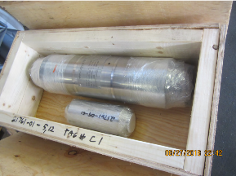 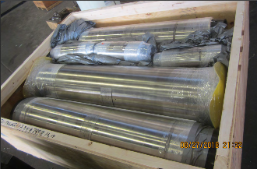

1. Control valves awarded.
   1. Long lead valves expedited by 10-weeks.
   2. Priority assigned to valves needed for C1 cryoplant.
2. Relief valves – Procurement in progress.
   1. Award expected this month.

**Oil Processing**

1. All (60 barrels) oil has been processed at PHPK
2. Site scheduled for this week to review quality prior to shipment to SLAC

**Deliveries & Installation**

1. Installation of final spools for warm helium compressors complete.
   1. Punch list still needs to be completed.
2. Control enclosure delivery scheduled for early September.
3. Last two Oil removal vessels delivered to SLAC.
   1. Surface corrosion discovered on inside of vessels.
   2. Investigation of additional oil removal vessels showed similar corrosion.
   3. Mitigation plan shall modify existing filtration system to capture and remove all contamination in order to prevent equipment damage and ensure no performance loss.
   4. Lessons learned documented and vendor held accountable for providing poor quality.
   5. A review of the weld quality of the vessels has determined the vessels certified as per the U-1A data report certificate.

**Major Procurement Status**



**QUALITY**: Issued formal answer to SLAC for welding concerns on Oil Removal Vessel manufactured by Eden Cryogenics for LCLS Cryoplant. Welds we reviewed were acceptable as per ASME, Section VIII, Division 1.

Technical staff onsite at 4.5K cold box vendor every week to review progress.

SO, SOTR & CWI scheduled for site visits to He Purifier, Oil processing & LN2 Dewar manufacturing vendors this week to witness/review in-process QC.

**Upcoming Travel/Reviews:**

* IPR Review Support @FNAL 28-August-2018
* Site Visit @ PHPK 4.5K Schedule Meeting 28-August 2018
* Site Visit @ AET – He purifier fabrication 29-August 2018
* Site visit @SLAC – JLab Controls staff monthly 28-30-August 2018
* Site Visit @ PHPK – Oil processor & Cold box 30-August 2018
* Site Visit @ AES – LN2 Dewar fabrication 31-August 2018
* 4.5K Cold Box Re-assembly Meeting @SLAC 06-September-2018

Weekly Reporting

WBS 1.02.03.05.12 LLRF

Week of August 23-29, 2018

**Issues:** None

**Accomplishments this week at JLab:** No report.

**Upcoming Activities:**

* LERF Readiness review in September.