Weekly Reporting

WBS 1.01.07 JLAB Management

Week of September 6-12, 2018

**Issues:**

**Accomplishments this week:**

Continue to participate in the shipping failure meetings.

Working on several shipping investigation LOI.

Telecon with MSU/FRIB to discuss their in-house Quality system.

All CP government furnished equipment has been received at SLAC.

**Upcoming Activities:**

Oct 2018 LERF Readiness Review

Weekly Reporting

WBS 1.04.06 JLAB Cryomodules

Week of September 6-12, 2018

**Issues**:

**Accomplishments this week:**

Continuing to support shipping work groups that have 14 LOIs as requested.

Conducted first phase of shipping test with concrete CM. Completed measurements on shipping frame with 8, 10 and 12. Recommend using 8 for further testing on J1.3-07. Awaiting sign-off on the test plan. J1.3-07 shipping caps are being installed in advance of next round of shipping tests. Next round of hammer tests on J1.3-07 will be conducted once caps are installed.

Developing removable shipping restraints for cold coupler bellows to be used with follow-on shipping tests.

Need to identify which CMs will be sent to LERF for first testing cycle. Identified CM-14 and CM-15 as first CMs to LERF in advance of Feb-2019 testing. Alternatives include limited re-test of CM-05 that currently resides in vault and receipt of FNAL CM for testing after shipment.

J1.3-01, 03 & 08 – Waiting for cantilever fixture.

J1.3-02 @ BlueCrab – Moved to offsite storage on 29-Aug.

J1.3-04 @ WS4 - Fastener rework complete. He vessel bellows inspected. Changes that correspond with latest drawing complete. HOMs checked.

J1.3-05 @ LERF; Used for fit up of cabling.

J1.3-07 @ WS5 – Installing shipping caps in preparation for hammer test and shipping test.

J1.3-09 @ BlueCrab – Moved to offsite storage on 29-Aug.

J1.3-10 @ CMTF - CM will rest idle in cave until space at WS4/5 is available to inspect HV bellows.

J1.3-11 @ BlueCrab – Moved to offsite storage on 29-Aug.

J1.3-12 @ WS3 – Tuner installation completion.

J1.3-13 @ WS3 – Cooldown lines welding and leak check complete. Mag lead soldering in progress.

J1.3-14 @ WS2 – Leak check complete. Instrumentation and Mag shields are in progress.

J1.3-15 – All cavities have been qualified. Re-planned string prep week for 10-Sep due to availability of key staff. Expect completion by 27-Sep. Hurricane may delay prep start by one week.

J1.3-16 – All cavities have been qualified for the string.

First batch of five HOM BLAs remains on hold.

Telecon with MSU/FRIB staff - Laura Popielarski (Cold Mass lead) and Mike Goodrich (QA Engineer III). Initial discussion regarding their Quality Systems.

**QUALITY**: SLAC, FNAL and JLab QA discussed identified QA issues from the recent review and and possible paths forward.  Resolution and actions TBD.

**Upcoming Travel/Meetings:**

LINAC 2018 Sep 14-19 (A. Solopova)

QA/QC Workshop at MSU/FRIB (TBD, TBD date)

Weekly Reporting

WBS 1.04.06 Cryomodules - LERF Conversion

Week of September 6-12, 2018

**Issues:** None

**Accomplishments this week:**

K. Jordan on travel attending IBIC in China.

RF cable terminations are completed upstairs, only a subset of cables in the vault remain.

Cryo can vendor visit on 11-Sep. Can is making progress. Expect completion and shipment by early October.

LERF Operational Safety Procedure is progressing – expect draft suitable for review in two weeks.

Making plans for Readiness Review in October.

Updates & photos can be seen on the WIKI wiki.jlab.org

Weekly Reporting

WBS 1.04.08 JLAB Cryoplant System

Week of September 6-12, 2018

**Issues:**

1. Reduction in baseline resources (Return funding to contingency; the top-down EAC ) without corresponding reduction in scope of cryoplant commissioning.
2. Resolution of structural interferences created during the design of the platforms and cable trays support systems (identified in 2017).
3. Installation of the LN2 Dewar and helium ‘tank farm’ foundations. The warm helium tanks have been in storage for several months awaiting completion of these supports.
4. Engineering change request associated with the interface box design-build subcontract resulting in delay.

**Accomplishments this week:**

2K Cold Boxes:

* Government furnished equipment (GFE) delivered to vendors
* Cryogenic valves, cold compressor casings, venturi

4.5K Cold boxes:

* Reassembly meeting held @SLAC 06-Sep-2018
* ALATUS, PHPK, JLab in attendance
* ALATUS did not have reassembly vendor under contract
* Follow-up meeting scheduled for later this month

C1 Lower Cold Box (LCB)

* Shell & first head installed; penetration welding in progress

C2 Upper cold box (UCB)

* Staged for final witness leak check next week

C2 Lower Cold Box

* Valves & process piping in progress

Oil processing:

* All (60 barrels) oil processing complete @PHPK

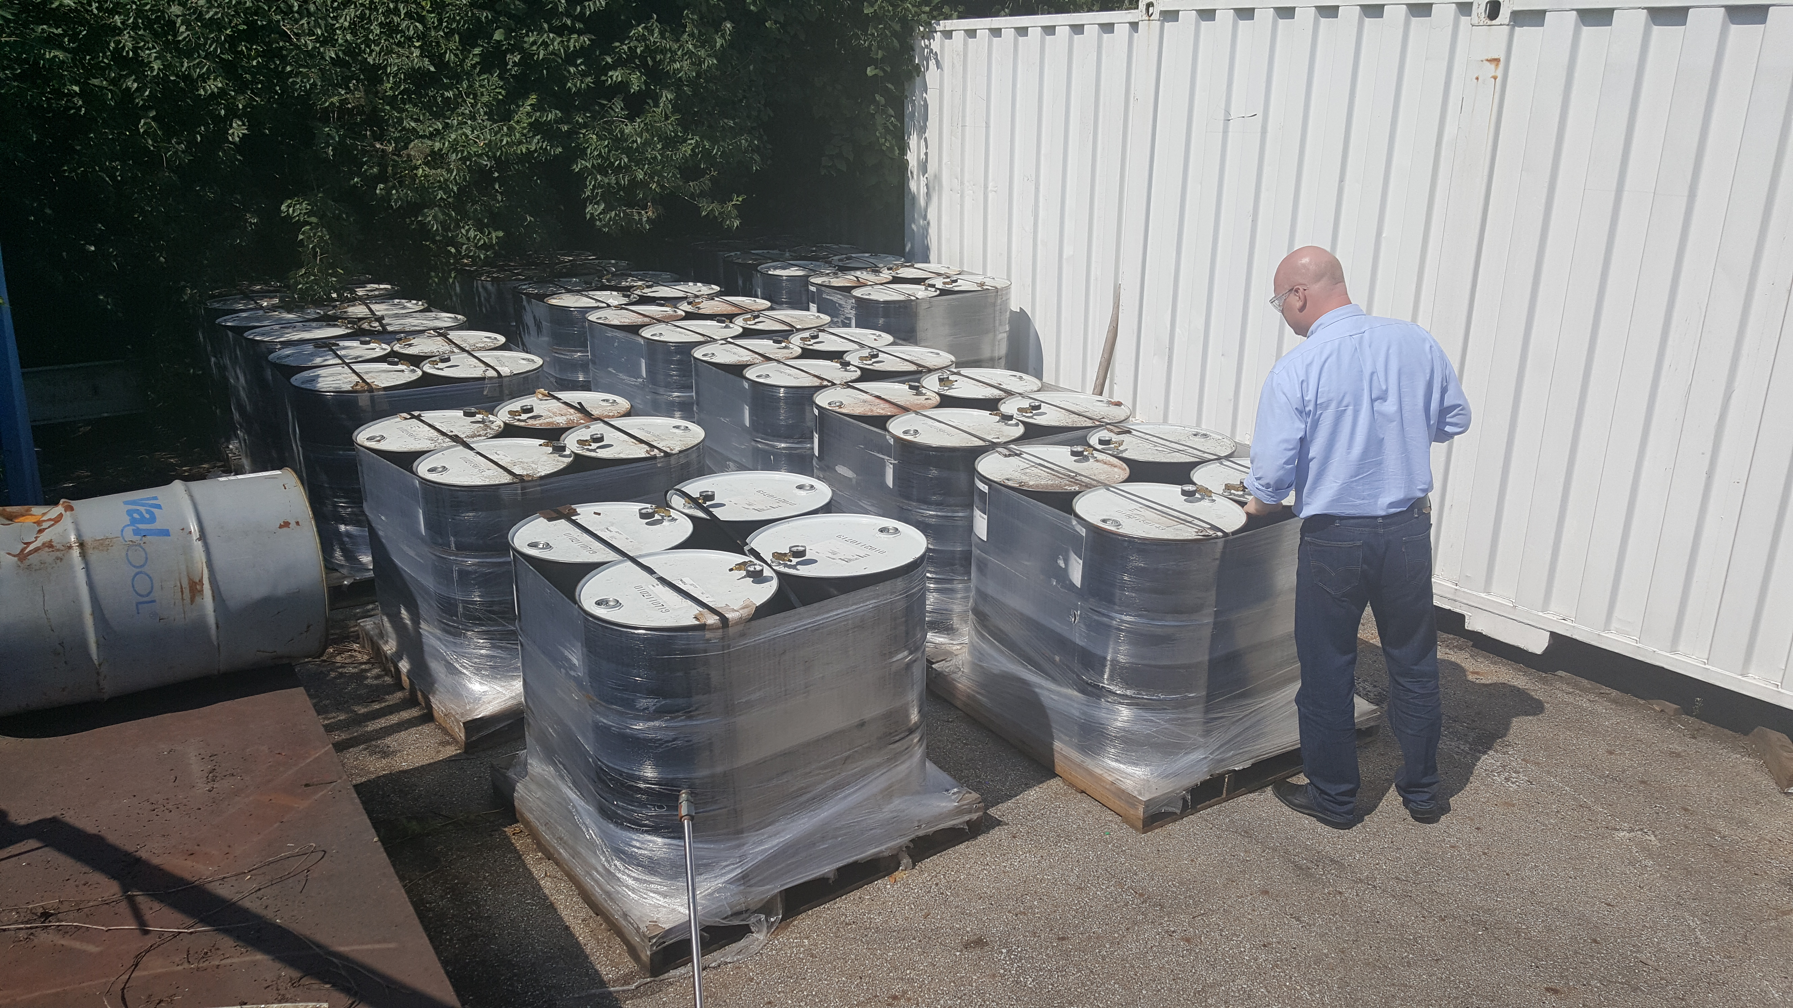

Controls Enclosures:

* Phase-2 (cold boxes) enclosures delivered to SLAC

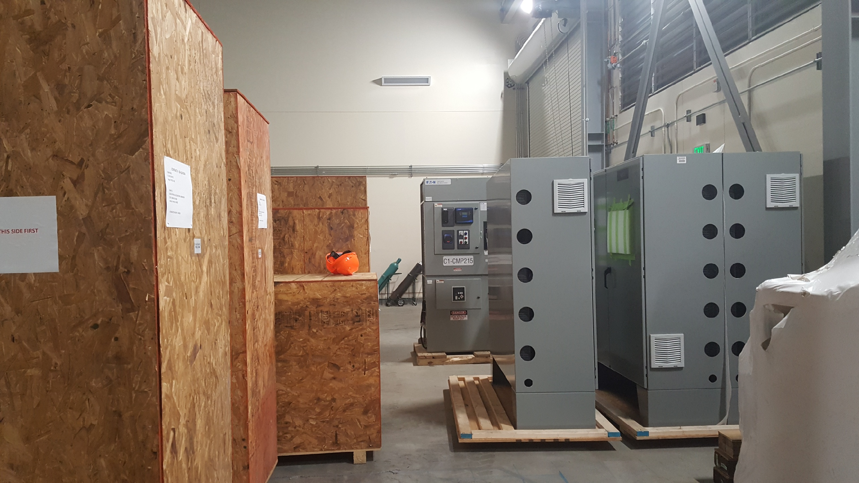

**Quality:** Conducted onsite Vendor (Craft) welding review for LCLS 2K Cold Box Top Plates (2x) and Cold Mass Assembly Fixture (2x).

Weekly call with Demaco, all action items closed from PDR and disclosed the platform will be in place PRIOR to installing DBX and INTF lines.

**Upcoming Travel/Reviews:**

* 4.5K C2 Upper Cold Box Final Leak-check @PHPK 06-Sep-2018
* 4.5K Control logic meeting @ALATUS (27-28)-Sep-2018
* Delivery of C2 UCB @SLAC Early October

Weekly Reporting

WBS 1.02.03.05.12 LLRF

Week of September 6-12, 2018

**Issues:** None

**Accomplishments this week at JLab:**

* Resonance/Interlock Chassis:
* EPICS driver: We are waiting on LBNL to give us the first cut of an EPICS driver.
* Rama drafted a Resonance and Interlocks procedure that is being reviewed and updated now by the team.
* LERF
* RF cables: We are slowly getting back to terminating the cables after recovering CEBAF.
* LLRF Chassis communication: The investigation has turned to 7-volt power supply voltages (too low) on the FPGA board. Larry, Rama and Curt measuring the voltages at various places along the path to the board.
* HOM Measurement: No change from last week.
* LERF Readiness Review:
  + - Matt is pursuing feedback on the cryo procedures from the cryo group (which is very busy with CEBAF recovery).
    - Mike Spata (Acc Div Deputy) was asked by Stuart Henderson to make sure there is a formal policy for remote operations in the LERF.
* CMTF
* SSA Control Screens: Higher priorities are keeping controls from moving this over from the LERF.
* Interlock Board/Chassis:
* Work at this time is on hold until needed for 3.9 GHz.

**Upcoming Activities:**

* Commission CM2 SSAs in the LERF.
* LERF Readiness review in October.