Weekly Reporting

WBS 1.01.07 JLAB Management

Week of September 20-26, 2018

**Issues:**

**Accomplishments this week:**

Continue to participate in the shipping failure meetings.

Working on several shipping investigation LOI.

Participated in the 4.5 K CB progress meeting and witnessed the loading of the C2 UCB at PHPK.

**Upcoming Reviews:**

Oct 2018 LERF Readiness Review

Nov 2018 CM Shipping Review

Dec 2018 DOE OPA Mini Review

Weekly Reporting

WBS 1.04.06 JLAB Cryomodules

Week of September 20-26, 2018

**Issues**:

**Accomplishments this week:**

Set up account to track charges related to out-of-scope shipping efforts.

Continuing to support shipping work groups (14 LOIs) as requested.

Conducted next round of hammer tests on J1.3-07 and reviewed results internally. Planning tests with removable shipping restraints.

Developing removable shipping restraints for cold coupler bellows to be used with follow-on shipping tests.

Need to identify which CMs will be sent to LERF for first testing cycle. Identified J1.3-14 and J1.3-15 as first CMs to LERF in advance of Feb-2019 testing. Requested project to consider leaving J1.3-05 in place and minimize testing.

Received requests for conducting shaker table tests and CCM shipment to SLAC. Wrote draft test plan for shaker tests for review. Work will proceed once test plan is approved.

EZ has continuing issues with the furnace the may impact cavity deliveries. RI has reported furnace issues and has contacted vendor to evaluate issue.

SLAC visiting JLab this week (9/19-9/21) to witness warm coupler removal and installation.

BCR for descope items ($630K) – JLab list is finalized.

BCR to include cost of inspecting bellows on J1.3-08 & J1.3-10 was facilitated. Preparing BCR presentation for this Friday 28-SEP.

J1.3-01, -03 @ WS6 – Waiting for cantilever fixture.

J1.3-02 @ BlueCrab – Moved to offsite storage on 29-Aug.

J1.3-04 @ WS5 – Moved to WS5. JT valves in progress. Warm coupler installation in progress. SLAC was on-site to observe warm coupler installation.

J1.3-05 @ LERF; Used for fit up of cabling.

J1.3-07 @ WS6 – Installed shipping caps. Hammer tests are on-going.

J1.3-08 – Waiting for cantilever fixture. Beam pipes prepared; MC Line removal in progress; Warm coupler removal in progress.

J1.3-09 @ BlueCrab – Moved to offsite storage on 29-Aug. NCR #1466

J1.3-10 @ CMTF - CM will rest idle in cave until space at WS4/5 is available to inspect HV bellows.

J1.3-11 @ BlueCrab – Moved to offsite storage on 29-Aug. NCR #1477

J1.3-12 @ WS4 – Vac Vessel demag complete. Fastener Checklist complete. HOM tuning complete. 50K shields are being installed.

J1.3-13 @ WS3 – Magnet lead soldering complete. String alignment started.

J1.3-14 @ WS3 – Moved to WS3.

J1.3-15 – All cavities have been qualified. Re-planned string prep week for 24-Sep due to lab actions related to recent staffing issues. Assembly will begin on 1-Oct with roll-out planned for 11-Oct.

J1.3-16 – All cavities have been qualified for the string. Return of lollipop tooling from J1.3-14 may affect string assembly start date.

J1.3-17 – Two cavities have been qualified for the string.

First batch of five HOM BLAs remains on hold.

**QUALITY**: Warm Helium Gas Piping in LERF completed up to Cryo Can Tie In (Can is due 10-3-18). Fast Cool Down Piping in LERF completed up to Cryo Can Tie In.

**Upcoming Travel/Meetings:**

QA/QC Workshop at MSU/FRIB (TBD, TBD date)

Weekly Reporting

WBS 1.04.06 Cryomodules - LERF Conversion

Week of September 20-26, 2018

**Issues:** None

**Accomplishments this week:**

Updates & photos can be seen on the WIKI wiki.jlab.org

The last of the RF cables for CM #2 are finished, the couplers & shorts are installed for SSA testing at full power (photo).

Warm helium piping and instrumentation is complete & waiting on delivery of the cryo can (photo).

Eden Cryogenics are still preparing for the acceptance test, they had started to pump down for the leak check but the way they had configured the piping it was not possible to fully cold shock all of the internal piping. This was reworked and should be ready for final inspection & pressure testing in a week or so.

A leak developed in the SSA heat exchanger in the area of a poorly done braze joint. We are awaiting guidance from Dian to get a replacement.

|  |  |
| --- | --- |
| ../../../../../Pictures/Photos%20Library.photoslibrary/resources/proxies/derivatives/2c/00/2cb9/UNADJUSTEDNONRAW_thumb_2cb9.  Shorts installed for SSA testing | Transferline & warm helium piping |
| Cryo can at Eden Cryogenics. | Bellows with degaussing coil frame. |

Weekly Reporting

WBS 1.04.08 JLAB Cryoplant System

Week of September 20-26, 2018

**Issues:**

1. Reduction in baseline resources (Return funding to contingency; the top-down EAC) without corresponding reduction in scope of cryoplant commissioning.
2. Resolution of structural interferences created during the design of the platforms and cable trays support systems (identified in 2017).
3. Installation of the LN2 Dewar and helium ‘tank farm’ foundations. The warm helium tanks have been in storage for several months awaiting completion of these supports.
4. Engineering change request associated with the interface box design-build subcontract resulting in delay.

**Accomplishments this week:**

2K Cold Boxes:

* + Government furnished equipment (GFE) delivered to vendors.
  + First top-plate received at Linde.
  + Second top plate scheduled to ship to PHPK in two weeks.

4.5K Cold boxes:

* + Follow-up re-assembly meeting scheduled for 10-October-2018.

C1 Lower Cold Box (LCB) 92+% complete

* + Shell & heads installed; final closure welding in progress.
  + 10-week shipping notice issued.

C2 Upper cold box (UCB) 99% complete

* + Completed C2 Upper cold box loaded onto trailer for shipment.
  + Delivery scheduled for 06-Oct-2018.

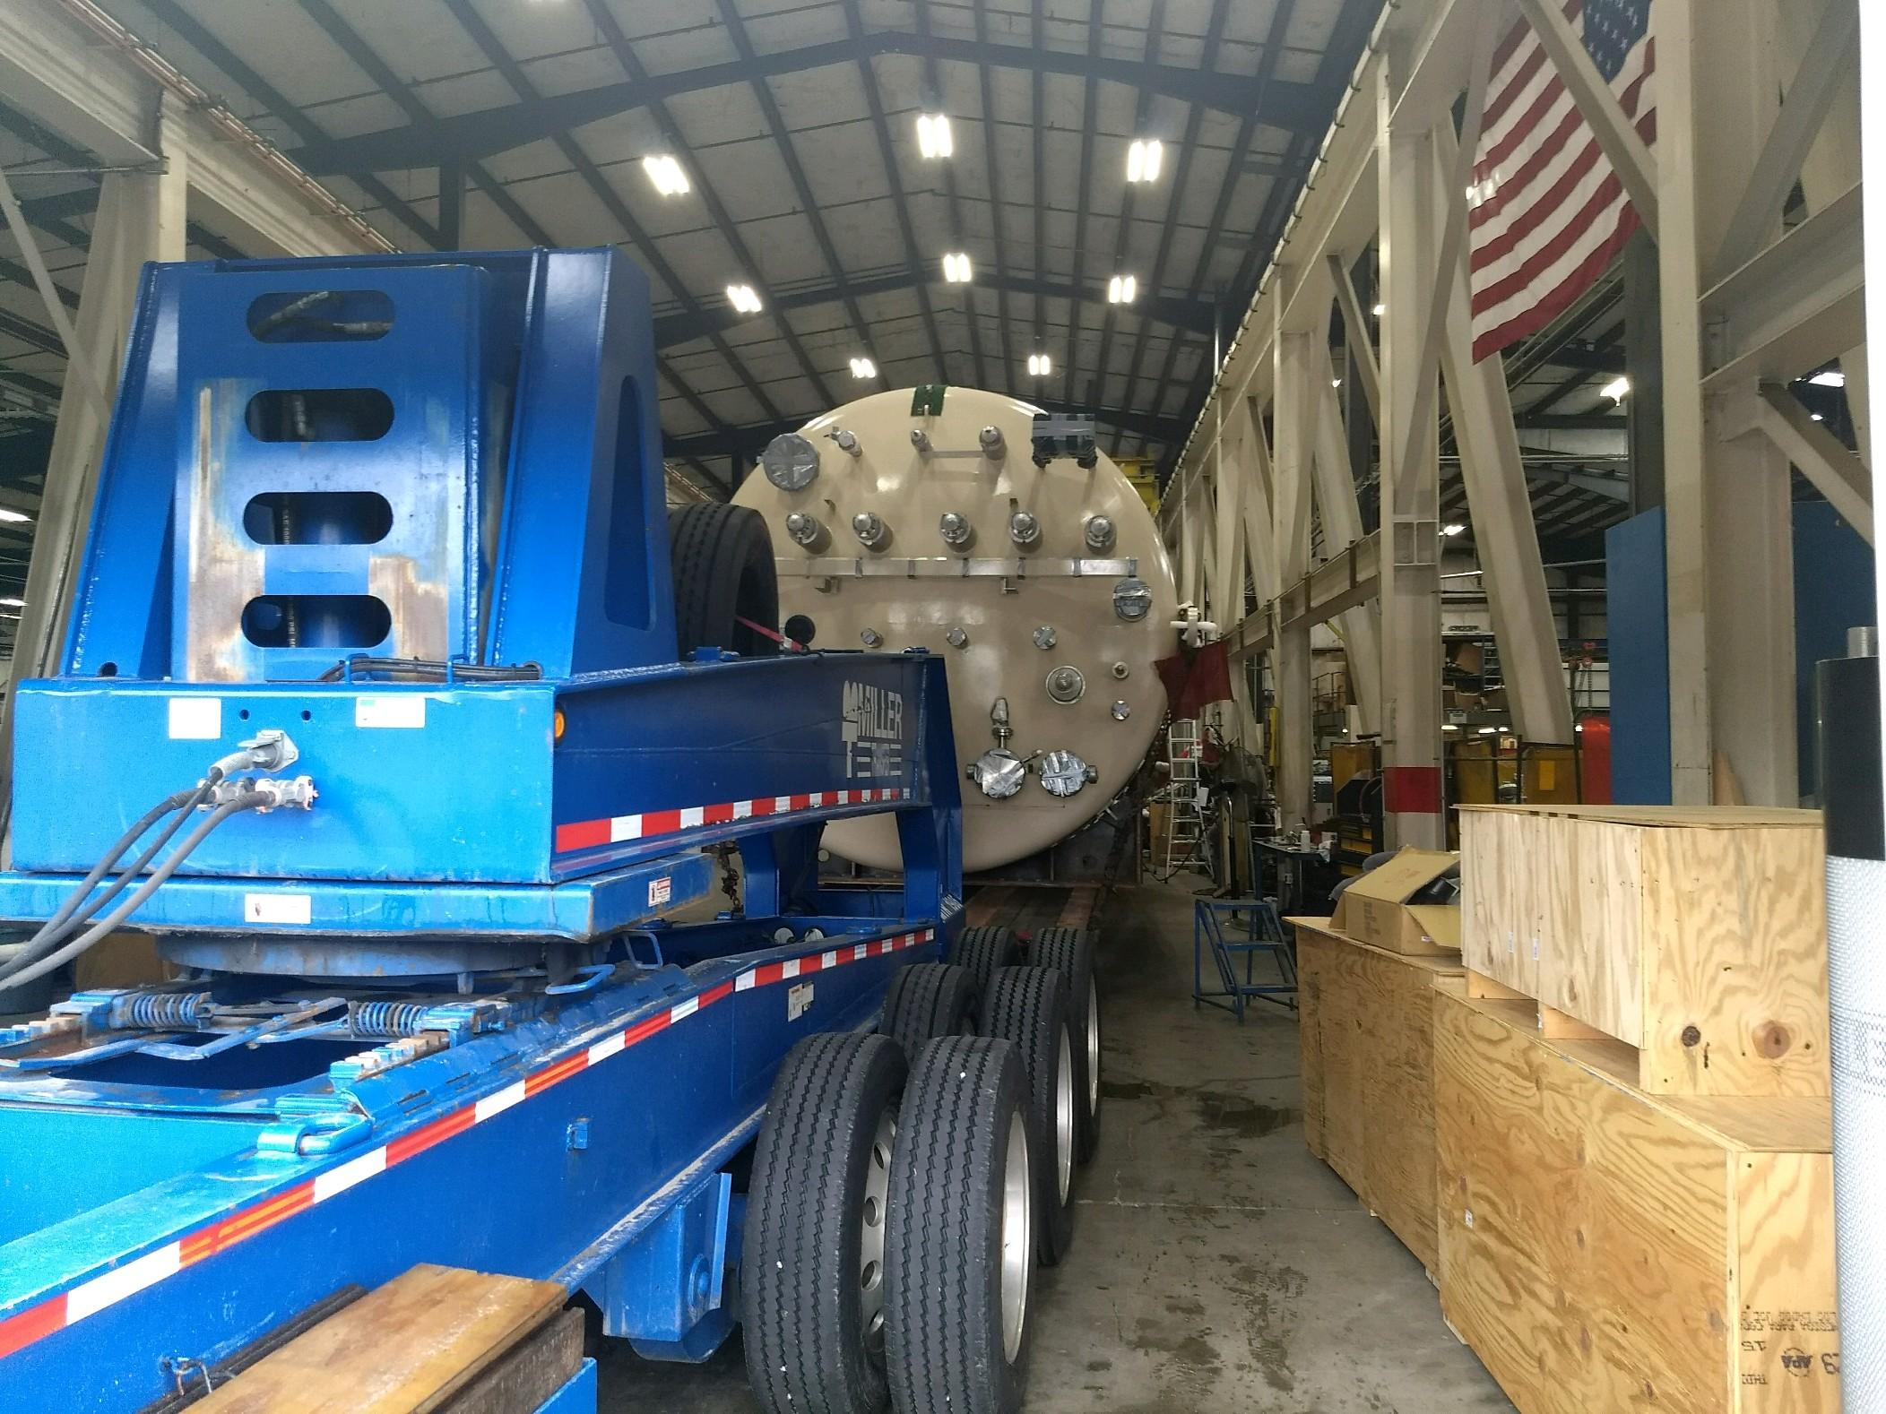

C2 Lower Cold Box 70% complete

* + Valves & process piping in progress.

Oil processing:

* + All (60 barrels) oil processing complete @PHPK.
  + Arranging delivery to SLAC for October.

Gas Helium tanks (6):

* + In storage since last year awaiting completion of tank farm foundations.
  + Foundations scheduled to be complete early October.
  + Tanks being scheduled for delivery 15-October

**Quality:**

* Verified at vendor that the first 2K Cold Box Top Plate was OK to ship. Still working with vendor (on-site) to ensure acceptable work on second 2K Cold Box Top Plate and upper Cold Mass Tooling for CM build area.
* Provided full U-1A forms (manufacture's data report for pressure vessels) for the oil removal vessels as per ASME code requirements.
* Weekly call with Demaco, all action items closed from PDR and disclosed the platform will be in place PRIOR to installing DBX and INTF lines.



**Upcoming Travel/Reviews:**

* 4.5K Cold Box monthly status review 25-Sep-2018
* LN2 Dewar vendor visit to witness progress 26-Sep-2018
* 4.5K Control logic meeting @ALATUS (27-28)-Sep-2018
* Interface Box FDR-1 04-Oct-2018
* Delivery of C2 UCB @SLAC 06-October-2018
* CryoPlant Software Development Review TBD
* Reassembly of 4.5K Cold Box Meeting @SLAC 10-October-2018

Weekly Reporting

WBS 1.02.03.05.12 LLRF

Week of September 20-26, 2018

**Issues:** None

**Accomplishments this week at JLab:** No report; reporting bi-weekly.

**Upcoming Activities:**

* Commission CM2 SSAs in the LERF.
* LERF Readiness Review in October.