Weekly Reporting

WBS 1.01.07 JLAB Management

Week of September 27-October 3, 2018

**Issues:**

**Accomplishments this week:**

Continue to participate in the shipping failure meetings.

Working on several shipping investigation LOI.

C2 UCB is in transit to SLAC

ALATUS finalized their contract for platform installation and provided a quote for placement of the UCB platform supports (4 posts per UCB).

Participated in a software working meeting at ALATUS Houston site.

Hosted Marc Ross for CM shipping meetings.

**Upcoming Reviews:**

Oct 2018 LERF Readiness Review

Nov 2018 CM Shipping Review

Dec 2018 DOE OPA Mini Review

Weekly Reporting

WBS 1.04.06 JLAB Cryomodules

Week of September 27-October 3, 2018

**Issues**:

**Accomplishments this week:**

Continuing to track charges related to out-of-scope shipping efforts.

Continuing to support shipping work groups (14 LOIs) as requested.

Conducting next round of hammer tests on J1.3-07 with removeable restraints.

Prepared test plan for shaker table testing of FPC with warm coupler installed. Submitted test plan for approval. Coordinating testing with FNAL colleagues.

Defined a draft set of objectives and acceptance criteria for removable shipping restraints.

Received initial guidance on QA/QC workshop plans from STL.

Need to identify which CMs will be sent to LERF for first testing cycle. Identified J1.3-14 and J1.3-15 as first CMs to LERF in advance of Feb-2019 testing. Requested project to consider leaving J1.3-05 in place and minimize testing.

EZ has continuing issues with the furnace the may impact cavity deliveries.

CS SM visiting JLab this week (10/2-10/3) to discuss F5 shipping plans including alternative that sends F5 to JLab as part of plan.

BCR for descope items ($630K) – JLab list is finalized.

BCR to include cost of inspecting bellows on J1.3-08 & J1.3-10 was facilitated. BCR on-hold pending discussions regarding total cost. Considering alternatives to full disassembly such as use-as-is, warm cycling of tuner bellows, etc.

J1.3-01, -03 @ WS6 – Waiting for cantilever fixture.

J1.3-02 @ BlueCrab – Moved to offsite storage on 29-Aug.

J1.3-04 @ WS5 – High pressure test and Radiograph passed. Warm coupler installation complete. MC vacuum line in progress. Instrumentation flanges in progress.

J1.3-05 @ LERF; Used for fit up of cabling.

J1.3-07 @ WS6 – Installed shipping caps. Hammer tests are on-going.

J1.3-08 – Warm coupler removal in progress. Instrumentation flanges removed.

J1.3-09 @ BlueCrab – Moved to offsite storage on 29-Aug. NCR #1466

J1.3-10 @ CMTF - CM will rest idle in cave until space at WS4/5 is available to inspect HV bellows.

J1.3-11 @ BlueCrab – Moved to offsite storage on 29-Aug. NCR #1477

J1.3-12 @ WS4 – Installed in vacuum vessel. Alignment of cold mass to Vac Vessel in progress.

J1.3-13 @ WS3 – String alignment complete. Tuners installation in progress.

J1.3-14 @ WS3 – Moved to WS3. UCM being surveyed and inspected.

J1.3-15 – All cavities have been qualified. Assembly began on 30-Sep with roll-out planned for 11-Oct.

J1.3-16 – All cavities have been qualified for the string. Return of lollipop tooling from J1.3-14 may affect string assembly start date.

J1.3-17 – Four cavities have been qualified for the string.

First batch of five HOM BLAs remains on hold.

**QUALITY**: In process weld inspections and pressure test on rework weld for CRM004 high-pressure line with RT done on Saturday 29th (weld passed).

On Site Vendor (Craft) welding review for LCLS Cold Mass Assembly Fixture.

Receipt Inspection and document review for the LERF Bellows Assemblies from Master Machine PO’s 18-D0829, 18-M0818, 18-D0833.

Attended weekly meeting with Eden concerning LERF Cryo Can Fabrication. LERF process piping inspections completed up to receiving the Cryo Can.

**Upcoming Travel/Meetings:**

* Vendor Visit to E. Zanon Nov 5-7 (A. Palczewski)
* QA/QC Workshop at MSU/FRIB (TBD, TBD date)

Weekly Reporting

WBS 1.04.06 Cryomodules - LERF Conversion

Week of September 27-October 3, 2018

**Issues:** None

Updates & photos can be seen on the WIKI wiki.jlab.org

Eden Cryogenics are still preparing for the acceptance test, they should be ready for final inspection & pressure testing next week.

R & K have shipped the replacement SSA heat exchanger, they will be at JLab on Oct. 26 to do the repair.

Matt Marchlik has made good progress on the new hot wire anemometer for the transferline. The heater/ support is made of Ti-Al-V wire (0.5 mm) & the element is 0.005 mm Niobium (photo).

We are working to get the tuner cables terminated in the LLRF racks & the cryo-diode cables for cryo-can, bridging section & end can in the cryo-con controllers.

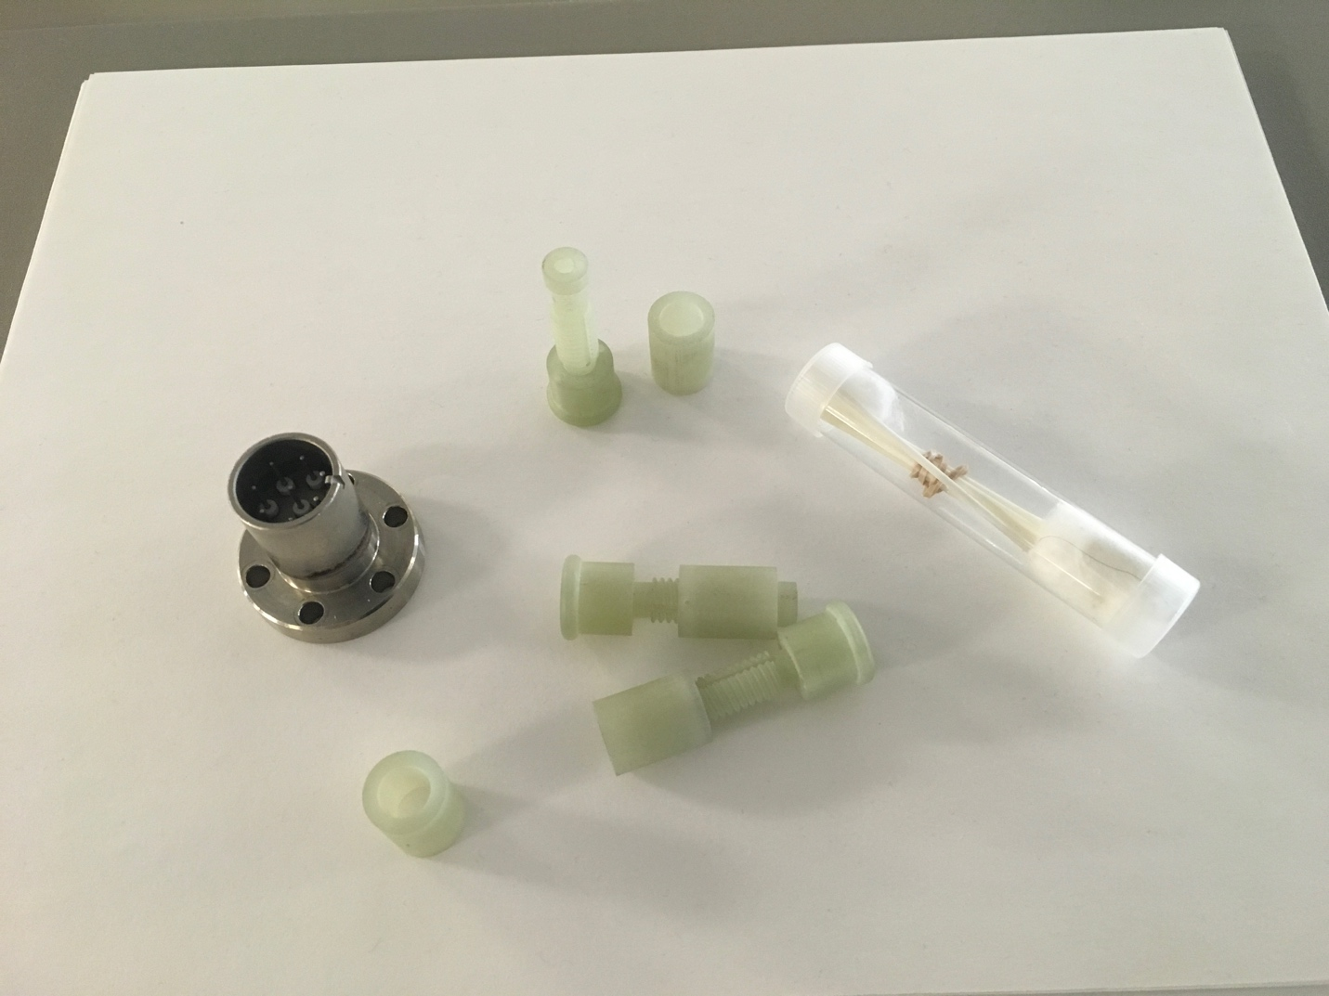

Support parts for hot wire anemometer

Weekly Reporting

WBS 1.04.08 JLAB Cryoplant System

Week of September 27-October 3, 2018

**Issues:**

1. Reduction in baseline resources (Return funding to contingency; the top-down EAC) without corresponding reduction in scope of cryoplant commissioning.
2. Resolution of structural interferences created during the design of the platforms and cable trays support systems (identified in 2017).
3. Installation of the LN2 Dewar and helium ‘tank farm’ foundations. The warm helium tanks have been in storage for several months awaiting completion of these supports.
4. Engineering change request associated with the interface box design-build subcontract resulting in increased cost and schedule delay.

**Accomplishments this week:**

2K Cold Boxes:

* + Government furnished equipment (GFE) delivered to vendors.
  + First top-plate received at Linde.
  + Second top plate scheduled to ship to PHPK in next week.

4.5K Cold boxes:

* + Follow-up re-assembly meeting scheduled for 10-October-2018.

C1 Lower Cold Box (LCB) 92+% complete

* + Shell & heads installed; final closure welding in progress.
  + 10-week shipping notice issued.

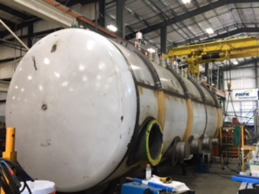

C2 Upper cold box (UCB) complete

* + C2 upper cold in transit to SLAC.
  + Delivery on schedule for 06-Oct-2018.

C2 Lower Cold Box 70% complete

* + Valves & process piping in progress.

Oil processing:

* + All (62 barrels) in transit to SLAC.
  + On schedule for delivery to SLAC 05-Oct-2018.

LN2 Dewar:

* + Inner-Outer vessel integration complete.

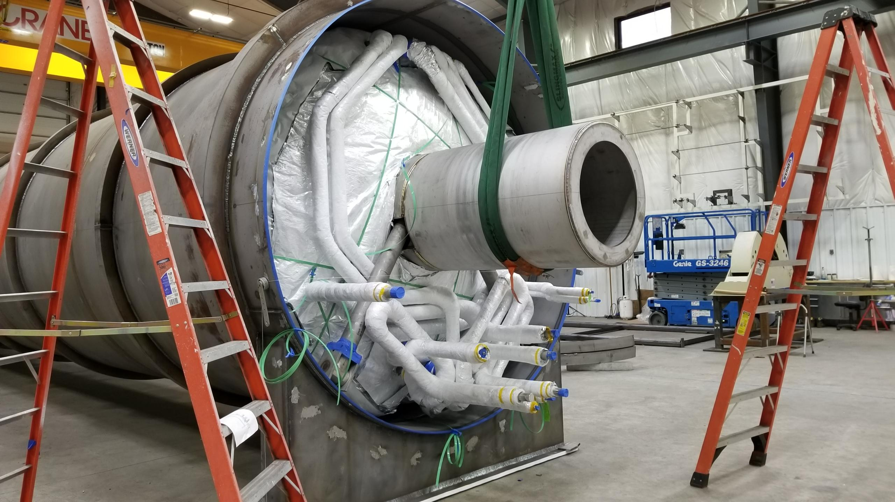

* + Foundations scheduled to be complete by October 8th.
  + LN2 Dewar scheduled for delivery 27-October

**Quality:**

* Verified at vendor that the first 2K Cold Box Top Plate was OK to ship. JLab CWI working with vendor (on-site) to ensure acceptable work on second 2K Cold Box Top Plate and upper Cold Mass Tooling for CM build area.
* Provided full U-1A forms (manufacture's data report for pressure vessels) for the oil removal vessels as per ASME code requirements.
* Weekly call with Demaco, all action items closed from PDR and disclosed the platform will be in place PRIOR to installing DBX and INTF lines.
* All engineering change requests (ECR) being tracked for cause, evaluation decision and impact on cost & schedule.



**Upcoming Travel/Deliveries/Reviews:**

* Interface Box FDR-1 04-Oct-2018
* Delivery of processed oil (62 barrels) @SLAC 05-Oct-2018
* Delivery of C2 UCB @SLAC 06-October-2018
* Reassembly of 4.5K Cold Box Meeting @SLAC 10-October-2018
* Delivery of Gas Helium Tanks (6) @SLAC 15-Oct-2018
* Delivery of first LN2 @SLAC 27-Oct-2018
* CryoPlant Software Development Review TBD - November

Weekly Reporting

WBS 1.02.03.05.12 LLRF

Week of September 27-October 3, 2018

**Issues:** None

**Accomplishments this week at JLab:** No report.

**Upcoming Activities:**

* Commission CM2 SSAs in the LERF.
* LERF Readiness Review in October.