Weekly Reporting

WBS 1.01.07 JLAB Management

Week of October 4-10, 2018

**Issues:**

Need to converge on a shipping solution.

**Upcoming Reviews:**

Oct 2018 LERF Readiness Review

Nov 2018 CM Shipping Review

Dec 2018 DOE OPA Mini Review

Weekly Reporting

WBS 1.04.06 JLAB Cryomodules

Week of October 4-10, 2018

**Issues**:

High performing cavities for CMs, the EZ furnace is broken and the path forward needs to be finalized.

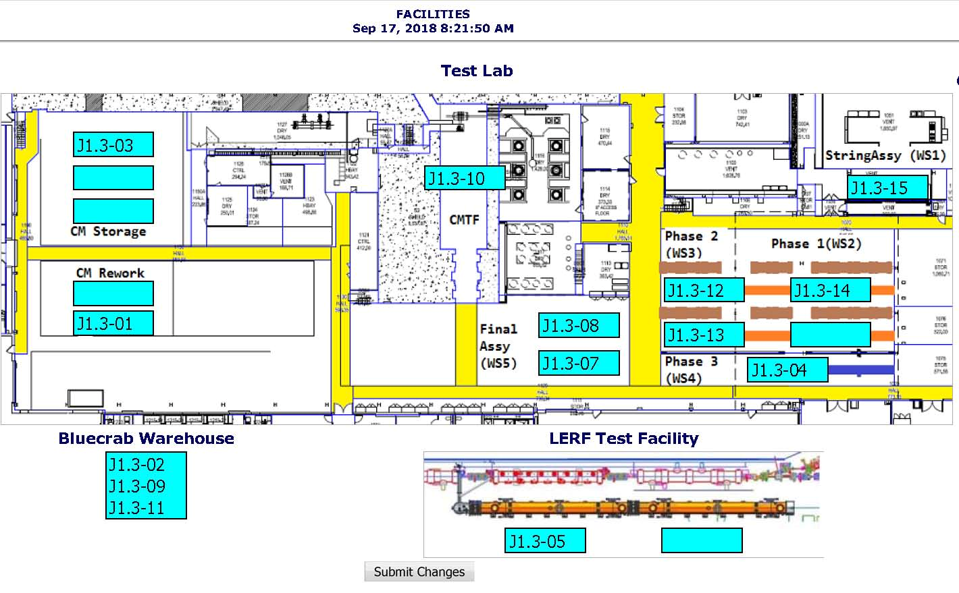

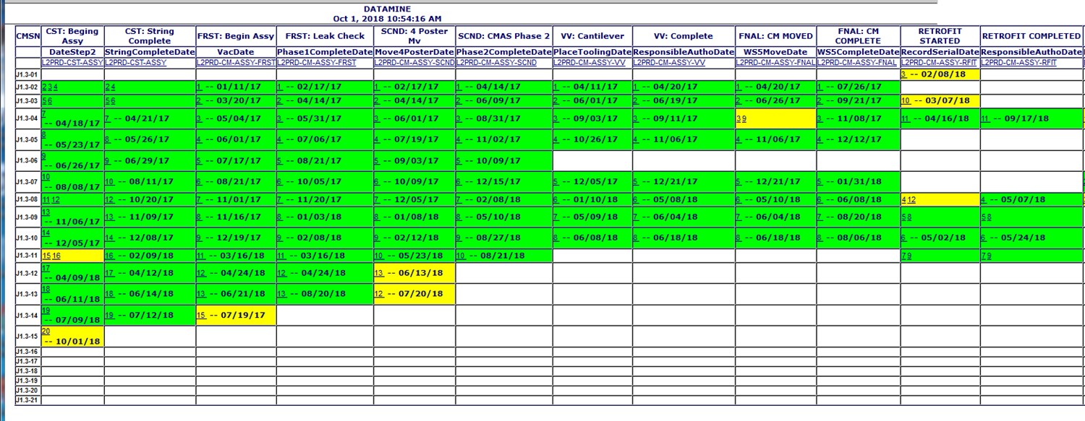

**QUALITY**: No report.

**Upcoming Travel/Meetings:**

* Shaker Table Vendor Visit Oct 12-15 (N. Huque)
* Vendor Visit to E. Zanon Nov 5-7 (A. Palczewski)
* QA/QC Workshop at MSU/FRIB (TBD, TBD date)

Weekly Reporting

WBS 1.04.06 Cryomodules - LERF Conversion

Week of October 4-10, 2018

**Issues:**

This week JLab folks on-site at Eden Cryogenics to witness leak checking and pressure test. This is now on critical path for early January cool-down.

Schedule for the 3 months is being populated & can be tracked at:

<http://lerfboard.acc.jlab.org/board1.html>

<http://lerfboard.acc.jlab.org/board2.html>

Weekly Reporting

WBS 1.04.08 JLAB Cryoplant System

Week of October 4-10, 2018

**Issues:**

1. Reduction in baseline resources (Return funding to contingency; the top-down EAC) without corresponding reduction in scope of cryoplant commissioning.
2. Resolution of structural interferences created during the design of the platforms and cable trays support systems (identified in 2017).
3. Installation of the LN2 Dewar and helium ‘tank farm’ foundations. The warm helium tanks have been in storage for several months awaiting completion of these supports.
4. Engineering change request associated with the interface box design-build subcontract resulting in increased cost and schedule delay.

**Accomplishments this week:**

At SLAC for Cryoplant #2 4.5K Upper Cold Box lift and placement (see photo below); and also attending reassembly meeting.

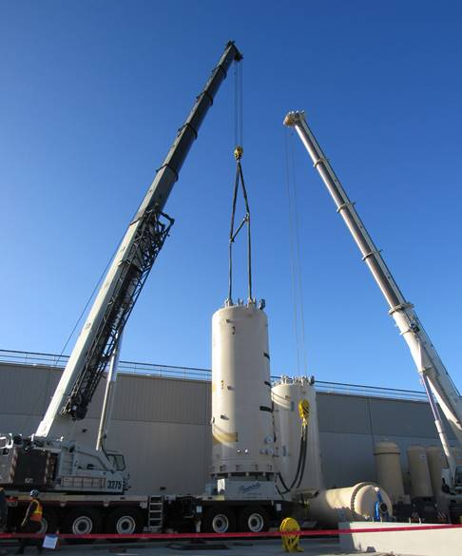

**Quality:**

* Addressed welding and machining issues that were documented and presented by Linde for the 2k Upper Cold Box plate unit 1 from Craft. Working with vendor to prevent the same issues with unit 2 going to PHPK.
* On Site Vendor (Craft) welding review for 2K Cold Box Top Plate Unit 2 and Cold Mass Assembly Fixture.

**Upcoming Travel/Deliveries/Reviews:**

* Reassembly of 4.5K Cold Box Meeting @SLAC 10-October-2018
* Delivery of Gas Helium Tanks (6) @SLAC 15-Oct-2018
* Delivery of first LN2 @SLAC 27-Oct-2018
* CryoPlant Software Development Review TBD - November