Weekly Reporting

WBS 1.01.07 JLAB Management

Week of October 11-17, 2018

**Issues:**

Need to converge on a shipping solution. Shipment of F05 to JLab tentatively 19 Oct should provide additional information.

**Upcoming Reviews:**

Nov 2018 LERF Readiness Review

Nov 2018 CM Shipping Review

Dec 2018 DOE OPA Mini Review

Weekly Reporting

WBS 1.04.06 JLAB Cryomodules

Week of October 11-17, 2018

**Issues**:

High performing cavities for CMs. Proposed solution to broken furnace at Zanon needs to be finalized and agreed to by all parties. Potential schedule delays due to Zanon furnace issues.



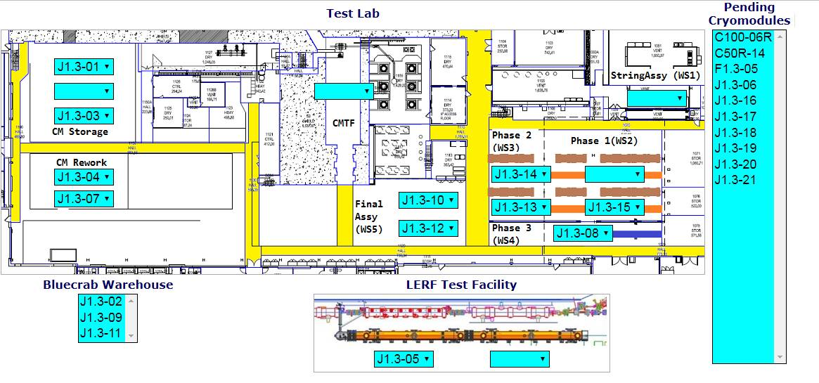

**QUALITY**: Coordinated final agenda for FRIB QA visit and Lines of Inquiry for partner Lab visits. FRIB benchmarking will occur Oct 23-24 and Partner Lab visits will be Nov 12-16. Forwarded final LOIs to SRF.

**Upcoming Travel/Meetings:**

* Vendor Visit to E. Zanon Nov 5-7 (A. Palczewski)
* QA/QC Workshop at MSU/FRIB Oct 23-24

Weekly Reporting

WBS 1.04.06 Cryomodules - LERF Conversion

Week of October 11-17, 2018

**Issues:**

No report.

Schedule for the 3 months is being populated & can be tracked at:

<http://lerfboard.acc.jlab.org/board1.html>

<http://lerfboard.acc.jlab.org/board2.html>

Weekly Reporting

WBS 1.04.08 JLAB Cryoplant System

Week of October 11-17, 2018

**Issues:**

1. Reduction in baseline resources (Return funding to contingency; the top-down EAC) without corresponding reduction in scope of cryoplant commissioning.
2. Resolution of structural interferences created during the design of the platforms and cable trays support systems (identified in 2017).
3. Engineering change request associated with the interface box design-build subcontract resulting in increased cost and schedule delay.

**Accomplishments this week:**

The upper 4.5K cold boxes and the oil removal vessels are installed for both cryoplants C1 & C2.

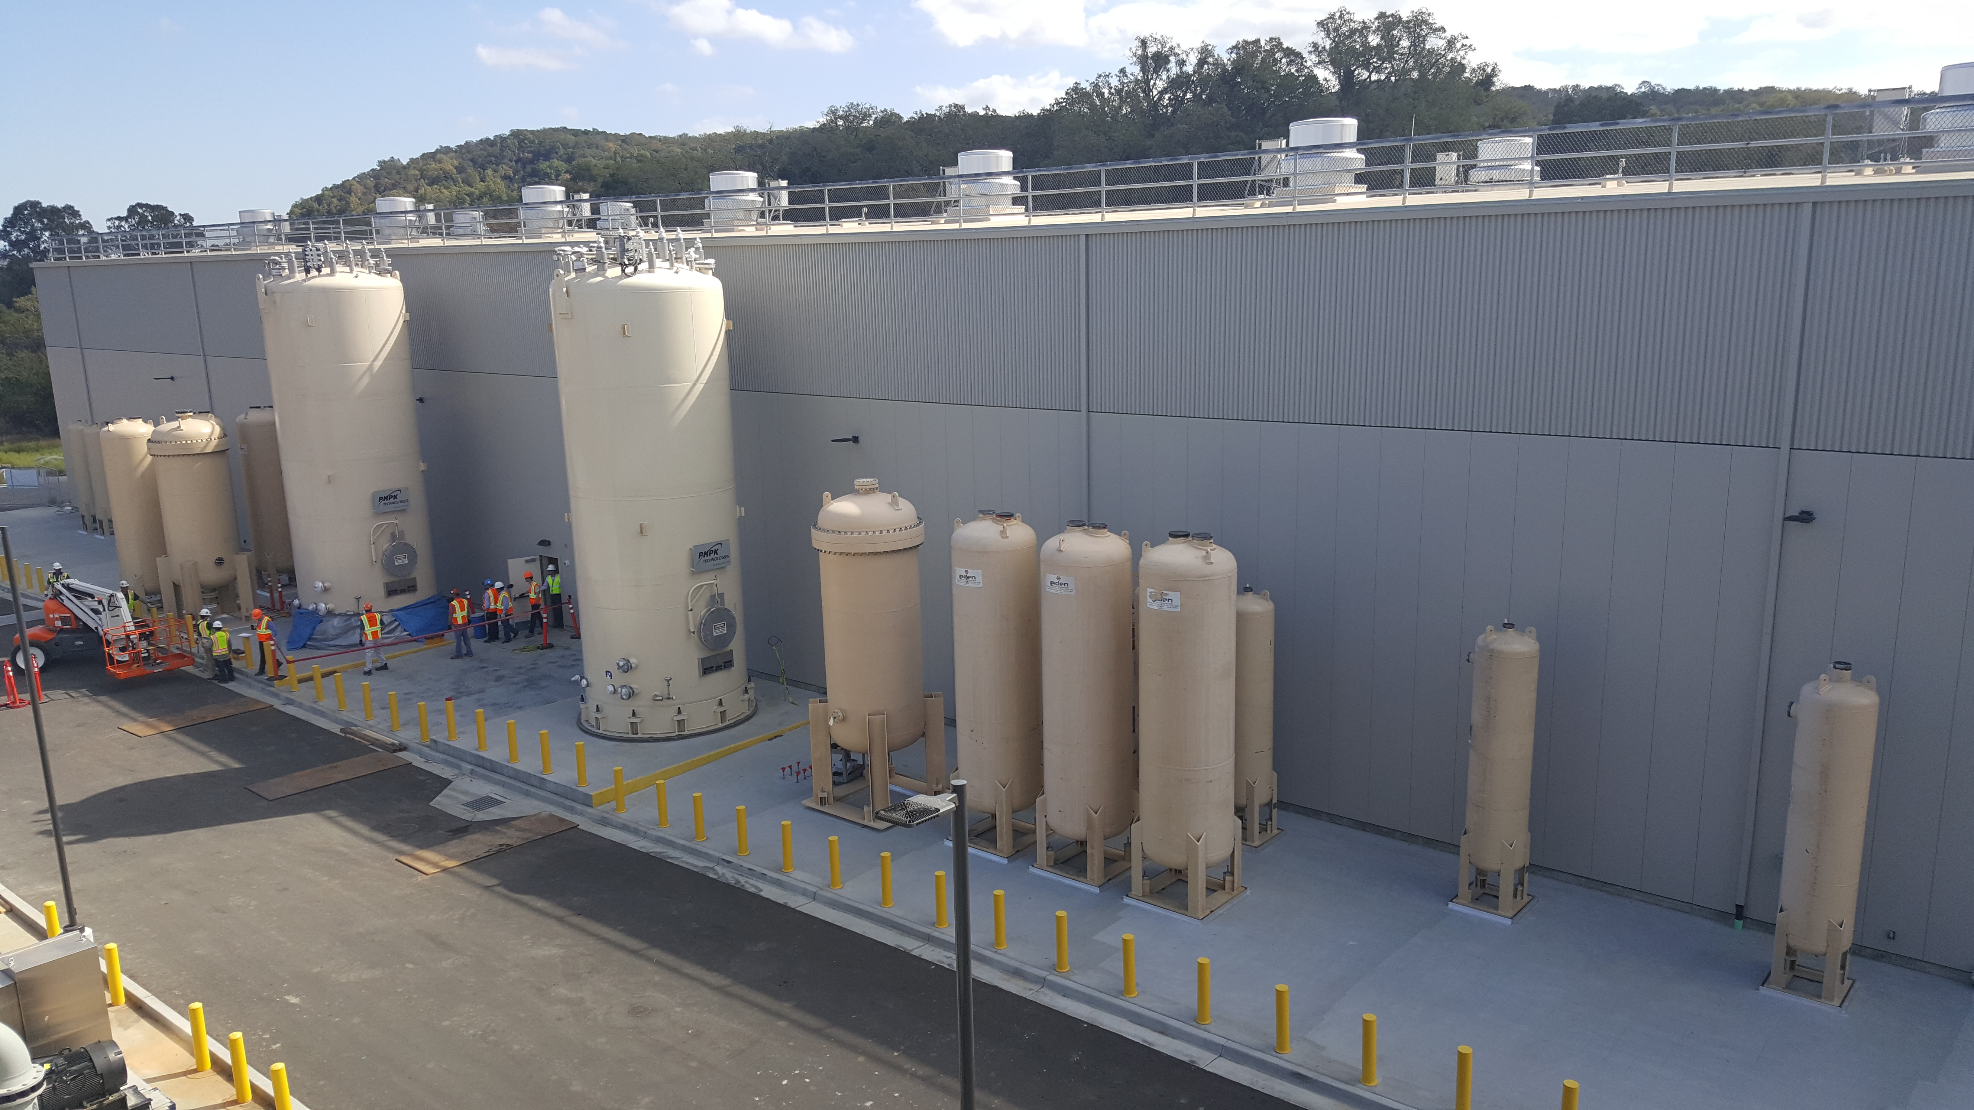

**Quality:**

* Successfully delivered the second 2K top plate weldment to PHPK – this is the end result of significant oversight from JLab CWI
* Continuing regular site visits to the LN2, 2K and 4.5K cold box vendors to ensure quality control is maintained.
* JLab CWI reviewed UCB platform weld hold points at PHPK, with no issues except for documentation.  ALATUS is coordinating this aspect of the work.

**Upcoming Travel/Deliveries/Reviews:**

* Delivery of Gas Helium Tanks (6) @SLAC 30-Oct-2018
* Interface Box FDR (-2) 07-Nov-2018
* CryoPlant Software Development Review 15-Nov-2018