Weekly Reporting

WBS 1.01.07 JLAB Management

Week of October 18-24, 2018

**Issues:**

Need to converge on a shipping solution.

**Upcoming Reviews:**

Nov 2018 LERF Readiness Reviews

Nov 2018 CM Shipping Review

Jan 2018 DOE OPA Mini Review

Weekly Reporting

WBS 1.04.06 JLAB Cryomodules

Week of October 18-24, 2018

**Issues**:

High performing cavities for CMs. Proposed solution to broken furnace at Zanon needs to be finalized and agreed to by all parties. Potential schedule delays due to Zanon furnace issues.

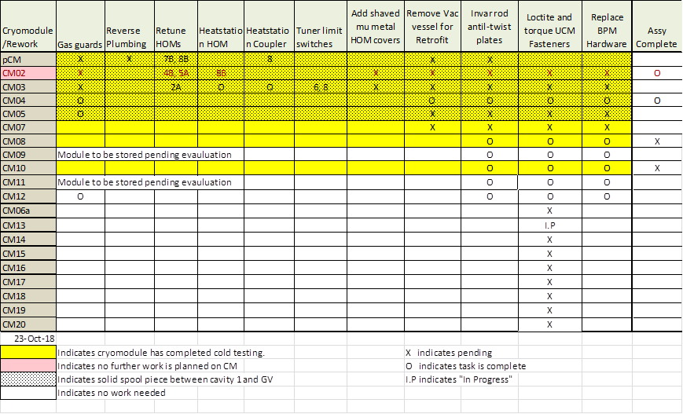

Two CMs (J-02, J-04) are completed and ready for shipment.

First HOM BLA assembly was shipped to SLAC on 23-OCT.

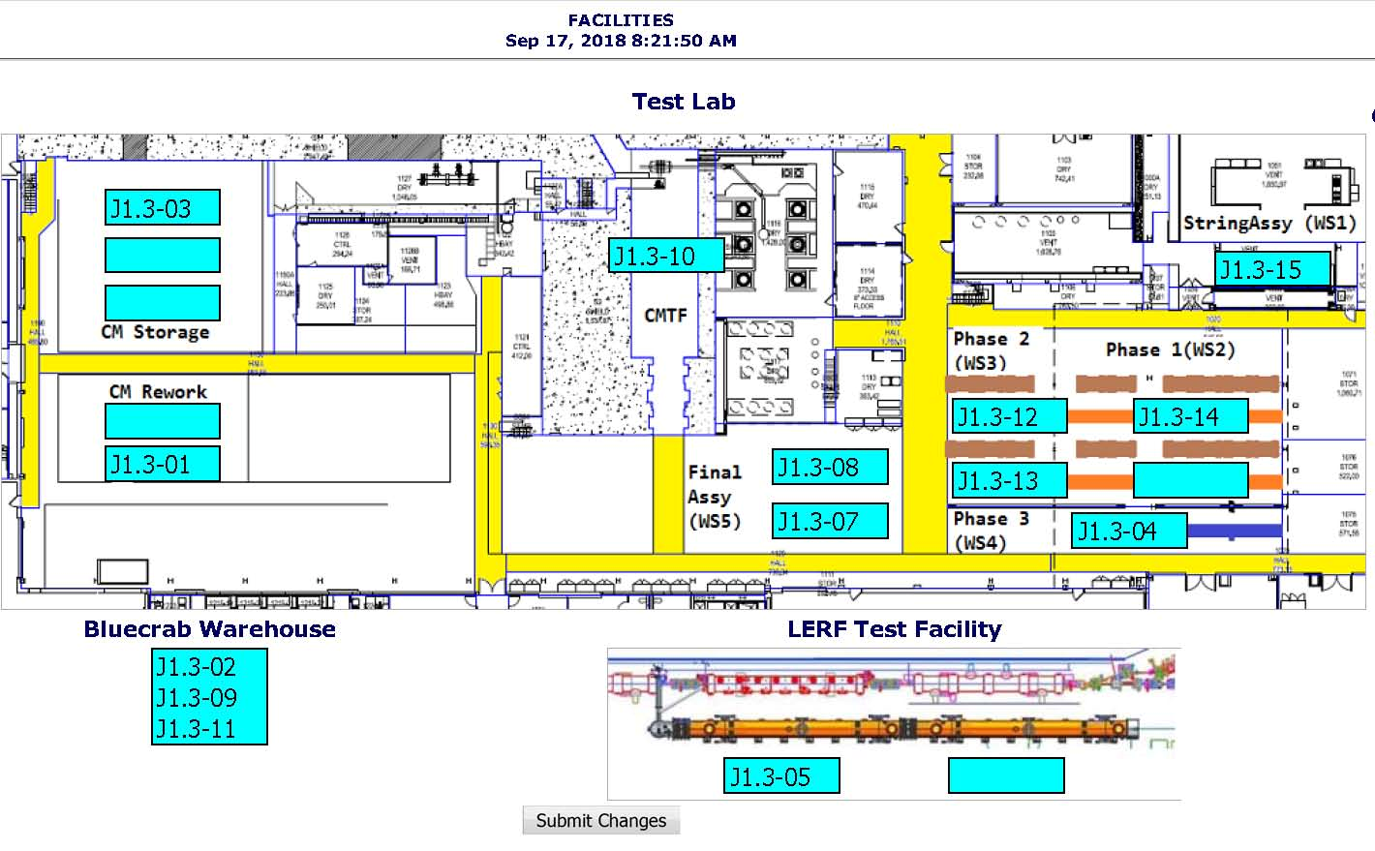

**QUALITY:**  QA visit at JLab scheduled for Nov 13-14. Welding and document review for LCLS UCM 033 for CRM 014. Pressure test CM012 High pressure circuit. Pressure test CM004 (repair work) low pressure circuit

**Upcoming Travel/Meetings:**

* Vendor Visit to E. Zanon Nov 5-7 (A. Palczewski)

Weekly Reporting

WBS 1.04.06 Cryomodules - LERF Conversion

Week of October 18-24, 2018

**Issues:**

Cryo-can final inspection did not go well due to inadequate vacuum conductance issues. They had too small of a hose pumping down the can. They did a leak check of the individual piping so we do not anticipate leaks. We will accept as is, redo the leak check onsite.

We are generating detailed procedures or the overall assembly of the modules together and to the end can. The bridging bellows extension ring is finished and shipped from Meyer tool. The bellows will be test fit in the Test Lab on an empty LCLS-II vacuum vessel. This will also confirm the wheels and cradle fit-up.

Schedule for the 3 months is being populated and can be tracked at:

<http://lerfboard.acc.jlab.org/board1.html>

<http://lerfboard.acc.jlab.org/board2.html>

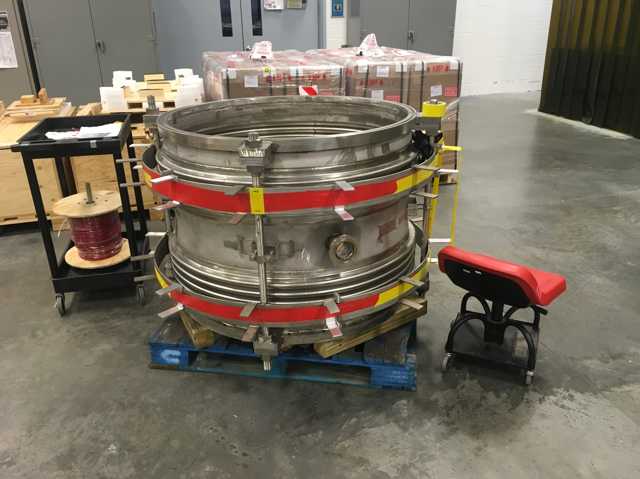

Bridging ring bellows.

Weekly Reporting

WBS 1.04.08 JLAB Cryoplant System

Week of October 18-24, 2018

**Issues:**

1. Reduction in baseline resources (Return funding to contingency; the top-down EAC) without corresponding reduction in scope of cryoplant commissioning.
2. Resolution of structural interferences created during the design of the platforms and cable trays support systems (identified in 2017).
3. Engineering change request associated with the interface box design-build subcontract resulting in increased cost and schedule delay.

**Accomplishments this week:**



The site layout plan for the installation of the upper 4.5K cold box platforms is has been finalized. ALATUS sub Alberici scheduled to be onsite 05-Nov-2018.

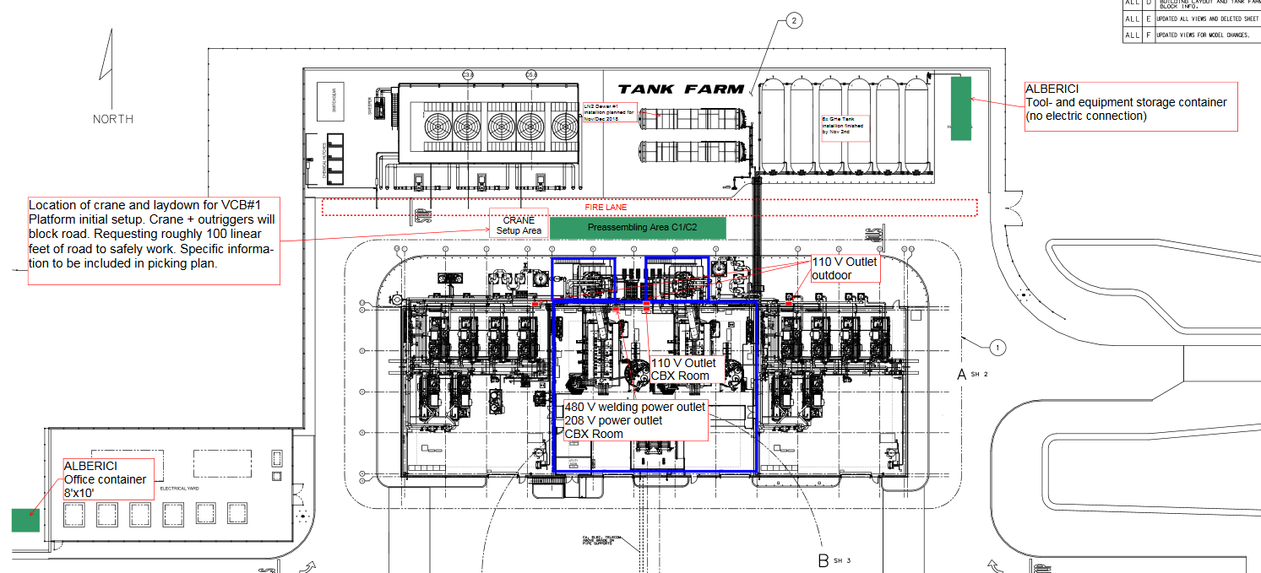

**Quality:**

* SO & SOTR onsite at LN2 vendor to witness progress and verify in process QC is in accordance with the performance requirements.
* Travel to PHPK for final on LCLS CP2 Platform; no fabrication issues; final documentation still outstanding.
* Demaco weekly call discussed FDR 2, ball valve handles interference, installation on site documents/training needed, structural vendor will be at FDR2.

**Upcoming Travel/Deliveries/Reviews:**

* Delivery of Oil Processing skid @SLAC 26-Oct-2018
* Delivery of Gas Helium Tanks (6) @SLAC 30-Oct-2018
* Interface Box FDR (-2) 07-Nov-2018
* CryoPlant Software Development Review 14-Nov-2018