Weekly Reporting

WBS 1.01.07 JLAB Management

Week of October 25-31, 2018

**Issues:**

Need to converge on a shipping solution.

**Upcoming Reviews:**

Nov 2018 LERF Readiness Reviews

Nov 2018 CM Shipping Review

Jan 2018 DOE OPA Mini Review

Weekly Reporting

WBS 1.04.06 JLAB Cryomodules

Week of October 25-31, 2018

**Issues**:

1. High performing cavities for CMs may be late due to potential schedule delays due to Zanon furnace issues.
2. Current workload at JLab is being dominated by unplanned work compared with baseline including F5 shipping activities and inspection of J8 & J10 helium vessel bellows. This will negatively impact cost and schedule performance indices.

F5 shipping schedule changed due to problems with infrastructure and priorities at FNAL. The ICB crane will not be available in order to support schedule.

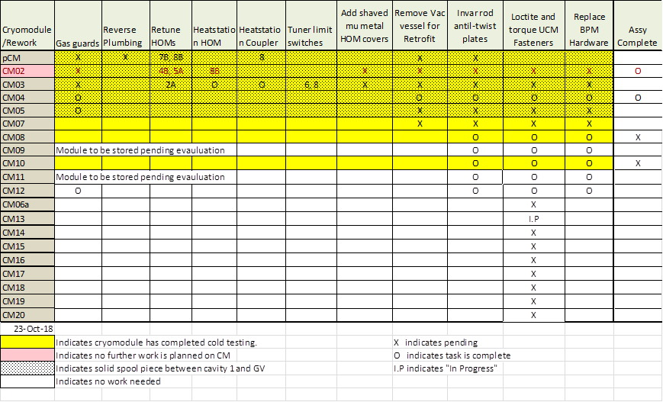

Two CMs (J-02, J-04) are completed and ready for shipment.

Two HOM BLA assemblies are in preparation for shipment to SLAC.

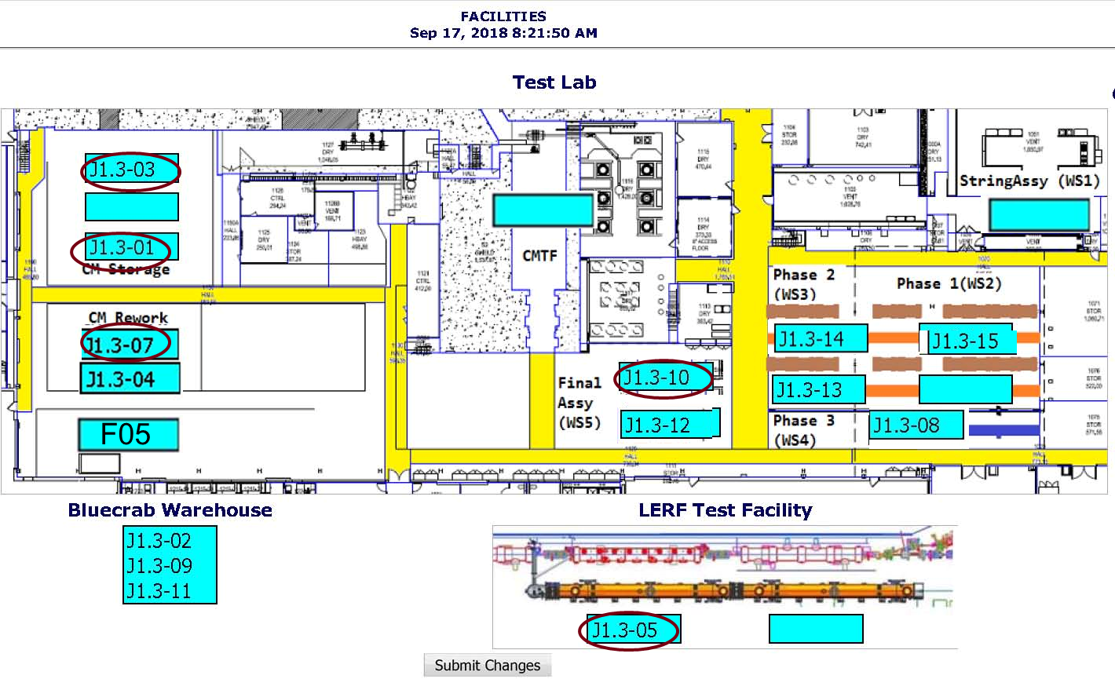

**QUALITY:**  QA representative participated in the benchmarking review at FRIB/MSU with SLAC and FNAL representatives.

**Upcoming Travel/Meetings:**

* Vendor Visit to E. Zanon Nov 5-7 (A. Palczewski)

Weekly Reporting

WBS 1.04.06 Cryomodules - LERF Conversion

Week of October 25-31, 2018

**Issues:**

Final leak check of the cryo can is being done today; it is due to arrive on Friday.

CM05 has been moved to position #2.

Schedule for the 3 months is being populated and can be tracked at:

<http://lerfboard.acc.jlab.org/board1.html>

<http://lerfboard.acc.jlab.org/board2.html>

Weekly Reporting

WBS 1.04.08 JLAB Cryoplant System

Week of October 25-31, 2018

**Issues:**

1. Reduction in baseline resources (Return funding to contingency; the top-down EAC) without corresponding reduction in scope of cryoplant commissioning.
2. Resolution of structural interferences created during the design of the platforms and cable trays support systems (identified in 2017).
3. Engineering change request associated with the interface box design-build subcontract resulting in increased cost and schedule delay.

**Accomplishments this week:**



After one-year in storage; the gas helium tanks have been successfully delivered to the SLAC site and installed in the tank farm.

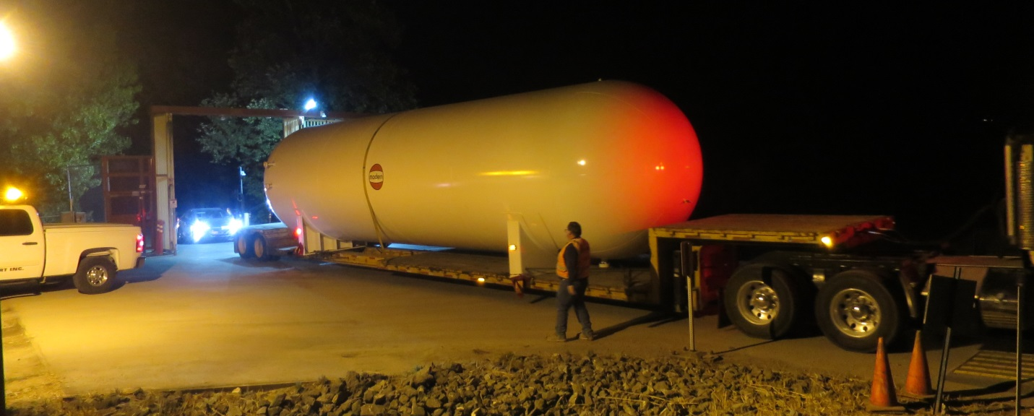

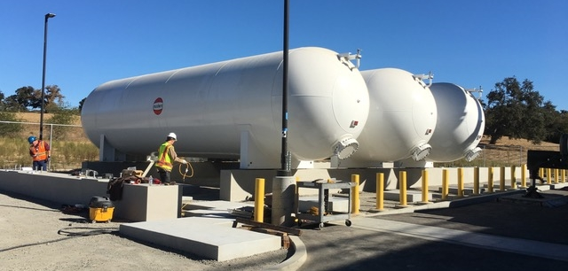

**Quality:**

* SO & SOTR onsite at LN2 vendor to witness progress and verify in process QC is in accordance with the performance requirements.
* STL & SO travel to PHPK for monthly schedule update; witness progress on 4.5K & 2K cold boxes; no quality issues identified.
* Good quality was maintained on the six-gas helium tanks while in storage at vendor’s site for more than one year; regular monitoring of inert pressurized gas.
* Pressure tested 2 LCLS Secondary Water Skids
* Began reviewing acceptance welding documentation and inspection results for the first LN2 Dewar from AES for CryoPlant

**Upcoming Travel/Deliveries/Reviews:**

* Interface Box FDR2 07-Nov-2018
* CryoPlant Software Development Review 14-Nov-2018