Weekly Reporting

WBS 1.01.07 JLAB Management

Week of November 8-14, 2018

**Issues:**

Hosted several meetings this week.

LERF Transition to Operations, Cryomodule QA review/Audit, Cryogenics Plant Software Review. Draft reviewer closeouts provided for all. We expect final closeouts as early as next week. As I saw it, there were no showstoppers.

John Schmerge was here and worked on JLab CP support beyond the project.

Delivered the JLab CM support beyond the project document to the JLab Director for review and signature.

**Upcoming Reviews:**

Nov 13-14 QA Audit Review

Nov 14 CryoPlant Software Development Review

Nov 29 CM Shipping Review

Jan 2018 DOE OPA Mini Review

Weekly Reporting

WBS 1.04.06 JLAB Cryomodules

Week of November 8-14, 2018

**Issues**:

1. High performing cavities for CMs may be late due to potential schedule delays due to Zanon furnace issues.
2. Current workload at JLab is being dominated by unplanned work compared with baseline including F5 shipping activities and inspection of J8 & J10 helium vessel bellows. This will negatively impact cost and schedule performance indices.

F5 had a successful long trip (3000 miles) that started Friday 09-NOV and returned to JLab on Monday 12-NOV. Beamline vacuum was leak-tight. Internal restraints remained intact. Preparing F5 for shipment to SLAC on Friday 16-NOV using trailer #2 supplied by FNAL.

Preparing documentation that supports removable restraint engineering and design that includes reports, test data, engineering notes, drawings and procedures.

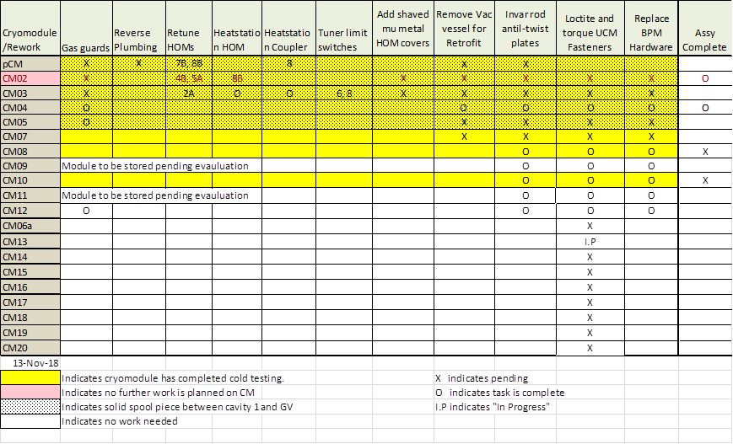

Two CMs (J-02, J-04) are completed and ready for shipment.

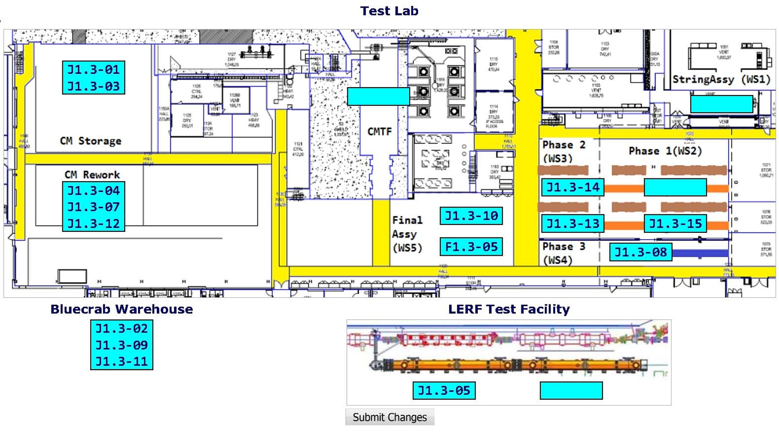

**QUALITY:**

* The SLAC/MSU/FNAL/JLab QA review held onsite this week.
* Received the LCLS Upper Cold Mass Assembly Station in Blue Crab Storage facility 11-12-18.
* Continued with in process inspections on the LCLS LERF Cryo Can Installation Welding.
* RT of LCLS cryomodule (012) low pressure welding was done Sunday 11-11-18 and welding was accepted.

**Upcoming Travel/Meetings:**

* None

Weekly Reporting

WBS 1.04.06 Cryomodules - LERF Conversion

Week of November 8-14, 2018

**Issues:**

Readiness Review was held and went well.

Cryocan connections to the transfer line are being leak checked.

Clean room is being finished up.

All LLRF wiring is complete, next are the 34 diodes for cryogenic thermometry.

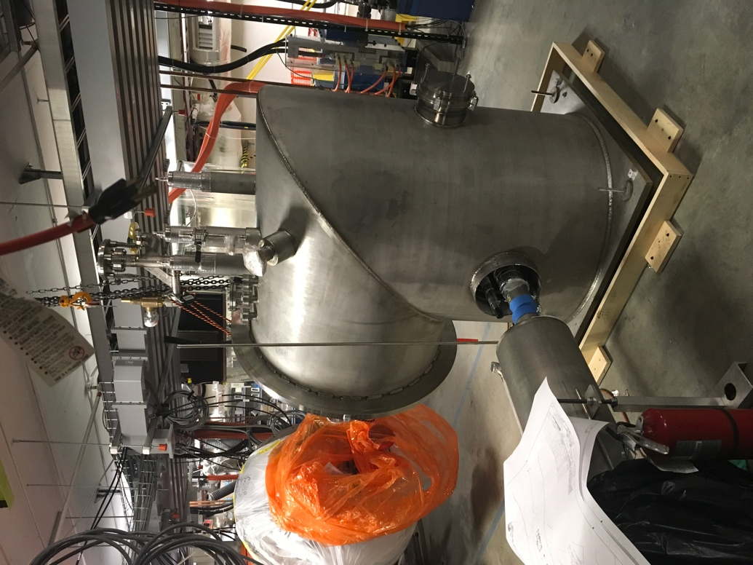 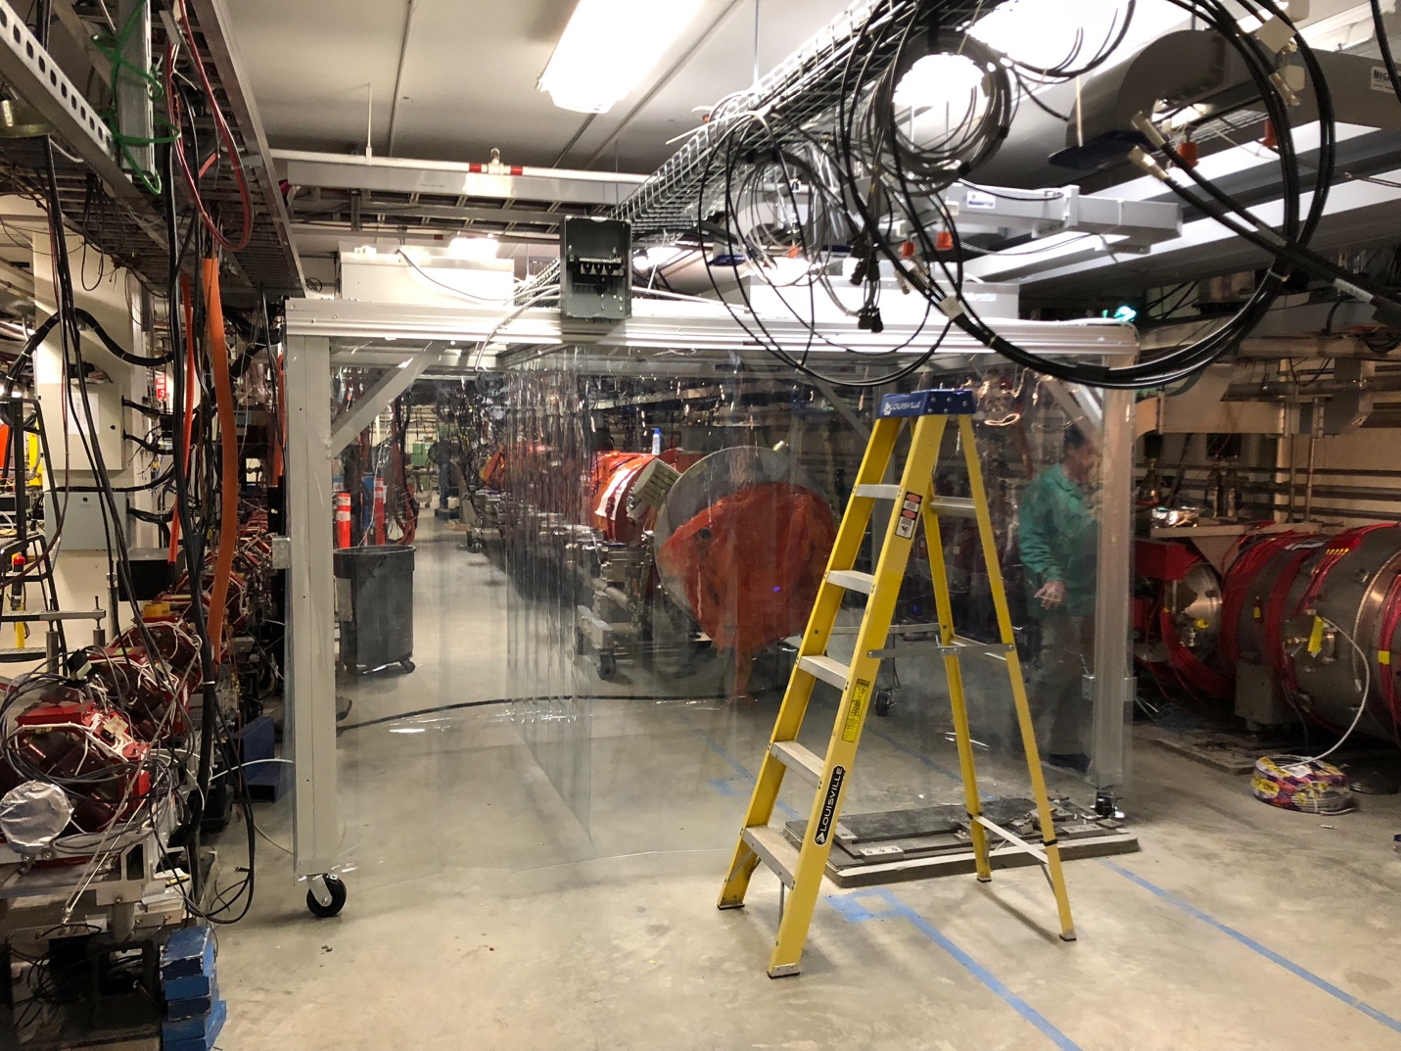

Weekly Reporting

WBS 1.04.08 JLAB Cryoplant System

Week of November 8-14, 2018

**Issues:**

1. Reduction in baseline resources (Return funding to contingency; the top-down EAC) without corresponding reduction in scope of cryoplant commissioning.
2. Resolution of structural interferences created during the design of the platforms and cable trays support systems (identified in 2017).
3. Engineering change request associated with the interface box design-build subcontract resulting in increased cost and schedule delay.

**Accomplishments this week:**



**Deliveries Received @SLAC**

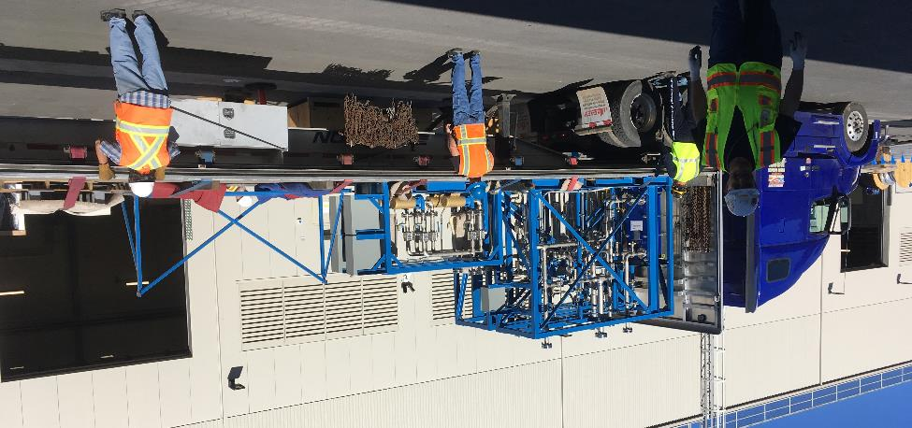

**Cooling water skids for C1 & C2 received @SLAC last week.**

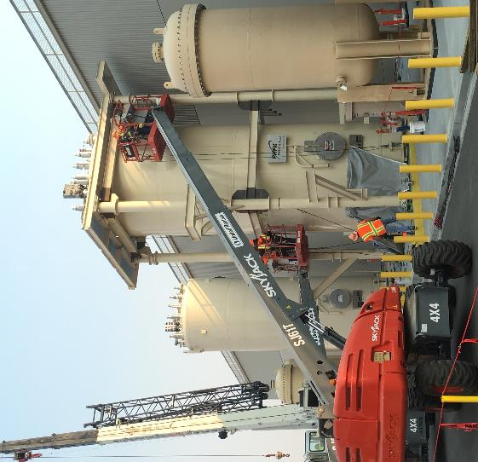

**C1 upper 4.5K cold box platform installation started last week.**

* JLab/SLAC staff at vendor site to review the final design of the interface boxes.
* A comprehensive risk mitigation plan and procedure was developed and distributed to address the potential contamination associated with the oil removal vessels.
* Began reviewing acceptance welding documentation and inspection results for the first LN2 Dewar from AES for CryoPlant.
* Gibson site visit (Richmond, VA) for LCLS cryo-plant gauge panels and frames.

**Upcoming Travel/Deliveries/Reviews:**

* CryoPlant Software Development Review 14-Nov-2018
* Helium purifier – Factory Acceptance Test 27-Nov-2018
* Monthly 4.5K Cold box status and update 29-Nov-2018
* CryoPlant Commissioning Workshop @JLab 4&5-Dec-2018