Weekly Reporting

WBS 1.01.07 JLAB Management

Week of November 15-21, 2018

**Issues:**

Getting feedback in from reviews held last week. Will track responses.

Shipped F5 to SLAC. Arrived still under vacuum.

JLab CM support beyond the project document signed by JLab Director and mailing to Lydia.

**Upcoming Reviews:**

Dec 4 & 5 CP Commissioning Workshop

Dec 13 CM Shipping Review

Jan/Feb 2018 DOE OPA Mini Review

Weekly Reporting

WBS 1.04.06 JLAB Cryomodules

Week of November 15-21, 2018

**Issues**:

1. High performing cavities for CMs may be late due to potential schedule delays due to Zanon furnace issues.
2. Current workload at JLab is being dominated by unplanned work compared with baseline. F5 shipping activities and inspection of J8 & J10 helium vessel bellows are concluded. This will negatively impact cost and schedule performance indices going forward.

F5 had a successful delivery trip (3000 miles) that started Saturday 17-NOV with the module arriving at SLAC on Monday 19-NOV. Beamline vacuum was leak-tight. Visit by JLab staff has been delayed until handling activities can be resumed. Targeting visit during week beginning 03-DEC.

J4 shipment preparations continue. Expect to ship module to SLAC before the end of the month.

Reviewed documentation that supports removable restraint engineering and design that includes reports, test data, engineering notes, drawings and procedures. Minor revisions in progress.

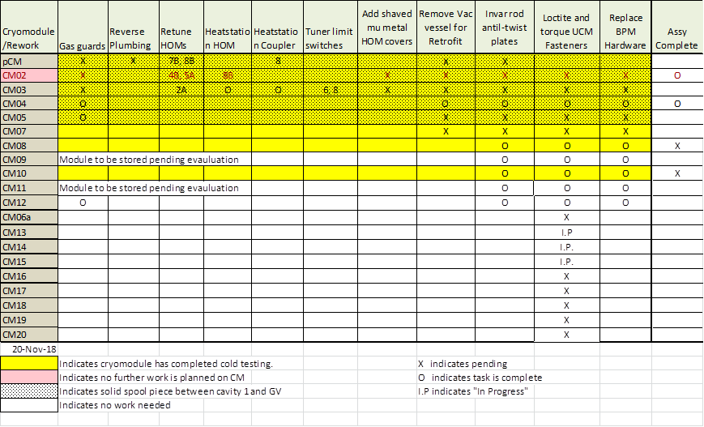

Two CMs (J-02, J-04) are completed and ready for shipment.

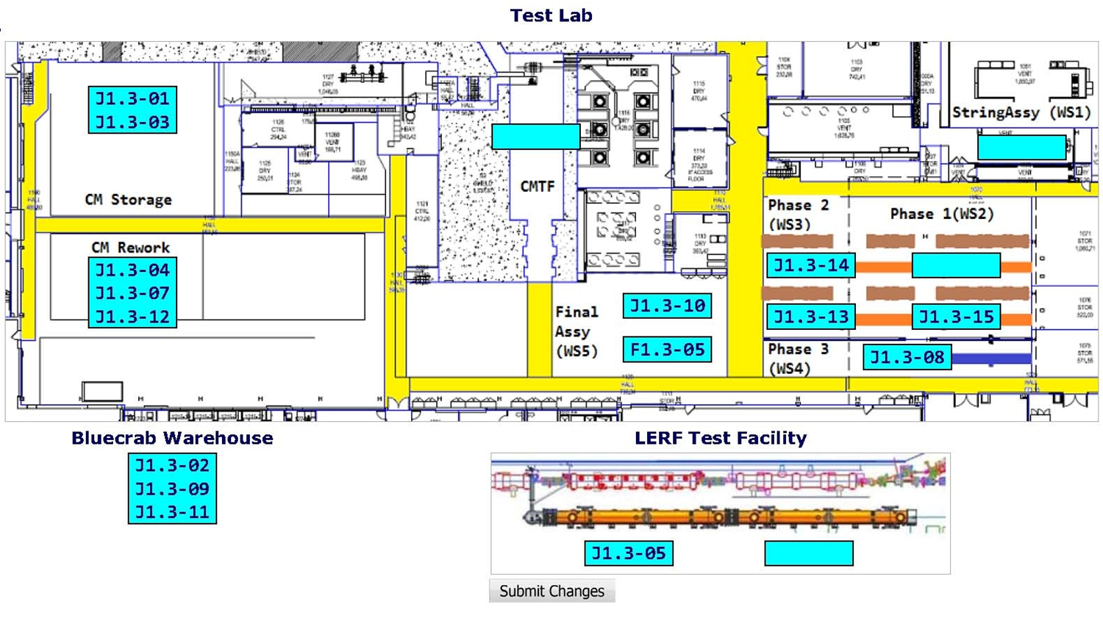

**QUALITY:**

* JLAB and FNAL completed their site QA reviews with SLAC, FNAL, FRIB and JLab personnel. Next step is SLAC review, tentatively set for the week of December 3.

**Upcoming Travel/Meetings:**

* F5 Shipping Receipt at SLAC – Week of 03-DEC
* J4 Shipping Receipt at SLAC – Week of 03-DEC

Weekly Reporting

WBS 1.04.06 Cryomodules - LERF Conversion

Week of November 15-21, 2018

**Issues:**

All LLRF cabling is complete.

Much of the piping for the Cryo Can is complete & leak checking is in progress.

Clean room is complete.

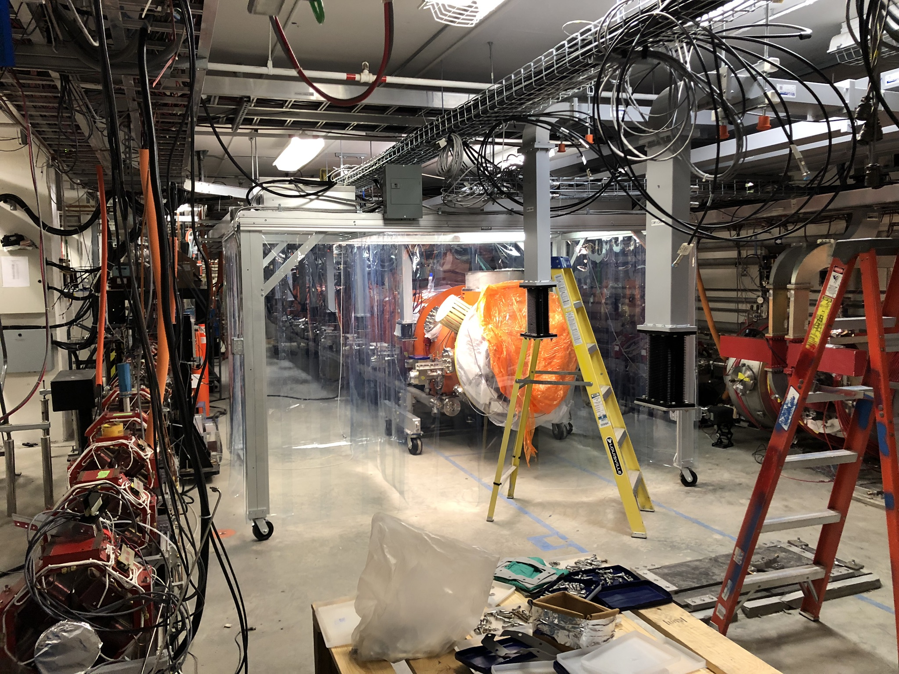

Weekly Reporting

WBS 1.04.08 JLAB Cryoplant System

Week of November 15-21, 2018

**Issues:**

1. Reduction in baseline resources (Return funding to contingency; the top-down EAC) without corresponding reduction in scope of cryoplant commissioning.
2. Resolution of structural interferences created during the design of the cold box room platforms and cable trays support systems (*identified in Nov 2017*).
3. Engineering change request associated with the interface box design-build subcontract resulting in increased cost and schedule delay.

**Accomplishments this week:**



**Deliveries Received @SLAC**

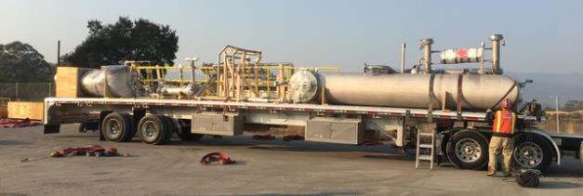

**C2 - 4.5K cold box platforms, piping spools & cryoduct delivered to SLAC.**

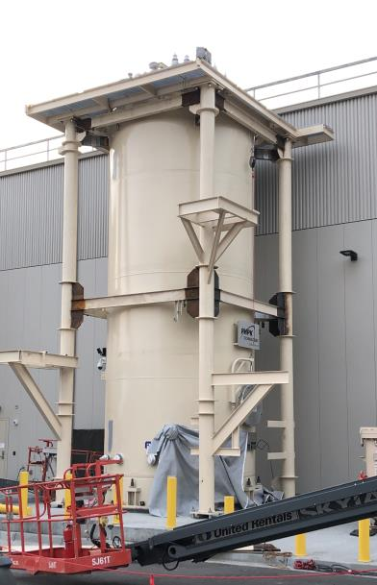

**C1 upper 4.5K cold box platform installation making good progress.**

**This outside work has been temporarily put on hold due to poor air quality.**

**Quality:**

* Successfully completed a formal review of the cryoplant software development.
* Successfully completed a final design review of the interface boxes.
* A comprehensive risk mitigation plan was developed and distributed to address the potential contamination associated with the oil removal vessels.
* Began reviewing acceptance welding documentation and inspection results for the first LN2 Dewar from AES for CryoPlant.

**Upcoming Travel/Deliveries/Reviews:**

* Helium purifier – Factory Acceptance Test 27-Nov-2018
* Monthly 4.5K Cold box status and update 29-Nov-2018
* LN2 Dewar witness of leak-check final acceptance 29-Nov-2018
* CryoPlant Commissioning Workshop @JLab 4&5-Dec-2018